Contract Generator (text Generator)

Introduction/Original Plans

Firstly, I began this project thinking that perhaps generating something tangible would be good, hoping to create a piece of software that could potentially be used in a day to day life attempting to perhaps fix a real-world problem?
I had just been in the process of waiting for my current employer to write up a version of a zero-hour contract and whilst I and my colleagues waited weeks for my managers to handwrite it up I figured, surely I could create a web app that could take templates, learn the legal lingo and then write up one of its own just with a press of a button.
“Sorted, easy peasy and not an issue to be had?”
I had presented my Idea with a quick mock-up of how I expected things to go in theory.
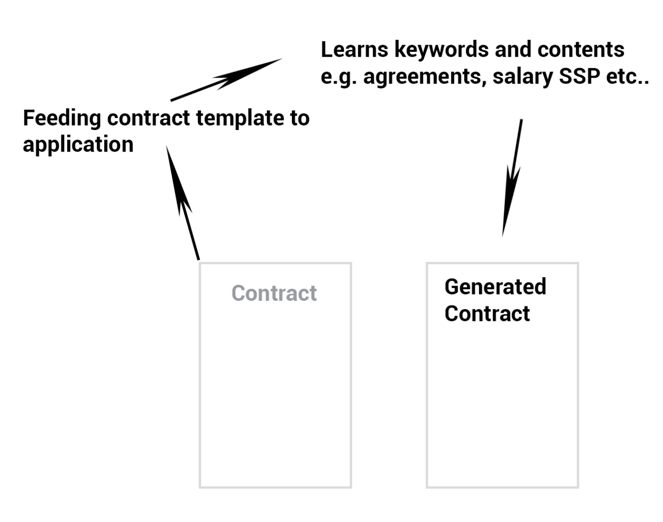

As shown above I was underestimating how much work is involved when tackling a problem like this which is probably why when I think of it that there’s a lack of applications similar to this except in specialised cases such as big banks and so on.

Learning Requirements

I began by looking into how to build GUI applications, still thinking in my head that we had covered some Machine learning concepts in class and that it shouldn’t be much harder than that. So there I was learning how to use Tkinter to build a basic simple GUI application that would once I had done building the machine learning model I would build it around and have some basic input fields for perhaps the employee's name, then press a button to generate the contract based on the filled-in values. This wasn’t too difficult it was mostly straight forward learning, just required understanding how to approach buttons and button placement. Tkinter mostly handles all of the hard work for the developer with the built-in functions.
Once I was familiar with the Tkinter aspects I started work on how was I exactly going to build this “simple” text generator?
This was where I would say I went wrong, but thus my rabbit hole began. I quickly realised that machine learning along with the text isn’t that straight forward. I hadn’t considered how was the computer supposed to know exactly what each letter in the alphabet meant to the computer? How was my application supposed to take these string conditions and understand their meaning and even their sentimental value?
I then started looking into solutions whilst also trying to understand the lower-level concepts of what I was reading I stumbled across a solution for text generation known as the “Markov Chain”. I happened to come across a few videos of the Markov Chain and some documentation that tried to understand how the Markov Chain worked. I spent a lot of my time going back and forth attempting to create different models of Markov Chain constantly running into problems with ‘pip’ and conditional errors on my local machine. This wasted a lot of project time as I frustratingly kept restarting. I then eventually realised that wait the Markov Chain won’t work for what I need anyway as it only has short term memory understanding the first letter in front and behind the current index.
Back to researching, I then found Natural Language Processing and learnt about tokenization and how that doesn’t just understand the characters of the index it takes into account the words within the current index, for example [‘hello’, ‘my’, ‘name’] would be read ‘hello’: 1 ‘my’: 2 ‘name’: 3. This was an improvement from the single characters that my model would now have to consider I figured hey I have my solution I have way fewer things my model needs to learn about. But this still doesn’t solve the remembering different words that had happened before the current point in the chain.
So I started looking LSTM (Long Short Term Memory), and the RNN (recurrent neural network) which basically will cycle between itself (the current word) then once its condition has been met will then push to the next step in the sequence while also retaining the current data that it has obtained during the sequences.
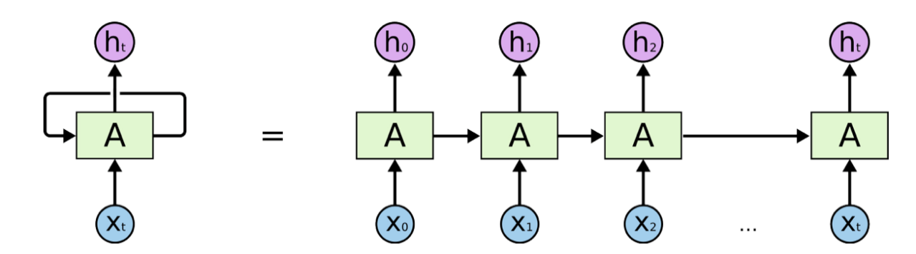
As you can see in the diagram above, it’s representing these different ideas showing how the RNN operates.

What went wrong

What I should’ve given up on sooner is probably building the model on my local machine as this gave me a lot of unneeded errors and set up problems with importing libraries which slowed my production down a lot and caused me to restart the programming a lot over and over when there was possibly no issue with the code. I think if I had just used google colab notebook or jupyter notebook I could’ve likely avoided these issues wasting production time and preventing myself from getting a working model operational.
I think this happened due to a lack of understanding of scope for the project. In comparison to the other projects I have developed in my experience I didn’t feel this was a huge application, however, I didn’t fully understand the learning curve needed to tackle machine learning and this particular machine learning model.

Production
At the beginning of the production, I had in my head a development plan, which first to find a template to act as my data (contract). I then went on to use import Docx to read the file and import it into the python file adding it to a directory and was going to use that to train, my model, on.
After I had started looking into how I was going to attempt to teach and develop a model using the documentation on TensorFlow and online sources about understanding what Markov Chain, RNN, LSTM and NLP. This required a lot of time and thinking about as I hadn’t tackled machine learning concepts very much before this project.
I, unfortunately, forgot to record images of my production process ( this is including the numerous failed attempts) which was incredibly silly of myself as this is not the first production diary I have done. I just kept getting carried away and going in circles which at the time caused me not to consider taking screenshots of the code and workflow process.

Conclusion/Improvements

To conclude this, I think if I had handled something a bit more manageable such as perhaps getting a small response bot that required perhaps an input and a basic reply I would’ve maybe been more successful. Whilst perhaps having a smaller scope and focusing on development time on an online notebook instead of developing on my machine. I could’ve also had more success with the project overall cutting off a lot of lost time trying over and over to fix unimportant import errors.
However, I do not regret attempting this project as I have learnt a whole bunch about Python and development using machine learning and allowed me to think about computing in a different way, such as understanding that a learning model can’t understand what exactly textual characters are without applying a number value to each character or a word depending on the model being built.

Bibliography
Edureka!, 2017. Recurrent Neural Networks (RNN) | RNN LSTM | Deep Learning Tutorial | Tensorflow Tutorial | Edureka. [Online]
Available at: https://www.youtube.com/watch?v=y7qrilE-Zlc
[Accessed 2020].
Edureka!, 2019. Introduction To Markov Chains | Markov Chains in Python | Edureka. [Online]
Available at: https://www.youtube.com/watch?v=Gs2xtNzogSY&t=1219s
[Accessed 2020].
Google, 2019. Intro to Machine Learning (ML Zero to Hero - Part 1). [Online]
Available at: https://www.youtube.com/watch?v=KNAWp2S3w94&list=PLQY2H8rRoyvwLbzbnKJ59NkZvQAW9wLbx&index=12
[Accessed 2020].
Google, 2020. Basics of machine learning with TensorFlow. [Online]
Available at: https://www.tensorflow.org/resources/learn-ml/basics-of-machine-learning
[Accessed 2020].
Google, 2020. Install TensorFlow with pip. [Online]
Available at: https://www.tensorflow.org/install/pip
[Accessed 2020].
Google, 2020. Module: tf.keras. [Online]
Available at: https://www.tensorflow.org/api_docs/python/tf/keras
[Accessed 2020].
Google, 2020. TensorFlow 2 quickstart for beginners. [Online]
Available at: https://www.tensorflow.org/tutorials/quickstart/beginner
[Accessed 2020].
Google, 2020. Text generation with an RNN. [Online]
Available at: https://www.tensorflow.org/tutorials/text/text_generation#generate_text
[Accessed 2020].
Johnson., J., n.d. Python Numpy Tutorial (with Jupyter and Colab). [Online]
Available at: https://cs231n.github.io/python-numpy-tutorial/
[Accessed 2020].
Python, n.d. pickle — Python object serialization. [Online]
Available at: https://docs.python.org/2/library/pickle.html
[Accessed 2020].
sentdx, 2018. Recurrent Neural Networks (RNN) - Deep Learning w/ Python, TensorFlow & Keras p.7. [Online]
Available at: https://www.youtube.com/watch?v=BSpXCRTOLJA
[Accessed 2020].
Train, T. C., 2016. Coding Challenge #42.1: Markov Chains - Part 1. [Online]
Available at: https://www.youtube.com/watch?v=eGFJ8vugIWA
[Accessed 2020].
Zhao, A., 2019. Natural Language Processing (Part 6): Text Generation with Markov Chains in Python. [Online]
Available at: https://www.youtube.com/watch?v=MGVdu39gT6k
[Accessed 2020].

