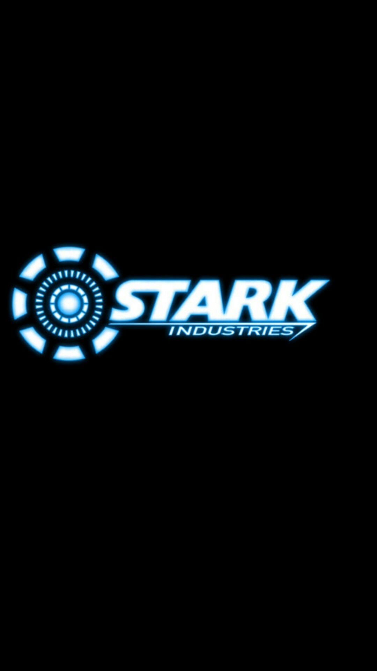

Key1 TO CONTINUE

Hello, I am Jarvis - Iron man’s personal AI.

Mr. Stark has requested that we run simulations on his suit’s new flight system. This is to ensure the safety and reliability of the suit for his upcoming Avengers battle. The suit has an autonomous mode that uses machine learning to gain experience. The more experience, the more support it can provide iron man in battle. Swiftly avoid/dodge enemies to level up Iron man’s suit!

***FLIGHT SIMULATOR***

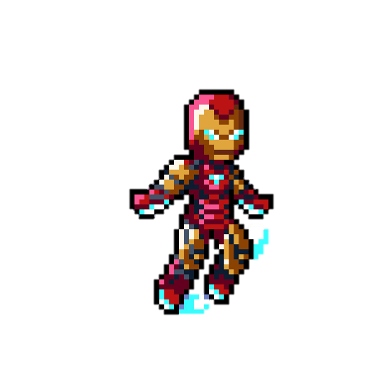

**PRESS KEY1 TO START**