

Diagrams

Software Developer - Music Player



Contents

User Interface Sketches 2

Entity Relationship Diagram 2

UML Diagram 3

Use Case Diagram 4

Flow Diagram 5

# User Interface Sketches

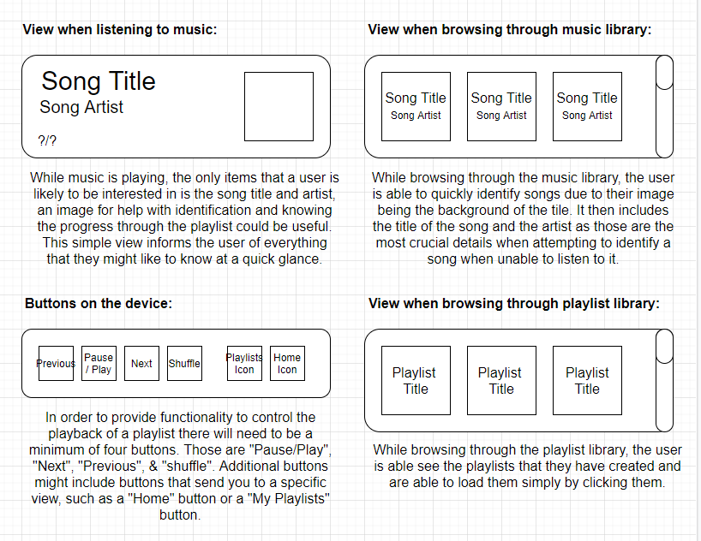

# Entity Relationship Diagram

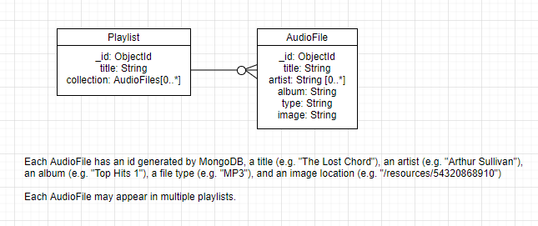

# UML Diagram

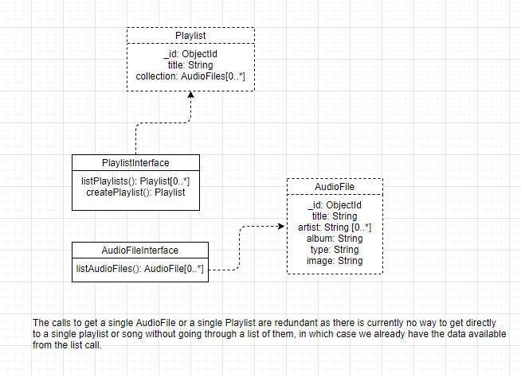

# Use Case Diagram

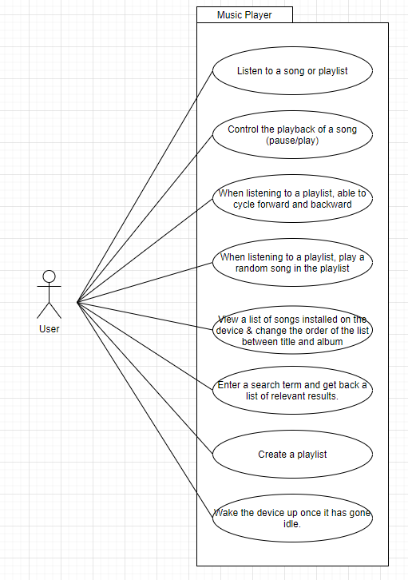

# Flow Diagram

