Glitch Art Is Dead

Glitch Art Is Dead is an international artistic project originating in Krakow, Poland in 2015. The project brought together more than 90 different artists for a three day weekend exhibition featuring Glitch Art workshops.

Project's Elements

The project had a great focus on glitch art and creating glitch art, the main elements of glitch art are the glitch, and the art.

The Glitch

A glitch by definition is “a sudden, usually temporary malfunction or fault of equipment”, and is described by Gamut Gallery as a “malfunction of a digital system, a computer error which can turn images into bizarre and colourful compositions”. The exhibition lasted three days and offered many workshops on how to create different glitches yourself.

The Art

Glitch Art Is Dead attempted to display glitches as art rather than malfunctions. The art element of this project, and any glitch art, is achieved by deliberately inciting these errors for aesthetic purposes.

What's Interesting?

The aspect of glitch art that interest me and pulls me to the media is the creation of an altered perception of the art. If your laptop were to malfunction and cause a colourful pattern of stripes to cover a portion of the screen, it would not be perceived as art. Throughout the three day exhibition there were also workshops offered on different techniques in creating glitch art, including 3D glitching, sonification, datamoshing, and creative coding. I find the wide range in methods to create a glitched art piece interesting, Glitch Art Is Dead exhibits glitched audio (sonification), 3D art, and coded pieces as well as manipulating the data itself of media files to create glitches (datamoshing).

What Don't I Like?

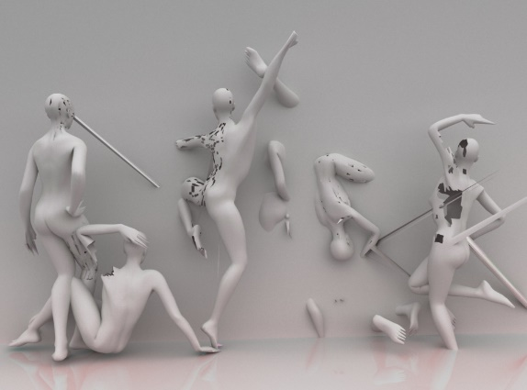An issue with glitch art I have discovered is at what point the glitch aspect of the piece overtakes the art aspect of the piece. In some pieces it appears that the pieces are glitched beyond recognition of any artistic interpretation. An example I have chosen for this criticism is a piece depicting five 3D modelled humans in various poses facing away from the camera. I understand the appeal of glitched 3D models, and that is one of the workshops offered at the exhibition, but I find the piece to lack much pull or meaning. The piece appears to be too focused on creating a glitch for the sake of creating a glitch. The lack of colour further accentuates my feelings about this, a core part of glitch art is the kaleidoscope of colours and patterns that can appear when errors occur.

What Would I Do?

I would like to incorporate the message of taking a malfunctioning system and using it to generate bizarre and colourful collages of errors and altering it’s perception from that of something that is broken, and instead becoming something artistic and creative. To avoid my own criticism of pieces lacking meaning I would like to keep my work focused around my main theme, the beauty of the broken. To focus on my theme I have outlined some core values for my work. Those being colour, glitch, and meaning. I chose colour because my first thought of glitch art, and the element that draws me to it immediately is the prevalence of colour in glitches. This is also the element that can most effectively breach the gap between a malfunctioning file or system to an actual piece of art. The glitch value is to ensure that the piece can actually be considered glitch art in that it utilises malfunctions and errors to completely transform whatever the piece would be without errors, this can be achieved with different effects that I will go into shortly. The final value, meaning, ensures that I don’t fall victim to my own criticisms, all work that I create must relate directly to the original message, which is that seemingly broken things can be perceived as beautiful, creative, and above all, art.

Ideas

* Create 3D models with a glitched aesthetic, use 3D printing to create physical copies of these models, and use projection mapping to map glitch effects (images, loops, videos, etc.). In a dark room I believe that a lit up model could be very interesting as it changes it’s patterns. An example idea I have for this is creating one or more humanoid models then projecting differing events onto each of them, this could be people from varying living situations with glitched footage spread across their bodies, or the severity of the glitch effects could correspond to how stable or unstable the living situation is for the person represented by the model.
* Utilising sonification to create glitched audio and a display, a piece could be formed by causing the audio to influence the display. By making the display an audio visualiser, the audio will change the image on screen. The audio for this piece could either be provided by viewers of the exhibition, either having the display react to the noises they make or repeat what is said with a distorted, glitched playback.