High-Freq Trading System Design Notes
1. System Components


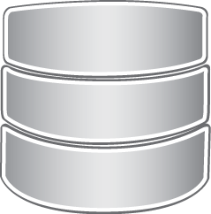
Strategy Analysis
Module
Trading Executing
Module
Data Access
Module
Trade Directives

Event Bus Module

Trade Monitoring
Module
Logging Module
Plotting Module
Strategy Evaluate Module

PIC-A
2. Interactions
2.1) DataAccess Module provides with interfaces of accessing data from local-storage(sqlite, general speaking) and, real-time indexes' ticks from internet.
2.2) in case of real-time indexes arrived from internet, data will be sent to the Strategy Analysis Module for analysing. For some test purpose, Strategy Analysis Module might call interfaces from DataAccess Module to get access to the local storage for cached indexes if necessary.
2.3) for test purpose, the Plotting Module might be involked to display some curves in the window.
2.4) The channel bypassing ONE financial index from DateaAccessModule to StrategyAnalysis Module is called IndexStream(FICH for short, and marked as orange in the PIC-A). In most cases, the indexes will be refined, say, it might need to bypassing a Gauss-Filter to make the historical curve smooth.
2.5) Strategy Evaluate Module is for evaluating the strategy by using a bunch of math-theories, to see if the strategy acts good or not.
2.6) Trading Monitor Module monitors behaviors of TradingExecute Module, according to the user settings. It will stop trading if the lowest level meets in the money pool, or there is network problem, or the real buy price is higher than expected from StrategyAnalysis Module, or more.
3. The StrategyAnalysis Module
3.1) the StrategyAnalysis Module is the most complex module of the whole system:
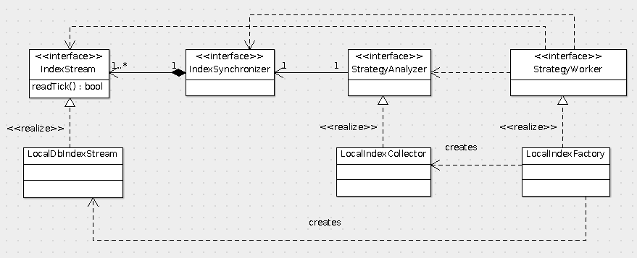
PIC-B
this subsystem consist of multiple parts:
3.1.1) IndexStream
An IndexStream abstracts stream of indexes coming from locale storage or Internet network. Some standard interfaces which can be extended/override are provided, e.g: open, close, and read. In reality, each IndexStream works separately and, in software perspective this module is derived from a thread object.
3.1.2) IndexSynchronizer
As we known, ticks of multiple indexes from Internet or local-storage need to be synchronized by a virtual clock. For example, we have to inspect 2 stocks: at a time, the index of stock#1 timestamped by t1 arrived, and index of stock#2 timestamped by t0 also reached at the same time; it is wrong to co-operate stock#1 t0 with stock#2 t1 together. In a word, we need a clock to synchronize between multiple stocks' index.
The IndexSynchronizer provides with 2 modes of synchronizing, RefEachClockMode or SystemClockMode. The RefEachClockMode looks into each stock's timestamp, and is very helpful if there is more than 1 stocks inspecetd.
The SystemClockMode uses system clock, makes each tick
3.1.3) StrategyAnalyzer
3.1.4) StrategyWorker

