exp2: 觀察lr變化

a=0.9 w=0.9/3 phi_p=0.8/3 phi_g=0.8/3 lr=0.2 iter=40 S=1000 k=1

0.9012820512820514 / 975

a=0.9 w=0.9/3 phi_p=0.8/3 phi_g=0.8/3 lr=1 iter=20 S=1000 k=1

0.9 / 981

a=0.9 w=0.9/3 phi_p=0.8/3 phi_g=0.8/3 lr=2.8 iter=20 S=1000 k=1

0.9192307692307692 / 977

a=0.9 w=0.9/3 phi_p=0.8/3 phi_g=0.8/3 lr=3 iter=20 S=1000 k=1

0.95 / 988

a=0.9 w=0.9/3 phi_p=0.8/3 phi_g=0.8/3 lr=3.2 iter=20 S=1000 k=1

0.9179487179487179 / 922

a=0.9 w=0.9/3 phi_p=0.8/3 phi_g=0.8/3 lr=5 iter=20 S=1000 k=1

0.9179487179487179 / 859

a=0.9 w=0.9/3 phi_p=0.8/3 phi_g=0.8/3 lr=8 iter=20 S=1000 k=1

0.8833333333333334 / 1038

exp3: 找出速度三分量係數(w,phi_p,phi_g)貢獻比例

**w大 3:1:1**

a=0.9 w=0.8*3/5 phi_p=0.8*1/5 phi_g=0.8*1/5 lr=3 iter=10 S=1000 k=1

0.9192307692307692 / 891

**w小 1:3:3**

a=0.9 w=0.8*1/7 phi_p=0.8*3/7 phi_g=0.8*3/7 lr=3 iter=20 S=1000 k=1

0.9333333333333332 / 957

**phi_p大 1:3:1**

a=0.9 w=0.8*1/5 phi_p=0.8*3/5 phi_g=0.8*1/5 lr=3 iter=20 S=1000 k=1

0.9 / 909

**phi_p小 3:1:3**

a=0.9 w=0.8*3/7 phi_p=0.8*1/7 phi_g=0.8*3/7 lr=3 iter=20 S=1000 k=1

0.9333333333333333 / 764

**phi_g大 1:1:3**

a=0.9 w=0.8*1/5 phi_p=0.8*1/5 phi_g=0.8*3/5 lr=3 iter=20 S=1000 k=1

0.9358974358974359 / 948

**phi_g小 3:3:1**

a=0.9 w=0.8*3/7 phi_p=0.8*3/7 phi_g=0.8*1/7 lr=3 iter=20 S=1000 k=1

0.9012820512820513 / 825

exp1: 觀察a的變化

a=0.1 w=0.9/3 phi_p=0.8/3 phi_g=0.8/3 lr=3 iter=20 S=1000 k=1

0.9179487179487179 / 543

a=0.3 w=0.9/3 phi_p=0.8/3 phi_g=0.8/3 lr=3 iter=20 S=1000 k=1

0.9333333333333333 / 684

a=0.5 w=0.9/3 phi_p=0.8/3 phi_g=0.8/3 lr=3 iter=20 S=1000 k=1

0.9192307692307693 / 843

a=0.7 w=0.9/3 phi_p=0.8/3 phi_g=0.8/3 lr=3 iter=20 S=1000 k=1

0.9 / 939

a=0.8 w=0.9/3 phi_p=0.8/3 phi_g=0.8/3 lr=3 iter=20 S=1000 k=1

0.9 / 1006

a=1 w=0.9/3 phi_p=0.8/3 phi_g=0.8/3 lr=3 iter=20 S=1000 k=1

0.8858974358974357 / 994

exp4: 換成w_decay=True, gamma = 1

a=0.9 w=0.1 phi_p=0.8/3 phi_g=0.8/3 lr=3 iter=20 S=1000 k=1 w_decay = True

0.9038461538461539 / 958

a=0.9 w=0.9/3 phi_p=0.8/3 phi_g=0.8/3 lr=3 iter=20 S=1000 k=1 w_decay = True

0.9025641025641026 / 986

a=0.9 w=0.5 phi_p=0.8/3 phi_g=0.8/3 lr=3 iter=20 S=1000 k=1 w_decay = True

0.885897435897436 / 977

Exp5: 觀察a的變化, 設定gamma = 1.8, w_decay = False

a=0.1 w=0.9/3 phi_p=0.8/3 phi_g=0.8/3 lr=3 iter=20 S=1000 k=1 w_decay = False

0.8679487179487181 / 547

a=0.3 w=0.9/3 phi_p=0.8/3 phi_g=0.8/3 lr=3 iter=20 S=1000 k=1 w_decay = False

0.9025641025641026 / 542

a=0.5 w=0.9/3 phi_p=0.8/3 phi_g=0.8/3 lr=3 iter=20 S=1000 k=1 w_decay = False

0.9012820512820514 / 709

a=0.7 w=0.9/3 phi_p=0.8/3 phi_g=0.8/3 lr=3 iter=20 S=1000 k=1 w_decay = False

0.9166666666666667 / 846

a=0.8 w=0.9/3 phi_p=0.8/3 phi_g=0.8/3 lr=3 iter=20 S=1000 k=1 w_decay = False

0.9166666666666666 / 886

a=1 w=0.9/3 phi_p=0.8/3 phi_g=0.8/3 lr=3 iter=20 S=1000 k=1 w_decay = False

0.9346153846153846 / 934

exp2: Data

a=0.9 w=0.9/3 phi_p=0.8/3 phi_g=0.8/3 lr=0.2 iter=40 S=1000 k=1

round 0 : 0.8679487179487181

round 1 : 0.8871794871794872

round 2 : 0.8871794871794872

round 3 : 0.8871794871794872

round 4 : 0.8846153846153847

round 5 : 0.8846153846153847

round 6 : 0.8846153846153847

round 7 : 0.8846153846153847

round 8 : 0.9012820512820513

round 9 : 0.9012820512820513

round 10 : 0.9012820512820513

round 11 : 0.9012820512820513

round 12 : 0.9012820512820513

round 13 : 0.9012820512820513

round 14 : 0.9012820512820513

round 15 : 0.9012820512820513

round 16 : 0.9012820512820513

round 17 : 0.9012820512820513

round 18 : 0.9012820512820513

round 19 : 0.9012820512820513

round 20 : 0.9012820512820513

round 21 : 0.9012820512820514

round 22 : 0.9012820512820514

round 23 : 0.9012820512820514

round 24 : 0.9012820512820514

round 25 : 0.9012820512820514

round 26 : 0.9012820512820514

round 27 : 0.9012820512820514

round 28 : 0.9012820512820514

round 29 : 0.9012820512820514

round 30 : 0.9012820512820514

round 31 : 0.9012820512820514

round 32 : 0.9012820512820514

round 33 : 0.9012820512820514

round 34 : 0.9012820512820514

round 35 : 0.9012820512820514

round 36 : 0.9012820512820514

round 37 : 0.9012820512820514

round 38 : 0.9012820512820514

round 39 : 0.9012820512820514

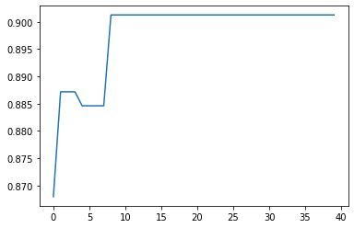

0.9012820512820514 / 975

a=0.9 w=0.9/3 phi_p=0.8/3 phi_g=0.8/3 lr=1 iter=20 S=1000 k=1

round 0 : 0.8833333333333334

round 1 : 0.8833333333333334

round 2 : 0.8833333333333334

round 3 : 0.8833333333333334

round 4 : 0.9

round 5 : 0.9

round 6 : 0.9

round 7 : 0.9

round 8 : 0.9

round 9 : 0.9

round 10 : 0.9

round 11 : 0.9

round 12 : 0.9

round 13 : 0.9

round 14 : 0.9

round 15 : 0.9

round 16 : 0.9

round 17 : 0.9

round 18 : 0.9

round 19 : 0.9

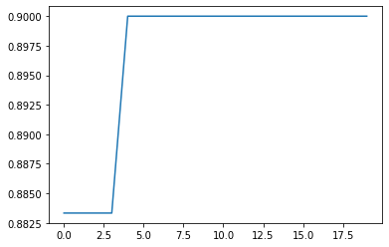

0.9 / 981

a=0.9 w=0.9/3 phi_p=0.8/3 phi_g=0.8/3 lr=2.8 iter=20 S=1000 k=1

round 0 : 0.9012820512820513

round 1 : 0.9012820512820513

round 2 : 0.9012820512820513

round 3 : 0.9025641025641026

round 4 : 0.9025641025641026

round 5 : 0.9025641025641026

round 6 : 0.9192307692307692

round 7 : 0.9192307692307692

round 8 : 0.9192307692307692

round 9 : 0.9192307692307692

round 10 : 0.9192307692307692

round 11 : 0.9192307692307692

round 12 : 0.9192307692307692

round 13 : 0.9192307692307692

round 14 : 0.9192307692307692

round 15 : 0.9192307692307692

round 16 : 0.9192307692307692

round 17 : 0.9192307692307692

round 18 : 0.9192307692307692

round 19 : 0.9192307692307692

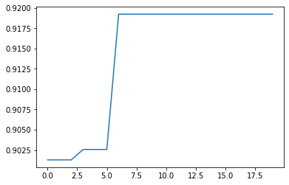

0.9192307692307692 / 977

a=0.9 w=0.9/3 phi_p=0.8/3 phi_g=0.8/3 lr=3 iter=20 S=1000 k=1

round 0 : 0.9012820512820514

round 1 : 0.9012820512820514

round 2 : 0.9012820512820513

round 3 : 0.9025641025641026

round 4 : 0.9333333333333332

round 5 : 0.9346153846153846

round 6 : 0.9346153846153846

round 7 : 0.9346153846153846

round 8 : 0.9346153846153846

round 9 : 0.95

round 10 : 0.95

round 11 : 0.95

round 12 : 0.95

round 13 : 0.95

round 14 : 0.95

round 15 : 0.95

round 16 : 0.95

round 17 : 0.95

round 18 : 0.95

round 19 : 0.95

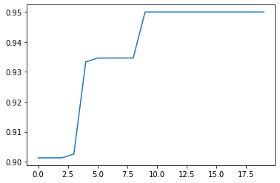

0.95 / 988

a=0.9 w=0.9/3 phi_p=0.8/3 phi_g=0.8/3 lr=3.2 iter=20 S=1000 k=1

round 0 : 0.8846153846153847

round 1 : 0.9012820512820513

round 2 : 0.9012820512820513

round 3 : 0.9012820512820513

round 4 : 0.9012820512820513

round 5 : 0.9025641025641026

round 6 : 0.9025641025641026

round 7 : 0.9179487179487179

round 8 : 0.9179487179487179

round 9 : 0.9179487179487179

round 10 : 0.9179487179487179

round 11 : 0.9179487179487179

round 12 : 0.9179487179487179

round 13 : 0.9179487179487179

round 14 : 0.9179487179487179

round 15 : 0.9179487179487179

round 16 : 0.9179487179487179

round 17 : 0.9179487179487179

round 18 : 0.9179487179487179

round 19 : 0.9179487179487179

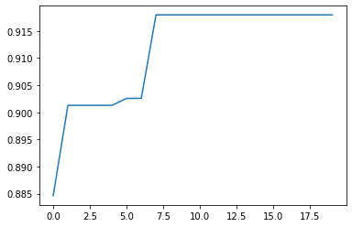

0.9179487179487179 / 922

a=0.9 w=0.9/3 phi_p=0.8/3 phi_g=0.8/3 lr=5 iter=20 S=1000 k=1

round 0 : 0.8692307692307694

round 1 : 0.9012820512820513

round 2 : 0.9012820512820513

round 3 : 0.9012820512820513

round 4 : 0.9012820512820513

round 5 : 0.9012820512820513

round 6 : 0.9012820512820513

round 7 : 0.9025641025641026

round 8 : 0.9025641025641026

round 9 : 0.9179487179487179

round 10 : 0.9179487179487179

round 11 : 0.9179487179487179

round 12 : 0.9179487179487179

round 13 : 0.9179487179487179

round 14 : 0.9179487179487179

round 15 : 0.9179487179487179

round 16 : 0.9179487179487179

round 17 : 0.9179487179487179

round 18 : 0.9179487179487179

round 19 : 0.9179487179487179

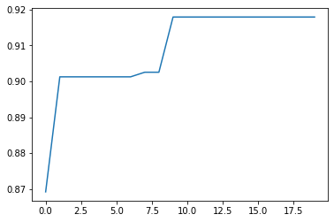

0.9179487179487179 / 859

a=0.9 w=0.9/3 phi_p=0.8/3 phi_g=0.8/3 lr=8 iter=20 S=1000 k=1

round 0 : 0.8833333333333334

round 1 : 0.8833333333333334

round 2 : 0.8833333333333334

round 3 : 0.8833333333333334

round 4 : 0.8833333333333334

round 5 : 0.8833333333333334

round 6 : 0.8833333333333334

round 7 : 0.8833333333333334

round 8 : 0.8833333333333334

round 9 : 0.8833333333333334

round 10 : 0.8833333333333334

round 11 : 0.8833333333333334

round 12 : 0.8833333333333334

round 13 : 0.8833333333333334

round 14 : 0.8833333333333334

round 15 : 0.8833333333333334

round 16 : 0.8833333333333334

round 17 : 0.8833333333333334

round 18 : 0.8833333333333334

round 19 : 0.8833333333333334

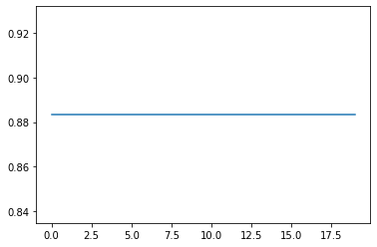

0.8833333333333334 / 1038

a=0.9 w=0.9/3 phi_p=0.8/3 phi_g=0.8/3 lr=3 iter=20 S=1000 k=1

**0.95** / 988

[0, 1, 4, 6, 7, 8, 9, 10, 11, 15, 17, 18, 23, 25, 26, 27, 28, 30, 32, 34, 35, 36, 38, 41, 42, 45, 53, 58, 62, 67, 68, 70, 75, 80, 81, 84, 86, 93, 94, 96, 103, 104, 105, 108, 109, 110, 113, 114, 115, 118, 120, 121, 122, 123, 124, 125, 127, 128, 135, 138, 139, 140, 143, 144, 145, 146, 147, 148, 150, 152, 153, 156, 157, 159, 162, 163, 165, 166, 170, 171, 172, 173, 174, 175, 176, 177, 179, 180, 181, 182, 183, 185, 187, 198, 199, 200, 202, 203, 204, 205, 206, 208, 211, 214, 215, 217, 218, 221, 224, 225, 227, 228, 229, 230, 232, 233, 235, 237, 239, 240, 241, 243, 244, 247, 251, 258, 260, 261, 262, 265, 269, 270, 271, 273, 274, 275, 277, 284, 294, 295, 298, 299, 300, 301, 303, 306, 307, 308, 314, 316, 318, 321, 322, 325, 330, 332, 334, 336, 337, 338, 339, 340, 341, 342, 344, 345, 346, 351, 352, 353, 354, 356, 357, 358, 369, 371, 372, 374, 376, 377, 380, 381, 383, 384, 386, 387, 390, 391, 392, 393, 394, 395, 398, 399, 401, 402, 403, 405, 406, 408, 410, 411, 413, 414, 417, 418, 419, 422, 424, 426, 427, 428, 429, 430, 431, 432, 433, 435, 437, 440, 448, 449, 453, 455, 456, 459, 463, 467, 468, 469, 470, 471, 472, 473, 474, 476, 477, 479, 484, 485, 488, 489, 491, 492, 496, 498, 502, 503, 504, 505, 506, 508, 509, 510, 511, 513, 516, 517, 520, 521, 524, 525, 526, 527, 532, 533, 534, 535, 538, 540, 541, 543, 544, 545, 547, 553, 555, 557, 558, 563, 564, 566, 568, 569, 570, 572, 574, 575, 576, 577, 578, 583, 584, 585, 588, 590, 591, 593, 596, 597, 598, 599, 600, 602, 607, 610, 612, 613, 614, 615, 617, 620, 621, 624, 626, 627, 629, 631, 632, 635, 638, 641, 642, 644, 645, 648, 649, 650, 651, 652, 654, 656, 657, 659, 660, 662, 664, 665, 672, 673, 674, 677, 679, 684, 686, 687, 689, 690, 693, 694, 695, 697, 698, 699, 700, 701, 703, 704, 707, 709, 710, 714, 715, 718, 720, 724, 725, 726, 727, 729, 731, 734, 735, 736, 738, 739, 742, 745, 755, 760, 762, 764, 767, 768, 770, 771, 772, 773, 774, 776, 778, 779, 781, 784, 789, 792, 795, 797, 800, 801, 811, 813, 814, 815, 819, 821, 823, 824, 825, 828, 829, 830, 831, 832, 835, 836, 837, 841, 843, 844, 846, 847, 849, 850, 852, 855, 857, 860, 861, 863, 864, 869, 870, 871, 873, 874, 876, 878, 879, 880, 881, 883, 886, 887, 888, 890, 891, 892, 894, 896, 897, 900, 901, 902, 903, 904, 905, 906, 908, 909, 911, 916, 920, 921, 923, 925, 927, 929, 931, 933, 935, 939, 940, 944, 948, 949, 951, 952, 953, 963, 964, 965, 966, 969, 970, 971, 975, 977, 979, 980, 981, 982, 983, 984, 990, 991, 993, 994, 998, 999, 1000, 1001, 1003, 1009, 1010, 1013, 1014, 1016, 1017, 1018, 1019, 1021, 1024, 1026, 1027, 1028, 1030, 1031, 1034, 1042, 1045, 1047, 1051, 1053, 1054, 1058, 1059, 1063, 1065, 1067, 1071, 1072, 1077, 1082, 1083, 1086, 1090, 1096, 1098, 1099, 1100, 1102, 1103, 1104, 1105, 1106, 1107, 1108, 1110, 1112, 1113, 1118, 1120, 1122, 1123, 1124, 1126, 1129, 1131, 1133, 1134, 1140, 1141, 1142, 1145, 1150, 1151, 1152, 1156, 1157, 1158, 1161, 1163, 1164, 1165, 1167, 1168, 1170, 1171, 1173, 1177, 1181, 1182, 1183, 1184, 1185, 1188, 1189, 1197, 1199, 1200, 1202, 1204, 1205, 1214, 1215, 1216, 1217, 1219, 1220, 1224, 1225, 1226, 1228, 1230, 1231, 1232, 1233, 1235, 1237, 1238, 1240, 1242, 1248, 1249, 1251, 1252, 1253, 1254, 1257, 1258, 1259, 1264, 1271, 1273, 1274, 1275, 1282, 1283, 1285, 1289, 1291, 1294, 1297, 1298, 1302, 1305, 1307, 1310, 1314, 1319, 1322, 1324, 1325, 1326, 1327, 1328, 1329, 1332, 1336, 1338, 1343, 1345, 1351, 1355, 1358, 1360, 1363, 1365, 1367, 1369, 1371, 1372, 1373, 1375, 1376, 1379, 1381, 1382, 1383, 1384, 1386, 1390, 1391, 1395, 1396, 1397, 1399, 1401, 1402, 1403, 1404, 1406, 1407, 1408, 1410, 1411, 1413, 1415, 1419, 1421, 1423, 1424, 1425, 1427, 1431, 1432, 1433, 1438, 1439, 1440, 1441, 1443, 1444, 1445, 1446, 1448, 1449, 1450, 1451, 1455, 1456, 1457, 1458, 1459, 1460, 1463, 1466, 1468, 1470, 1472, 1473, 1474, 1476, 1477, 1478, 1480, 1482, 1487, 1488, 1489, 1491, 1492, 1494, 1498, 1500, 1502, 1505, 1506, 1507, 1508, 1510, 1512, 1513, 1514, 1515, 1517, 1519, 1520, 1522, 1523, 1524, 1525, 1526, 1527, 1528, 1530, 1532, 1534, 1535, 1539, 1541, 1542, 1543, 1545, 1546, 1549, 1550, 1553, 1554, 1557, 1558, 1563, 1565, 1569, 1570, 1572, 1573, 1574, 1576, 1578, 1581, 1582, 1583, 1585, 1587, 1588, 1589, 1591, 1595, 1597, 1603, 1607, 1608, 1609, 1610, 1611, 1612, 1618, 1619, 1623, 1624, 1625, 1628, 1630, 1632, 1633, 1637, 1638, 1639, 1641, 1642, 1643, 1644, 1646, 1649, 1650, 1652, 1653, 1655, 1657, 1660, 1664, 1665, 1668, 1669, 1673, 1674, 1675, 1678, 1679, 1680, 1681, 1684, 1685, 1687, 1689, 1691, 1693, 1695, 1696, 1701, 1702, 1703, 1705, 1707, 1709, 1710, 1711, 1716, 1717, 1718, 1719, 1724, 1726, 1727, 1728, 1730, 1731, 1732, 1734, 1735, 1736, 1737, 1739, 1740, 1741, 1742, 1743, 1744, 1748, 1749, 1751, 1752, 1754, 1756, 1759, 1761, 1762, 1763, 1767, 1768, 1770, 1773, 1775, 1776, 1777, 1779, 1780, 1783, 1789, 1792, 1793, 1794, 1796, 1805, 1806, 1809, 1810, 1816, 1817, 1820, 1821, 1827, 1828, 1829, 1832, 1836, 1837, 1839, 1840, 1843, 1845, 1846, 1847, 1848, 1850, 1851, 1858, 1863, 1865, 1868, 1870, 1871, 1872, 1873, 1877, 1881, 1883, 1885, 1887, 1888, 1889, 1892, 1893, 1895, 1899, 1901, 1904, 1906, 1911, 1916, 1917, 1918, 1921, 1922, 1925, 1926, 1929, 1930, 1931, 1933, 1936, 1940, 1942, 1943, 1944, 1946, 1947, 1948, 1953, 1954, 1955, 1956, 1957, 1958, 1960, 1963, 1964, 1965, 1968, 1970, 1972, 1973, 1976, 1979, 1982, 1985, 1986, 1987, 1988, 1989, 1990, 1995, 1996, 1997, 1998, 1999]

exp3: Data

w大 3:1:1

a=0.9 w=0.8*3/5 phi_p=0.8*1/5 phi_g=0.8*1/5 lr=3 iter=10 S=1000 k=1

round 0 : 0.8846153846153847

round 1 : 0.9192307692307693

round 2 : 0.9192307692307693

round 3 : 0.9192307692307693

round 4 : 0.9192307692307693

round 5 : 0.9192307692307693

round 6 : 0.9192307692307693

round 7 : 0.9192307692307693

round 8 : 0.9192307692307692

round 9 : 0.9192307692307692

round 10 : 0.9192307692307692

round 11 : 0.9192307692307692

round 12 : 0.9192307692307692

round 13 : 0.9192307692307692

round 14 : 0.9192307692307692

round 15 : 0.9192307692307692

round 16 : 0.9192307692307692

round 17 : 0.9192307692307692

round 18 : 0.9192307692307692

round 19 : 0.9192307692307692

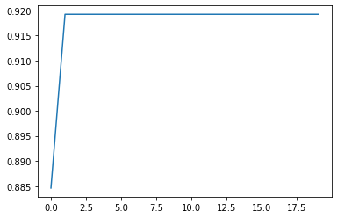

0.9192307692307692 / 891

w小 1:3:3

a=0.9 w=0.8*1/7 phi_p=0.8*3/7 phi_g=0.8*3/7 lr=3 iter=20 S=1000 k=1

round 0 : 0.8717948717948719

round 1 : 0.8846153846153847

round 2 : 0.9012820512820514

round 3 : 0.9025641025641026

round 4 : 0.9166666666666666

round 5 : 0.9166666666666667

round 6 : 0.9179487179487179

round 7 : 0.9333333333333332

round 8 : 0.9333333333333332

round 9 : 0.9333333333333332

round 10 : 0.9333333333333332

round 11 : 0.9333333333333332

round 12 : 0.9333333333333332

round 13 : 0.9333333333333332

round 14 : 0.9333333333333332

round 15 : 0.9333333333333332

round 16 : 0.9333333333333332

round 17 : 0.9333333333333332

round 18 : 0.9333333333333332

round 19 : 0.9333333333333332

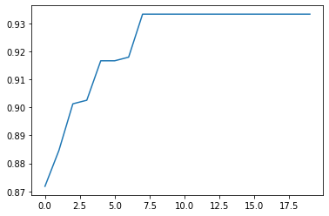

0.9333333333333332 / 957

phi_p大 1:3:1

a=0.9 w=0.8*1/5 phi_p=0.8*3/5 phi_g=0.8*1/5 lr=3 iter=20 S=1000 k=1

round 0 : 0.8833333333333334

round 1 : 0.8833333333333334

round 2 : 0.8846153846153847

round 3 : 0.9

round 4 : 0.9

round 5 : 0.9

round 6 : 0.9

round 7 : 0.9

round 8 : 0.9

round 9 : 0.9

round 10 : 0.9

round 11 : 0.9

round 12 : 0.9

round 13 : 0.9

round 14 : 0.9

round 15 : 0.9

round 16 : 0.9

round 17 : 0.9

round 18 : 0.9

round 19 : 0.9

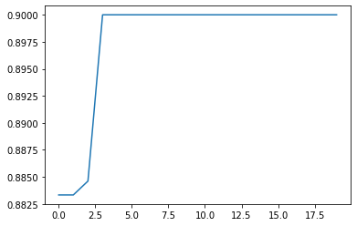

0.9 / 909

phi_p小 3:1:3

a=0.9 w=0.8*3/7 phi_p=0.8*1/7 phi_g=0.8*3/7 lr=3 iter=20 S=1000 k=1

round 0 : 0.917948717948718

round 1 : 0.917948717948718

round 2 : 0.917948717948718

round 3 : 0.917948717948718

round 4 : 0.917948717948718

round 5 : 0.917948717948718

round 6 : 0.9333333333333333

round 7 : 0.9333333333333333

round 8 : 0.9333333333333333

round 9 : 0.9333333333333333

round 10 : 0.9333333333333333

round 11 : 0.9333333333333333

round 12 : 0.9333333333333333

round 13 : 0.9333333333333333

round 14 : 0.9333333333333333

round 15 : 0.9333333333333333

round 16 : 0.9333333333333333

round 17 : 0.9333333333333333

round 18 : 0.9333333333333333

round 19 : 0.9333333333333333

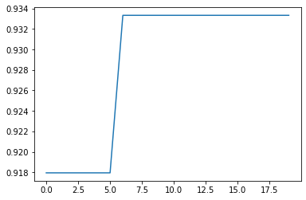

0.9333333333333333 / 764

phi_g大 1:1:3

a=0.9 w=0.8*1/5 phi_p=0.8*1/5 phi_g=0.8*3/5 lr=3 iter=20 S=1000 k=1

round 0 : 0.8871794871794872

round 1 : 0.9192307692307693

round 2 : 0.9192307692307693

round 3 : 0.9358974358974359

round 4 : 0.9358974358974359

round 5 : 0.9358974358974359

round 6 : 0.9358974358974359

round 7 : 0.9358974358974359

round 8 : 0.9358974358974359

round 9 : 0.9358974358974359

round 10 : 0.9358974358974359

round 11 : 0.9358974358974359

round 12 : 0.9358974358974359

round 13 : 0.9358974358974359

round 14 : 0.9358974358974359

round 15 : 0.9358974358974359

round 16 : 0.9358974358974359

round 17 : 0.9358974358974359

round 18 : 0.9358974358974359

round 19 : 0.9358974358974359

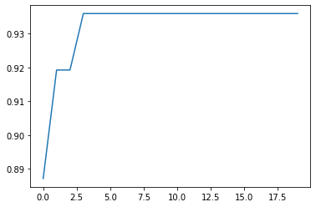

0.9358974358974359 / 948

phi_g小 3:3:1

a=0.9 w=0.8*3/7 phi_p=0.8*3/7 phi_g=0.8*1/7 lr=3 iter=20 S=1000 k=1

round 0 : 0.8858974358974357

round 1 : 0.8858974358974357

round 2 : 0.8858974358974357

round 3 : 0.9012820512820513

round 4 : 0.9012820512820513

round 5 : 0.9012820512820513

round 6 : 0.9012820512820513

round 7 : 0.9012820512820513

round 8 : 0.9012820512820513

round 9 : 0.9012820512820513

round 10 : 0.9012820512820513

round 11 : 0.9012820512820513

round 12 : 0.9012820512820513

round 13 : 0.9012820512820513

round 14 : 0.9012820512820513

round 15 : 0.9012820512820513

round 16 : 0.9012820512820513

round 17 : 0.9012820512820513

round 18 : 0.9012820512820513

round 19 : 0.9012820512820513

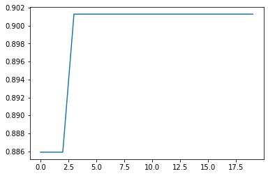

0.9012820512820513 / 825

phi_g大 1:1:3

a=0.9 w=0.8*1/5 phi_p=0.8*1/5 phi_g=0.8*3/5 lr=3 iter=20 S=1000 k=1

0.9358974358974359 / 948

[0, 1, 2, 5, 7, 9, 12, 13, 19, 20, 23, 25, 26, 27, 29, 31, 34, 38, 43, 46, 51, 53, 54, 56, 57, 58, 60, 64, 66, 68, 69, 72, 73, 76, 78, 81, 82, 83, 86, 92, 93, 100, 102, 103, 104, 105, 106, 110, 113, 117, 121, 122, 126, 130, 131, 135, 136, 137, 139, 142, 143, 146, 151, 154, 155, 156, 157, 159, 160, 161, 167, 168, 171, 172, 177, 179, 183, 185, 187, 188, 189, 190, 192, 194, 196, 197, 198, 204, 205, 207, 208, 209, 211, 213, 214, 215, 216, 218, 219, 223, 224, 226, 227, 228, 232, 233, 236, 237, 238, 239, 242, 244, 246, 249, 251, 254, 256, 257, 258, 261, 265, 266, 267, 271, 273, 276, 279, 280, 281, 282, 286, 289, 291, 292, 295, 299, 300, 301, 304, 305, 306, 307, 309, 311, 313, 314, 320, 324, 327, 328, 329, 331, 332, 334, 336, 337, 338, 339, 340, 342, 343, 348, 349, 351, 352, 355, 356, 359, 362, 364, 369, 372, 373, 374, 375, 378, 379, 380, 381, 384, 385, 386, 393, 395, 397, 399, 400, 402, 403, 407, 411, 418, 420, 422, 423, 424, 427, 430, 432, 433, 434, 436, 438, 441, 443, 444, 445, 446, 447, 448, 451, 452, 453, 454, 455, 457, 458, 465, 466, 467, 468, 475, 476, 478, 479, 482, 484, 485, 490, 491, 492, 493, 494, 496, 498, 502, 504, 506, 509, 511, 514, 517, 518, 519, 520, 523, 526, 527, 530, 534, 536, 538, 541, 542, 543, 545, 546, 547, 548, 550, 557, 558, 560, 563, 565, 567, 569, 575, 577, 578, 579, 585, 586, 587, 588, 589, 590, 596, 599, 603, 605, 606, 609, 616, 618, 619, 621, 622, 624, 625, 628, 633, 634, 635, 636, 640, 643, 648, 650, 651, 654, 661, 662, 665, 666, 667, 672, 678, 680, 681, 684, 685, 686, 689, 696, 697, 699, 701, 702, 703, 706, 708, 713, 714, 716, 717, 727, 728, 731, 737, 738, 739, 740, 744, 745, 746, 747, 748, 749, 754, 761, 764, 765, 766, 768, 769, 770, 772, 773, 776, 777, 778, 779, 781, 785, 787, 788, 789, 793, 794, 796, 800, 801, 802, 803, 805, 807, 808, 809, 810, 812, 813, 814, 815, 816, 817, 818, 819, 822, 823, 825, 826, 828, 834, 838, 839, 841, 843, 846, 847, 848, 849, 853, 858, 859, 861, 863, 864, 867, 868, 869, 870, 871, 872, 873, 876, 880, 881, 883, 884, 886, 889, 892, 895, 896, 897, 898, 900, 902, 905, 906, 908, 911, 914, 915, 917, 918, 919, 920, 921, 922, 926, 928, 929, 931, 934, 936, 937, 939, 941, 942, 944, 945, 946, 947, 949, 952, 954, 956, 957, 958, 959, 960, 963, 964, 965, 971, 972, 975, 978, 979, 983, 990, 991, 992, 994, 997, 998, 1000, 1002, 1003, 1005, 1006, 1007, 1011, 1013, 1015, 1022, 1023, 1025, 1026, 1027, 1031, 1034, 1035, 1037, 1042, 1043, 1044, 1047, 1050, 1052, 1053, 1054, 1056, 1059, 1061, 1063, 1067, 1071, 1072, 1073, 1074, 1075, 1076, 1079, 1080, 1081, 1084, 1086, 1089, 1090, 1094, 1095, 1096, 1097, 1103, 1105, 1108, 1109, 1110, 1112, 1114, 1115, 1117, 1118, 1121, 1122, 1123, 1128, 1130, 1138, 1140, 1141, 1144, 1145, 1150, 1152, 1155, 1157, 1159, 1160, 1166, 1169, 1175, 1177, 1179, 1180, 1182, 1187, 1188, 1191, 1192, 1193, 1194, 1195, 1196, 1198, 1200, 1201, 1203, 1205, 1210, 1211, 1213, 1214, 1218, 1220, 1221, 1223, 1224, 1230, 1232, 1234, 1235, 1236, 1240, 1244, 1247, 1248, 1249, 1251, 1252, 1254, 1255, 1256, 1257, 1260, 1261, 1262, 1264, 1265, 1268, 1272, 1275, 1279, 1283, 1285, 1287, 1289, 1291, 1293, 1294, 1295, 1296, 1299, 1300, 1304, 1308, 1310, 1311, 1312, 1313, 1314, 1316, 1317, 1324, 1325, 1326, 1327, 1329, 1331, 1333, 1335, 1336, 1337, 1341, 1345, 1346, 1349, 1350, 1351, 1353, 1354, 1357, 1358, 1361, 1365, 1366, 1367, 1371, 1372, 1378, 1382, 1387, 1400, 1401, 1402, 1404, 1405, 1407, 1408, 1410, 1411, 1413, 1414, 1415, 1416, 1420, 1421, 1426, 1428, 1430, 1431, 1432, 1436, 1437, 1438, 1441, 1442, 1444, 1445, 1446, 1447, 1453, 1455, 1457, 1458, 1460, 1461, 1462, 1463, 1465, 1470, 1472, 1473, 1477, 1478, 1479, 1482, 1483, 1485, 1488, 1489, 1494, 1495, 1496, 1497, 1499, 1500, 1505, 1506, 1507, 1508, 1509, 1513, 1516, 1518, 1519, 1521, 1523, 1524, 1525, 1526, 1527, 1529, 1531, 1532, 1534, 1538, 1539, 1540, 1542, 1545, 1546, 1547, 1551, 1552, 1554, 1556, 1558, 1560, 1561, 1562, 1567, 1568, 1569, 1572, 1575, 1578, 1580, 1581, 1582, 1584, 1585, 1586, 1589, 1591, 1596, 1598, 1601, 1602, 1603, 1604, 1605, 1606, 1607, 1609, 1610, 1611, 1613, 1614, 1615, 1616, 1618, 1623, 1625, 1627, 1630, 1631, 1632, 1636, 1637, 1638, 1640, 1641, 1643, 1645, 1646, 1647, 1648, 1653, 1655, 1657, 1658, 1659, 1660, 1662, 1665, 1666, 1668, 1671, 1672, 1673, 1674, 1675, 1677, 1678, 1679, 1681, 1682, 1684, 1688, 1690, 1691, 1695, 1697, 1699, 1705, 1706, 1711, 1712, 1713, 1716, 1718, 1719, 1722, 1723, 1728, 1730, 1733, 1737, 1740, 1743, 1744, 1748, 1749, 1750, 1751, 1752, 1753, 1754, 1755, 1756, 1757, 1758, 1762, 1763, 1765, 1766, 1774, 1775, 1778, 1779, 1783, 1786, 1789, 1793, 1794, 1795, 1799, 1801, 1804, 1805, 1806, 1807, 1808, 1810, 1815, 1816, 1818, 1819, 1822, 1823, 1827, 1828, 1836, 1837, 1845, 1847, 1850, 1852, 1853, 1854, 1855, 1858, 1860, 1861, 1863, 1864, 1865, 1866, 1867, 1868, 1869, 1874, 1875, 1877, 1879, 1883, 1885, 1886, 1888, 1894, 1896, 1897, 1898, 1900, 1904, 1906, 1907, 1909, 1910, 1911, 1912, 1913, 1914, 1917, 1919, 1922, 1923, 1924, 1925, 1926, 1930, 1931, 1932, 1936, 1937, 1938, 1941, 1945, 1949, 1950, 1952, 1953, 1956, 1959, 1960, 1963, 1966, 1967, 1969, 1970, 1971, 1974, 1975, 1976, 1979, 1980, 1983, 1987, 1990, 1994, 1995, 1997, 1998, 1999]

exp1: Data

a=0.1 w=0.9/3 phi_p=0.8/3 phi_g=0.8/3 lr=3 iter=20 S=1000 k=1

round 0 : 0.8846153846153847

round 1 : 0.8371794871794872

round 2 : 0.8217948717948718

round 3 : 0.8525641025641025

round 4 : 0.8512820512820513

round 5 : 0.8692307692307691

round 6 : 0.8371794871794872

round 7 : 0.9012820512820514

round 8 : 0.9025641025641026

round 9 : 0.9025641025641026

round 10 : 0.9025641025641026

round 11 : 0.9025641025641026

round 12 : 0.9179487179487179

round 13 : 0.9179487179487179

round 14 : 0.9179487179487179

round 15 : 0.9179487179487179

round 16 : 0.9179487179487179

round 17 : 0.9179487179487179

round 18 : 0.9179487179487179

round 19 : 0.9179487179487179

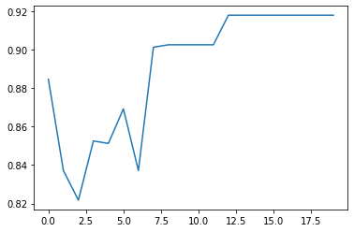

0.9179487179487179 / 543

a=0.3 w=0.9/3 phi_p=0.8/3 phi_g=0.8/3 lr=3 iter=20 S=1000 k=1

round 0 : 0.8358974358974359

round 1 : 0.8525641025641025

round 2 : 0.8525641025641025

round 3 : 0.8846153846153847

round 4 : 0.917948717948718

round 5 : 0.917948717948718

round 6 : 0.9333333333333333

round 7 : 0.9333333333333333

round 8 : 0.9333333333333333

round 9 : 0.9333333333333333

round 10 : 0.9333333333333333

round 11 : 0.9333333333333333

round 12 : 0.9333333333333333

round 13 : 0.9333333333333333

round 14 : 0.9333333333333333

round 15 : 0.9333333333333333

round 16 : 0.9333333333333333

round 17 : 0.9333333333333333

round 18 : 0.9333333333333333

round 19 : 0.9333333333333333

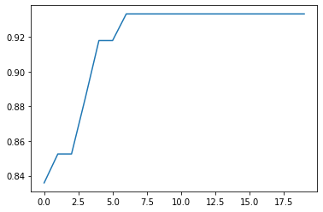

0.9333333333333333 / 684

a=0.5 w=0.9/3 phi_p=0.8/3 phi_g=0.8/3 lr=3 iter=20 S=1000 k=1

round 0 : 0.8846153846153847

round 1 : 0.8858974358974357

round 2 : 0.9012820512820513

round 3 : 0.9025641025641026

round 4 : 0.9192307692307693

round 5 : 0.9192307692307693

round 6 : 0.9192307692307693

round 7 : 0.9192307692307693

round 8 : 0.9192307692307693

round 9 : 0.9192307692307693

round 10 : 0.9192307692307693

round 11 : 0.9192307692307693

round 12 : 0.9192307692307693

round 13 : 0.9192307692307693

round 14 : 0.9192307692307693

round 15 : 0.9192307692307693

round 16 : 0.9192307692307693

round 17 : 0.9192307692307693

round 18 : 0.9192307692307693

round 19 : 0.9192307692307693

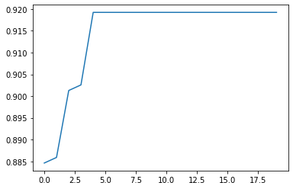

0.9192307692307693 / 843

a=0.7 w=0.9/3 phi_p=0.8/3 phi_g=0.8/3 lr=3 iter=20 S=1000 k=1

round 0 : 0.85

round 1 : 0.9

round 2 : 0.9

round 3 : 0.9

round 4 : 0.9

round 5 : 0.9

round 6 : 0.9

round 7 : 0.9

round 8 : 0.9

round 9 : 0.9

round 10 : 0.9

round 11 : 0.9

round 12 : 0.9

round 13 : 0.9

round 14 : 0.9

round 15 : 0.9

round 16 : 0.9

round 17 : 0.9

round 18 : 0.9

round 19 : 0.9

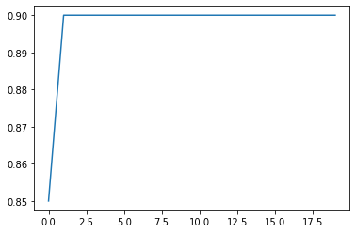

0.9 / 939

a=0.8 w=0.9/3 phi_p=0.8/3 phi_g=0.8/3 lr=3 iter=20 S=1000 k=1

round 0 : 0.8833333333333334

round 1 : 0.8833333333333334

round 2 : 0.8833333333333334

round 3 : 0.9

round 4 : 0.9

round 5 : 0.9

round 6 : 0.9

round 7 : 0.9

round 8 : 0.9

round 9 : 0.9

round 10 : 0.9

round 11 : 0.9

round 12 : 0.9

round 13 : 0.9

round 14 : 0.9

round 15 : 0.9

round 16 : 0.9

round 17 : 0.9

round 18 : 0.9

round 19 : 0.9

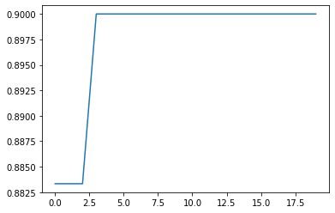

0.9 / 1006

a=1 w=0.9/3 phi_p=0.8/3 phi_g=0.8/3 lr=3 iter=20 S=1000 k=1

round 0 : 0.8846153846153847

round 1 : 0.8846153846153847

round 2 : 0.8858974358974357

round 3 : 0.8858974358974357

round 4 : 0.8858974358974357

round 5 : 0.8858974358974357

round 6 : 0.8858974358974357

round 7 : 0.8858974358974357

round 8 : 0.8858974358974357

round 9 : 0.8858974358974357

round 10 : 0.8858974358974357

round 11 : 0.8858974358974357

round 12 : 0.8858974358974357

round 13 : 0.8858974358974357

round 14 : 0.8858974358974357

round 15 : 0.8858974358974357

round 16 : 0.8858974358974357

round 17 : 0.8858974358974357

round 18 : 0.8858974358974357

round 19 : 0.8858974358974357

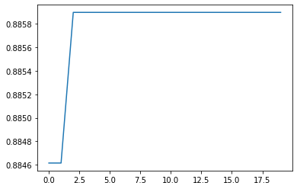

0.8858974358974357 / 994

a=0.1 w=0.9/3 phi_p=0.8/3 phi_g=0.8/3 lr=3 iter=20 S=1000 k=1

0.9179487179487179 / **543**

[0, 4, 5, 7, 8, 11, 12, 14, 20, 27, 30, 32, 33, 36, 41, 45, 53, 54, 55, 58, 59, 60, 70, 75, 79, 81, 86, 88, 90, 94, 103, 106, 107, 108, 118, 122, 125, 127, 135, 139, 145, 147, 149, 151, 152, 162, 163, 164, 167, 175, 177, 179, 188, 190, 191, 197, 198, 205, 213, 215, 216, 217, 219, 222, 224, 233, 234, 235, 248, 249, 254, 255, 272, 273, 280, 282, 285, 291, 296, 297, 298, 303, 305, 310, 312, 313, 314, 315, 316, 317, 319, 320, 327, 328, 334, 335, 344, 357, 360, 361, 362, 363, 366, 368, 370, 371, 373, 374, 378, 382, 384, 387, 406, 408, 409, 415, 424, 426, 432, 433, 435, 441, 442, 443, 445, 447, 454, 461, 463, 468, 469, 471, 477, 478, 485, 504, 505, 506, 508, 514, 516, 517, 522, 525, 537, 543, 550, 553, 554, 555, 557, 559, 567, 570, 572, 574, 577, 588, 591, 593, 599, 600, 603, 605, 606, 613, 617, 621, 626, 628, 629, 632, 642, 646, 648, 650, 651, 656, 659, 663, 675, 676, 678, 685, 698, 714, 717, 718, 722, 725, 730, 732, 734, 737, 741, 743, 745, 751, 752, 759, 770, 779, 781, 788, 789, 791, 798, 799, 801, 803, 809, 810, 813, 818, 819, 820, 824, 827, 828, 835, 836, 862, 864, 865, 867, 870, 878, 884, 887, 890, 895, 898, 900, 909, 912, 913, 925, 931, 935, 936, 950, 953, 955, 958, 965, 966, 968, 973, 980, 989, 990, 992, 993, 1008, 1016, 1017, 1018, 1027, 1028, 1035, 1037, 1043, 1044, 1047, 1051, 1052, 1056, 1059, 1072, 1073, 1074, 1077, 1078, 1079, 1085, 1092, 1094, 1096, 1100, 1102, 1105, 1109, 1111, 1112, 1113, 1117, 1120, 1125, 1126, 1127, 1129, 1133, 1136, 1137, 1139, 1142, 1148, 1160, 1167, 1168, 1170, 1174, 1178, 1185, 1186, 1188, 1190, 1192, 1194, 1197, 1199, 1201, 1204, 1207, 1213, 1216, 1223, 1224, 1225, 1228, 1234, 1236, 1238, 1250, 1252, 1253, 1254, 1255, 1256, 1259, 1260, 1262, 1265, 1269, 1270, 1272, 1274, 1280, 1287, 1292, 1295, 1305, 1310, 1313, 1314, 1316, 1317, 1322, 1323, 1324, 1326, 1331, 1340, 1345, 1347, 1348, 1352, 1355, 1357, 1358, 1364, 1368, 1374, 1378, 1384, 1386, 1390, 1391, 1398, 1402, 1411, 1413, 1415, 1417, 1418, 1420, 1433, 1441, 1443, 1448, 1449, 1452, 1453, 1459, 1465, 1472, 1474, 1475, 1491, 1494, 1497, 1500, 1502, 1504, 1511, 1514, 1522, 1523, 1525, 1528, 1529, 1530, 1531, 1536, 1539, 1541, 1546, 1547, 1551, 1557, 1563, 1566, 1569, 1570, 1571, 1575, 1576, 1583, 1585, 1589, 1593, 1599, 1604, 1606, 1607, 1609, 1615, 1616, 1617, 1619, 1625, 1626, 1627, 1629, 1632, 1636, 1637, 1638, 1642, 1644, 1646, 1648, 1650, 1651, 1654, 1655, 1663, 1664, 1666, 1667, 1705, 1707, 1710, 1711, 1718, 1724, 1728, 1729, 1736, 1737, 1744, 1748, 1750, 1751, 1752, 1754, 1755, 1759, 1760, 1763, 1768, 1771, 1776, 1781, 1786, 1788, 1794, 1795, 1798, 1802, 1809, 1810, 1811, 1814, 1815, 1818, 1820, 1821, 1822, 1823, 1828, 1829, 1837, 1843, 1844, 1845, 1854, 1860, 1862, 1863, 1867, 1869, 1873, 1875, 1876, 1882, 1885, 1891, 1892, 1895, 1896, 1901, 1902, 1907, 1915, 1917, 1926, 1927, 1929, 1931, 1932, 1934, 1943, 1946, 1948, 1952, 1953, 1954, 1956, 1957, 1961, 1966, 1973, 1975, 1977, 1979, 1981, 1982, 1984, 1986, 1988, 1992, 1993]

exp4: Data

a=0.9 w=0.1 phi_p=0.8/3 phi_g=0.8/3 lr=3 iter=20 S=1000 k=1

round 0 : 0.885897435897436

round 1 : 0.9025641025641026

round 2 : 0.9025641025641026

round 3 : 0.9025641025641026

round 4 : 0.9038461538461539

round 5 : 0.9038461538461539

round 6 : 0.9038461538461539

round 7 : 0.9038461538461539

round 8 : 0.9038461538461539

round 9 : 0.9038461538461539

round 10 : 0.9038461538461539

round 11 : 0.9038461538461539

round 12 : 0.9038461538461539

round 13 : 0.9038461538461539

round 14 : 0.9038461538461539

round 15 : 0.9038461538461539

round 16 : 0.9038461538461539

round 17 : 0.9038461538461539

round 18 : 0.9038461538461539

round 19 : 0.9038461538461539

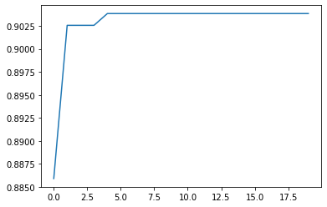

0.9038461538461539 / 958

a=0.9 w=0.9/3 phi_p=0.8/3 phi_g=0.8/3 lr=3 iter=20 S=1000 k=1

round 0 : 0.9025641025641026

round 1 : 0.9025641025641026

round 2 : 0.9025641025641026

round 3 : 0.9025641025641026

round 4 : 0.9025641025641026

round 5 : 0.9025641025641026

round 6 : 0.9025641025641026

round 7 : 0.9025641025641026

round 8 : 0.9025641025641026

round 9 : 0.9025641025641026

round 10 : 0.9025641025641026

round 11 : 0.9025641025641026

round 12 : 0.9025641025641026

round 13 : 0.9025641025641026

round 14 : 0.9025641025641026

round 15 : 0.9025641025641026

round 16 : 0.9025641025641026

round 17 : 0.9025641025641026

round 18 : 0.9025641025641026

round 19 : 0.9025641025641026

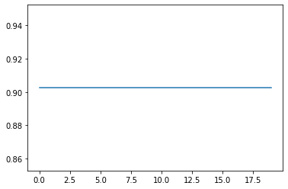

0.9025641025641026 / 986

a=0.9 w=0.5 phi_p=0.8/3 phi_g=0.8/3 lr=3 iter=20 S=1000 k=1

round 0 : 0.885897435897436

round 1 : 0.885897435897436

round 2 : 0.885897435897436

round 3 : 0.885897435897436

round 4 : 0.885897435897436

round 5 : 0.885897435897436

round 6 : 0.885897435897436

round 7 : 0.885897435897436

round 8 : 0.885897435897436

round 9 : 0.885897435897436

round 10 : 0.885897435897436

round 11 : 0.885897435897436

round 12 : 0.885897435897436

round 13 : 0.885897435897436

round 14 : 0.885897435897436

round 15 : 0.885897435897436

round 16 : 0.885897435897436

round 17 : 0.885897435897436

round 18 : 0.885897435897436

round 19 : 0.885897435897436

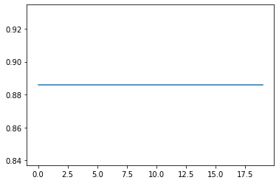

0.885897435897436 / 977

Exp5: Data

a=0.1 w=0.9/3 phi_p=0.8/3 phi_g=0.8/3 lr=3 iter=20 S=1000 k=1 w_decay = False

round 0 : 0.7371794871794872

round 1 : 0.7102564102564102

round 2 : 0.7243589743589743

round 3 : 0.8051282051282052

round 4 : 0.8358974358974359

round 5 : 0.8205128205128206

round 6 : 0.8205128205128205

round 7 : 0.8358974358974359

round 8 : 0.8525641025641025

round 9 : 0.8512820512820513

round 10 : 0.8358974358974359

round 11 : 0.8692307692307694

round 12 : 0.8858974358974357

round 13 : 0.8525641025641025

round 14 : 0.8679487179487181

round 15 : 0.8679487179487181

round 16 : 0.8679487179487181

round 17 : 0.8679487179487181

round 18 : 0.8679487179487181

round 19 : 0.8679487179487181

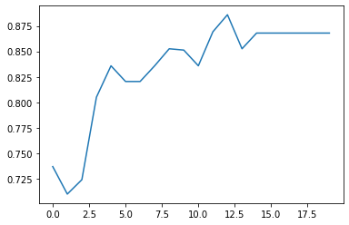

0.8679487179487181 / 547

a=0.3 w=0.9/3 phi_p=0.8/3 phi_g=0.8/3 lr=3 iter=20 S=1000 k=1 w_decay = False

round 0 : 0.8179487179487179

round 1 : 0.8205128205128205

round 2 : 0.8679487179487179

round 3 : 0.8371794871794872

round 4 : 0.8525641025641025

round 5 : 0.8846153846153847

round 6 : 0.8371794871794872

round 7 : 0.8358974358974359

round 8 : 0.8538461538461538

round 9 : 0.8525641025641025

round 10 : 0.8858974358974357

round 11 : 0.8679487179487181

round 12 : 0.8858974358974357

round 13 : 0.8858974358974357

round 14 : 0.9025641025641026

round 15 : 0.9025641025641026

round 16 : 0.9025641025641026

round 17 : 0.9025641025641026

round 18 : 0.9025641025641026

round 19 : 0.9025641025641026

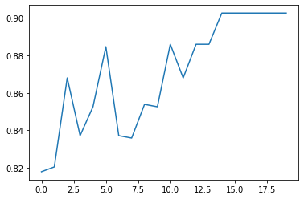

0.9025641025641026 / 542

a=0.5 w=0.9/3 phi_p=0.8/3 phi_g=0.8/3 lr=3 iter=20 S=1000 k=1 w_decay = False

round 0 : 0.8512820512820513

round 1 : 0.8705128205128204

round 2 : 0.885897435897436

round 3 : 0.8538461538461538

round 4 : 0.8679487179487181

round 5 : 0.8679487179487181

round 6 : 0.9012820512820514

round 7 : 0.9012820512820514

round 8 : 0.9012820512820514

round 9 : 0.9012820512820514

round 10 : 0.9012820512820514

round 11 : 0.9012820512820514

round 12 : 0.9012820512820514

round 13 : 0.9012820512820514

round 14 : 0.9012820512820514

round 15 : 0.9012820512820514

round 16 : 0.9012820512820514

round 17 : 0.9012820512820514

round 18 : 0.9012820512820514

round 19 : 0.9012820512820514

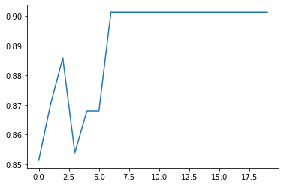

0.9012820512820514 / 709

a=0.7 w=0.9/3 phi_p=0.8/3 phi_g=0.8/3 lr=3 iter=20 S=1000 k=1 w_decay = False

round 0 : 0.885897435897436

round 1 : 0.8833333333333334

round 2 : 0.9166666666666667

round 3 : 0.9

round 4 : 0.9

round 5 : 0.9

round 6 : 0.9

round 7 : 0.9166666666666667

round 8 : 0.9166666666666667

round 9 : 0.9166666666666667

round 10 : 0.9166666666666667

round 11 : 0.9166666666666667

round 12 : 0.9166666666666667

round 13 : 0.9166666666666667

round 14 : 0.9166666666666667

round 15 : 0.9166666666666667

round 16 : 0.9166666666666667

round 17 : 0.9166666666666667

round 18 : 0.9166666666666667

round 19 : 0.9166666666666667

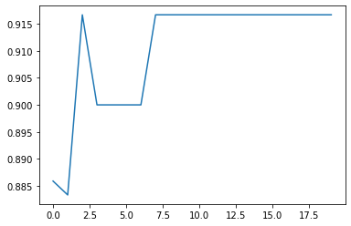

0.9166666666666667 / 846

a=0.8 w=0.9/3 phi_p=0.8/3 phi_g=0.8/3 lr=3 iter=20 S=1000 k=1 w_decay = False

round 0 : 0.8833333333333334

round 1 : 0.9

round 2 : 0.9

round 3 : 0.9166666666666666

round 4 : 0.9166666666666666

round 5 : 0.9166666666666666

round 6 : 0.9166666666666666

round 7 : 0.9166666666666666

round 8 : 0.9166666666666666

round 9 : 0.9166666666666666

round 10 : 0.9166666666666666

round 11 : 0.9166666666666666

round 12 : 0.9166666666666666

round 13 : 0.9166666666666666

round 14 : 0.9166666666666666

round 15 : 0.9166666666666666

round 16 : 0.9166666666666666

round 17 : 0.9166666666666666

round 18 : 0.9166666666666666

round 19 : 0.9166666666666666

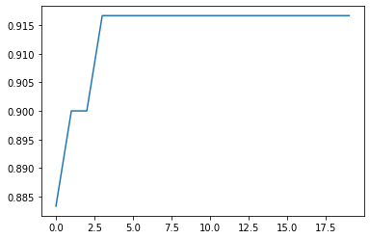

0.9166666666666666 / 886

a=1 w=0.9/3 phi_p=0.8/3 phi_g=0.8/3 lr=3 iter=20 S=1000 k=1 w_decay = False

round 0 : 0.8692307692307691

round 1 : 0.8871794871794872

round 2 : 0.9012820512820514

round 3 : 0.9025641025641026

round 4 : 0.9038461538461539

round 5 : 0.917948717948718

round 6 : 0.9192307692307692

round 7 : 0.9192307692307692

round 8 : 0.9346153846153846

round 9 : 0.9346153846153846

round 10 : 0.9346153846153846

round 11 : 0.9346153846153846

round 12 : 0.9346153846153846

round 13 : 0.9346153846153846

round 14 : 0.9346153846153846

round 15 : 0.9346153846153846

round 16 : 0.9346153846153846

round 17 : 0.9346153846153846

round 18 : 0.9346153846153846

round 19 : 0.9346153846153846

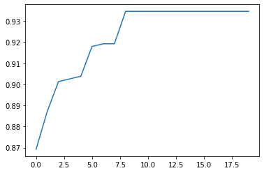

0.9346153846153846 / 934