## Instructional Objectives

1. Familiarize students with series and parallel equivalent resistances.
2. Predict and measure circuit quantities in circuits with series and parallel components.
3. Design a circuit to deliver a specified voltage according to given constraints.

## Procedures

1. Parts list: All 1/4W resistors. 1-1.5K, 1-3.3K, 1-6.2K, 1-6.8K, 2-8.2K, 1-20K, 1-30K, 1-33K.
2. Complicated resistor network analysis and measurement:
3. Measure the values of the resistors using the Digital Multi-Meter (DMM). Record the values of R1 to R6. Remember your fingers will affect the measured resistance!

**R1= 1.481 K, R2=29.970 K, R3= 6.707 K, R4= 3.320 K, R5= 6.133 K, R6= 20.179 K $Ω$**

**32.723 kohm , 8.065 kohm, 8.159 kohm**

1. Build the circuit shown in Figure 1.



Figure 1: Not So Simple resistor circuit.

Use the DC Power Supply to supply 5V DC.

* + Connect the red wire of the Power Supply to R1 on the breadboard..
  + Connect the black wire of the Power Supply to your GND node on the breadboard.

1. Measure the voltage output of the power supply using the DMM **VS = 4.999 V.**
2. Use the DMM to measure the voltage drop from point A to point B as well as the current through resistor R5 (IR5). The procedure to measure current using DMM was covered in Lab 0 and Lab 1.

**VAB = 2.051 V**  IR5 = **0.334 mA**

1. Use the values of VAB and IR5 to calculate the equivalent resistance between points A and B.

**Req =_6.14_KΩ**.

**NOTE:** If you put this circuit in the LTSpice simulator you can see what the voltages and currents should be. It is a good idea to learn how to use the simulator because it works well and you will be able to use it on the bench exam at the end of the semester if you want to.

1. KVL and KCL on a series parallel circuit.
2. Get 2 - 8.2K for R1 and R3 and a resistor between 24K and 39K for R2.



Figure 2

1. Build the circuit in Fig. 2. Connect the Power Supply to R1 and GND.
2. Measure the voltage drop across each resistance (VR1, VR2 and VR3) with the DMM. Enter the data in Table 1.
3. Use the measured value of resistance and voltage to “Calculate” IR1, IR2 and IR3. (I=V/R). Enter the calculated values of current in Table 1.
4. Determine the values of the current using I=V/R and enter them in the "Theoretical Current” column. (Use the nominal resistor values)

|  |  |  |  |  |  |
| --- | --- | --- | --- | --- | --- |
| **Resistor** | **Nominal**  **R Value**  **(kΩ)** | **Measured**  **R Value**  **(kΩ)** | **Measured**  **Voltage**  **(V)** | **Calculated**  **Current**  **(mA)** | **Theoretical**  **Current**  **(mA)** |
| R1 | 8.2 | 8.065 | 2.761 | 0.342 | 0.336 |
| R2 | 33 | 32.723 | 2.236 | 0.06833 | 0.06776 |
| R3 | 8.2 | 8.159 | 2.236 | 0.274 | 0.273 |

Table 1: Measured and Calculated Data for Fig. 2

1. Measure the voltage output of Vs (the power supply) using the DMM: VS= 4.999 V.

Calculate the % error of your “Calculated Current” values compared to the “Theoretical Current” values. Use the “Calculated Current” values from above in your second column and use the Theoretical values as the reference values for the third column in the % error calculation. Place these results in Table 2.

|  |  |  |  |
| --- | --- | --- | --- |
| **Resistor** | **Calculated**  **Current (mA)** | **Theoretical Current (mA)** | **Calculated vs**  **Theoretical**  **Error %** |
| R1 | 0.342 | 0.336 | 1.754 % |
| R2 | 0.06833 | 0.06776 | 0.834 % |
| R2 | 0.274 | 0.273 | 0.365 % |

Table 2: Calculated Data and Errors for Fig. 2.

1. Here is a design problem. Your task is to design a circuit that will deliver 2.0V, or 2.5V, or 3.0V ± 5% across a load resistor of 8.2kΩ. Figure 3 presents the problem.

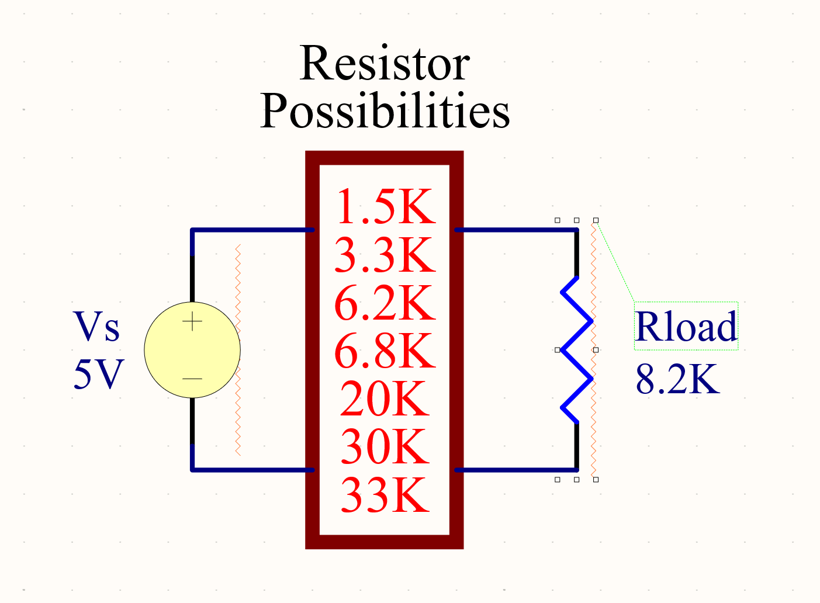

Figure 3: Circuit Design Schematic for Step 3

The resistors available for use are listed in Fig. 3. There are design constraints as with most engineering design problems. In this case, your component cost must be less than 7 cents. You only need to pay for the resistors, which cost 2 cents each. The load resistor is free. Assume your time is free but only this one time

;-).

1. Pick an output voltage across RLOAD of 2.0, 2.5 or 3.0V.
2. Design and document a circuit that will meet the design criteria.
3. Record your proposed solutions and brainstorm until you have found a solution.
4. Construct your proposed circuit. Verify that it meets the design criteria by measuring VIN (5V source) and VOUT (VRLOAD).
5. When your circuit is working, demonstrate the design to the lab instructor/TA. You may use more than one resistor of a particular value.

**VIN 5V VOUT 2.484V**

1.493 kohms 6.695 kohm, 8.095 kohm

**Post Lab Questions**

1. Compare the “Theoretical Currents” to the “Measured Currents” for Fig. 2. Explain why they may not be exactly equal. Verify that Kirchhoff’s Current Law applies to this circuit.
2. For Figure 2, write and verify KVL for the loop containing Vs, R1 and R2. Use the voltage values that you measured in step 2 of this lab.
3. Write and verify KCL at Node A of the circuit shown in Figure 2. Use the “Calculated Current” values you entered in Table 1.
4. Draw the circuit you designed in step 3. Explain the reasoning you used to get to your final solution and discuss how you verified that the circuit met the design criteria. I recommend you use LTSpice to draw the circuit.
5. Assume that the supply voltage was exactly 5V and the resistors were ideal in step 3. What voltage did you choose to put out. For what range of RLOAD will your circuit deliver the voltage you chose ± 5%? In other words, what is the maximum and minimum resistance of RLOAD for which the circuit will still operate as specified?
6. Refer to Figure 1. Give the currents through R1, R2, R3, R5 and R6 when Vs = 10V and

R1 = R2 = R3 = R4 = R5 = R6 = 1KΩ.

|  |  |  |  |  |
| --- | --- | --- | --- | --- |
| IR1 | IR2 | IR3 | IR5 | IR6 |
| mA | mA | mA | mA | mA |