**Instructional Objectives**

1. To work through the procedural steps involved in Thevenin’s theorem.
2. To verify the values obtained by measuring them using the digital multimeter.
3. To construct a Thevenin equivalent circuit.

**Procedure**

1. Parts: 1-3.3KΩ, 1-6.2KΩ and 1-8.2KΩ.

We will run through 12 steps to use Thevenin’s theorem to find the current through R3 shown in Fig. 5.

1. **Building the circuit and doing measurements**:
   1. Measure R1, R2 and R3 using Digital Multi Meter (DMM)

R1 = ____3.262____KΩ, R2 = __8.115_______KΩ, R3= ____6.110_____KΩ

* 1. Setup the (YELLOW) power supply to deliver 5V DC with a 25mA current limit to the breadboard.
  2. Build the circuit as shown in Figure 5.



Figure 5

* 1. Measure the voltage across R3 (VR3) using the DMM. Record the voltage and use the measured value of R3 to **Calculate** IR3:

VR3 = _________2.585__________V IR3 = VR3 / R3 = ________0.423__________mA

1. **Analyzing the circuit**.
   1. Referring to Fig. 6, which is Fig. 5 with R3 removed, calculate VTH for Fig.6, **showing/describing all work.**



Figure 6

**V_{th} = R_2 / (R_1+R_2) * V_s = 8.2 KΩ / (3.3 KΩ + 8.2 KΩ) * 5V = 3.565V**

* 1. VTH = _______________3.565_________(calculated)
  2. Verify the real Thevenin equivalent voltage by measurement. Construct the circuit shown in Fig.6. Measure and record VTH.

VTH = ____________________3.260________(measured)

1. **Measuring RTH by removing the source and replacing it with a short circuit.** 
   1. Construct the circuit in Fig. 7, which is the circuit in Fig. 5 with R3 removed and the 5V source replaced by a short circuit (RSOURCE assumed 0).



### Figure 7

* 1. Calculate RTH in Fig. 7, **showing/demonstrating all work.**

**R_{th} = R_1 || R_2 = 1/(1/3.5 KΩ + 1/8.2 KΩ) = 2.353 K****Ω**

RTH = ____________2.353_____ kΩ________(calculated)

* 1. Verify your RTH calculation by measurement. Connect the circuit in Fig. 7.Measure and record the equivalent resistance (RTH) measured between terminals A and B.

RTH = _____________2.125____kΩ________(measured)

1. **Drawing the Thevenin equivalent circuit.**
   1. Draw the Thevenin equivalent circuit and use your calculated values for VTH and RTH. **Label this Fig. 8.** You can use LTSpice or any other program to draw the circuit. Even a photo of a hand drawn picture.

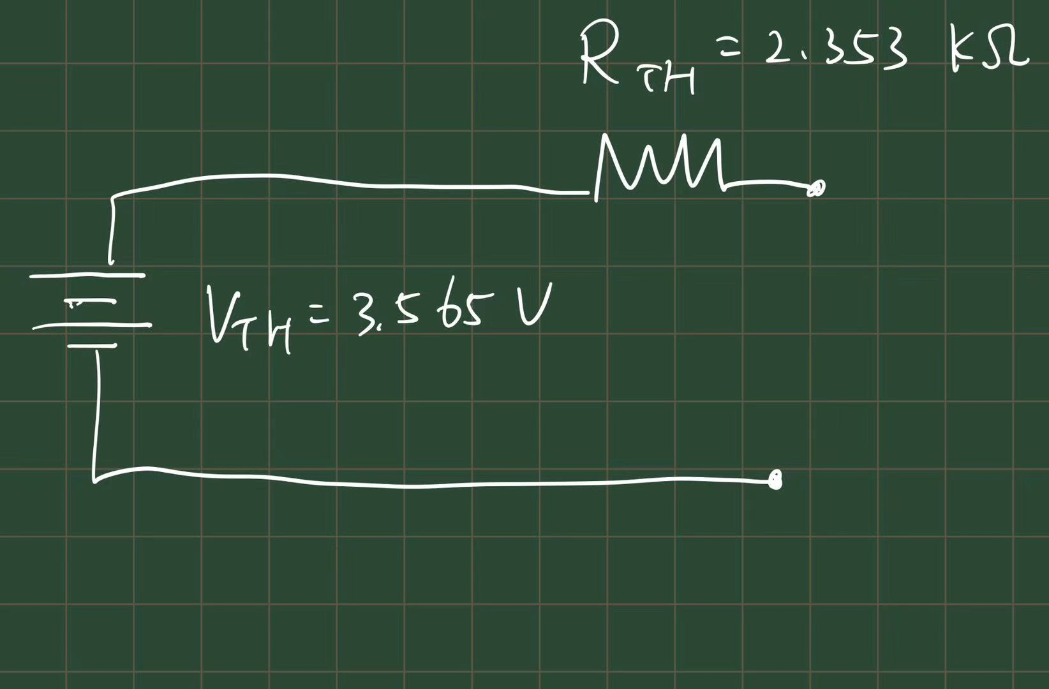

Figure 8

* 1. With the Thevenin equivalent circuit loaded with R3, calculate IR3 using the Thevenin equivalent circuit from Fig. 8.

= 3.565V / ( 2.353 kΩ + 6.2 kΩ) = 0.417 mA (6)

* 1. Compare the current calculated in procedure 1.d and the current calculated in procedure 4.b.Find the reasons for any discrepancy.

**Result in 1d was 0.423 mA, and 4b gave 0.417mA. The discrepancy between calculated and measured is acceptable. The discrepancy can be due to factors like inaccuracies from manufacturing, creating non-ideal components, etc.**

1. **Building Thevenin equivalent circuit**
   1. Build the circuit of Fig. 8. Obtain a resistance for RTH as close as possible to its calculated value. It doesn’t have to be 1 resistor. Hint 2 resistors in parallel is ‘real close’.
   2. Measure the value of RTH and VTH using the DMM.

RTH = _________2.125________kΩ VTH = _______________3.260______V

**\*\*\*\*\* Load the Thevenin equivalent circuit with R3. \*\*\*\*\***

* 1. Measure the voltage across RTH , (VRTH not VTH).

VRTH = _________0.841__________ V

* 1. Measure the voltage across the load resistor R3 (V3)

VR3 = _________2.583__________ V

* 1. Calculate the current through RTH and R3 using measured values of VTH, RTH and R3 (The resistors are in series so the same current flows through each of them).

I= IR3 = VRTH / RTH=VTH/(RTH+R3) _________0.396____________mA

* 1. Compare these measured results with the results of steps 4. Find the reasons for any discrepancies.

**Calculated results from 4 gives I=0.417 mA, while I from measured values is 0.396. The discrepancy is acceptable and is likely due to non-ideal measurement procedure.**

* 1. Compare the current calculated in procedure 1.d and the current calculated in procedure 5.e. Find the reasons for any discrepancy

**5e gave I=0.396 mA, while theoretical value in 1d was 0.426 mA. Since the two circuits are theoretically equivalent, the discrepancy is likely due to non-ideal manufacture, or due to the measurement environment.**

1. **Complex Thevenin equivalent circuit**

In this step, you are required to apply the Thevenin theorem to a more complicated circuit.



Figure 9

Using procedure explained in the theory section and/or your knowledge about finding a Thevenin equivelant, calculate the value of VTH and RTH for the circuit shown in Figure 9. Use R5 as the load resistance (i.e. R5 is removed for calculating the value of RTH and VTH). You can use the LTSpice simulator to check your Thevenin equivalents for this circuit if you want to. BTW LTSpice can not directly give you Thevenin equivalent values.

* 1. VTH = ____4.762______V
  2. RTH = __8.140________KΩ

1. Calculate the value of IR5 using the Thevenin Equivalent Circuit

I_{R_5} = V_{th} / (R_{th} + R_{s}) = 4.76V / (8.14 KΩ + 6.2 KΩ) = 0.332mA

* 1. IR5 = ____0.332______mA

1. Implement the Thevenin Equivalent Circuit on the proto board and measure the voltage across R5 as shown in Figure 10. Pick the closest 5% resistor for RTH.



Figure 10. Thevenin equivalent of Circuit in Fig.8.

* 1. VR5 (Measured) =___2.148_______V, IR5 = VR5 / R5 = ___0.352_______mA
  2. Does the value of IR5 match the calculated value in Part 7a?

**Yes!**

**Post Lab Questions**

1. What is meant by the word "equivalent" in Thevenin Equivalent circuits?

It means a theoretical equivalency in values of the **I-V relation** between the two terminals of a Thevenin circuit and that of the original.

1. What is the practical value of Thevenin Equivalent circuits? Give several practical applications in which Thevenin Equivalent circuits are used.

It reduces the complexity of linear circuits, and help focus on the load behaviour. It is particularly helpful in applications like power supply design.