**Instructional Objectives**

* 1. Assemble a non-inverting amplifier circuit with an op-amp and measure the transfer function or gain of the output voltage with respect to the input voltage of the circuit.
  2. Look at some parameters of a real op-amp.
  3. Measure the output current limit of **real** op amp.
  4. Observe clipping limitations of the op amp when used with AC or DC inputs.
  5. Determine a ‘reasonable’ range for the resistances and gains used for op-amp circuits as dictated by the **real** op-amp.

## Procedure

Components needed:

1 - 1Ω, 3 – 100Ω, 2 – 1KΩ, 2 – 3.3KΩ, 1 – 100KΩ, 1 - TLV271 OpAmp, 2 – 0.1uF ceramic capacitors.

1. Make sure you have looked at the Inverting and Non-Inverting amplifier configuration in the theory section.

**STOP: Read the PowerSupplyDesc.docx now**

It explains how to setup the power supply for this lab!

1. Assemble the circuit shown in Fig. 1 on a breadboard. This is a non-inverting amplifier circuit as described in the theory section. Note the op-amp you will use in the lab has 8 pins. The schematic has the 8 pins shown with 2 distinct bodies. This is done to make the schematic easier to understand. The power supply is separated from the op-amp proper. In the schematic, pins 1, 5 and 8 have small X’s on them. This means those pins are not connected to anything.
2. 

Figure 1: Schematic of a non-inverting amplifier

Use the picture in figure 2 as a construction guide. It is just a guide don’t consider it as the only way you can make it. The schematic in Figure 1 is the real circuit. Fig 2 however the recommended way to minimize errors. The errors will slow down the completion of the lab so minimize the possibility of them.

* Pin 1 of the op-amp is usually marked with an indented circle. The data sheet always indicates how to find pin 1 and which way the pins are numbered around the physical part.
* In Fig 2: The +5 and -5 volt power supplies are the red and blue mini clips connected to the 100 ohm resistors on the red and blue buses near the outer edge of the breadboard. They are the vertical buses that run the whole length of the board. I use Red for +5V and Blue for -5 volts. The bus next to it is usually GND. The +5 and -5 come from the + and – 30V supplies set to 5V. Note if Tracking is turned on you will see that the -30V supply will automatically be set to -5V when the +30V supply is set to +5V. **IMPORTANT: The 2 power supplies have to be connected correctly to create the circuit GND. See article on the Power Supply Desc.**
* I use two of the vertical buses on the breadboard are GND. The blue bus next to the +5V red bus line and the red bus next to the blue -5V bus. There is a black wire that connects the GND on one side to the GND on the other side.

**NOTE:** If you are confident you can correctly connect the power supplies directly to pins 4 and 7 of the op-amp you can omit the 100Ω resistors, RP and RM. They are only there to protect the op-amp if it gets connected incorrectly. The opamp will most likely burn out if it is not connected to the power supplies correctly.

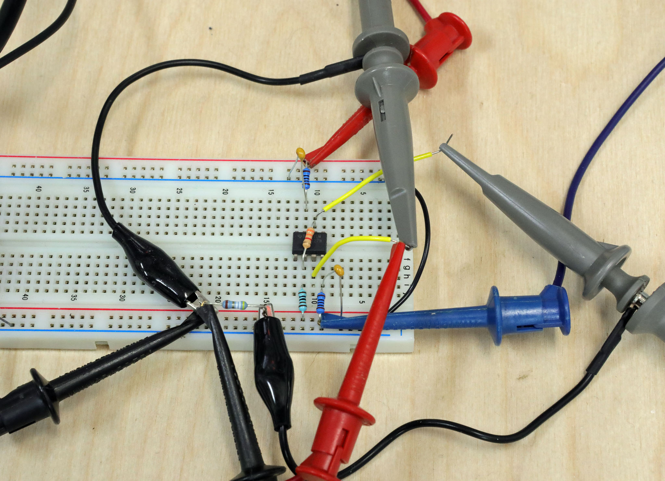

Figure 2: Non-Inverting Amp with Gain Prototype Example.

Note that there is a plus 5V DC source connected to pin 7 of the op-amp through a 100Ω resistor (Red clip) and a minus 5V source connected to pin 4 through a 100Ω resistor (Blue Clip). Any op-amp always needs external power. The TLV271 will not work without supplies. The 100Ω resistors are not usually needed. We are using them so if there are any mistakes in the building of the circuit the op-amp won’t self-destruct. You don’t really need them if you are confident the power supplies are properly connected.

Note: The two 0.1uF capacitors connected to pins 4 and 7 are usually referred to as bypass capacitors. The bypass capacitors are your friends. Always use them with op amp circuits! One of the benefits of using these is they prevent the op-amp circuit from oscillating (self-generating a high frequency at the output).

Equipment setup:

1. You will use 3 distinct pieces of equipment.

* The Power Supplies are the +30V and -30V supplies set to +5V and -5V respectively. I strongly suggest you set the current limit on both channels of the power supply to 0.025A. This will save your op-amp from blowing up if it gets hooked up incorrectly.
  + Remember that using tracking on the power supply means you only have to set the +5V voltage.
* The Signal Generator is the Wav Gen on the scope for Vin.
  + Red mini clip. No voltage yet. Use the BNC to mini clip cable for this.
* The Oscilloscope will be used to measure up to 4 signals during lab.
  + CH1 to Vin and GND.
  + CH2 to Vout and GND.
  + CH3 and CH4 to other signals and GND.
* Enable the outputs on the supply where the +5 and -5 V and common GND connected.
* The power supply will indicate what voltage the + and – 30V supplies are at once turned on. Make sure they are somewhere near 5V in magnitude.
  + If the either voltage is low you probably have a short circuit that must be fixed. You may have ruined the op-amp. Figure out what is wrong and see if it works after correcting the mistake(s).

Always look at the Vout on the scope. It is a great way to make sure the circuit is still working after changes are made. This will also speed up lab completion. You will catch errors early and fix them in a timely manner.

What is the theoretical gain, A = Vout/Vin, of the circuit shown in Fig.1? A = Gain ___4.3__________V/V

1. **Use the DMM** to measure Vin and VOUT for the different DC VIN voltages listed in Table 1 using the circuit shown in Fig. 1. Use the DMM on DC for these measurements. Remember you must set the Wav Gen to put out DC corresponding to the DC input voltages as you go.

|  |  |  |  |  |  |  |  |
| --- | --- | --- | --- | --- | --- | --- | --- |
| VIN  Desired | Measured Vin | Measured VOUT | Vin*A  Theoretical | VIN  Desired | Measured Vin | Measured VOUT | Vin*A  Theoretical |
| 0 VDC | 2.00 mv | 6.93 mV | 3.40 | -0.5 VDC | -0.501V | -2.135V | 4.27 |
| 0.5 VDC | 0.50V | 2.200V | 4.241 | -1.0 VDC | -1.00V | -4.260V | 4.256 |
| 1.0 VDC | 1.00 | 4.249V | 4.247 | -1.5 VDC | -1.505V | -4.779V | 3.056 |
| 1.5 VDC | 1.501V | 4.802V | 3.205 |  |  |  |  |
|  |  |  |  |  |  |  |  |

Table 1: DC voltage measurements.

What is the gain A again? ____4.3________

Fill in the Vin*A Theoretical column in Table 1.

Did measured Vout always match Vin*A? ­­__No___ What was Vin if it didn’t? __0V, 1.5V, -1.5V_____ _______ _______

So what you just did was measure Vout and Vin for an op-amp circuit. 1 DC voltage at a time. This is not real efficient. There is an easier way to see the Vout and Vin signals with respect to each other.

* First you should use a waveform that moves linearly from the lowest voltage of interest to the highest.
* We are in luck there is a triangle waveform that does this.
* Set the signal generator to a 3VPP 1KHz triangle wave with 0V offset and 50% Symmetry.
* The oscilloscope probes should be connected to Vin and Vout.
* Set the Vin sensitivity to 0.5V/Div and the Vout sensitivity to 2V/Div.
* Set the time base to 200uS/Div.
* You should see the input and output voltages appear on the screen. The output should be clipped.

**Please note the scope settings are recommendations. You can change them if you want or need to.**

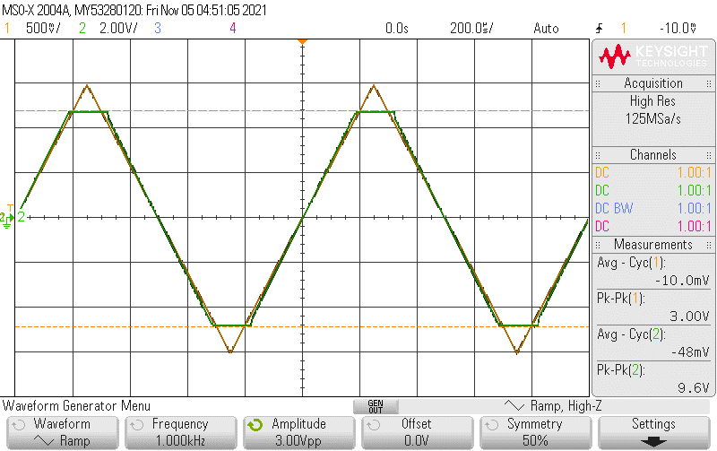

Figure 3: Triangle Vin (Yellow) and Vout (Green).

Next we will use the same circuit you built for the previous measurements. You will be adding a load resistor. You will be changing the load resistor during the next experiment. Just add the load resistor from pin 6 to GND on the breadboard.



Figure 4: Non-inverting amplifier with gain and variable load resistor.

1. Qualitatively observe the output resistance of the op amp circuit shown in Fig. 4. This circuit is the same one in Figure 1 with the addition of a load resistor. In this case qualitative means: See if the output voltage changes when the load resistor changes. You will do this by measuring VOUT with the scope.

* Use the Oscilloscope to measure AC voltages and the DMM for DC.
* Use a DC input first and secondly use a 1KHz **Sine** wave input for each RLOAD.
* Use RLOAD as specified in table 2 for each test.
* Use the ‘Wavegen’ trigger to hold the sine wave still.
* Set VIN to 1VDC for the DC input or 2VPP for a sine wave input of 1KHz. **NOTE:** Only input the AC or the DC not both at once.
* Measure the real value of RLOAD with the DMM before you put it in the circuit and enter it in the Measured column of Table 2.
* Measure the voltages at VIN and VOUT as per Table 2 and enter the actual value next to the nominal value into the table. Use the Peak-peak measurement for AC and the DMM for DC measurements.
* Please note the output voltages will not change much until 100Ω.

Capture VOUT with the AC input for 3.3KΩ and 100Ω RLOAD cases. A picture or USB key can be used for this.

|  |  |  |  |  |  |
| --- | --- | --- | --- | --- | --- |
| RLOAD | | DC | | 1KHz sine wave | |
| Nominal | Measured | VINDC | VOUTDC | VINPP | VOUTPP |
| 100K Ω | 99.181Kohm | 1VDC |1.002V | 4.370V | 2VPP |2.002V | 8.27V |
| 3.3K Ω | 3.251 Kohm | 1VDC |1.002V | 4.362V | 2VPP |2.002V | 8.27V |
| 1.0K Ω | 997ohm | 1VDC |1.002V | 4.245V | 2V PP|2.002V | 8.30V |
| 100 Ω | 99.9ohm | 1VDC |1.002V | 1.977V | 2V PP|2.002V | 3.81V |

Table 2. Measured data.

**Op-amp output limit explorations:** For now assume the op-amp is constrained by either a voltage limit or a current limit. Both limits look like the output voltage is limited when driving a resistor so first we will measure the voltage limit with no load resistor. No load so the op-amp is not delivering any current. In this state we will get the highest possible output voltage for the op-amp. Then we will ask for more current than the op-amp can deliver to measure the current limit.

1. Voltage clipping limits: Set VIN to a 3VPP, 1KHz sine wave with no offset. Using the circuit shown in Fig. 1, observe VOUT on the Scope. Use RLOAD = ∞Ω (No Load) . You will use the **scope** to measure the flattened (clipped) voltage levels.

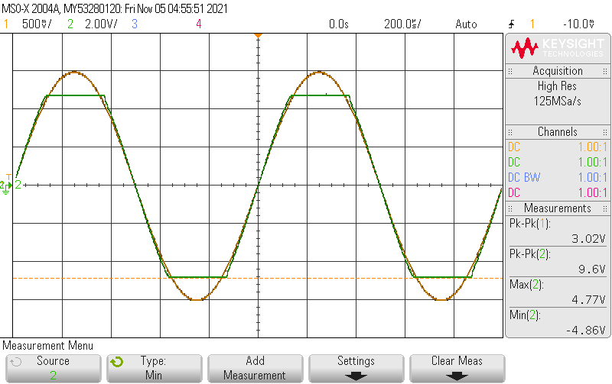

Figure 5: Clipped Vout display Vin Yellow and Vout Green..

1. I recommend that you use the Max and Min measurement to determine VHIGH and VLOW. Record the positive and negative voltage levels where VOUT flattens out. The levels will be smaller in magnitude than the power supply voltages but close. This occurs because an op-amp can not put out a voltage outside of the power supply voltages.

VOutClippedHighNoLoad _________4.754V_________ VOutClippedLowNoLoad _____-4.893V_____________

1. Output current limit: Use the circuit from the Figure 4. Use an RLOAD of 100Ω.

First put a 2VPP 1KHz sine wave in and look at the output with the scope. It should be clipping at a lower voltage than the voltage limits.

Next set VIN to -1.0VDC. Use the **DMM** to measure VOUTDC. Copy the theoretical gain calculated above down here.

ATHEORETICAL _______4.3___________ V/V.

What should the output voltage be for the 1.0VDC input? _4.36V____________.

At what positive and negative voltages should the circuit clip due to no load voltage limit measured above. (VOutClippedXNoLoad)? pos ____4.27______V, neg ____-4.29_________V.

Measure the High voltage limit and Low voltage limit that you get when driving the 100Ω resistor. Use Vin = +1VDC or -1VDC.

VIlimitOutHigh __1.943______V, VIlimitOutLow __-1.948______V.

Are the measured High and Low voltages smaller in magnitude than the no load clipping limits? ___yes_______

So is the output voltage limited or current limited with the 100Ω load? ____current____

Calculate the output currents by dividing the high and low voltage limits by RLOAD (100Ω).

IIlimitOutHigh+__19.43______ mA, IIlimitOutLow___-19.48_____ mA

1. **We are going to build a simple inverting amplifier with low gain.** The schematic is shown in Fig. 6. Determine the theoretical gain (Theory), Vout/Vin, of this circuit. GainLOW = _____-3.3___________. Build this circuit on the breadboard.Since you got the circuit in Figs 1 and 4 running you- can skip using the 100Ω current limiting resistors. They were there to prevent the destruction of the op-amp in case the circuit was built wrong. The assumption being you built it correctly and will this time too.



Figure 6: Inverting amplifier with low gain.

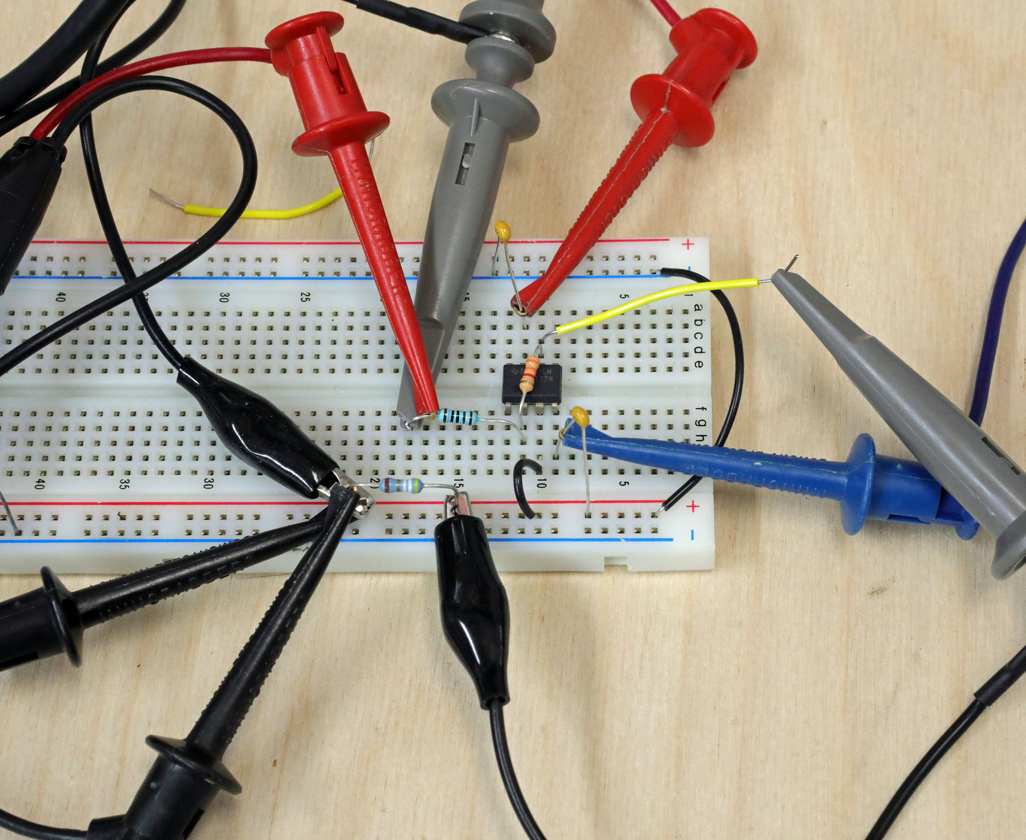

Figure 7: Inverting amplifier layout example.

* Set the input voltage Vin to 2.0VPP at 200Hz with 0VDC offset.
* What should the theoretical DC output voltage be? _____0____________VDC.
* Note the AC input is 2.0VPP.
* What should the AC output voltage be? _______-6.6__________VPP.
* Monitor the AC output voltage with the scope. (Peak to peak Measurement) Measure the DC output with the DMM.

1. **Measure Vin and VOUT.** to make sure the circuit is working as expected. Set the time base to about 1ms/div. Put the measured values in Table 3 for the Low gain row.

Review the theory section of the inverting amplifier. Make sure you understand what virtual ground means. Now connect the CH3 input to pin 3 of the op-amp. Pin 3 is connected directly to ground. The CH3 scope trace should be a straight line at 0V. Change the CH3 sensitivity to 1 mV/div. Is it still a straight line at 0V? For the next measurements. Put the CH4 probe on pin2 of the op-amp. Now measure the Pin2 (2) and pin3 (3) AC and DC voltages only with the scope. Only fill in the -3.3 Gain row right now. NOTE: If the output of the op-amp gets noisy try the X10 probe setting. Don’t forget to change the probe setting on the scope too.

|  |  |  |  |  |  |  |  |  |
| --- | --- | --- | --- | --- | --- | --- | --- | --- |
| OpAmp  Gain | 200Hz 1VP sine wave with 0VDC | | | | | | | |
| VinAC | VinDC | VOUTAC | VOUTDC | V3AC | V3DC | V2AC | V2DC |
| LOW (Fig 6) | 980mV | 0.025mV | -3.3V | 0.870mV | -401mV | -0.004 | -21mV | -0.126mV |
| HIGH (Fig 8) | Fill in later. | | | | | | | |

Table 3:

Change R1 to 100Ω and R2 to 100KΩ as shown in Figure 8.

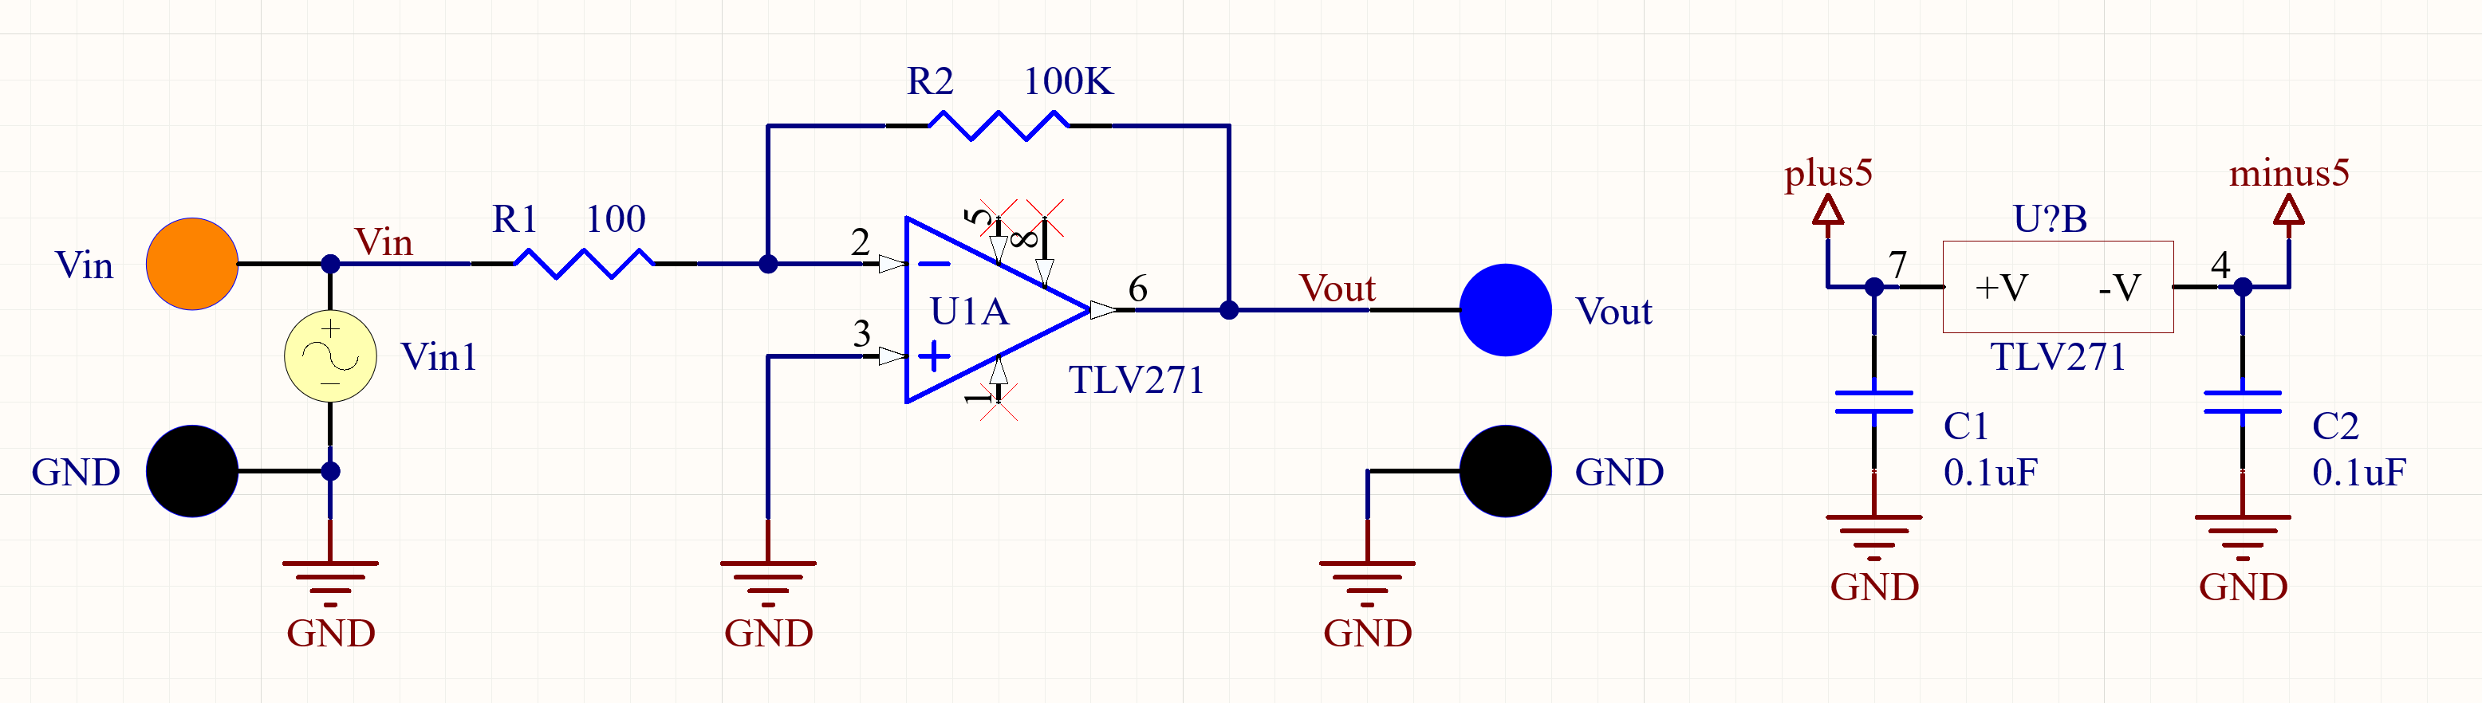

Figure 8: Inverting amplifier with high gain.

What is the theoretical gain, Vout/Vin, of this inverting amplifier? GainHIGH ___-1000__________.

We want to put about in a 1 mVPP Vin so that Vout will be 1 VPP. We can’t really do that with the existing signal generators so we need to do something special. We need to divide a 1VPP signal down by about 1000 using a resistor divider. Fig 9. shows a scheme to do this division. This is usually called an attenuator.

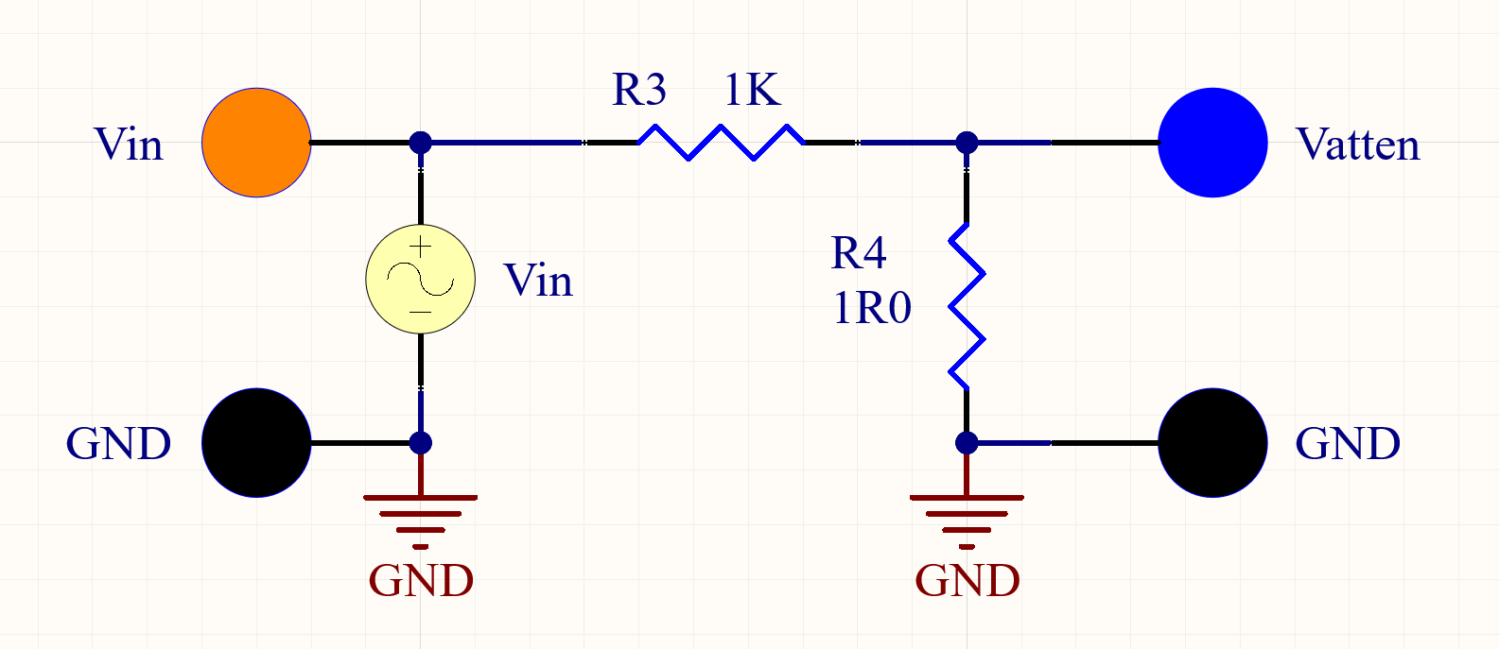

Figure 9: Resistor attenuator to generate a clean very low voltage.

Note the resistor marked 1R0 is a convenient way to list the value as 1Ω. The R takes the place of the decimal point (.). The R is much more visible than the decimal point so the value is clearly indicated this way.

What is the theoretical gain ( It will be << 1) ? GAINRESISTORS = ___9.999*10^(-4)_______

Note when gain is < 1 we sometimes use attenuation ratio which is the inverse of the gain.

Gain = Vout/Vin and Attenuation ratio is Vin/Vout. Again we usually call this little 2 resistor circuit an attenuator.

Connect in a 5VPP 1KHz sine wave at Vin of the resistor divider. Connect CH1 from Vin to GND and connect CH2 from Vout to GND. Use the X1 setting on CH2 (Vout) if you aren’t already. Adjust the CH2 sensitivity to 1mV / Div. Use the **Normal** “Acquire” mode.

Ch1 should be a nice clean sine wave. Ch2 looks like (pick 1) Good, **Bad** or Ugly google the phrase “The good the bad and the ugly”.

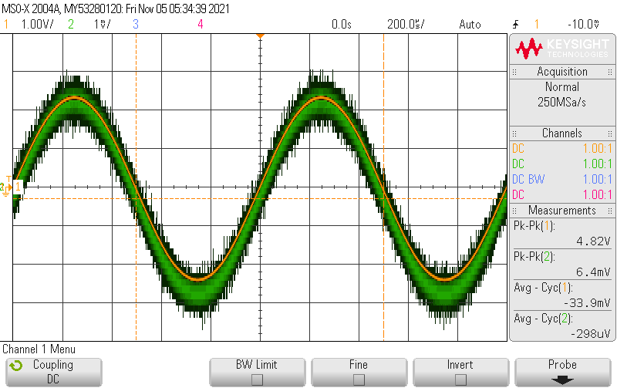

Figure 10: Attenuator signal voltages across each resistor. Yellow R3 and Blue R4.

Now us se the **Average** mode of “Acquire” instead of Normal. I used 32 averages and got a pretty good trace. For Averaging to work you need to have a stable trigger so the sine wave is not moving. Use Wavegen triggering.

What is the approximate size of Vin and ____4.83____ V VOUT___5.9___________mV ?

Build the circuit shown in Fig.11. It is the attenuator in series with the high gain amplifier. What is the theoretical gain from V1 to Vout? GAINAMPLIFIER _____1000_________

**Note the gain is for both AC and DC signals that are at Vin.**

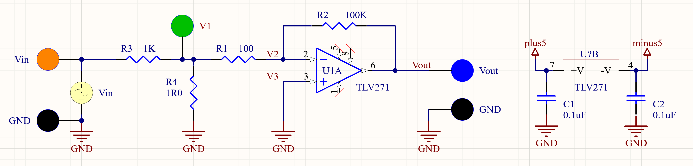

Figure 11: High gain inverting amplifier with attenuated input signal.

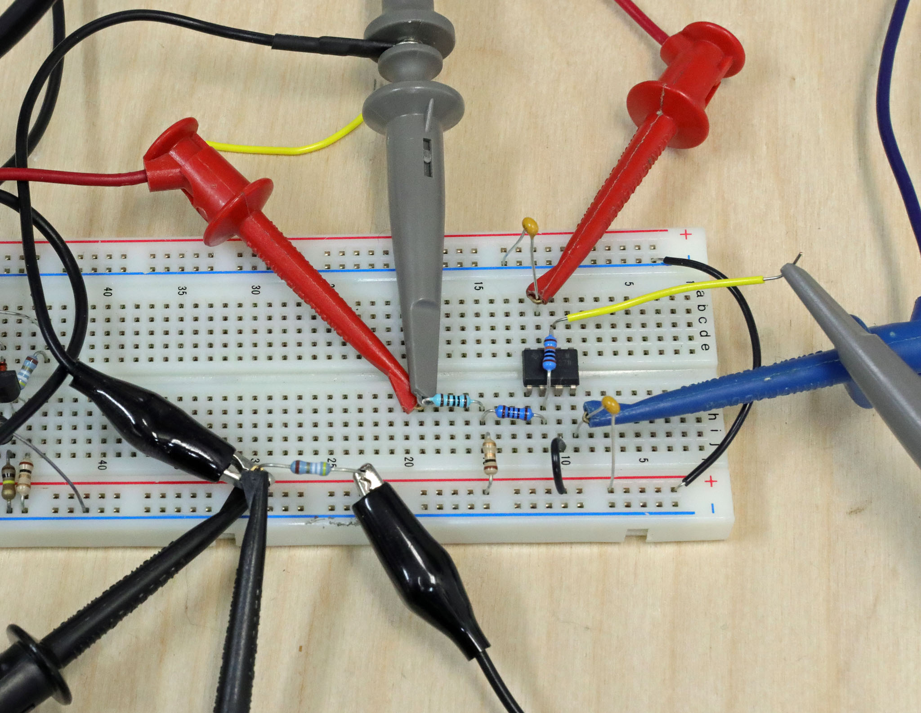

Figure 12: High gain inverting amplifier with attenuator layout example. This is similar to Fig 7 with R1 and R2 changed and R3 and R4 added.

What is the theoretical gain from Vin to VOUT? GAINATTEN_W_GAIN = _______0.999_______

Hint: GAINATTEN_W_GAIN = GAINRESISTORS*GAINAMPLIFIER = V1/Vin * Vout/V1

So anything at Vin should show up at VOUT times GAINATTEN_W_GAIN.

Set Vin to a 200Hz 5VPP sine wave. Is the output a clean sine wave? __yes_____

Remember Table 3 from above. Here it is again. Copy the values from above for the LOW gain row.

|  |  |  |  |  |  |  |  |  |
| --- | --- | --- | --- | --- | --- | --- | --- | --- |
| OpAmp Gain | 200Hz 1VP sine wave with 0VDC | | | | | | | |
| VinAC | VinDC | VOUTAC | VOUTDC | V3AC | V3DC | V2AC | V2DC |
| LOW | 980mV | 0.025mV | -3.3V | 0.870mV | -401mV | -0.004 | -21mV | -0.126mV |
| HIGH | 1.01V | 0.533mV | 1.01V | 1.403mV | 1.63mV | 0.051mV | 20mV | 1.431mV |

Table 3: Again

Copy the info for the LOW gain entries from the previous table. Measure the data for the HIGH gain amplifier

Measure Vin and Vout first. Use the scope for AC and the DMM for DC. Then measure V2 and V3 with only the scope.

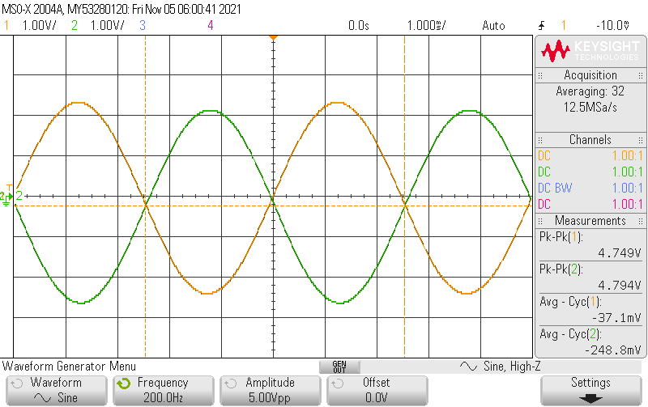

Figure 13: High Gain amplifier with attenuated input. Vin and Vout.

VINAC and VOUTAC should be about the same voltage. Remember: For V2 and V3 use the 1mV setting for CH3 and CH4 on the scope.

Is there anything suspicious about the waveform of VOUT for the HIGH gain amplifier? Does it look different than it should in theory (Consider both the AC and DC output.)?____YES____

If yes what is “funny”?

There is probably a DC offset on the Vout signal. Where could that DC output voltage be coming from?

Is the DC offset of Vout the DC offset of VinDC * GAINATTEN_W_GAIN? Consider that. ____NO_______

* What is the DCoffset measurement of Vin (Use the DMM)? _0.508mV______
* VinDC * GAINATTEN_W_GAIN = ___0.507mV____.
* Measure the DC offset of Vout. VOUTDC ____1.421_____VDC
* Is that close to the VOUTDC? ___NO______

Is it coming from the amplifier with a HIGH gain ? Consider that. __YES__________

* Disconnect Vin from R3, the 1.0K resistor, and ground the R3 input. Use the DMM to measure Vout. What is VOUTDC? ______1.421mV______
* Is that close to the original VOUTDC? _____YES____

Neither of these possibilities should be responsible for the DC offset ay Vout. You have discovered one of the problems with using op-amp circuits with very high gain. In a real op-amp there is a small amount of dc offset between the In+ and In- terminals. With low gain circuits it doesn’t really cause trouble. With high gain circuits it often causes trouble. To see what the DCoffset at the input terminals is you just take the VOUTDC from table 3 and divide it by the gain. So if you got 1V DCoffset with a gain of -1000 the calculated input referred offset is 1V/(-1000) or -1 mV. We call this the input referred offset. What is the input referred offset for your -1000 gain amplifier? _____1.4e-6 V____________

Unless you buy a special op-amp (expensive) that has very low input referred offset like say 10uV you will have a large DC offset in an op-amp when high gain is used.

## Post Lab Questions

1. Plot the transfer function of VOUT versus VIN for the values you obtained in step 3, Table 1. Explain what is happening in the different regions of your plot.
2. What are all the paths that the current coming out of or going into the output (pin 6) of the TLV271 for the circuit shown in Fig.4?
3. What is the minimum load resistance (smallest resistive load) you can connect to the output so the current limit is reached just as the voltage clipping limit is reached? Choose the larger resitance of the positive or negative limits for the answer.