**Instructional Objectives**

* 1. Use an Op-amp as a comparator.
  2. Discover how a comparator is different than an Op-amp.
  3. Use an RC circuit as a filter.
  4. Use the device called a light emitting diode (LED) with current limiting.

## Procedure

1. **Components needed:**

1 - RFILTER, 1 – RLED, 2 – 100KΩ, 1 – RED LED, TLV271 Op-amp, 1 – 0.1uF Film capacitors, 2 – 0.1uF ceramic capacitors.

1. **Build a comparator and test it.**

* Build the circuit in Fig. 1. There is a sample of this circuit on the bread board shown in Figure 2.
* Use the Scope Wav Gen as Vin.
* Use the 30V Power Supplies for the +5V and -5V op-amp power supplies. Remember tracking can be useful.
* Use the 6V (YELLOW) power supply for VDET. **(Note the picture does not have the correct VDET.)**

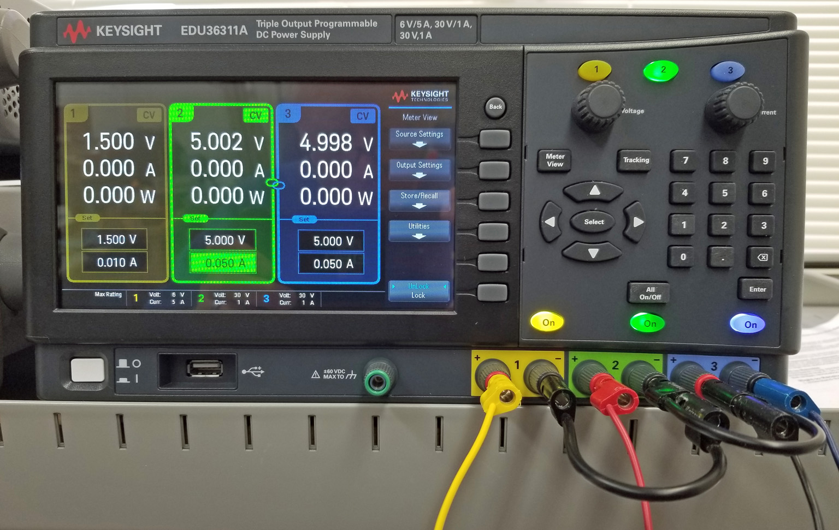



Figure 1: Comparator

**NOTE:** The op-amp is in a single 8pin Plastic DIP package. The schematic shows it as 2 separate parts. Part A the op-amp as described in electronics courses like ECE230 and part B the power supply pins of the op-amp. The parts are drawn separately because it is easier to see the purpose of the circuitry when the parts are separated. The power supply is essential for the op-amp to work at all. Always use power supplies with an op-amp even when not shown.

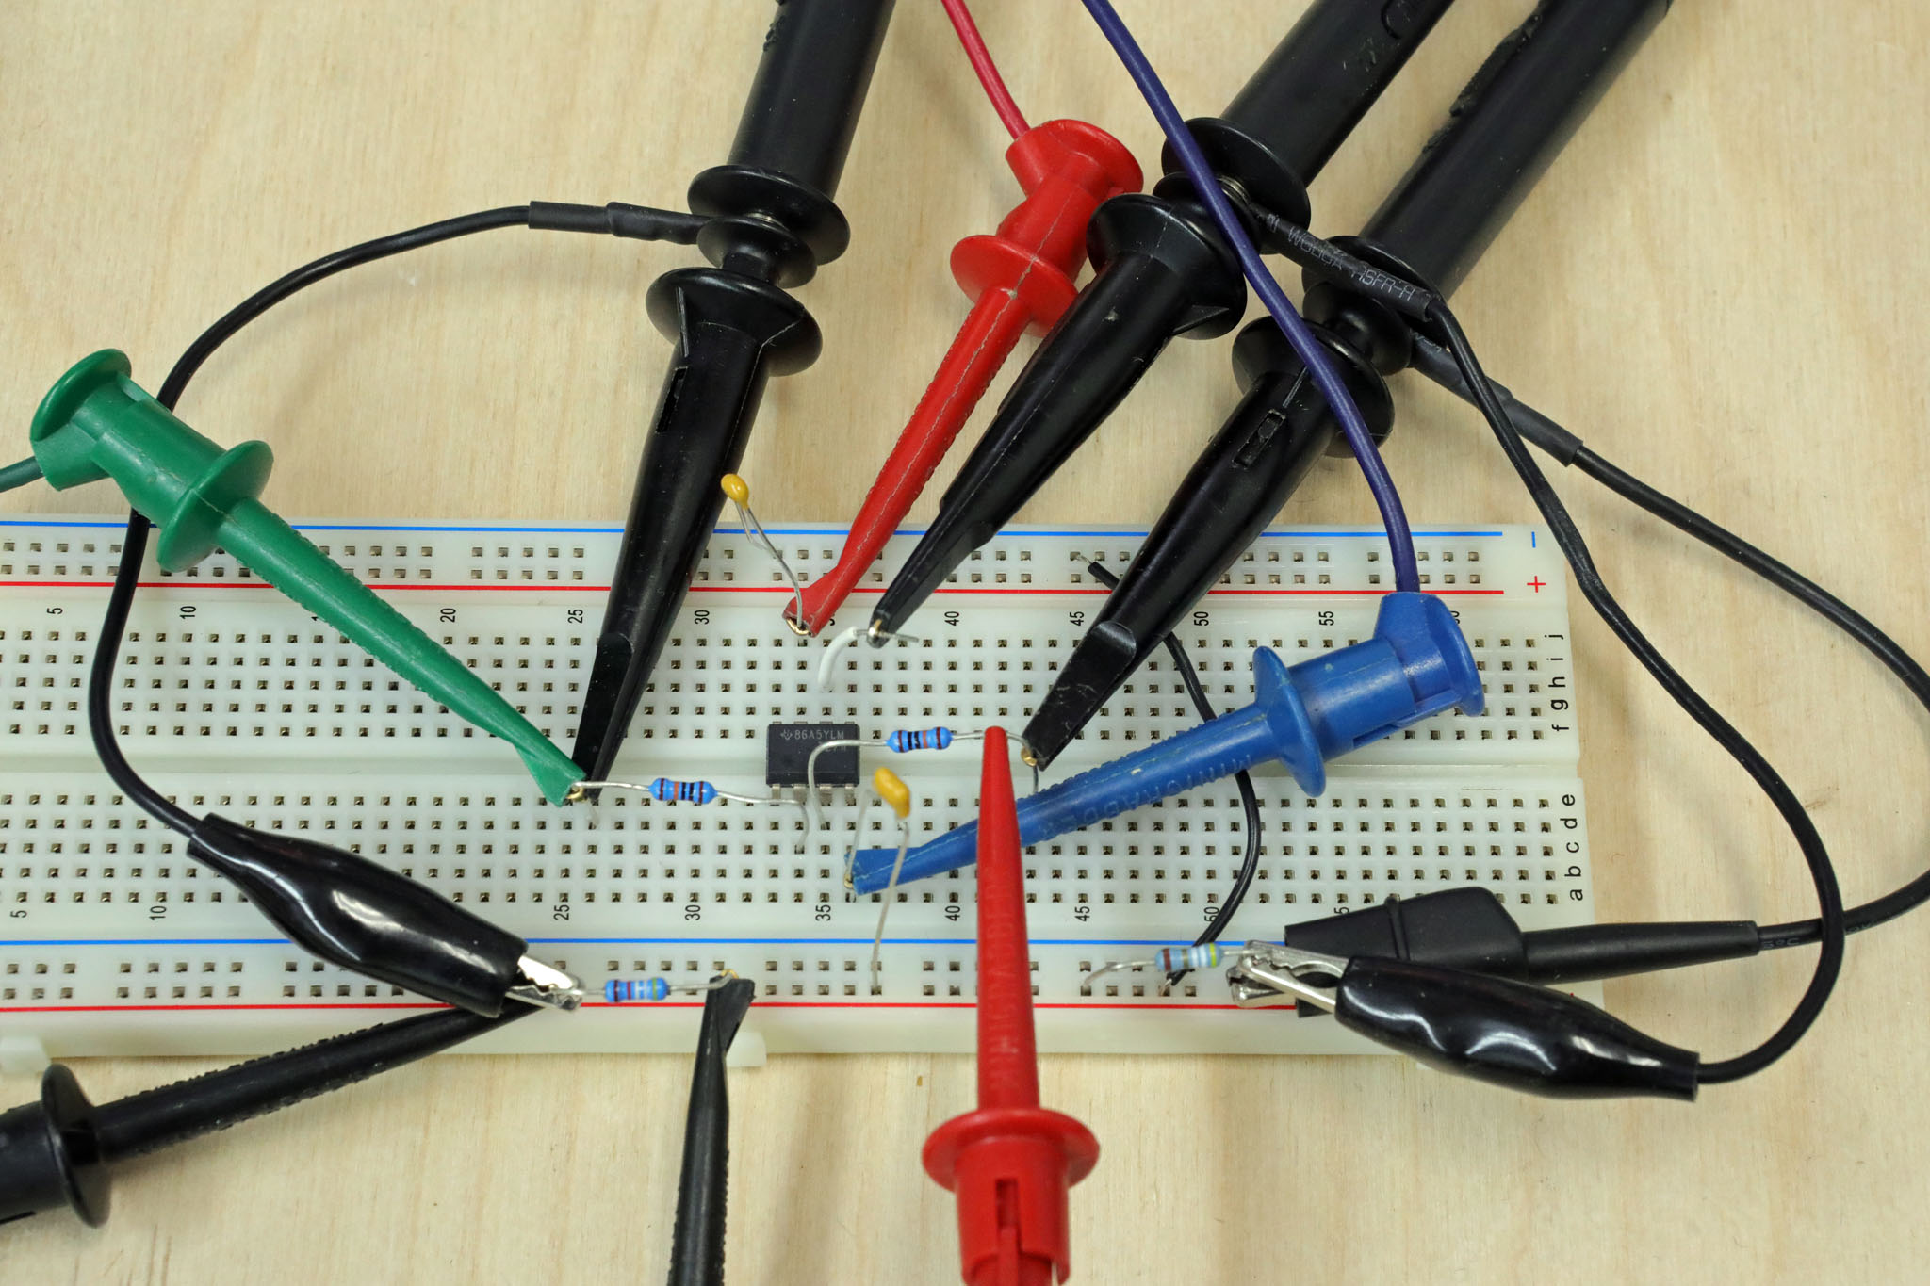

Figure 2: Bread board example of the comparator circuit shown in Figure 1.

1. **Test the comparator**

* Set Vin to a 4VPP triangle wave at 1KHz with no DC offset using the Wav Gen.
* Set VDET to 0VDC. We will call this the detector input reference voltage or threshold. Use the 6VDC power supply for this input.
* Use CH1 to measure Vin.
* Use CH2 to measure VOUT.
* Use CH3 to measure VDET.
* Choose the appropriate V/Div for the measured voltages.
* Choose a Time Base (s/Div) to show a few cycles of the triangle waveform.
* Put the ground reference for both channels at the same spot on the screen. The best is mid screen. You can do this by pushing the position knob,

You have just built a 0V detector. We call this a 0V detector because when VIN is above 0V the output is HIGH and when VIN is below 0V the output is LOW. In general, when VIN is below VDET the output of the op-amp is near the negative supply voltage, minus5 and when Vin is above VDET the output is near the positive supply voltage, plus5. For the triangle input and a 0V VDET the comparator output is close to a square wave. The output spends about equal time positive as it does negative.

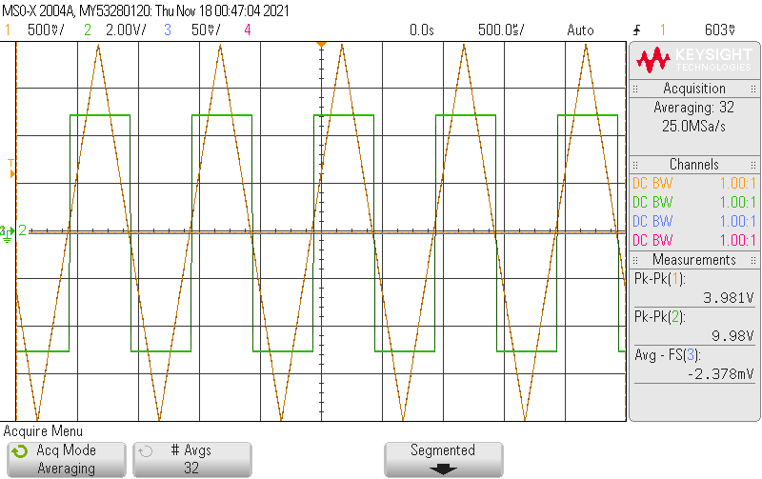

Figure 3: Scope capture of comparator VIN (CH1), VOUT(CH2) and VDET(CH3).

* What is the high level output voltage? _____4.953_______V. Use the Top measurement.
* What is the low level output voltage? ______-5.015_______V. Use the Base measurement.

1. **Try different detector (Threshold) voltages.**

* Set VDET to 1.5V DC and observe the output.

What happens to the amount of time the output is positive compared to negative?

**More time being negative, shorter time being positive.**

About what percentage of time is the output high compared to the period? ____~12%______________

This percentage is commonly called the duty cycle of the rectangular wave (PosDuty). The output waveform shows how much time the input waveform spends above the threshold or detector input voltage reference.

1. **Remove the -5V supply.**

* The rest of the lab will only use positive power supply voltages.
* We no longer need the -5V supply connected to pin 4 so disconnect it.
* Connect pin 4 which had the -5V connected to the GND node.
* This means the op-amp cannot put out any voltage less than 0V or ground. You no longer need C2.



Figure 4: Comparator circuit with a single supply voltage of 5V.

1. **Pick the threshold voltage VDET that gives a 0.75V DC detector.**

* Set 6V power supply to the voltage you think will result in a 0.75 volt detector. This is not a trick question. It is easy.
* Use a 2 VPP, 100Hz sine wave for Vin input signal for the circuit in Fig. 4.
* Set the V/Div of CH1 and CH3 to the same sensitivity. This lets you viauly compare the 2 inputs as the comparator would, assuming the grounds are lined up.
* Set V/div of CH3 to an appropriate sensitivity. I suggest you line up the he CH1 and CH3 grounds.
* The time base will have to slow down a bit from the 1KHz triangle waveform. You may want to reduce the number of averages if you are averaging.

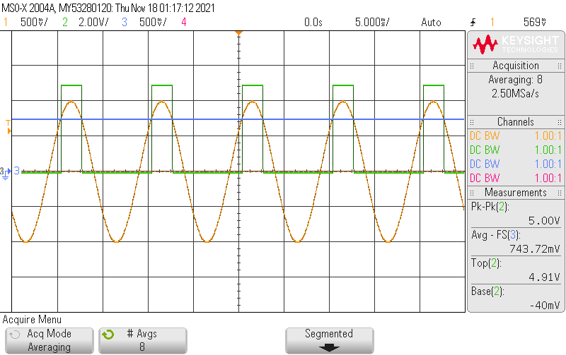

Figure 5: 2VPP, 100Hz VIN (CH1), VOUT (CH2) and VDET (CH3).

* Vary the sine wave amplitude from 2VPP to less than 1VPP to see if the comparator changes state at 0.75V as it should.
* What voltage did you use for the threshold (VDET) ? _____0.75_______
* Design a test that demonstrates that the detector really detects 0.75V? The test should use a single input AC waveform which demonstrates that the output changes from one state to the other when the input goes through the 0.75V threshold voltage in both directions. (Above 0.75 to below 0.75 and vice versa). Make sure it is an adequate test procedure. Hint: The triangle waveform is a good choice here.

Describe your test?

We set up a 1.78V triangle wave. Expect increasing output if voltage is higher than 0.75V

1. **Install the ‘Frequency Discriminator’ you designed in the pre-lab.**

* Replace R2, Fig 4 with the RC network you designed in the pre-lab.
* You circuit should look like Fig. 6 now.
* Don’t forget the power supply connection!

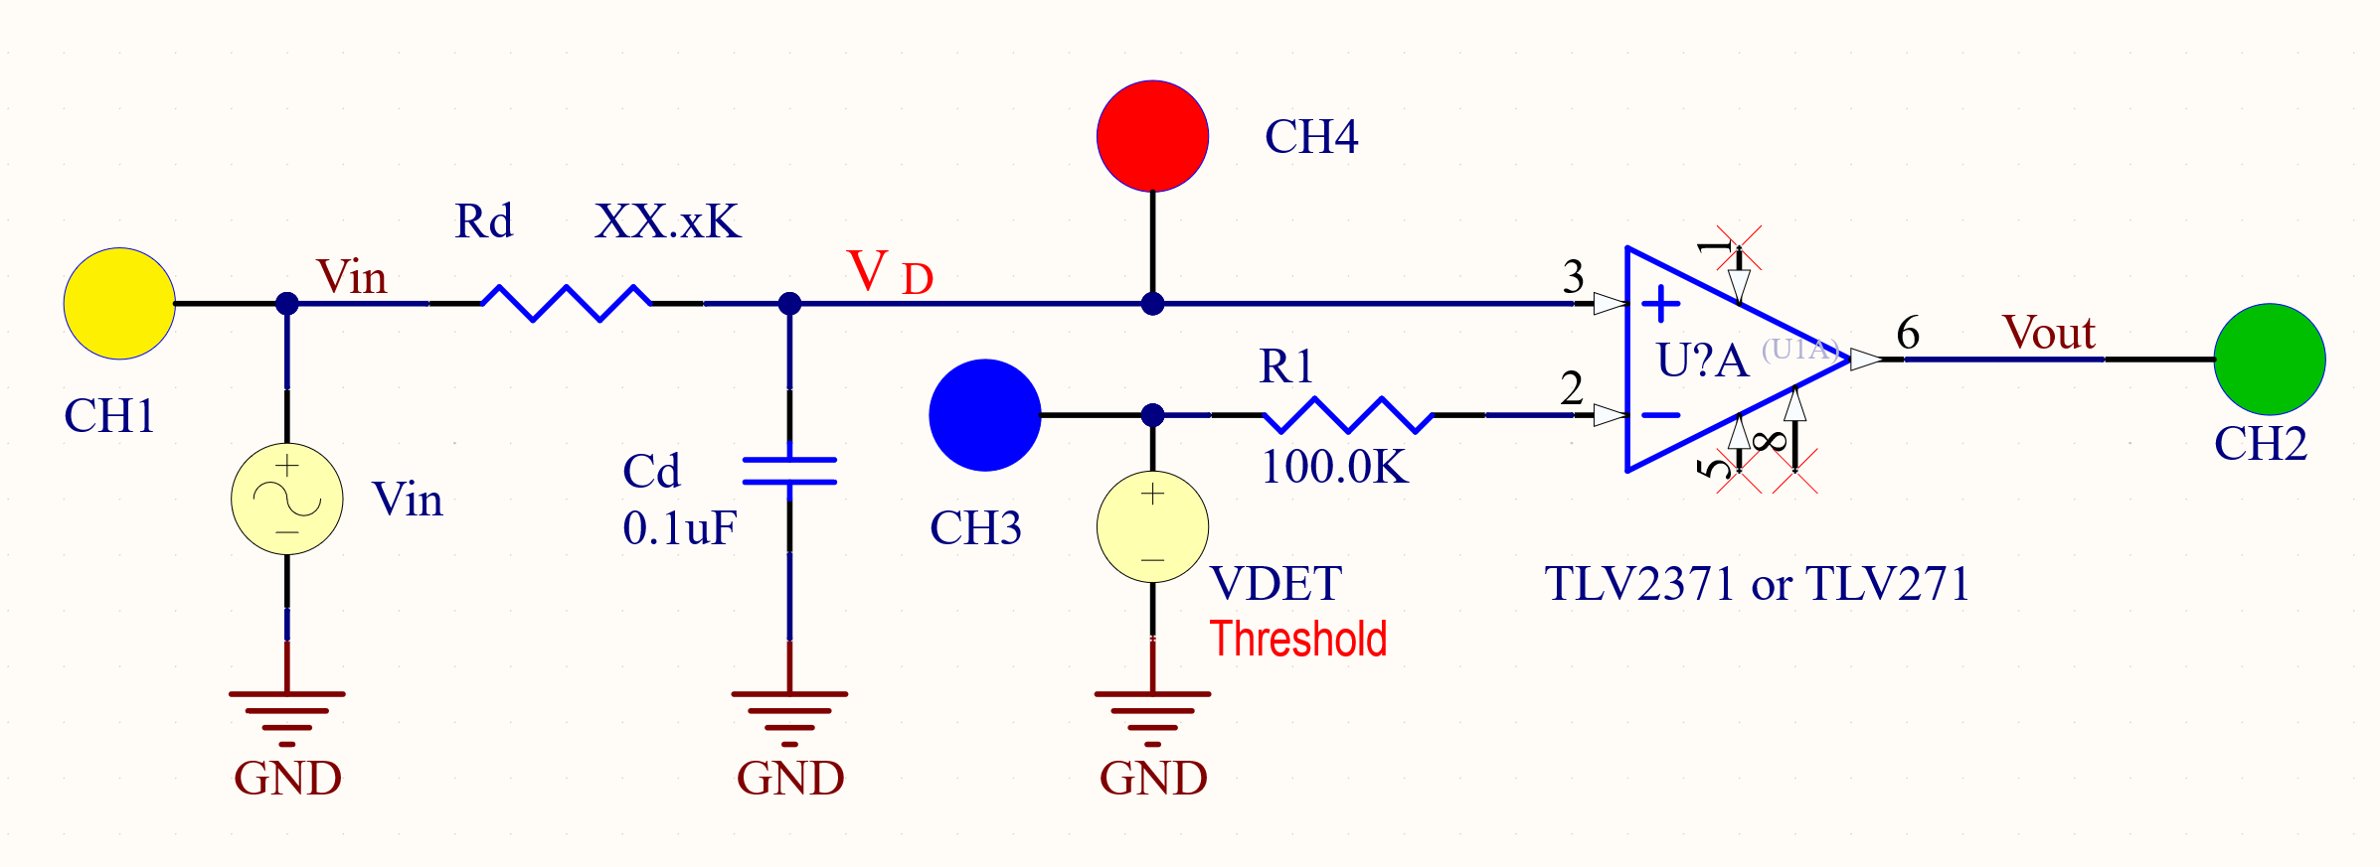

Figure 6: Voltage detector with input frequency discriminator. Power supply connection not shown but you still need it!

Just a reminder: The frequency discriminator you designed is really a low pass filter and should have VD of 1.6VPP or higher output when the input is a 2VPP 100Hz sin wave. It also should have VD less than or equal to 1.4VPP when the input is 2VPP 200Hz sine wave. This will be useful information for testing this part of the circuit.

1. **Test the frequency discriminator voltage detector circuit.**

* Make sure the threshold (VDET) is set at 0.75V DC. (Half way between 0.7 and 0.8)
* You need to input a 2VPP sine wave at 100Hz or 200Hz and observe the output of the comparator.
* Like before CH1 has VIN, CH2 VOUT, CH3 VDET and now CH4 goes to VD.

VD is the signal that actually gets compared to VDET. It should be smaller than VIN.

* Make sure the voltage at VIN measures 2VPP.
* The output should be high for X% of the time for the 100Hz 2VPP input signal.
* The output should be low 100% of the time for the 200Hz 2VPP input signal.

If the circuit didn’t work as the 2 statements above states make sure you are measuring properly or fix it!

What was the duty cycle of the output for the 100Hz input? _____16__________%

***When all the steps above work correctly show your TA what you have***.

The final requirement of the design has you adding an LED indicator to the circuit so the LED is emitting light when the output is high. The circuit with this addition is shown in Figure 6. Note CH3 of the scope is now connected to the resistor in series with the LED. The power supply connections are not shown and they are still needed.

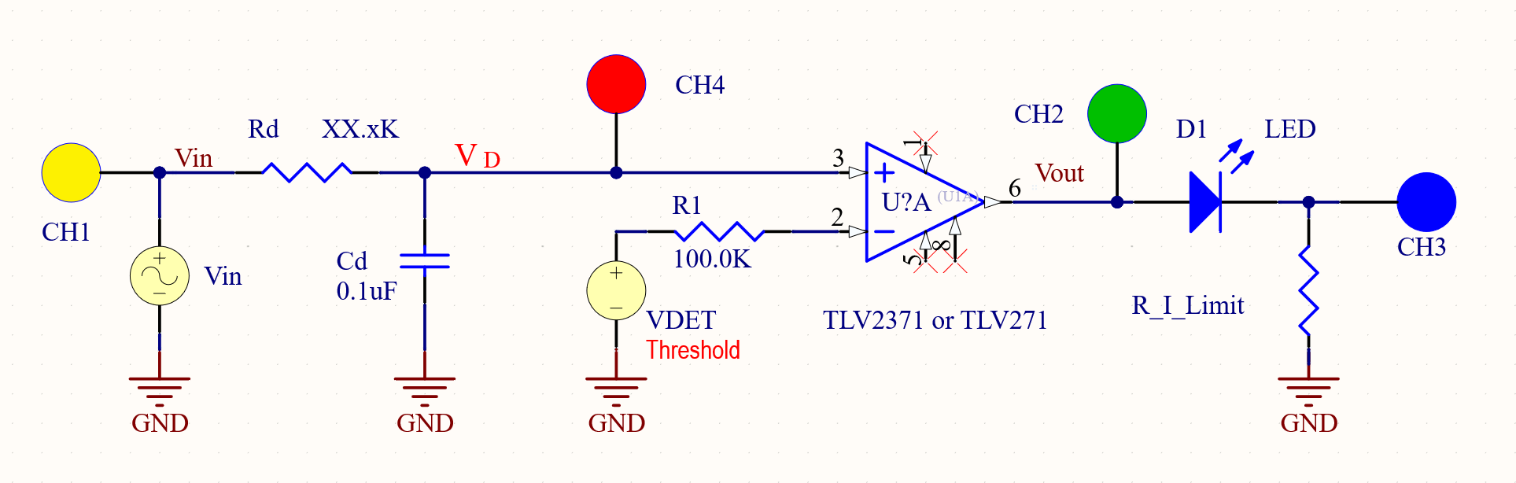

Figure 7: Voltage level detector with LED indicator.

1. You need to calculate a resistor value to put in series with the LED to get about 5mA of current through the LED when the output is high. The following steps tell how based on the theory of the LED.

* Note VOUT drives the resistor in series with the diode. In step 2 above you measured the high level output voltage of the op-amp. What was the output voltage with no load that you measured in step 2? __4.95_______V.
* Now you are going to put a load on the op-amp output. You will draw about 5mA. You should see what the output voltage is with about a 5mA load. Since the output with no load was about 5V put a 1KΩ resistor on the output for the load. No LED. What is the new output voltage at the output of the op-amp with the 1KΩ load. VOUT1K __4.72________ V. Use this VOUT1K for the next calculation.
* Use the forward biased diode model to determine the voltage across the resistor which results in 5mA of current through the resistor. The model of the LED is a resistor in series with a 1.7V offset. The offset is there because it takes about 1.7V to turn on a RED LED. The following schematic of VOUT driving the resistor and diode model should help you design in the right resistor value. Use the internal resistance of the diode, R_LED, as 0 ohms.

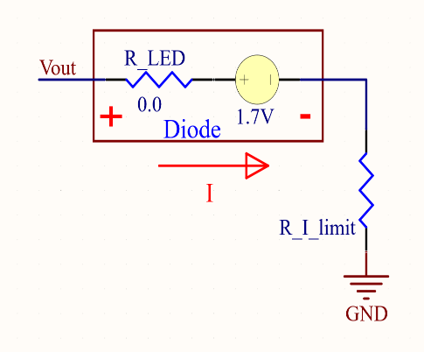

You know VOUT and the diode forward voltage drop of the LED. This allows you to calculate the value of R_I_limit needed to give 5mA of current through the LED.

__607_____Ω

Choose the nearest 5% resistor ___620___ Ω

* Put the resistor into the circuit as R_I_Limit . Test the circuit with 2VPP at 100Hz then 200Hz. Does the LED light up for the 100Hz 2VPP input signal ? ___YES__

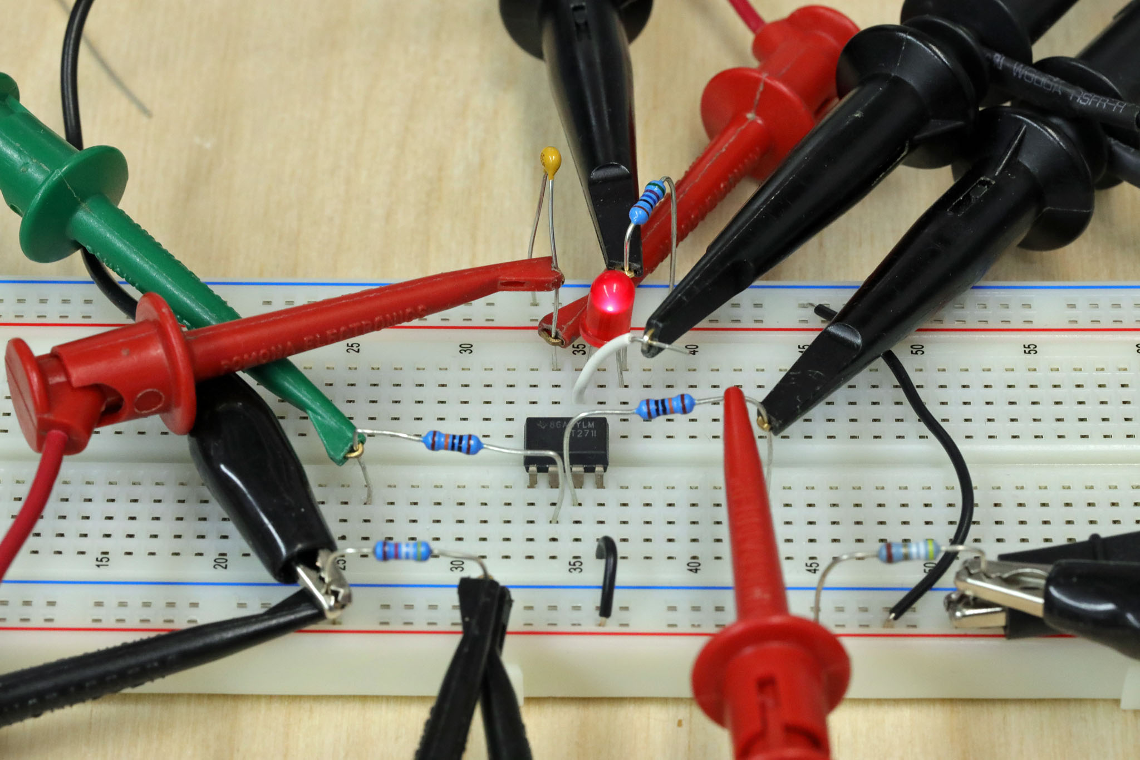

Figure 8: Breadboard example of the circuit in Figure 7.

* Connect the Channels as given in Figure 7.
* Math of CH2-CH3 gives the voltage across the diode.
* How much voltage is across the diode when it is on? ___1.85______ V
* Is this close to the assumption of 1.7V? ___YES_____
* Use the scope to determine the voltage is across R_I_Limit when the LED is on?

VR_I_LIMIT_LED_ON = ______2.84_____.

* How much current is going through the LED when it is on? I_LED_ON _____4.58_____ mA
* What is the duty cycle of the 100Hz output wave? ___16_________%
* Does the LED stay off for the 200Hz 2VPP input signal? ____YES______

If the LED lights up at 100Hz and also lights up for 200Hz something is wrong. If the LED does not light up at 100Hz and also does not light up for 200Hz something is wrong. You did more than put in the LED and the R_I_Limit series combination. Fix the problem.

When the circuit is correct there is one last thing to do:

* Visually compare the LED brightness of the 2VPP 100Hz input to a 4VPP 100Hz sine wave input using a 0.75VTHRESHOLD for both inputs. Look straight down on the LED when comparing the brightness.

Which input results in a brighter output? 2VPP @ 100Hz or 4VPP @100Hz 4Vpp is brighter

What are the duty cycles? 2VPP @ 100Hz ___16________%,

4VPP @100Hz ____36.52________%

* Compare the LED brightness of the 4VPP 100Hz sine wave input to a 2VPP 100Hz sine wave + 1.5VDC offset input to the comparator using a 0.75VTHRESHOLD for both inputs. You can add the offset in Wav Gen.

Which input results in a brighter output? 4VPP @100Hz or 2VPP @100Hz + 1.5VDCoffset 4Vpp is brighter

What is the duty cycle of 2VPP @100Hz + 1.5VDCoffset ? ____85_______%

Explain what you think controls the LED brightness when the input signal changes. Use things you measured or calculated to answer this question.

The perceived LED brightness is directly controlled by the measured **duty cycle** of the comparator's output, which reflects the percentage of time the LED receives its ~4.58 mA "on" current each cycle. A **higher duty cycle,** resulting from input signal characteristics that keep the filtered voltage above the threshold longer, indicates the LED is powered for a larger fraction of time and therefore **appears brighter** due to higher average light output.