## nstructional Objectives

* 1. Measure Current Using Digital Multi Meter.
  2. Take voltage readings at various points in a circuit.
  3. Take current readings at various points in a circuit.

## Procedure

0. You need a 887Ω, 2-10KΩ and a 3.3KΩ resistor for this lab.

1. In this part, you are required to measure the current flowing through the resistor R1 (IR1) in the circuit given in figure 1. R1 is 887Ω.

 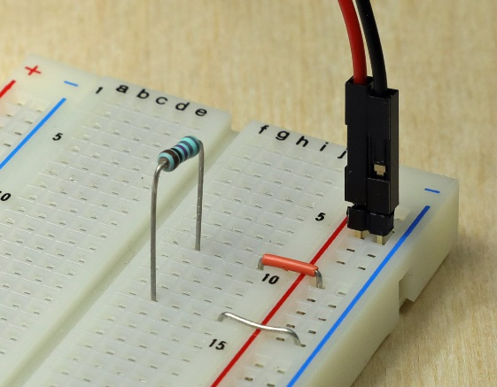

Figure 1: Schematic and Breadboard.

* Build the circuit as shown in figure 1 on the proto board. For this setup, you are required to set up a 5VDC source for the PowerSupply shown in figure 2.

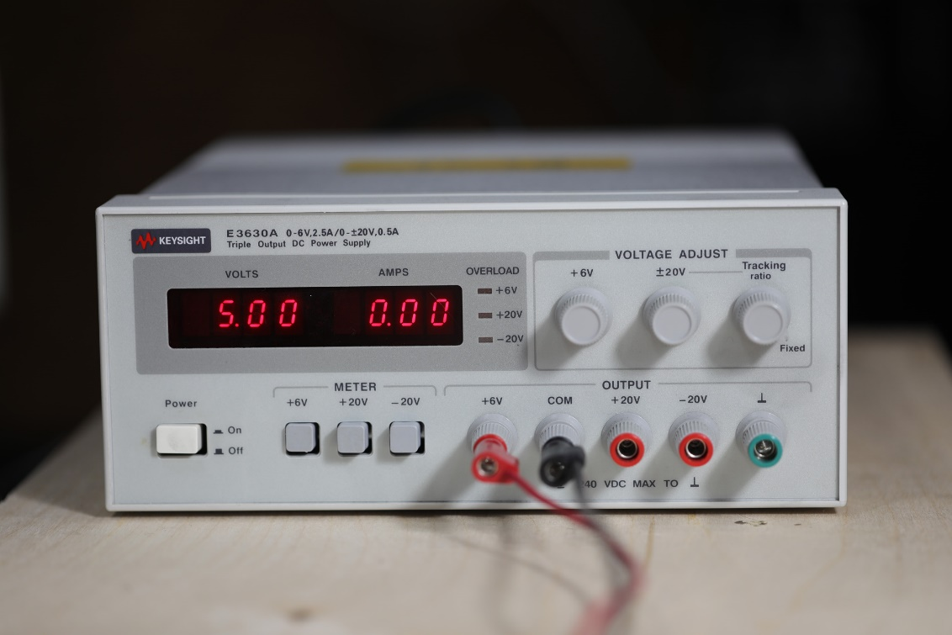

Figure 2: DC Power Supply

* + Connect the red wire of the Power Supply to the R1 node on the breadboard .
  + Connect the black wire of the GND node on the breadboard.
* Desktop DMM: Set the DMM such that it measures DC Amperes. Choose the 1A scale. Make sure the red DMM lead is going into the 10A jack and the black lead is in COM.
* Handheld DMM: Set the DMM such that it measures DC Amperes. Choose the 200mA scale. Make sure the red DMM lead is going into the mA jack and the black lead is in COM.
* To measure current you need to connect the DMM **in series** with the resistor R1. This has to be done because current is a “**through**” variable. To make a current measurement, the DMM actually replaces a piece of wire in the schematic. This is demonstrated in Fig. 3: **NOTE:** You may be using mini clips instead of headers to bring the power into the circuit.

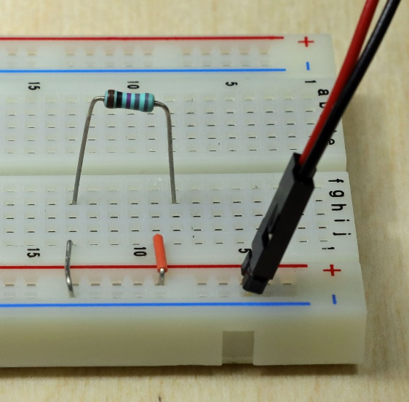 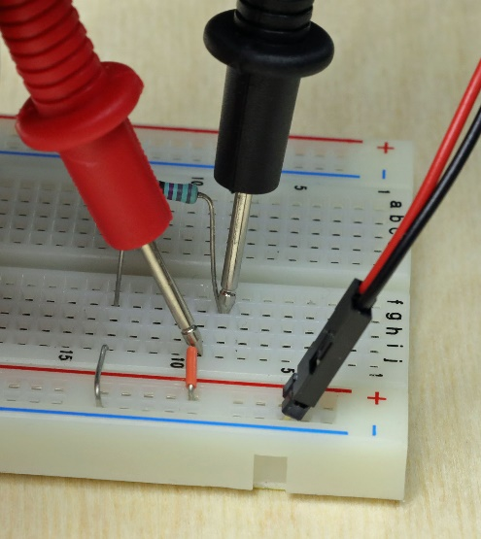

Figure 3: Measuring Current.

For this connection you have to physically move one end of R1. Then you re-connect the 5V supply to R1 with current meter. The probes are in the same holes as the wires. You are replacing the wire that goes from the DC 5V supply to the resistor with the DMM for measuring the current.

* Once, you have the correct setup, read the DMM display to get the value of IR1. IR1=______5.55_______mA

Note: If the value of current is in the range of 5mA then you are measuring the current correctly.

**Table top:** You can then change the red wire to the 100mA input and the range to auto for a more accurate measurement.

**Hand held:** You can then change the range to 20mA for a more accurate measurement.

If you get an over ranged reading and then no reading you have probably connected the current meter up incorrectly and blown the fuse on the meter or shorted out the 5V supply.

You can also calculate the current through R1 by measuring the Voltage drop across R1 and dividing it by the Resistance of R1 i.e. IR1 = VR1/R1. For calculating the current in this manner, implement the following steps:

**Table top:**

* + Measure R1 with the DMM. Remember you can’t measure with the power supply connected to both ends of the resistor. R1 ____886.96_____ Ω
  + Reconnect the circuit as shown in figure 1.
  + Set the digital multi-meter (DMM) to measure DC voltage (and put the red lead at the DMM into the VΩ jack !). Now you can safely use it to measure voltage across resistor R1. VR1 = _____5.004_____V

**Hand held:**

* + Measure R1 with the DMM on the 2K ohm setting. Remember you can’t measure with the power supply connected to both ends of the resistor. R1 _________ Ω
  + Reconnect the circuit as shown in figure 1.
  + Set the digital multi-meter (DMM) to measure voltage (and put the red lead at the DMM into the VΩ jack !). Pick the 20V range. Now you can safely use it to measure voltage across resistor R1. VR1 = __________V

Calculate the value of IR1 = VR1/R1 = _____0.00564______ A. How does this value of current compare to the value of current you found in the previous step?

Very close.

1. Pick 2 resistors with a nominal value of 10K. These are R1 and R3. Pick a resistor with a nominal value of 3.3K. This is R2. Record the nominal (Marked) and measured values in Table 1.

|  |  |  |  |
| --- | --- | --- | --- |
| Table 1 | Marked Value | Measured value | Measured Voltage Drop |
| R1 | 10KΩ | 9.9932KΩ | 2.1485V |
| R2 | 3.3KΩ | 3.3032KΩ | 0.71001V |
| R3 | 10KΩ | 9.9722KΩ | 2.1440V |

Build the circuit shown in Fig. 4, using V1 = 5VDC and your selected R1, R2, and R3. Be sure to keep track of the resistors and not mix them up since you will use the measured values later.

 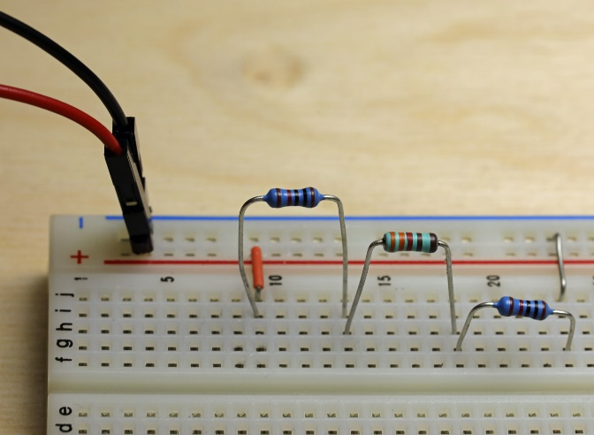

Figure 4: Series schematic and Breadboard example.

* Measure the voltages VR1, VR2, and VR3. Use the following procedure to measure the voltage values:

1. Use the DMM to measure the voltages V1, VR1, VR2 and VR3. Connect the red lead to the side of the resistor that corresponds to the plus sign in the schematic. Make sure the red lead is connected to the VΩ input on the DMM. Enter the voltages across the resistor in Table 1. Remember to touch the DMM probe tips to the resistor leads where they go into the breadboard.

V1 = _________5.0052_______VDC

* Using your measured values for R1, R2, R3, and Vs, calculate the expected voltage drops for VR1, VR2, and VR3. You can calculate this by hand or use a simulation to do it. (LTSpice works well)

VR1 ____2.1459____ V, VR2 ____0.7081____ V and VR3 ____2.1459____ V

1. Enter these in the “Calculated Voltage Drop” column in Table 2. Calculate the % error of your measured voltages from table 1 compared to the calculated voltages from table 2 using the calculated values as the reference values. Put this in table 2. Use the measured resistor values to calculate the reference values in Eq. (29). Place these results in Table 2. Remember % error is determined by:

 (29)

|  |  |  |  |
| --- | --- | --- | --- |
| **Voltage** | **Measured Voltage Drop copied from table 1 (V)** | **Calculated**  **Voltage Drop from Ohms law (V)** | **Calculated to**  **Measured**  **Error %** |
| VR1 | 2.1485 | 2.1459 | 0.1216 |
| VR2 | 0.71001 | 0.7081 | 0.2683 |
| VR3 | 2.1440 | 2.1459 | 0.0885 |

Table 2: Calculated Data and Errors for Fig. 4.

1. The errors you obtained in Table 2 should be less than 5%. If they are not, try to find the reason why.
2. Using the readings from Table 1, measured R’s and V’s, calculate the current passing through resistors R1, R2 and R3.

|  |  |
| --- | --- |
| **Voltage** | **Current (I) = VMEASURED / RMEASURED** |
| VR1 = 2.1485 V | IR1 = 0.2150 mA |
| VR2 = 0.71001 V | IR2 = 0.2150 mA |
| VR3 = 2.1440 V | IR3 = 0.2150 mA |

Table 3: Current through resistors

A, B, C and D are wires. Determine the currents IA = ____0.2150mA____, IB = ___0.2150mA_____, IC = ____0.2150mA____, ID = ____0.2150mA___ using the currents you just calculated in Table 3 IR1, IR2 and IR3. Describe the method you choose to make this calculation. Include the units ie. A, mA, uA etc in your determination.

I calculate the average value using the following equation:

(0.2150mA + 0.2150mA + 0.2150mA)/3 = 0.2150mA

What is the average current for IA, IB, IC and ID IAVE ___0.2150mA______

1. Using the DMM in voltage mode, measure the voltage drop from nodes A to C, B to D, and A to D in Fig. 4. Record these values in Table 4.

VAtoC___2.8581_____V , VBtoD ___2.8535_____V , VAtoD ___5.0050_____V

1. **Calculate** the measured equivalent resistance from A to C, B to D, and A to D using the voltages you measured in step 7, the average current from step 6 and ohms law. For example, the equivalent resistance between nodes A and C is given by . Where IAVE = the current through R1, R2 and R3. Record the results in Table 4.
2. Add up the measured resistance values to compute a **Theoretical** equivalent resistance from nodes A to C, B to D, and A to D. Record the values in Table 4, and then calculate the percent error between the calculated measured and theoretical measured columns.

|  |  |  |  |  |  |
| --- | --- | --- | --- | --- | --- |
| **Voltage** | **Measured**  **Voltage Drop (V)** | **Calculated**  equivalent resistance | **Theoretical**  equivalent resistance | **%error theoretical to calculated** | **Measured DMM**  **equivalent**  **resistance** |
| VAC | 2.8581 | **13.2935KΩ** | **13.3KΩ** | **0.04887** | **13.293KΩ** |
| VBD | 2.8535 | **13.2721KΩ** | **13.3KΩ** | **0.20978** | **13.271KΩ** |
| VAD | 5.0050 | **23.2786KΩ** | **23.3KΩ** | **0.09184** | **23.265KΩ** |

Table 4: Data from Fig. 4.

1. Now measure the actual equivalent resistances with the DMM. Enter them into table 4. Remember the power supply has to be disconnected for this measurement.
2. Next we investigate a parallel circuit. Build the circuit in Fig. 5, using V1 = 5V, R1, R2 and R3 from the series circuit in Figure 4.

 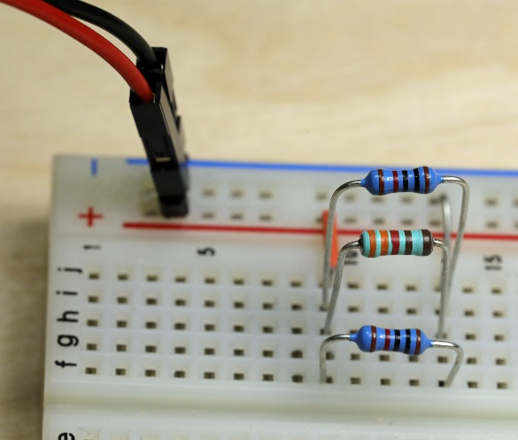

Figure 5: Parallel circuit schematic and breadboard example.

1. Write the measured values of your resistors in Table 5, and then measure the voltage across and current through each resistor as labeled in Fig. 5 Use the DMM to measure voltage. Don’t measure IS, IA, IB or IC yet. Look at figure 6 to see an easy way to measure the R1, R2 and R3 currents.

|  |  |  |  |
| --- | --- | --- | --- |
| **Resistor** | **Measured Resistance** | **Measured Voltage across** | **Actual Measured Current through** |
| R1 | **9.9932KΩ** | **5.0053V** | **0.4962mA** |
| R2 | **3.3032KΩ** | **5.0054V** | **1.5151mA** |
| R3 | **9.9722KΩ** | **5.0053V** | **0.4972mA** |

Table 5: Data from Fig. 5.

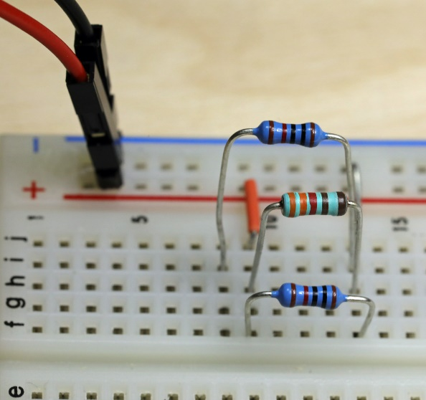 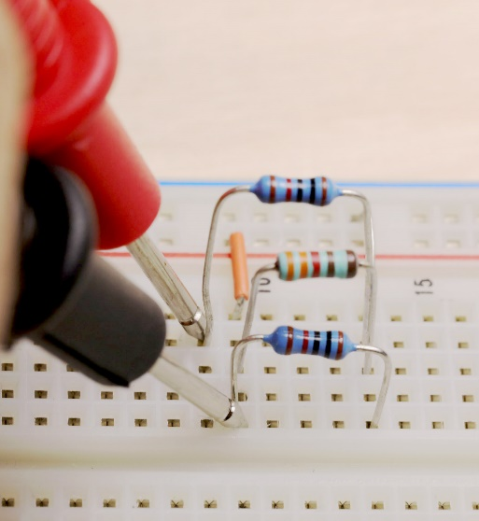

Figure 6: Parallel current measurement for a a single resistor.

1. Calculate the current that should flow through R1, R2 and R3 using the measured V across and measured resistances from table 5. Record these values in Table 6. Calculate the % error of your measured currents from Table 5 compared to the Calculated current.

|  |  |  |
| --- | --- | --- |
|  | **Calculated current using measured V and R** | **% error Measured to Calculated.** |
| R1 | **0.5009mA** | 0.9383 |
| R2 | **1.5153mA** | 0.0066 |
| R3 | **0.5019mA** | 0.9165 |

Table 6: calculations and errors from Fig. 6

1. Measure the currents labeled IS, IA, IB, and IC in Fig. 5 using the DMM. This procedure is similar to the one you followed in step 1 of this lab. Figure 7 illustrates how DMM can be connected to measure each current value:

IS = ___2.5170mA___, IA = ____2.0167mA____, IB = ___2.0168mA___, IC=_____2.5192mA_____

 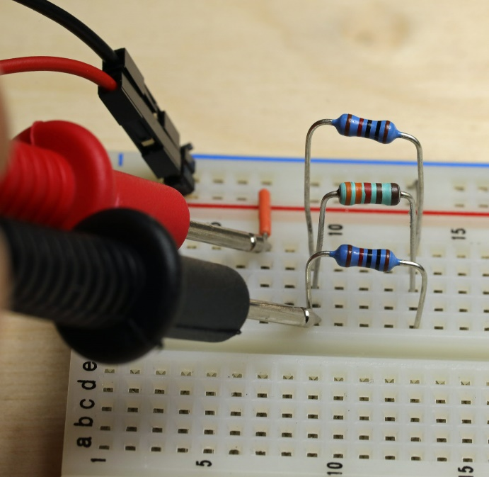

 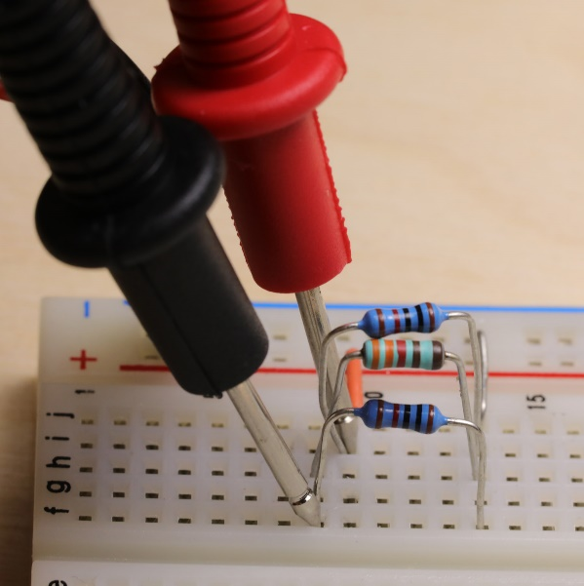



Figure 7: Current meter connection guide.

## Post Lab Questions

1. Draw a schematic diagram similar to Fig. 4 except label the elements with the measured resistance and computed voltage. Label this Figure 8. Compare the voltages you calculated to the voltages you measured for the circuits in Fig 4 and Fig. 8. Explain why they may not be exactly equal.

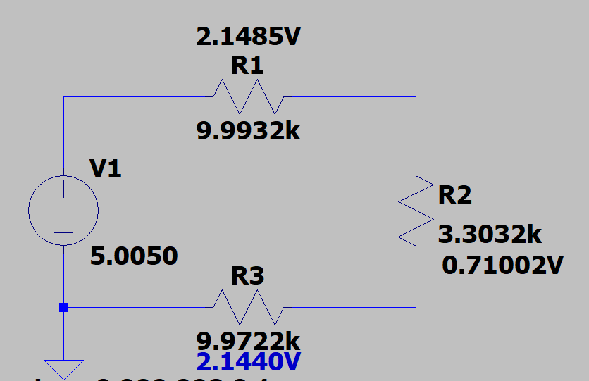

The reason why these values are not exactly equal is because of both systematic error and random error.

1. Verify that Kirchhoff’s Voltage Law applies to the circuit in Fig. 4. Do this by plugging your numbers from Table 1 into Eq. (1).

-5.0050V + 2.1485V + 0.71002V + 2.1440V = -0.00248V

1. Verify Kirchhoff’s Current Law at the voltagae source V1 node in Fig. 5. Remember the node includes all of the lines (wires). Do this by plugging the correct numbers into Eqs. 15 or 16. Only use the currents through the resistors and source. The other currents were measured to demonstrate what happens to the currents in the various loops.

2.5170mA - 0.4962mA - 1.5151mA - 0.4972mA = 0.0095mA

1. Fill in table 7 with sums of currents from the schematic in Fig. 5 that equal the current in the left column.

|  |  |
| --- | --- |
| Current | Sums of Currents  Use IR1,IR2 and IR3 |
| IS =2.5170mA | Symbolic: |
| Numeric:0.4962mA + 1.5151mA + 0.4972mA = 2.5085mA |
| IC =2.5192mA | Symbolic: |
| Numeric:0.4962mA + 1.5151mA + 0.4972mA = 2.5085mA |
| IA =2.0167mA | Symbolic: |
| Numeric: 1.5151mA + 0.4972mA = 2.0123mA |
| IB =2.0168mA | Symbolic: |
| Numeric: 1.5151mA + 0.4972mA = 2.0123mA |

Table 7