# Instructional Objectives

* Understand if our measuring equipment affects the circuit being measured.
* Analyze the transient response of a simple RC circuit.
* Analyze the transient response of a simple RL circuit.

# Procedure

Parts needed for this lab: 510Ω, 3.3K and 10K resistors, a 0.1uF capacitor and a 10mH Inductor.

For all experiments in this lab you will be using a bread-board, an Oscilloscope and Signal Generator.

You may need to install the Scopy app. It is available from: <https://wiki.analog.com/university/tools/m2k/scopy>

**Part 1: Measuring the transient response of an RC network.**

Before we actually measure the RC time constant there are a few things that need to be determined about the circuit and the measurement instruments.

The theory section talks about the initial and final conditions of the voltage on the capacitor. We will investigate these conditions, since they influence the measured results. The initial conditions are not difficult to set or measure. To make it easy to measure τ we force the initial voltage across the capacitor to a known voltage and change the voltage across the capacitor to the final voltage. With this setup we can use Eq. 7 or 9 to measure τ with the scope.

**IMPORTANT NOTE: We are going to drive the RC with a very slow square wave. Slow is defined as a square wave having a period, T, about 30 times the time constant, , of the RC circuit. We do this so that the capacitor has time to get extremely close to the final voltage that is driving the circuit. This defines the initial and final conditions for us because we wait long enough before the square wave to change voltage. The square wave is supposed to be close enough to $\text{∞}$ time. This dictates that we use low frequency square waves to determine the initial and final voltages across the device under test (d.u.t). Also we will have t use higher frequency square waves to measure the value of τ once we know the initial and final values.**

Another issue we need to deal with is the influence the input resistance of the oscilloscope has on our measurement since we will use it to measure the τ of the RC circuit. The oscilloscope has the input impedance marked on the scope probe or in the probe manual. The input impedance changes when you switch from X1 and X10. Use this value and check to see if the value will effect your measurement results significantly. Use the X10 setting if the X1 setting will affect the measured results too much. Find the impedances of the scope probe. 1X __*1M Ohm* _ 10X ___*10M Ohm* ___

**Now that we know the input resistance of the Oscilloscope** we can determine if it will influence the measuring of the time constant τ. From figure 5 below we can evaluate whether or not the input resistance of the scope probe discharges the capacitor too much while R1 charges it. Too much means the connected scope probe discharges the capacitor fast enough to change the measured time constant by more than 1% for this lab. Does this input resistance discharge the cap at a rate high enough to influence the measureable charging through R1 by more than 1%?

To determine this compare the charging R to the discharging R.

If the input resistance of the probe is >> than the charging R, R1, there won’t be a problem unless you are trying to measure with incredible accuracy. For example 100:1 ratio of Rin / R1 yields a 1% error. 1000:1 ratio a 0.1% error etc. It all depends on the accuracy you need for your tests. You should consider to 1% accuracy to be good enough for the ECE270 labs.

Do you need to worry about the oscilloscope input resistance when determining $τ$ For R1 = 10K? _ *No, Rin/R1 only yields a 0.1% error* __

1. Parts: 1 - 0.1uF Film Cap, 1 - 10mH Inductor, 1 - 510Ω, 1 - 3.3KΩ, 1 – 10KΩ
2. Measure the charging of a capacitor to determine $τ_{Charge}$: Build the circuit shown in Figure 5 below. R1 is 3.3K and C1 is 0.1uF. Note the labeled nodes are where you will make your measurements with the CH1 and CH2 inputs.

 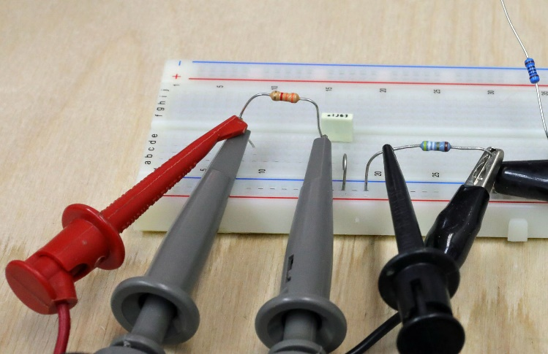

Figure 5: RC circuit with breadboard example.

What is the theoretical $τ$ for this RC circuit? ____*0.00033*_____ S

General Setup:

* Connect the Sig Gen output 1 to the circuit at Node A and GND with the header.
* Start up the Signal Generator.
* Setup the Sig Gen source to put out a 5VPP square wave with 2.5V offset at a frequency low enough that lets the voltages across the capacitor reach the initial or final values. A frequency in Hz where the period is about 20 or 30 times τ in time is a good start. This low frequency will be used to determine the initial and final voltages across the D.U.T. (Device Under Test). You can tell if the frequency you choose is low enough by looking at the voltage across the capacitor and seeing if it approaches a constant voltage, 5V or 0V, before it changes to the other voltage, 0V or 5V respectively.
* Start the Oscilloscope.
* Set triggering to Auto, CH1 for falling edge and about 500mV.
* Set the time base (Horizontal Control) to an appropriate uS/ or mS/ (time per division) which allows you to see both the charging and discharging of the capacitor on one screen and also shows the initial and final voltages. This will show about 2 cycles of the square wave.

Oscilloscope inputs.

* Connect the CH1 tip to Node A and the alligator clip to GND.
* Connect the CH2 tip to Node B and the alligator clip to GND.
* Turn on the MATH channel and set it to CH1-CH2.

I got a scope image that looked like figure 6.

First of all what is CH1 measuring? **CH1 measures the input voltage of the square wave.**

What is CH2 measuring? **CH2 measures the voltage across capacitor.**

Which curve(s) can you measure the time constant from? **CH2, the green curve.**

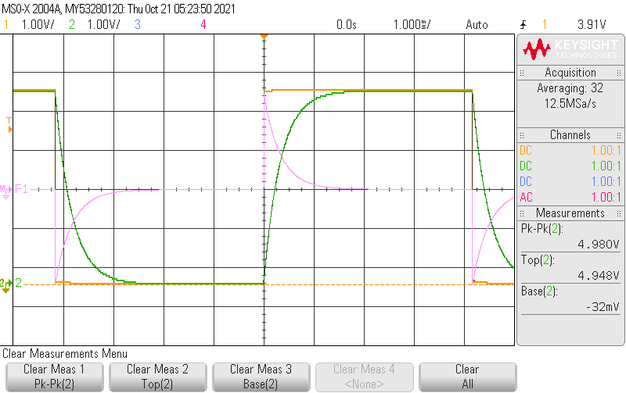Figure 6: RC time constant measurement traces.

* I added some measurements that we will use to determine some of the charging and discharging parameters.
* Use the Base and Top measurements on CH2, the initial (about 0 V for charging) and final (about 5V for charging) voltages across the capacitor. If there are peaks that are present on the trace you should not use Min and Max but rather use Base and Top because they ignore any spikes that may be in the curve which are just noise for our measurements.

VINIT __0mV__, VFINAL __493.4mV__ across the capacitor.

Make sure you are convinced the waveform is done rising or falling.

1. Use the cursors to measure the time constant $τ_{Charge}$

* You need to determine what voltage is 63% from initial to final to make this measurement.
* You will use the Cursors for this. Click on the Cursors button.
* Use the Manual Mode. Set the Source to CH2 (VC). We will use this trace to find the time constant. We could use the MATH trace as well.
* Move the Y1 cursor using the Cursors pot to put the cursor at the INITIAL voltage on CH2. (About 0 volts).
* Move the Y2 cursor to the FINAL voltage of the CH2 trace (About 5V).
* Calculate the voltage which is $(1-e^{-1})\sim$ 0.63 the way to from VINIT to VFINAL. This is 63% from VINIT to VFINAL = VINIT + 0.63(VFINAL-VINIT) ____3.108___V. From Eq. 9 in the theory section.
* Drag the other Vertical cursor to the 63% voltage for the CH2 trace.
* Move the X1 cursor to the point in time where the CH2 trace starts rising from VINITIAL.
* Make the Horizontal Time Base faster about 2 clicks. Fast enough so you can still see the CH2 trace where 63% occurs.
* Move the X2 cursor to the time where the CH2 trace intersects the Y2 cursor.
* Now you can read the ∆X value of the cursor data in the lower right portion of the screen. This is the time constant, $τ$, for the circuit.
* Capture the resulting display and put it in the report instead of the plot I captured. Make sure your plot has CH1, CH2 and MATH. Also have the cursor menu showing your ∆X as well.

$τ_{ChargeRC}=$______0.00034s_______.

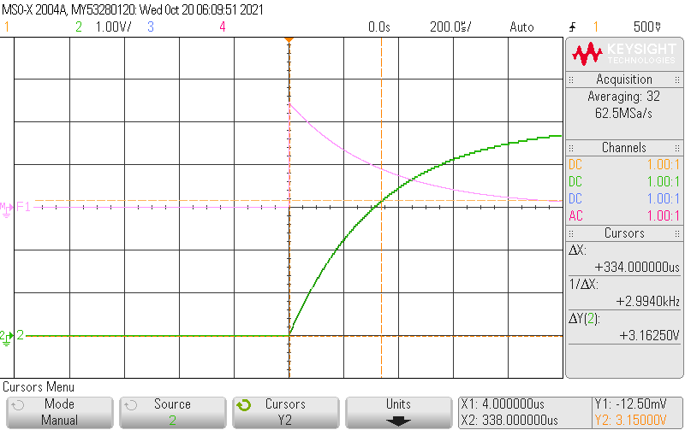

Figure 7: My plot of the time constant.

1. Use the cursors to measure the time constant $τ_{Discharge}$.

* Change the trigger from rising to falling to get this done.
* Now you need to calculate the voltage that is 63% down from the 5V initial value to the 0V final value.
* The vertical voltage you need this time is $(1-e^{-1})\sim$ 0.63 the way to VFINAL. This is 63% from VINIT to VFINAL = VINIT + 0.63(VFINAL-VINIT) ____1.826___V. From Eq. 9 above. VFINAL-VINIT should be negative. This is not the same voltage as the first one. It should be closer to 0V than to 5V.
* Capture the resulting display for your report.

$τ_{DischargeRC}$ = __0.00034s __.

1. Measure the peak current values during charge and discharge cycles. The current starts at 0 and either increases or decreases depending on whether the capacitor is charging or discharging.
2. You use MATH to measure the current. The voltage across the resistor is CH1-CH2.

VPOS __463.9mV__, VNEG __-457.9mV___.

1. The current is the voltage across the resistor divided by the resistance. What is R 3.2618 kΩ.
2. Calculate peak ICHARGE __1.4195mA__ and peak IDISCHARGE _-1.4034mA__.
3. One more measurement. Use the R1 current curve to determine the time constant. The current is initially a negative spike and finally settles to 0.

* The scope image you used previously should allow you to do this nicely.
* Use the negative peak value of current for VINIT or IINIT as it really is. INIT __-457.9mV/-1.4034mA__.
* VFINAL or IFINAL is about 0V or 0mA.
* What is the 63% voltage on the current curve for finding the time constant? __-2.89V___.
* Capture the scope image with the cursors shown for this measurement.

$τ_{DischargeCurrentRC}$ = _____0.00033s_______.

1. Change R1 to 10.0K. The following steps are similar to steps 2 - 3.

* Setup the Sig Gen source to put out a 5VPP square wave with 2.5V offset at a frequency low enough that lets the voltages across the capacitor reach the initial or final values. A frequency in Hz where the period is about 20 or 30 times τ in time is a good start. This low frequency will be used to determine the initial and final voltages across the D.U.T. (Device Under Test). You can tell if the frequency you choose is low enough by looking at the voltage across the capacitor and seeing if it approaches a constant voltage, 5V or 0V, before it changes to the other voltage, 0V or 5V respectively. (Note that the frequency will have to be lower than the frequency used in previous steps, because of the larger value of τ)
* Set triggering to Normal, CH1 at rising edge and 100mV
* Set the time base (Horizontal Control) to an appropriate uS/ or mS/ (time per division) which allows you to see both the charging and discharging of the capacitor on one screen and also shows the initial and final voltages. This will show about 2 cycles of the square wave.
* Measure the initial and final voltages, VINIT _0mV__, VFINAL __493.4mV __ across the capacitor.

1. Use the cursors to measure the time constant ${ τ}_{Charge}$.

* Change the Time Base to cover the initial to final event to easily measure τ.
* Use X and Y cursors again.
* Use the 0.63 value of the voltage across the capacitor again.
* Capture the resulting display for your report.

$τ_{Charge10KC}=$_____0.00098s______.

**Part 2 Measuring the transient response of an RL network.**

1. Measure the charging of an inductor to determine $τ_{ChargeRL}$: Build the circuit shown in figure 8. R1 is 510 for a 10mH inductor. However before you build this circuit measure the resistance of the indictor. RL = __9.08_ Ω and the resistance of R1 = ___507.6___ Ω

 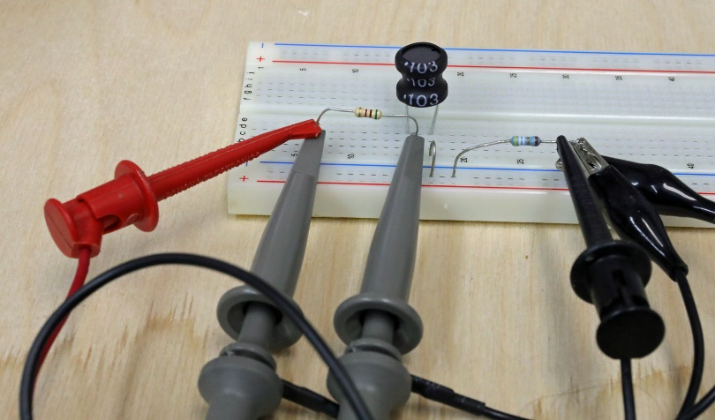

Figure 8: LC circuit with breadboard example.

What is the theoretical $τ$ for this RL circuit? ___1.935e-5___ S

* Setup the Wav Gen Source to put out a 5VPP square wave with 2.5V offset at a frequency low enough that lets the voltages across the inductor reach the initial or final values. A frequency in Hz where the period is about 20 or 30 times τ in time is a good start. This frequency will be used to determine the initial and final voltages across or current through the D.U.T. (Device Under Test). You can tell if the frequency you choose is correct by looking at the voltage across the inductor and seeing if it approaches a constant voltage, before it changes to the other voltage. (Note that the frequency will have to be much higher than the frequency used for the capacitor because of the lower value of τ)
* Set triggering to Auto, CH2 at rising edge at about 4V.
* Set the time base (Horizontal Control) to an appropriate uS/ or mS/ (time per division) which allows you to see both the charging and discharging of the capacitor on one screen and also shows the initial and final voltages. This will show about 2 cycles of the square wave.

Oscilloscope inputs.

* Connect the CH1 to Node A and the alligator clip to GND.
* Connect the CH2 to Node B and the alligator clip to GND.
* Turn on the MATH channel and set it to CH1-CH2.

I got a scope image that looked like figure 9.

First of all what is CH1 measuring? **CH1 measures the input voltage of the square wave.**

What is CH2 measuring? **CH2 measures the voltage across inductor.**

What is MATH measuring? **The difference between CH1 and CH2**

What is the source V1 min and max voltages based on the Wave gen settings?

Min __0__ V, Max _5_ V.

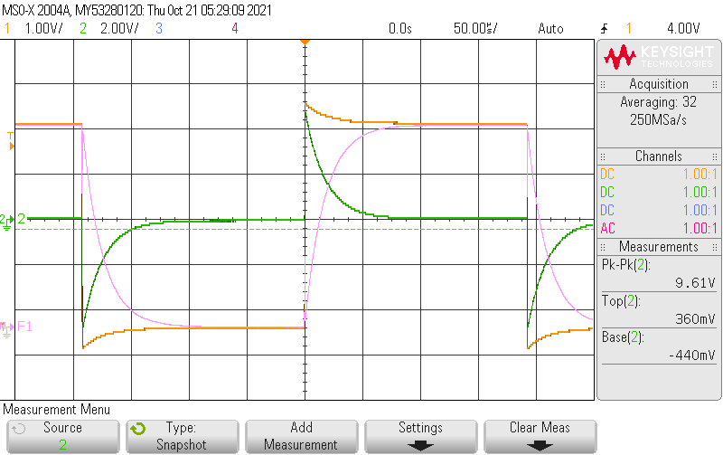

Figure 9: RL time constant measurement traces.

Notice a few things about these traces.

* First the square wave source is no longer square. It peaks up at the change of direction.
* There is a spike in the voltage across the inductor (CH2)
* The curves are complimentary to the capacitor curves. The VC curve looks like the IL and the IC looks like the VL.

When we looked at the RC circuit we used the directly measured VC to find the time constant. We will do the same thing for finding the RL time constant. We will use VL. So you should do a similar thing to what you did to find the RC time constant using the current trace. One problem is the Measurement of Base and Top don’t give us anything useful for the time constant determination. You will have to measure VINITIAL and VFINAL manually.

Measure the initial and final voltages for charging the inductor, CH2, VINIT _4.64V__, VFINAL _10.18mV__ across the inductor. This is not trivial as the inductor voltage never goes to 0 and starts out as a peak value. Don’t use the negative half of the curve for this. That is for the discharging.

* Use the Cursors to measure CH2, the initial (top of the peak) and final (not quite 0V for charging) voltages across the inductor. VINIT _-4.80V_, VFINAL _90.08mV_ across the inductor. Make sure you are convinced the waveform is done rising or falling.

As with the RC circuit there are 2 ways to measure the time constant $τ_{ChargeRL}$. Using the voltage across the inductor or the voltage across the R (current through) the resistor.

Which RL voltage looks more the voltage across the capacitor from the previous steps? VR _4.89V__ or VL _4.81V__

You will use the voltage across the inductor to determine $τ$.

Use the cursors to measure the time constant $τ_{ChargeRL}$.

* Change the Horizontal Time Base to cover most of the rising event on the screen.
* Set one y cursor to the initial voltage across the inductor.
* Set the other y cursor to the voltage which is $(1-e^{-1})\sim$ 0.63 the way to VFINAL. This is 63% from VINIT to VFINAL = VINIT + 0.63(VFINAL-VINIT) ____1.717____V. Note VFINAL-VINIT is a negative number.
* Capture the resulting display for your report.

$τ_{ChargeRL}=$___1.885e-5s______.

The CH1 and CH2 curves show that there is voltage across the resistor and the inductor just as charging changes to discharging.

1. Why is there voltage across the inductor? **Because inductor is non-ideal. It has internal resistance and will cause a voltage drop.**
2. How much current is flowing through the inductor just before the charging curve changes to discharge? VFINAL / RL = ILcharge ___9.92___ mA.
3. How much current is flowing through R1 at the end of charging?

VR1MAX / R1 = IR1charge ___9.88___ mA

1. Is ILcharge = IR1charge ? ___Yes, only 0.04mA difference__ They should be identical.
2. Assuming the WaveGen is set to 5V calculate the amount of resistance that gives this current.

5 / IR1charge = RLcharge = ____506.07_____ Ω

1. Is this close to the measured values RL + R1? __ Yes, only 1.53Ohm difference ____ It should be.
2. If RLcharge is the resistance used in the time constant what value of inductance would give you the measured time constant $τ$. Remember the inductance should be within 10% or 20% of 10mH.

LACTUAL = ___10.1___mH

1. Use LTSpice (or any program) to draw the Voltage source, V1, measured R1 and RL and LACTUAL you just determined and include it here.

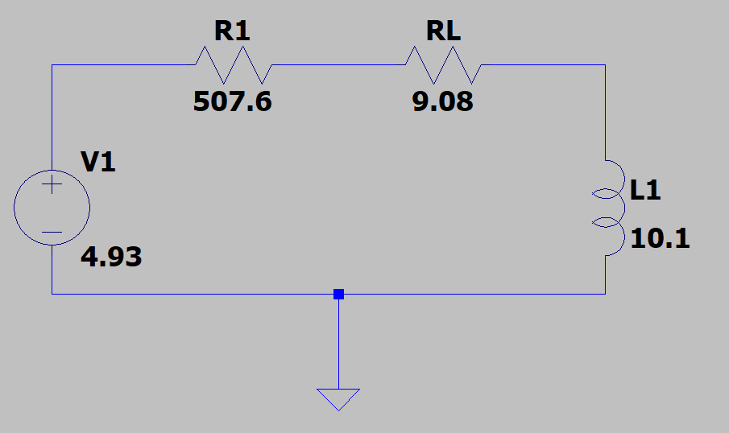ss