The prelab for this week requires you to submit a document to a Dropbox. This set of instructions tells you what is needed for that document.

I recommend you use LTSpice to simulate the Op-Amps prelab. Remember there are links to LTSpice video tutorials near the top of the ECE270 website.

Open LTSpice.

You are going to create a new schematic that looks like the one in Figure 1:

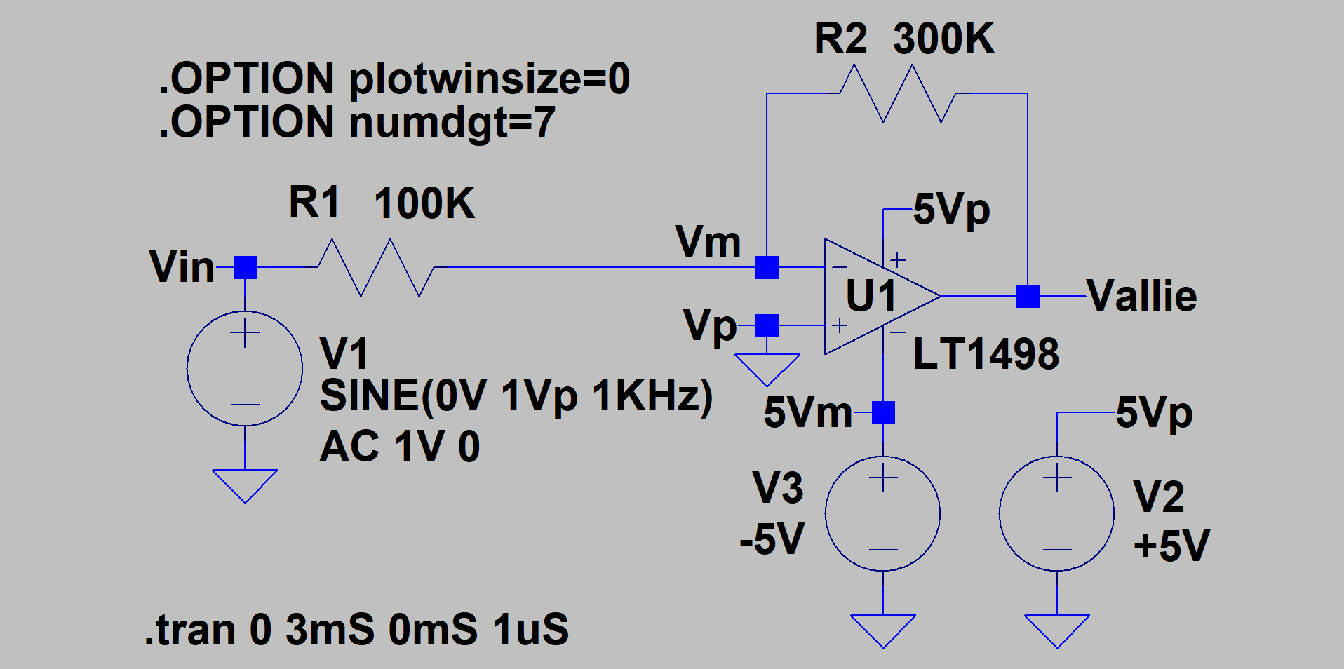

Figure 1: Inverting Op-Amp circuit.

This is how you create it.

Open LTSpice and create a new schematic sheet.

Place 3 voltage sources: Select the component icon.

Choose ‘voltage’ from the window that pops up. Press OK. Right click on the voltage source symbol that you will use for the input signal Vin. Since it is not DC click on the advanced box. Choose the SINE option in the function area and enter the desired info. This sets up the necessary signals for transient analysis. For the DC power supply sources set them to the appropriate voltages. To get the AC spec enter 1V and 0 phse in the small signal AC Analysis (AC) box.

* Type in LT1498 Select Component Symbol window.
* Place an LT1498 into the schematic by clicking OK
* Press the ‘R’ key and the cursor will become a resistor. Either place it as is or press CTL R to rotate the symbol and then place it. Put down 2 resistors in about the right places based on figure 1.

The LTSpice Keyboard Shortcuts Guide has all of these convenient keys listed. It makes creating a schematic much faster.

You should have something that looks like figure 2:

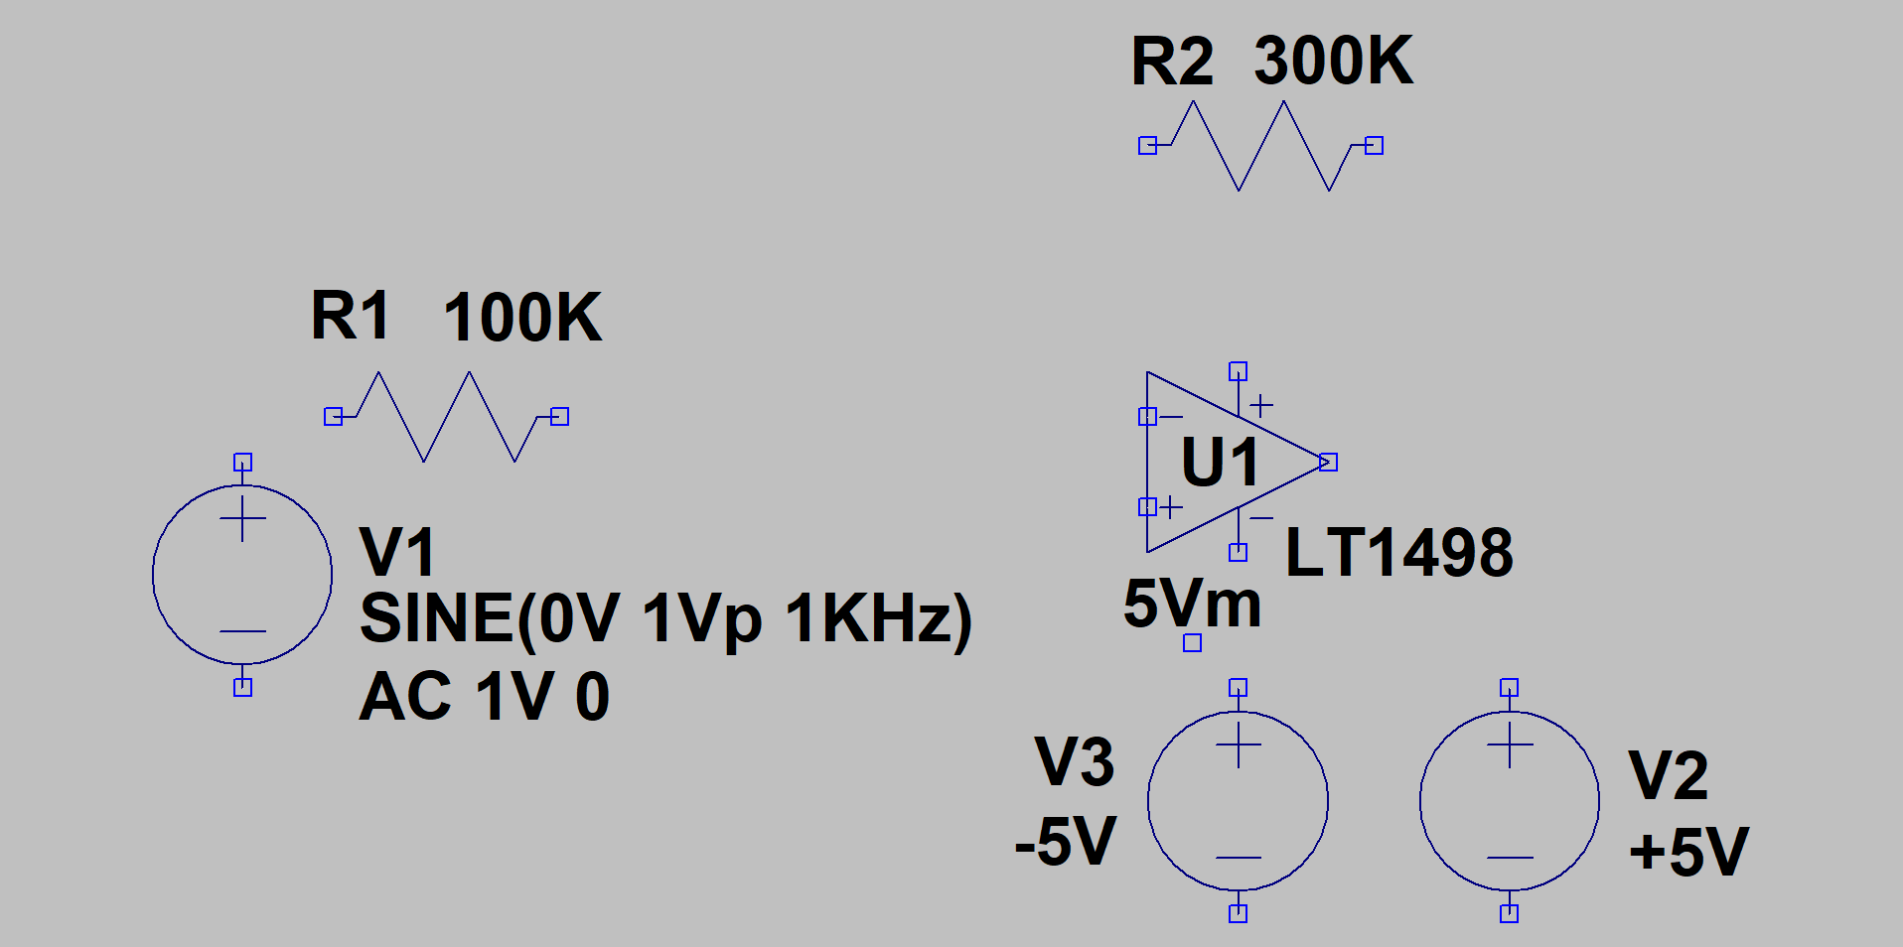

Figure 2: Start of the simulation schematic.

* You can either connect the parts together with wires (F3) or right click on each part to set the values. Whichever one you do first doesn’t matter as long as both get done.
* Add the circuit grounds. Guess which key you can push for that one? Right ‘G”. Attach the ground to the sources and the positive input of the op-amp.
* If you want to make it look nice then F7 moves and F8 drags things around the schematic. This includes labels.
* Add some node labels by pressing the F4 key and typing the name you want. You have to place the label on a valid node. As Figure 1 shows I used Vin, Vm, Vp, Vout, 5Vp and 5Vm. These are almost necessary because without them the labels on the graphs that get created are N000X which doesn’t really tell you what voltage it is for.

One last thing before you can run the simulation. You have to tell what to simulate.

Click on the .op (right most) symbol and type .trans 0 3ms 0mS 1uS then click OK. Place this on the schematic somewhere. You can also add a .tran command by clicking the run icon and LTSpice will ask you to enter the .tran parameters before it starts.

I also put in .OPTION plotwinsize=0 and .OPTION numdgt=7. These 2 commands make LTSpice use low distortion sine waves during the simulation. You don’t really need them for this simulation but I usually put them in any simulation in case I care about measuring distortion.

Once this is done you should have something that looks like figure 1. Now you are ready to run the simulation. I usually have LTSpice go to full screen. Save this circuit and run it by clicking on you guessed it the running stick figure on the menu bar.

Probably nothing plotted. You have to indicate what you want displayed. Voltages, currents and such.

* Click anywhere empty in the schematic window.
* Hover the mouse over the Vout node. The cursor should become a red probe symbol. If it looks like a clamp on current meter then you are hovering over a component. Move onto a wire to get the red probe symbol.
* Click on the node when the probe symbol is present.
* A default plot of the time signal should show up like an oscilloscope will give you.
* To plot a current hover over a component and the icon should look like a a clamp on current meter. Click when this happens and a current will be added to the plot.

You can add more things to the plot.

* Hover over the Vin node. Click the left mouse button. You just added Vin to the time plot.

You should have something that looks like figure 3 without the Vallie. Actually you should change the Vout name to V(your last name). Then I know you created the simulation plot when you turn it in.

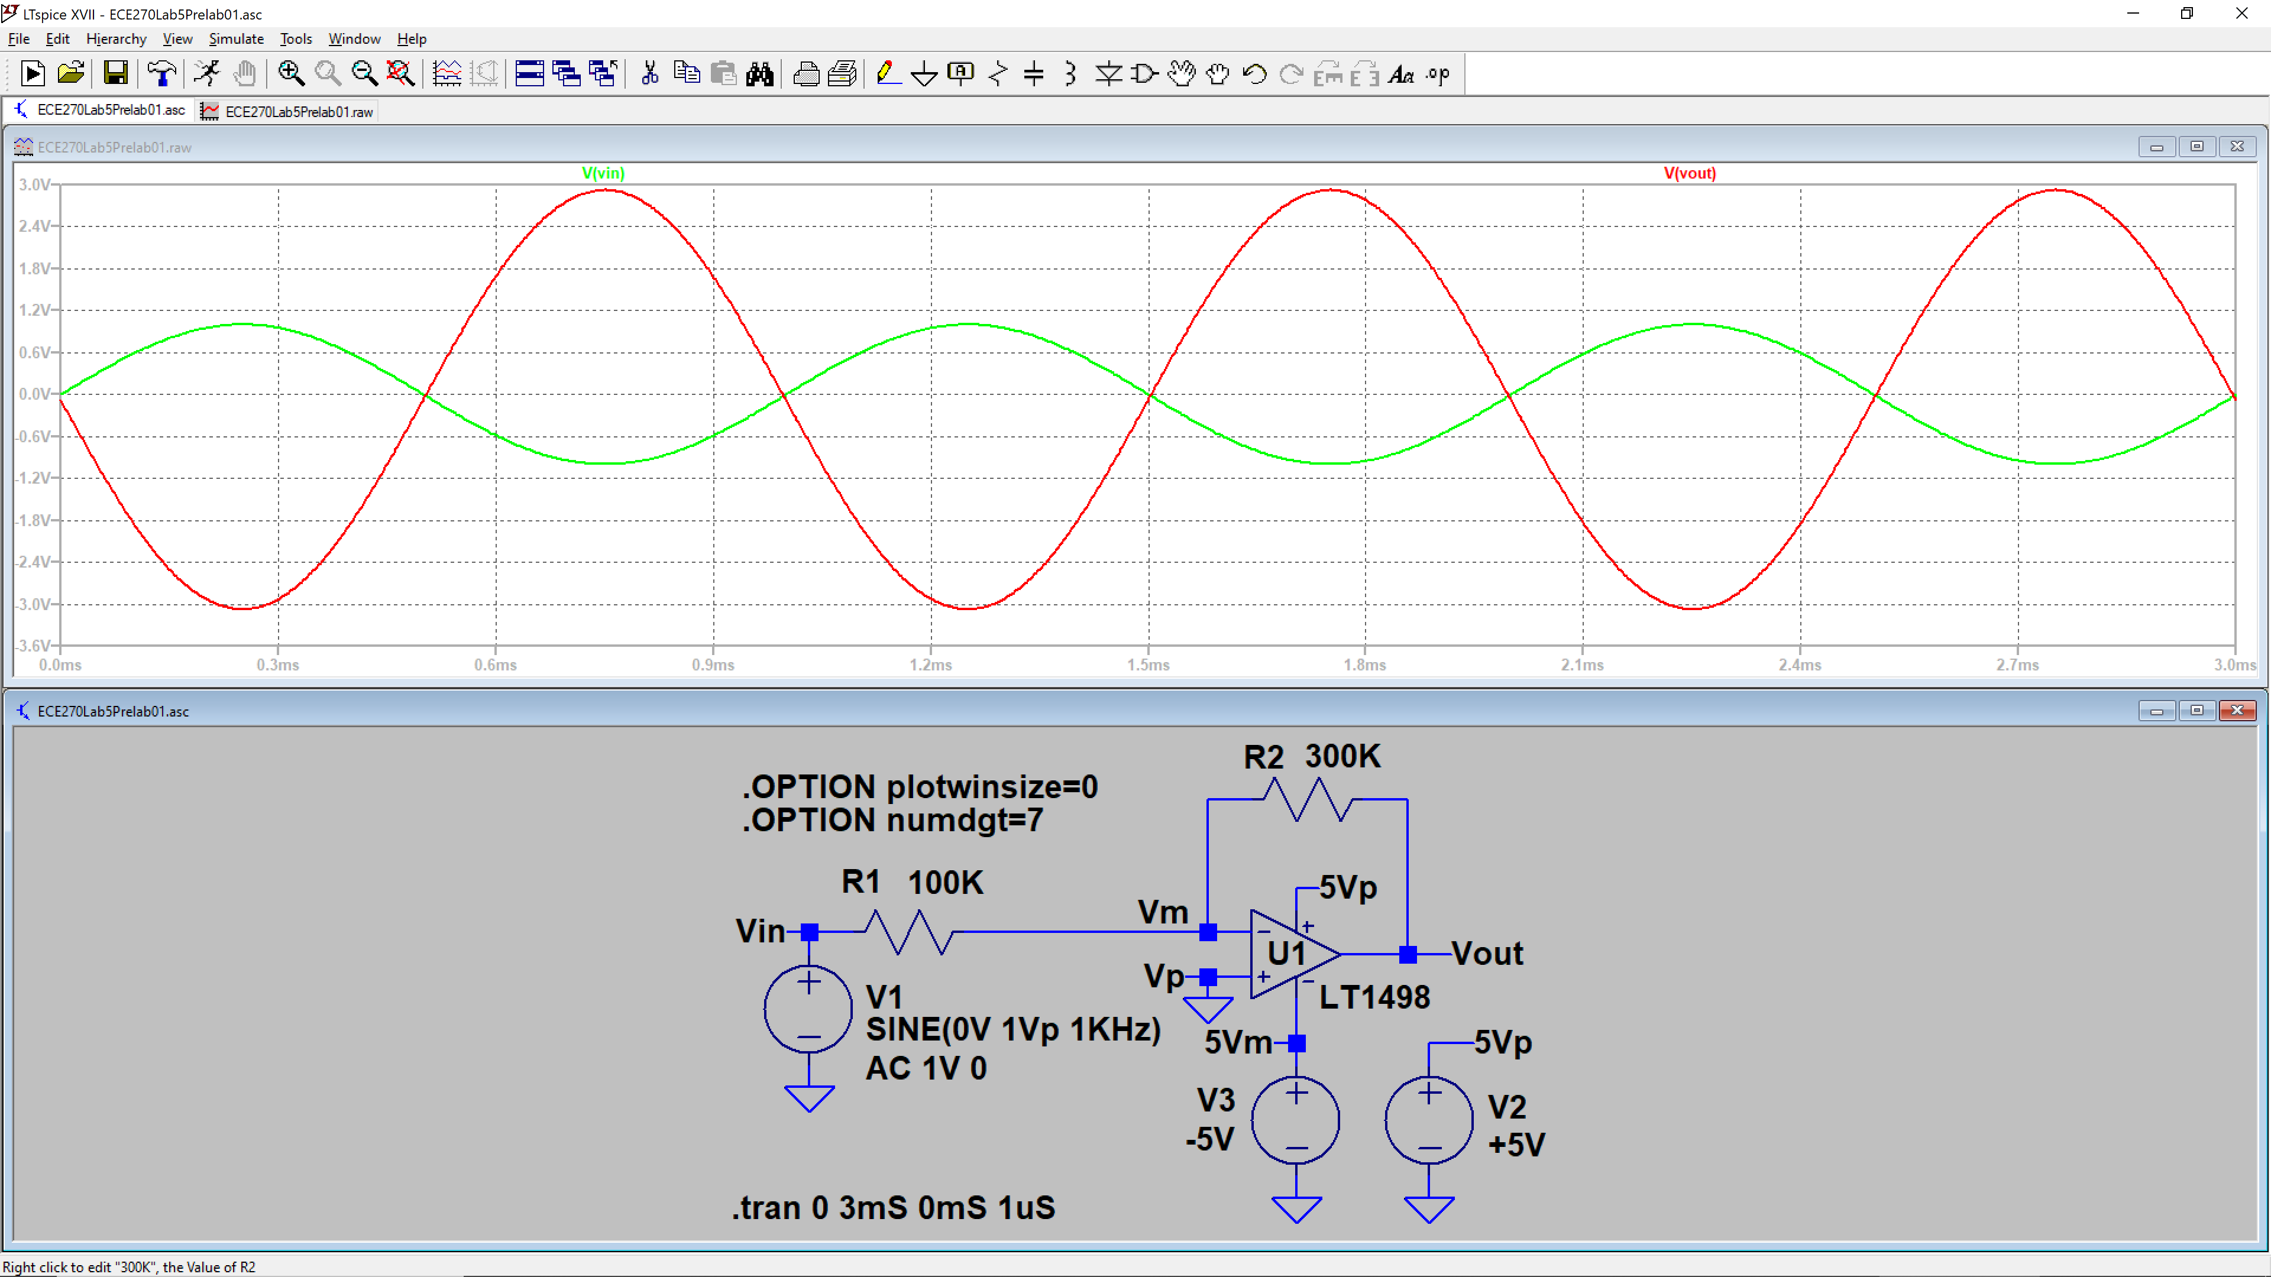

Figure 3. Inverting Op-Amp with gain simulation.

Another type of simulation run which is quite valuable is invoked by using the .AC command.

* Replace the .trans statement with .AC dec 50 10 10Meg
* Run the simulation.

This shows the amplitude verses frequency of the circuit nodes and currents you display.

Calculate the gain of the circuit in one of several ways.

Now determine the gain of the circuit. This should be fairly easy by comparing Vin+to Vo. Remember gain is Vo/Vin. There are several ways to make this measurement.

When using the .trans operation you can compare the peak to peak voltage amplitudes of Vo and Vin.

* You can eyeball the values.
* You can left click on the Vin label and use the cursor to get the positive and negative values of the voltage and repeating for Vo.
* You can left click near the top of Vin+ and while holding the mouse button down move to the bottom of the Vin curve. While still holding the mouse button down you can see the delta y in the lower left corner of the LTSpice window. Right click and choose Zoom to Fit (Ctl E) to restore the zoomed in curve that this operation will yield.
* There is a .MEAS command that can be used to get VPP and other things. You have to check on that one yourself if you want to use .MEAS.

When using the .AC operation you can use the dB amplitudes of Vout and Vin+.

* Compare the dB values of Vo and Vin using the following formula.
* For example with a Vin of 6dB and Vout of 16dB gives a gain of Vo – Vin+ or 16-6 = 10dB
* Remember to get back to a linear gain you have to take 10^(dBgain/20).

All of these work and some are more accurate than others.

Calculate the gain of the inverting amplifier used in Figure 1 theoretically. Compare this gain with the gain found from the simulation. You should find the gain from the simulation using one of the methods described just above.

Run the simulation using the .trans command. Plot V(last name), Vin, Vn, I(R1) and I (R2).

1. ***Include the LTSpice window in your dropbox document.***

**PART 2**

Now let us simulate the circuit with a high value of gain. Change the R1 value in Figure 1 to 100Ω. Now the gain = 3000 since R2 = 300K and R1 =100 and Gain = -R2/R1. Change the V1 sine wavee amplitude to 1mV.

The schematic should look like the one in Figure 2.

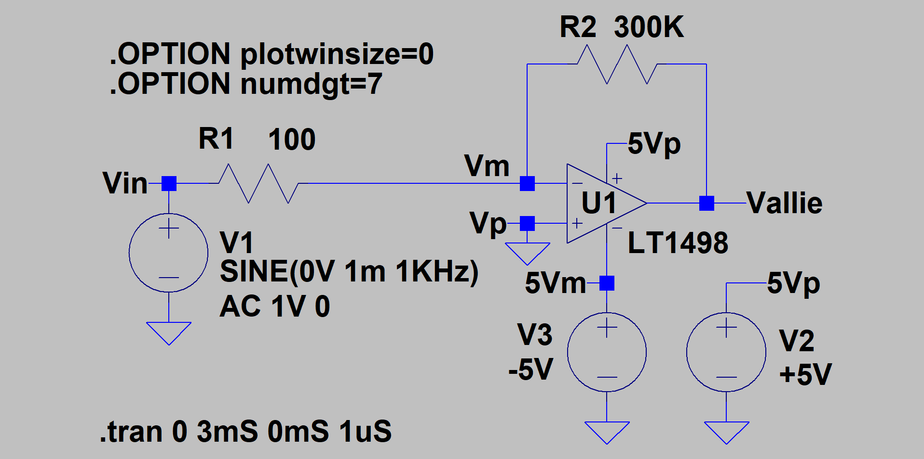

Figure 2 High gain inverting op-amp.

After making the all the changes re-run the simulator.

1. Calculate the gain of the inverting amplifier used in Figure 2 theoretically. Compare this gain with the gain found from the simulation. You could find the gain from the simulation by dividing the output voltage Vout by the input voltage Vin.
2. Does the simulation output look different from the previous plot? Comment on the R1[i] and R2[i[ currents , Vin, Vn and Vout .
3. Attach the screenshot of the simulation output. Remember your last name on the output voltage like before. The plot should contain the output voltage Vout, Vn, Vin+ and R1[i] and R2[I]. ***Include this plot in your dropbox document.***

Turn the plots document and answers to the questions into the drop box as your prelab assignment in pdf format if possible.