Software Engineering Group Project 02

Design Specification

|  |  |
| --- | --- |
| Authors: | Tom Clark [toc27] |
| Config Ref: | SE_QA05 |
| Date: | 21st March 2022 |
| Version: | 0.2 |
| Status: | Draft |

Department of Computer Science

Aberystwyth University

Aberystwyth

Ceredigion

SY23 3DB

Copyright © Aberystwyth University 2021

CONTENTS

CONTENTS 2

1. Introduction 3

1.1 Purpose of this Document 3

1.2 Scope 3

1.3 Objectives 3

2. OVERview of the website 4

2.1 Architectural overview 4

2.2 Page structure of the site 5

2.3 Mapping from requirements to pages 6

3. Details of each page 7

3.1 USER NEUTRAL 7

3.2 QUIZ MAINTAINER 10

3.3 QUIZ PARTICIPANT 21

4. Database Access 25

4.1 Description of the database 25

4.2 Database calls 25

REFERENCES 26

Appendices 27

DOCUMENT HISTORY 28

# Introduction

## Purpose of this Document

The purpose of this document is to provide a detailed overview of the web quiz solution we are developing in group 02.

## Scope

This document details the architecture and structure of the site and will take an in depth look at each web page as well as discuss database access.

Before reading any this document any further it should be noted that this document is to be read and used by members of group 02. It will be assumed that the reader is already familiar with the overview of the project and the functional requirements outlined in both **Group Project Overview** [1] and **WebQuiz Requirements Specification** [2].

## Objectives

The objective of this document is to both carry the template and explain a little of how it works.

# OVERview of the website

## Architectural overview

## Diagram Description automatically generatedPage structure of the site

## Mapping from requirements to pages

# Details of each page

The following is an overview of each page used within WebQuiz, detailing the page hierarchy, what calls are made when buttons are pressed and how databases are accessed and updated as required.

Some pages are not dependent on what type of account the user is using and do not contain any user-specific features. Other pages will depend on what type of account the user is logged in. All forms are documented under their own sub-section as such.

## USER NEUTRAL

### Homepage

The homepage is the first page the user will see when using the WebQuiz. As such, it is designed to be clean, easy to read and user neutral. First time users wishing to use the system as a Quiz Master or Quiz Maintainer **[2]** will need to click the register button on the navigation bar to be taken to **Registration [3.2.1]** first to create an account before any administrator features can be accessed. If the user already has an account, then they can click either the login button located at the bottom of the screen or the button on the navigation bar. Both buttons will take the user to the **Login [3.2.2]** form.

The navigation bar is persistent across all forms in WebQuiz and can be used to access other forms in the system at any time.

### Registration

The registration form is used to gather necessary data from the user to create an account. This includes an email address, a username and a password. The email address is used as the unique identifier when logging into an account, with the username being used to greet the user upon successfully logging in. The password must be confirmed for validation purposes. The user must enter valid data in each textbox before clicking the register button at the bottom to finalize. If the user has left any of the boxes blank then registration will not be completed and **EC1.0 [3]** will be triggered.

If all boxes are filled with valid details when the user clicks the register button below the textboxes, a new account will be created and added to the accounts database.

### Login

The login form requires the user to enter the login details used when creating an account during **Registration [3.2.1]**. When the user has filled in both boxes and clicks the login button, a call to the database will be made to verify the details provided and will be taken to a user-specific homepage when logged in, determined by what type of account is being used.

If the user enters invalid data when attempting to login then the user will trigger **EC1.1 [3]**. Similarly, if the user attempts to login without filling in both textboxes first, then **EC1.2 [3]** will occur.

## QUIZ MAINTAINER

### Graphical user interface Description automatically generatedHomepage

When the user has logged into an account they will be taken to the homepage, but this time it will be made to tailor to the needs of the user, altering what buttons the user has access to. This will be determined by the type of account the user has logged in with. In this case, a quiz maintainer account has been used. A custom greeting will also be displayed, using the username bound to the account.

When the user clicks the create quiz button below the greeting, they will be taken to the **Create Quiz [3.2.2]** form. Clicking the start quiz button on the navigation bar will take the user to the **Start Quiz [3.2.5]** form. If the quiz maintainer wishes to view the quizzes already created, then clicking the quizzes button along the navigation bar will take them to the **Display Quizzes [3.2.9]** form.

### Graphical user interface, application Description automatically generatedCreate Quiz

The initial create quiz form requires the quiz maintainer to enter a title and description for the quiz they are creating, both of which will be displayed to users in the **Quiz Lobby** **[TODO]**. The default time widget will alter the default time of each question on the **Create Question [3.2.3]** forms.

When the user has filled in both of the textboxes and is happy with the default time, the next button at the bottom of the form can be clicked to move on to the **Create Question [3.2.3]** form. If either textbox is left blank then **EC1.4 [3]** will trigger.

The details entered within each box will not be stored in the database until the whole quiz has been finalized (see **Quiz Preview [TODO]**) when the quiz will all be saved at once.

### Graphical user interface Description automatically generatedCreate Question

Multiple-Choice question creation

When the quiz maintainer has successfully filled in the initial details of the quiz and clicked the next button, they will be taken to the create question form. This form changes dynamically depending on the question type selected form the dropdown menu at the top of the form, and how many questions have been created so far. The quiz maintainer must fill in the “question” and “mark” boxes for every question regardless of the type.

If the multiple-choice option has been selected, a minimum of two possible answers must be given for the question. More possible answers will be added as needed, up to a maximum of four.

If the quiz maintainer has picked true or false from the dropdown menu, the “answers” checklist will be removed and replaced with an appropriate true or false button choice.

True-false question creation

An accompanying image can be uploaded to be displayed alongside the question; however, this is optional and will use a default image if no custom image is chosen.

Once the user has filled in all of the required details to a question, they can click next to added another question. The arrows by the side of the question number can be used to cycle between questions. Once the quiz maintiner has finished creating the quiz, they can click save to move on to the **Quiz Preview [3.2.4]** form. If any of the required details are missing when the user attempts to click either next or save then **EC1.5 [3]** will be triggered.

### Quiz Preview

Previewing a multiple-choice question

After the quiz maintainer has finished creating the quiz and clicked save, they will be brought to the quiz preview form. On this form, a preview of the quiz will be generated using the details that the user entered on the **Create Question [3.2.3]** form. This form is dynamic and will alter depending on whether a multiple choice question or a true or false question is being displayed.

The question is displayed above the image that the user uploaded to accompany the question. The question time is displayed at the top right alongside a delete button that the quiz maintainer can click to delete the question if needed. An edit button can be found at the top left of each question that can be clicked to return to the **Create Question [3.2.3]** form to alter the question. The quiz maintainer can use the page numbers or arrows along the bottom cycle between each question. The plus icon next to the arrows can be used to add another question to the quiz, alongside a floppy disk icon which is used to save the quiz once the quiz maintainer is happy with the quiz.

If the question being previewed is multiple-choice then answers A-D will be displayed below the image, with a tick next to each correct answer. When previewing a true or false question, the answers will be switched with two true or false buttons, with a tick next to the correct answer.

The quiz is only saved to the database once the user clicks the floppy disk icon. If the quiz maintainer closes the quiz at any point before finishing, the quiz will be lost. Any saved quizzes can be found on the **Display quizzes [3.2.9]** form.

Previewing a true-false question

### Start Quiz

The start quiz form will display all quizzes that are currently stored in the database, with the option to import more by clicking the import button located at the bottom of the list. This will open a dialogue that will allow the user to find the desired file and select it to import it into the system.

Quizzes descending by date

Using the dropdown menu located at the top of the form, the quiz maintainer can change how the list of quizzes is sorted. These options include:

* Ascending alphabetically
* Descending alphabetically
* Descending by date created

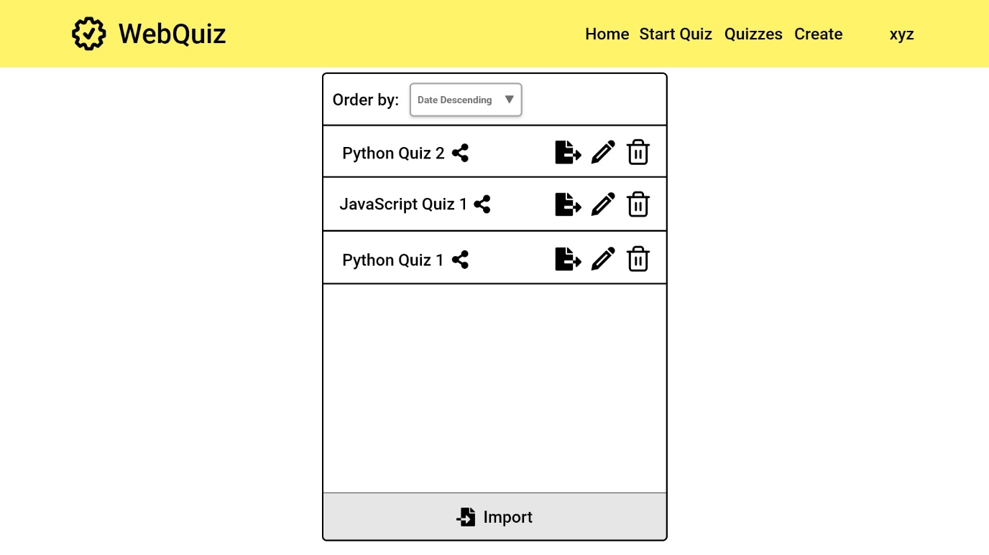Clicking the share icon next to the name of a quiz will open a dialogue containing the URL to send to quiz participants. The start button next to a quiz can be clicked to go to the **Quiz lobby [3.2.6]** form where both the quiz master and quiz participants will wait until the quiz has been started.

Quizzes after an import

### Quiz lobby

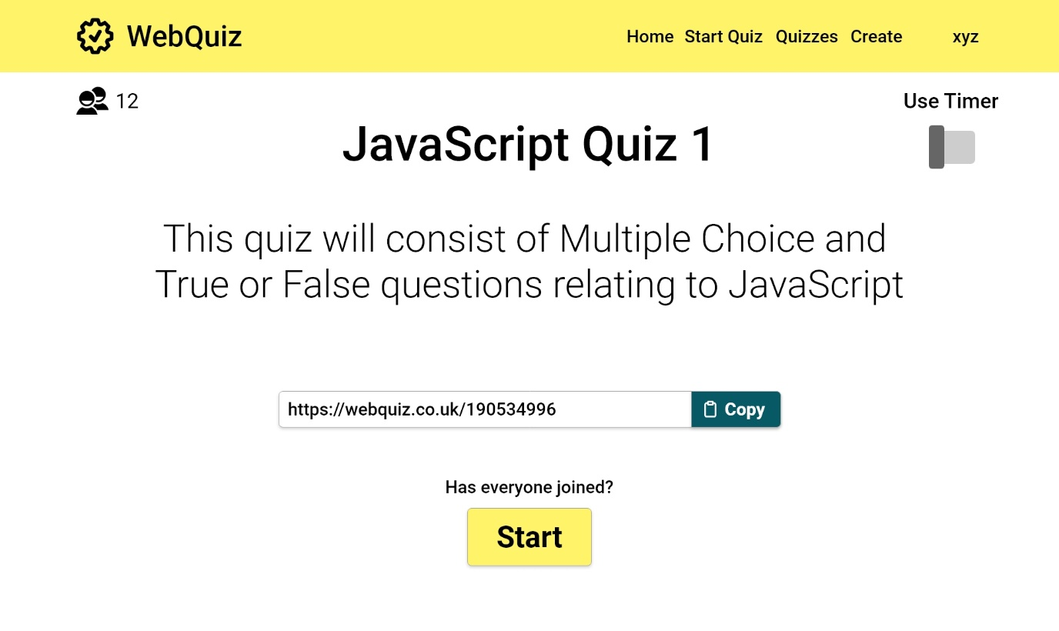The quiz lobby will display the title and description of the quiz at the top, along with a social icon at the top left to indicate how many quiz participants are currently waiting. The timer can be toggled using the switch at the top right of the form. A link to the quiz will be displayed in a textbox in the centre of the form with a copy button to automatically copy the link to the clipboard.

Once all the quiz master is ready to begin the quiz proper, the start button at the bottom of the form must be clicked.

If the user wishes to go back or move to another form, the navigation bar contains links to all forms detailed throughout previous sections.

### Quiz running

Once the quiz has been started, the question will be displayed along the top, with the question number located to it’s left. The time left on the question is found to the right of the question. The image is displayed in the centre, with the possible answers displayed to the quiz master below. This form is dynamic and will shift to accommodate the type of question being displayed.

The arrow below the answers can be used to override the timer and manually move on to the next question. The red end quiz button at the bottom of the form can be used to manually cancel the quiz early if needed. If the quiz is ended prematurely with the button, then the quiz master will be returned to the **Start quiz [3.2.5]** form.

### Display quizzes

The display quizzes form will display all quizzes that are currently stored in the database, with the option to import more by clicking the import button located at the bottom of the list. This will open a dialogue that will allow the user to find the desired file and select it to import it into the system.

Using the dropdown menu located at the top of the form, the quiz maintainer can change how the list of quizzes is sorted. These options include:

* Ascending alphabetically
* Descending alphabetically
* Descending by date created

Clicking the share icon next to the name of a quiz will open a dialogue containing the URL to send to quiz participants. The export button next to each quiz can be used to export a previously created quiz to later import. The pencil icon can be clicked to be taken to the **Create quiz [3.2.2]** form where they can edit the selected quiz. Clicking the bin icon next to any quiz will delete the quiz. The user will be greeted with a confirmation dialogue first.

## QUIZ PARTICIPANT

### Graphical user interface, text, application, email Description automatically generatedQuiz lobby

Using the URL generated by the quiz master on the **Quiz lobby [3.2.6]** form will take the quiz participant to the quiz lobby, where the quiz title and description will be displayed at the top along with a message below informing the participant that the quiz master is waiting to start the quiz.

The quiz participants cannot start the quiz and do not have access to the timer toggle or the participant count.

### Quiz running

When the quiz master has started the quiz, the quiz participants will be moved to the quiz form. The question will be displayed along the top, with the question number located to it’s left. The time left on the question is found to the right of the question. The image is displayed in the centre, with the possible answers displayed to the quiz participants below. This form is dynamic and will shift to accommodate the type of question being displayed.

Quiz running in question view

Clicking the switch to answer view button at the bottom will remove the image and the question and only display the possible answers.

Once the timer has run out or the quiz is ended early, the participant will be taken to the **Quiz marks [3.3.3]** form.

Quiz running the same question in answer view

Quiz running showing a true or false question in answer view

### Quiz marks

When the quiz has finished, regardless of whether the quiz was run to completion or ended early, this is the marking form the quiz participants will be greeted with.

The total marks value and score percentage are all calculated and displayed to the user. If the user wishes to continue using the WebQuiz then they can use the persistent navigation bar to return to any previously documented forms.

# Database Access

## Description of the database

## Database calls

REFERENCES

[1] Software Engineering Group Projects: Group Project Introduction and Guidelines C.W. Loftus. 2021 - 2022 Release

[2] Software Engineering Group Projects: WebQuiz Requirements Specification C.W. Loftus. SE.QA.RS-CS22220. 1.0 Release

[3] Software Engineering Group Projects: User Interface Specification Standards C.W. Loftus. SE.QA.04. 1.3 Release

Appendices

DOCUMENT HISTORY

| *Version* | *Issue No.* | *Date* | *Changes made to document* | *Changed by* |
| --- | --- | --- | --- | --- |
| 0.1 | N/A | 07/03/22 | N/A - original version | Toc27 |
| 0.2 | N/A | 21/03/22 | Started work on section 3; Added Oliver’s diagrams to the doc; Added Harry’s db schema | Toc27 |