Poster’s content

Project’s name: Visualising networks in the Bestiary: discovering author relationships in the meta-heuristics literature

Researcher: Harry Ngo (MSc. Applied Artificial Intelligence) 190206327@aston.ac.uk

Supervisors: Professor Aniko Ekart and Dr. Felipe Capelo

How can I tell the story about my project?

Introduction

“If there is one word to describe the society in the early 21st century, it surely must be connected” (National Research Council, 2006). Network appears everywhere and its applications exist in every aspects of life. This is the main driving force behind the formation of Network Science and it also evokes the curiosity for this project of Visualising the EC Bestiary.

- Đặt vấn đề

The Bestiary là một publicly repository tập hợp hundreds of metaphor-based contributions to the Swarm and Evolutionary Computation literature. Đây là thành quả of a team of international researchers coordinated by Dr Felipe Campelo, with the goal to catalog the exuberance of the meta-heuristic “eco-system”.

- Motivation

. The motivation of the project is to visualising the Bestiary’s author networks in a way that helps us understand better the knowledge flow and proliferation of these approaches.

- Đề xuất giải quyết

This project aims to illustrate the co-authorship relationships between authors from different articles and topics in the Bestiary. Furthermore, it also focuses on the application of Network science and Graph Theory in Co- authorship Network Analysis (a research branch of Social Network Analysis), providing intelligence on the academic community, authors, scientific collaboration and the Bestiary’ structure of Knowledge.

Methods and Implementation (Steps)

Processing Data:

Để giảm thiểu sự inconsistency giữa các ký tự viết hoa hay không viết hoa trong tên tác giả, sau khi trích xuất, các tên tác giả sẽ được chuyển về lowercase và sắp xếp theo cú pháp: Sirname. + Chữ cái đầu Firstname

Constructing Adjacency Matrix

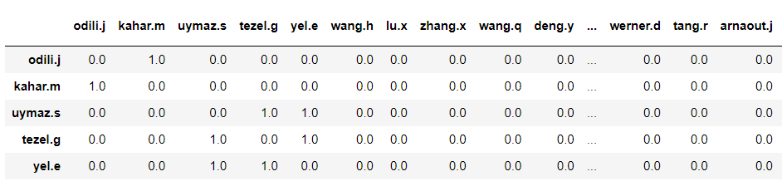

A graph/network can also be encoded as a Matrix. An Adjacency matrix of graph G is an n by n matrix holding the values of 0 and 1. If there is a connection between any two authors, it is coded as 1, and 0 otherwise and the weight values of these links will be increased by 1 every time mối liên hệ co-authorship giữa 2 tác giả được lặp lại.

Data visualization

This project sử dụng pyvis library in Python to create the visualization of the Bestiary

Results and Analysis

- Graphs: Illustration

2 layout + 1 Zoom out

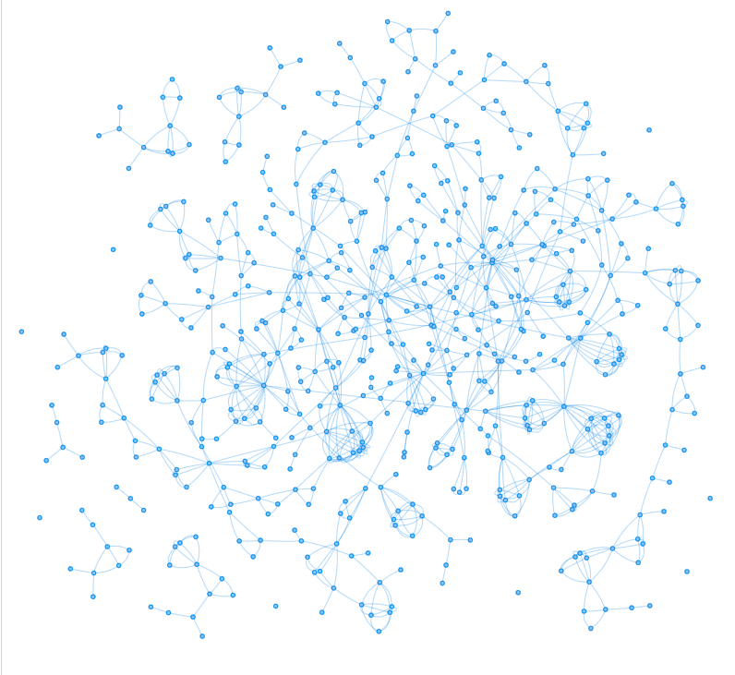

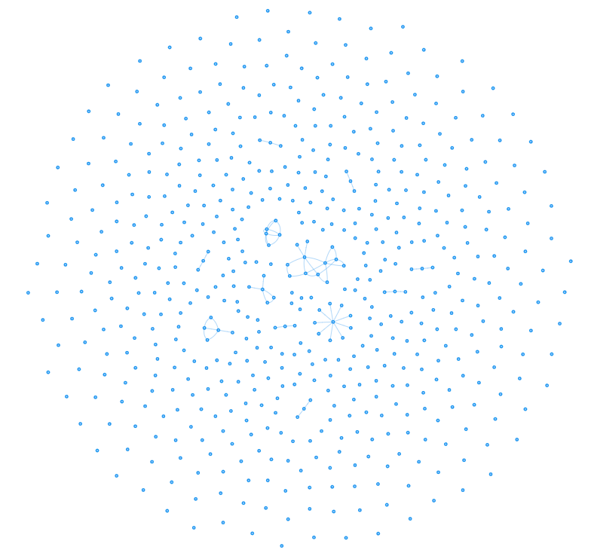

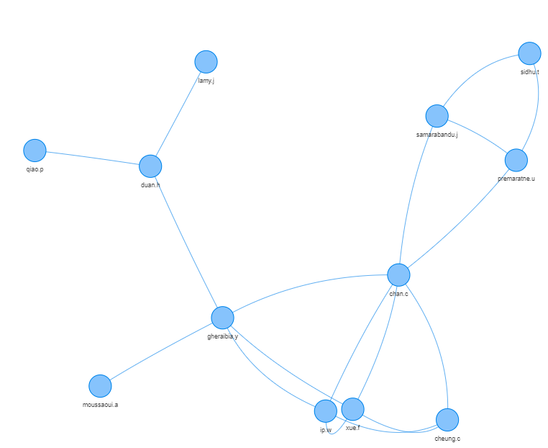

- Network indicators and implications

Who are the thought leaders and leading scholars in that field of study?

By analysing some of the network’s properties, we can find the answer for that question.

Network density: calculated by dividing the number of edges in the graph by the maximum number of edges (the case where every author is connected to each other in a Completed graph). It implies how well the authors is connected.

Degree centrality: The number of connections that an author (a node) has with other authors. The most collaborated scholar in the network is also the author with the highest degree of centrality.

Closeness Centrality focusing on how close an author is to all other authors. A high closeness centrality for an author indicates that he or she is connected to every other author via a small number of paths (8).

Betweenness centrality regulate the flow of information in the network. Authors with a high betweenness play the role of “middlemen” connecting diverse groups in the network (Otte and Rousseau, 2002).

Clustering coefficient: analyses the possibility whether two of a scientist's colleagues have co-authored a paper (Kılıç, Uyar and Koseoglu, 2019).

- Conclusion?

Co-authorship Network Analysis has been applied, with subjects being articles and authors' collaborations in various disciplinary areas.

Ref

1. Kılıç, M., Uyar, A. and Koseoglu, M. A. (2019) ‘Co-authorship Network Analysis in the Accounting Discipline’, *Australian Accounting Review*, 29(1), pp. 235–251. doi: 10.1111/auar.12271.

2. National Research Council (2006) *Network science*, *Network Science*. doi: 10.17226/11516.

3. Otte, E. and Rousseau, R. (2002) ‘Social network analysis: A powerful strategy, also for the information sciences’, *Journal of Information Science*, 28(6), pp. 441–453. doi: 10.1177/016555150202800601.