# **WDD 130: Web Fundamentals**

[**Home**](https://byui-cse.github.io/wdd130-ww-course/)[**W1**](https://byui-cse.github.io/wdd130-ww-course/week01/)[**W2**](https://byui-cse.github.io/wdd130-ww-course/week02/)[**W3**](https://byui-cse.github.io/wdd130-ww-course/week03/)[**W4**](https://byui-cse.github.io/wdd130-ww-course/week04/)[**W5**](https://byui-cse.github.io/wdd130-ww-course/week05/)[**W6**](https://byui-cse.github.io/wdd130-ww-course/week06/)[**W7**](https://byui-cse.github.io/wdd130-ww-course/week07/)

## CSS: Box Model

### Overview

The CSS Box Model is a box that wraps around every element. From the inside out, the model defines how the content, padding, border, and margin are rendered.

"When laying out a document, the browser's rendering engine represents each element as a rectangular box according to the standard CSS basic box model. CSS determines the size, position, and properties (color, background, border size, etc.) of these boxes." - MDN

### Prepare

* Video Demonstration: ▶️ [The Box Model](https://www.youtube.com/embed/Np1FuPKLb3E) | (5:19 mins, [Transcript](https://byui-wdd.github.io/wdd130/text/box_model.pdf))
* Read: [Box Sizing: Border Box](https://byui-cse.github.io/wdd130-ww-course/week02/add-box-sizing.html)

## CSS: Box Sizing and Border Box

The CSS property of **box-sizing** lets the developer control the dimensions, both width and height, of an HTML element.

"By default in the CSS box model, the width and height you assign to an element is applied only to the element's content box. If the element has any border or padding, this is then added to the width and height to arrive at the size of the box that's rendered on the screen. This means that when you set width and height, you have to adjust the value you give to allow for any border or padding that may be added."  
📑 [box-sizing](https://developer.mozilla.org/en-US/docs/Web/CSS/box-sizing) - MDN

Using the **border-box** value for **box-sizing** makes the browser include the element's **border** AND **padding** values in the width and height allocations. The content area will automatically shrink to account for this additions versus rendering using the default **content-box**, where the content equals the width or height set for the element.

### Example

Here is an example of a **div** element with a **border** and **padding** set. The **box-sizing** property is set to **border-box** so the width and height of the element will include the border and padding.

Here is a CSS rule for div elements that defines the width and box model. The content is 400 pixels wide and the height is driven by the actual (but not shown) content, whatever it happens to be.

div {

width: 400px;

margin: 10px;

border: 1px solid #000000;

padding: 15px;

background-color: #247247;

color: #ffffff;

}

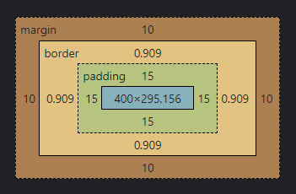

Now apply the box-sizing property of border-box to this same example.  
Note the difference in the content dimensions (blue shaded area):

div {

box-sizing: border-box;

width: 400px;

margin: 10px;

border: 1px solid #000000;

padding: 15px;

background-color: #247247;

color: #ffffff;

}

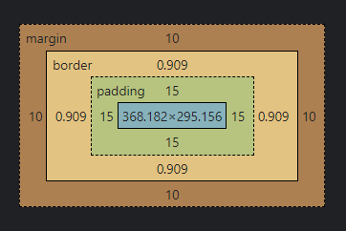

Some common 'reset' natured CSS declarations using the **universal selector** include setting the box-sizing to border-box in order for all elements to follow this method.

* {

margin: 0;

padding: 0;

box-sizing: border-box;

}

[**Back**](https://byui-cse.github.io/wdd130-ww-course/week02/index.html)[**I-Learn**](https://byui.instructure.com/calendar/)

#### The CSS Box Model

The box model can be applied to HTML elements that are block-level, table, or inline-block.

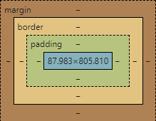

* Content: This is where the text and images appear.
* Padding: This is the area around the content and separates the content from the border.
* Border: The border goes around the padding and separates the padding from the margin.
* Margin: This the the area outside of the border and can extend beyond the physical characters of the box model.

#### CSS Shorthand Notation

CSS shorthand notation is generally considered best practice for conciseness, readability, and performance. However, longhand notation has its uses and can be more appropriate in certain situations where specificity is needed.

|  |  |
| --- | --- |
| **Summary: CSS Shorthand Declarations using the margin property** | |
| **Longhand** | **Shorthand** |
| margin-top: 10px;  margin-right: 20px;  margin-bottom: 30px;  margin-left: 40px; | margin: 10px 20px 30px 40px; |
| margin-top: 10px;  margin-right: 20px;  margin-bottom 30px;  margin-left: 20px; | margin: 10px 20px 30px;  The right and left margins are the same at 20 pixels. |
| margin-top: 10px;  margin-right: 20px;  margin-bottom 10px;  margin-left: 20px; | margin: 10px 20px;  The top and bottom are the same (10 pixels) and right and left margins are the same (20 pixels). |
| margin-top: 10px;  margin-right: 10px;  margin-bottom 10px;  margin-left: 10px; | margin: 10px;  All sides of the margin are the same 10 pixels. |

|  |
| --- |
| **Common Border Shorthand** |
| border: 1px solid rgb(0 0 0 / .1);  This applies a 1 pixel border around the element with a solid line and a color that match the background of the containing/parent element. The color is set to 10% opacity. |

### Activity Instructions

#### File Setup

1. In the **week02** folder, create a file named "**box-model.html**".
2. Add a folder named **styles** and put a CSS file named "**box-model.css**" in that folder.

At this point in the course, setting up the folders and files to complete activities and assignments should be a common task where you need little direction.

#### HTML

1. Link to the CSS in your HTML document using the **<link>** tag.  
   Make sure this link element is located within the **<head>** section.Check Your Understanding

<link rel="stylesheet" href="styles/box-model.css">

1. Copy the HTML from the HTML section of the following CodePen into your **box-model.html** file.  
   You will have to add the minimum HTML outer structure to make this work. [CodePen - Box Model Start](https://codepen.io/blazzard-jason/pen/qByVMpK)

#### CSS

1. Now copy the CSS selectors from the CSS section of the given CodePen into **box-model.css** file.
2. Use the CSS selectors to style the HTML elements to match the image below using box model concepts for the .callout class, img, blockquote, and cite elements. The following summary of declarations is your guide:

|  |  |
| --- | --- |
| **Element** | **Required CSS Declarations** |
| callout class | maximum width, margin, border, padding, background color, and text color |
| image | position (float), margin, border, padding, background color, width, height |
| blockquote | margin |
| cite | display, top border, top padding, text alignment, size of font |

1. 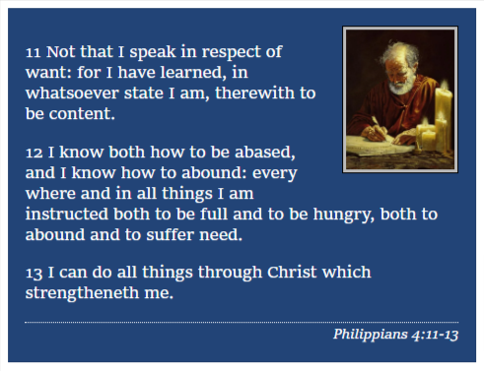Screenshot of Example Solution

Check Your Understanding

CodePen - [Box Model Activity - Example Solution](https://codepen.io/blazzard-jason/pen/wvxPExK)

Did you notice the semantic HTML used to encase the actual scripture and scripture reference?  
**<blockquote>** was used versus a **<div>** or **<p>** and the reference was encased with a **<cite>** element. There is nothing special about these elements except their semantic names and maybe, default styling by the browser. Otherwise they behave and look like any other element.

Do not worry if you did not use these in your design. Refactoring work as you discover new elements and methods is part of the overall development process.

#### Optional Solution Discussion

* Video Demonstration: ▶️ [Activity Walkthrough](https://video.byui.edu/media/t/1_z86dcjad) | (20:00 mins)

### Testing

1. Test your page in your local browser using Live Server.
2. You can commit and sync up your work to your **wdd130** GitHub Pages enabled repository so that others may review your work, especially if you have questions. Post your link on Microsoft Teams.

#### Optional Resources

* [An Introduction to the CSS Box Model](https://developer.mozilla.org/en-US/docs/Web/CSS/CSS_Box_Model/Introduction_to_the_CSS_box_model) - MDN

[**Back**](https://byui-cse.github.io/wdd130-ww-course/week02/index.html)[**I-Learn**](https://byui.instructure.com/calendar/)

Check Your Understanding

CodePen - [Box Model Activity - Example Solution](https://codepen.io/blazzard-jason/pen/wvxPExK)

<main>

<div class="callout">

<img src="https://churchofjesuschrist.org/imgs/0d9965bac82711eda736eeeeac1e6a3620d4c7dc/full/500%2C/0/default" alt="Paul the Apostle" width="150" height="150">

<blockquote>

<p>11 Not that I speak in respect of want: for I have learned, in whatsoever state I am, therewith to be content.</p>

<p>12 I know both how to be abased, and I know how to abound: every where and in all things I am instructed both to be full and to be hungry, both to abound and to suffer need.</p>

<p>13 I can do all things through Christ which strengtheneth me.</p>

</blockquote>

<cite>Philippians 4:11-13</cite>

</div>

</main>

.callout {

max-width: 400px;

margin: 10px;

border: 1px solid rgba(0,0,0,.1);

padding: 15px;

background-color: #247;

color: #fff;

}

.callout img {

float: right;

margin: 0 0 10px 15px;

border: 1px solid #000;

padding: 3px;

background-color: #bbb;

width: 100px;

height: auto;

}

blockquote {

margin: 0;

}

cite {

display: block;

border-top: 1px dotted #fff;

padding-top: 3px;

text-align: right;

font-size: smaller;

}