**W02 Learning Activities**

* **Срок** 16 Янв в 23:59

* **Баллы** 10

* **Вопросы** 10

* **Доступно** до 30 Янв в 23:59

* **Ограничение времени** Нет

* **Разрешенные попытки** 3

**Инструкции**

* Complete [W02 Learning ActivitiesLinks to an external site.](https://byui-cse.github.io/wdd130-ww-course/week02/) and then return to this quiz to report on your work.
  + The quiz is open note, application, and internet.
  + Your latest score will be recorded into the gradebook.

Эта контрольная работа была заблокирована 30 Янв в 23:59.

История попыток

|  | **Попытка** | **Время** | **Оценка** |
| --- | --- | --- | --- |
| **ПОСЛЕДНЯЯ** | [Попытка 1](https://byupw.instructure.com/courses/3251/quizzes/18636/history?version=1) | 97 минут(ы) | 10 из 10 |

 Правильные ответы скрыты.

Оценка за эту попытку: **10** из 10

Отправлено 11 Янв в 17:00

Эта попытка длилась 97 минут(ы).

**Вопрос 1**

**1 / 1 балла (-ов)**

A fellow student reports that the audit tool on his Holy Grail learning activity report marks his **<header>** element as incomplete ❌.

Which of the following piences of advice should you give?



You must including a heading using the h1 element.



Make sure you use a header element with an start tag of <div id="header"> and end tag of </div>.



Make sure you use a head element with an start tag of <head> and end tag of </head>.



Make sure you use a semantic header element with an start tag of <header> and end tag of </header>.

**Вопрос 2**

**1 / 1 балла (-ов)**

The CSS box model refers to the conceptual, rectangular area that exists on HTML elements.  
The box model has four, basic components listed below.  
Match each component to its correct label given the image below.

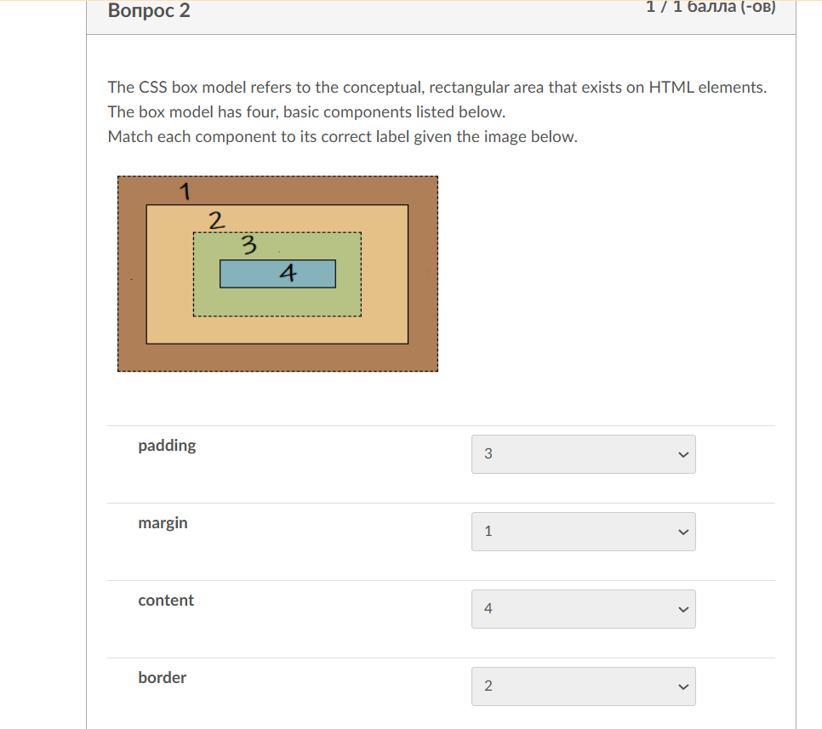

**padding**



**margin**



**content**



**border**



**Вопрос 3**

**1 / 1 балла (-ов)**

Which of the following uses the correct CSS element selector syntax for a CSS declaration?



pic { padding: 1em; border: 1px solid black; }



image { padding: 1em; border: 1px solid black; }



img { padding: 1em; border: 1px solid black; }



pict { padding: 1em; border: 1px solid black; }

**Вопрос 4**

**1 / 1 балла (-ов)**

In CSS, an element's width is calculated differently depending on the box-sizing property. With the default content-box value, padding and borders are added to the content width. If an element has:

* width: 100px;
* padding: 10px;
* border: 1px solid black;

What is the total width of the element? (Ignore margins for this calculation.)



122 pixels



Cannot be determined



100 pixels



154 pixels

**Вопрос 5**

**1 / 1 балла (-ов)**

Given a hexadecimal (base16) color value of #00AA9A, what value is the **Blue**color amount in HEX?



**Вопрос 6**

**1 / 1 балла (-ов)**

Given the following CSS, what is this entire code snippet called?

nav {  
 background-color: steelblue;  
 padding: 10px;  
}



A CSS Property



A CSS Unit



A CSS Rule



A CSS Declaration

**Вопрос 7**

**1 / 1 балла (-ов)**

A fellow student reports that the audit tool at the end of the Holy Grail learning activity does **NOT**return a report.  
This student indicates that they have a working GitHub Pages enabled repository named https://xavierrod.github.io/wdd130 and that the file was named "Holygrail.html" and that is was located in the wdd130, root folder.  
What advice would you give this student? Check all that apply.



Be sure that you are only entering in your GitHub username into the page evaluation tool.



A subfolder named "week02" was required within the wdd130 and the file needs to be located within that subfolder.



The file for this activity required you to name it "holygrail.html".



The domain for GitHub Pages content is actually github.com.



Everything seems to be in order. The error is with the page evaluation tool. Contact the instructor.

**Вопрос 8**

**1 / 1 балла (-ов)**

Given the following learning activity CodePen example: [Block vs. Inline ElementsLinks to an external site.](https://codepen.io/blazzard-jason/pen/dyjOaLB), what happens to the appearance of the rendered output when you switch the labeled 1️⃣ paragraph **<p>** element to a divider **<div>** element?



Nothing changes in the layout. Only the background color changes to #eeeeee.



The paragraph moves to the place right after the containing divider and the background color remains the same.



You are not allowed to change the HTML markup in CodePen.



The element layout changes from a block to inline. In addition, the background color changes.

**Вопрос 9**

**1 / 1 балла (-ов)**

You wish to run the **Web Developer** HTML validation service tool on your web page which you have launched in your local browser using **Live Server** in Visual Studio Code.  
However, when you click **Tools->Validate HTML**, it does not work and returns an error saying, "Sorry! This document cannot be checked."  
What should you do?



You need to change the security settings on your operating system to allow local asset checks using third-party validation services.



You just need to run the Web Developer tool again because the page is running locally and the service needs to restart.



You actually cannot use the Web Developer browser extension until your page is loaded on GitHub Pages, which is public.



In the Web Developer tool, use Tools->Validate Local HTML because the service will not check non-public addresses such as your localhost (127.0.0.1)

**Вопрос 10**

**1 / 1 балла (-ов)**

Given the following **CSS**, what is the line padding: 10px called?

nav {  
 background-color: steelblue;  
 padding: 10px;  
}



Unit



Property



Rule



Declaration

Оценка контрольной работы: **10** из 10