**W03 Learning Activities**

* **Срок** 23 Янв в 23:59

* **Баллы** 10

* **Вопросы** 10

* **Доступно** до 6 Фев в 23:59

* **Ограничение времени** Нет

* **Разрешенные попытки** 3

**Инструкции**

* **Complete** the [W03 Learning ActivitiesLinks to an external site.](https://byui-cse.github.io/wdd130-ww-course/week03) and then return to this quiz to check your understanding.
  + The quiz is open note, application, and internet.
  + Your latest score will be recorded into the gradebook.

Эта контрольная работа была заблокирована 6 Фев в 23:59.

История попыток

|  | **Попытка** | **Время** | **Оценка** |
| --- | --- | --- | --- |
| **ПОСЛЕДНЯЯ** | [Попытка 1](https://byupw.instructure.com/courses/3251/quizzes/18630/history?version=1) | 54 минут(ы) | 10 из 10 |

 Правильные ответы скрыты.

Оценка за эту попытку: **10** из 10

Отправлено 11 Янв в 18:42

Эта попытка длилась 54 минут(ы).

**Вопрос 1**

**1 / 1 балла (-ов)**

Which of the following statements correctly makes the following text an HTML markup **comment?**

Dev Note: Add the banner ad here



<!-- Dev Note: Add the banner ad here -->



<? Dev Note: Add the banner ad here ?>



<% Dev Note: Add the banner ad here %>



<// Dev Note: Add the banner ad here />

**Вопрос 2**

**1 / 1 балла (-ов)**

Which of the following answers correctly comments the font-size declaration in this CSS rule for the h1 element?

h1 {  
 color: #999BBB;  
 font-size: larger;  
 margin: 10px;  
 border: 1px solid rgba(0, 0, 0, .1);  
 padding: 10px;  
}



/* font-size: larger; */



// font-size: larger;



<? font-size: larger; ?>



<!-- font-size: larger; -->

**Вопрос 3**

**1 / 1 балла (-ов)**

A student posts a question about an HTML validation error she is receiving on this line of code which is meant to assign multiple classes to an element:

<div class="callout, larger, reference">

What should be your advice?



The correct syntax is <div class="callout: larger: reference">.



You cannot assign multiply classes to an element.



The correct syntax is <div class="callout" class="larger" class="reference">.



The validator issue can be ignored as this is correct syntax for assigning multiply classes to an element.



The correct syntax is <div class="callout larger reference">.

**Вопрос 4**

**1 / 1 балла (-ов)**

Which of the following is the correct syntax to create a CSS Rule for the **universal selector**?



# { ... }



* { ... }



html { ... }



body { ... }



! { ... }

**Вопрос 5**

**1 / 1 балла (-ов)**

Add a class named "active" to the following list item <li>?

<li><a href="products.html" title="Products We Sell Currently!">Products</a></li>

***You only need to include the start tag in your answer.***



**Вопрос 6**

**1 / 1 балла (-ов)**

Given this ⚙️CodePen: [Float Layout and ClearLinks to an external site.](https://codepen.io/blazzard-jason/pen/jMpbRN) from the learning activity, what declaration causes the footer to resume the normal flow of the page and forces the footer to appear below the floated image found in the previous, sibling div element?



clear: both;



position: absolute;



float: right;



float: left;

**Вопрос 7**

**1 / 1 балла (-ов)**

One way we can overlay text onto a parent container and sibling elements is to use absolute positioning.   
Here is an example where the text "The Teachings of Jesus Christ" overlays the

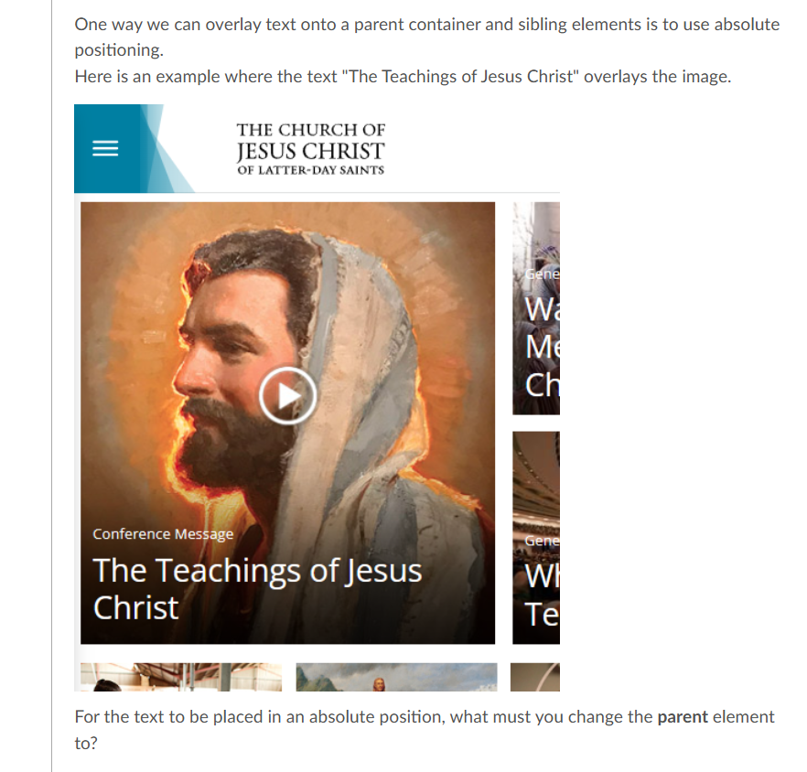

For the text to be placed in an absolute position, what must you change the **parent**element to?



position: relative;



display: block;



position: absolute;



overlay: true;

**Вопрос 8**

**1 / 1 балла (-ов)**

Write the first part of a CSS rule (the CSS selector) that selects all the article elements on a page.  
*You only need to write the first line of the rule and include the opening  {*



**Вопрос 9**

**1 / 1 балла (-ов)**

Given the following file and folder structure diagram, write the correct **img src attribute value** that points to the ***heroimage.png*** file.

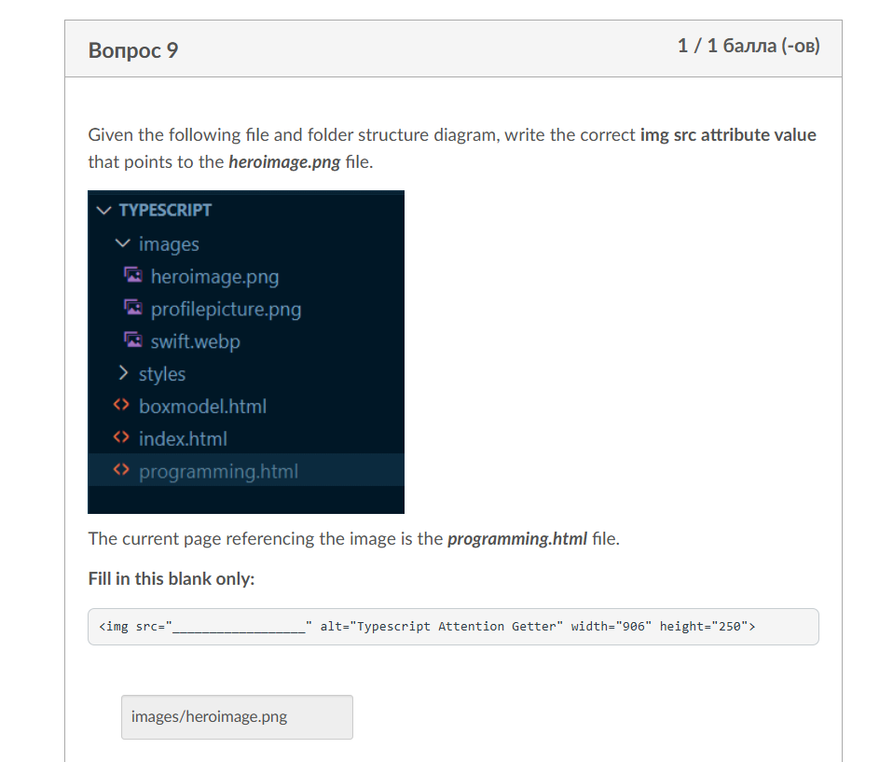

The current page referencing the image is the ***programming.html*** file.

**Fill in this blank only:**

<img src="__________________" alt="Typescript Attention Getter" width="906" height="250">



**Вопрос 10**

**1 / 1 балла (-ов)**

A student posts on MS Teams that the image on his page will not show up when he uploads his work to his GitHub Pages wdd130 repository.  
He has verified that the image file exists, the HTML file has been updated, and that it has been more than 15 minutes since he has last pushed with the changes.  
He does not know what is wrong given that the image shows up when he is using Live Server and viewing the page on his local computer.

What advice would you give him? Select all that apply.



You must wait at least one hour before updates are live on GitHub Pages.



GitHub Pages does not serve up all image file types for the web. Change the file type and try again.



Check the file name against the file name reference. Remember that case matters.



Check the src path of the img element. You cannot use root element references given that the root is different when posting to a subfolder on your GitHub account.

Оценка контрольной работы: **10** из 10