**W04 Learning Activities**

* **Срок** 30 Янв в 23:59

* **Баллы** 10

* **Вопросы** 10

* **Доступно** до 13 Фев в 23:59

* **Ограничение времени** Нет

* **Разрешенные попытки** 3

**Инструкции**

* **Complete** the [W04 Learning Activities](https://byui-cse.github.io/wdd130-ww-course/week04/) and then return to this quiz to report on your work and check your understanding.
  + The quiz is open note, application, and internet.
  + Your latest score will be recorded into the gradebook.

Эта контрольная работа была заблокирована 13 Фев в 23:59.

История попыток

|  | **Попытка** | **Время** | **Оценка** |
| --- | --- | --- | --- |
| **СОХРАНЕННАЯ** | [Попытка 3](https://byupw.instructure.com/courses/3251/quizzes/18642/history?version=3) | 7 минут(ы) | 10 из 10 |
| **ПОСЛЕДНЯЯ** | [Попытка 3](https://byupw.instructure.com/courses/3251/quizzes/18642/history?version=3) | 7 минут(ы) | 10 из 10 |
|  | [Попытка 2](https://byupw.instructure.com/courses/3251/quizzes/18642/history?version=2) | 9 минут(ы) | 8 из 10 |
|  | [Попытка 1](https://byupw.instructure.com/courses/3251/quizzes/18642/history?version=1) | 766 минут(ы) | 9 из 10 |

 Правильные ответы скрыты.

Оценка за эту попытку: **10** из 10

Отправлено 27 Янв в 19:03

Эта попытка длилась 7 минут(ы).

**Вопрос 1**

**1 / 1 балла (-ов)**

I completed all the levels in the Flexbox Froggy tutorial in the CSS Layout: Flexbox learning activity.



True



False

**Вопрос 2**

**1 / 1 балла (-ов)**

I completed all the levels in the Grid Garden tutorial in the CSS Layout: Grid learning activity.



True



False

**Вопрос 3**

**1 / 1 балла (-ов)**

A fellow student has a question about his flex box container. He has the flexbox items spaced as shown here:

He wants the flexbox items to be spaced as shown here is the second figure:

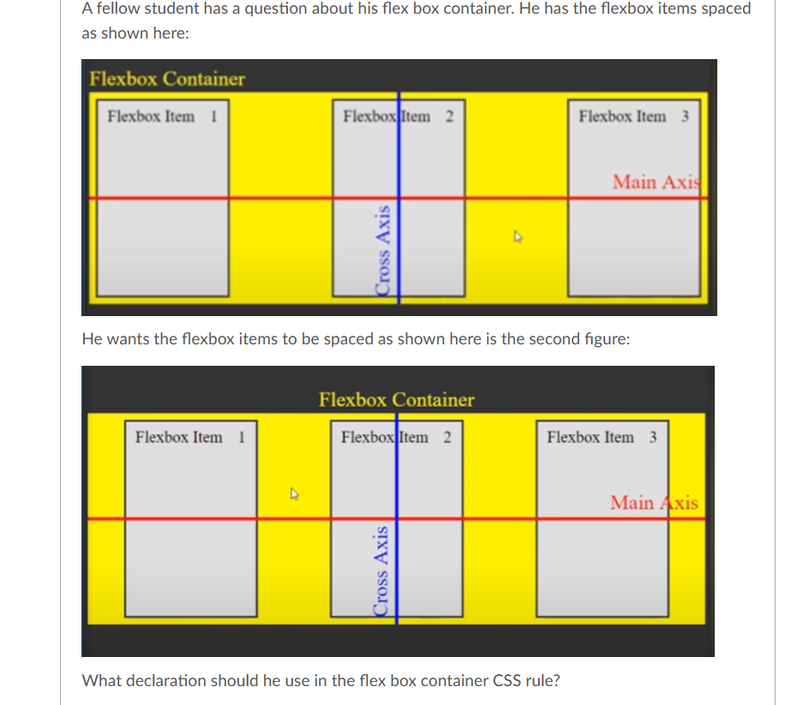

What declaration should he use in the flex box container CSS rule?



justify-content: middle;



align-items: center;



justify-content: center;



justify-content: space-around;



align-content: middle;

**Вопрос 4**

**1 / 1 балла (-ов)**

The text content in the following HTML ***div***with a class of ***centering***needs to be centered within the colored element.

➡️

The declarations for the centering class selector are set to center the content in the middle of the block, but these alone do **not**work.

.centering {  
 align-items: center;  
 justify-content: center;  
}

Which of the following additional declarations in the centering rule would achieve the desired centering in the middle of the colored element?  
**Select all that apply.**

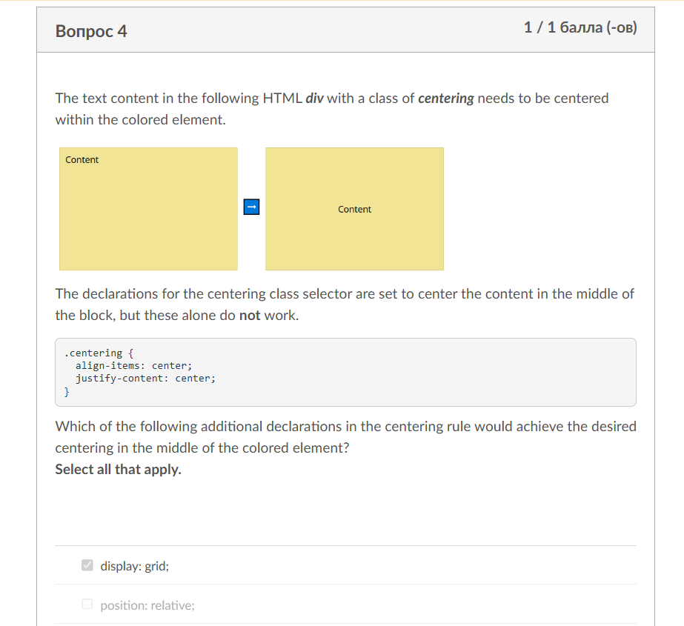



display: grid;



position: relative;



position: absolute;



display: block;



display: flex;

**Вопрос 5**

**1 / 1 балла (-ов)**

Given the following CSS grid driven layout using three templated columns, what declaration should be given to the last grid item labeled "10" CSS rule in order for it to span all three columns?

 ➡️ 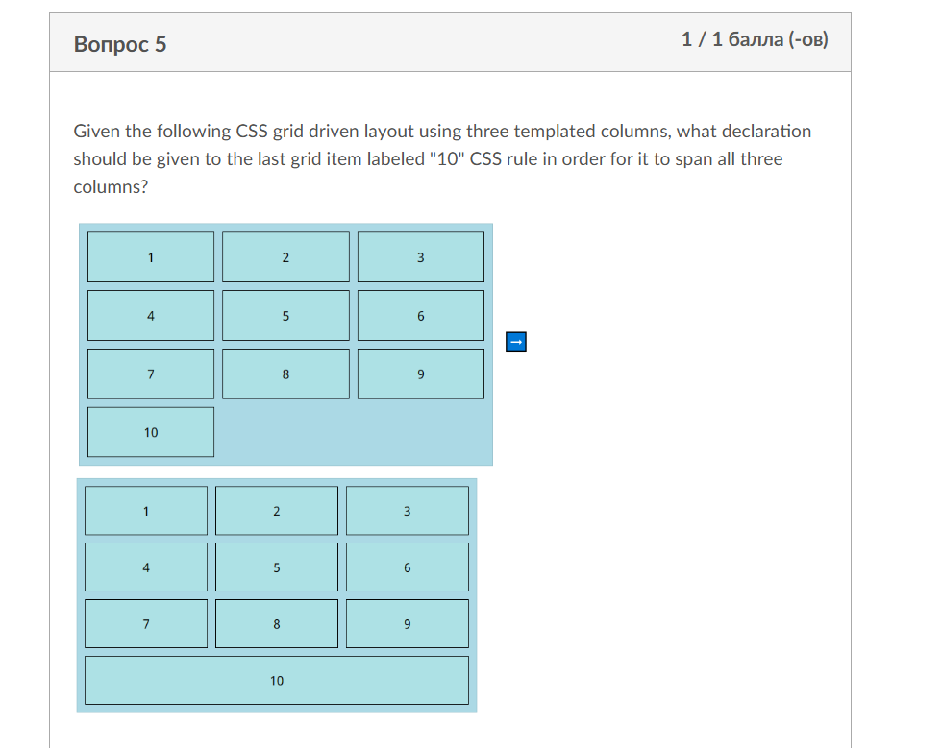



grid-column: 1/4;



grid-template-columns: 1/3;



grid-template-columns: 3;



grid-column: 3;



grid-column: 1/3;

**Вопрос 6**

**1 / 1 балла (-ов)**

Which CSS unit represents one fraction of the available space in the grid container to flexibly size grid rows and columns?



vh



fr



%



ex



em

**Вопрос 7**

**1 / 1 балла (-ов)**

In the [Grid GardenLinks to an external site.](https://cssgridgarden.com/) activity, Level 19, what**CSS declaration** was used in the .poison rule to solve the alternating problems?



**Вопрос 8**

**1 / 1 балла (-ов)**

A student is trying to complete a layout where the columns are automatically filling up a CSS grid containers screen space. The intent is to repeat the grid items within the container to fit the screen limiting their size to 150 pixels at a minimum and 1 equally fractioned unit at a maximum. The student is stuck setting up the declaration.

Here is the student's CSS rule for the container:

.container {  
 display: grid;  
 grid-template-columns: repeat(autofill, minmax(150px, 1fr));  
 gap: 10px;  
}

What should be your advice to this student?



Setting the grid-template-rows declaration for a grid is required.



The correct keyword is auto-fill.



You cannout use minmax keyword to size columns.



You must indicate the number of columns to create, not just two.

**Вопрос 9**

**1 / 1 балла (-ов)**

Given the following background and foreground (text) pairs of named colors, which pair **passes the color contrast, accessibility test**? (**green level** 4.5+ WCAG 2.1)  
It is recommended that you use a tool like the [color contrast comparison tool.Links to an external site.](https://contrast-ratio.com/)

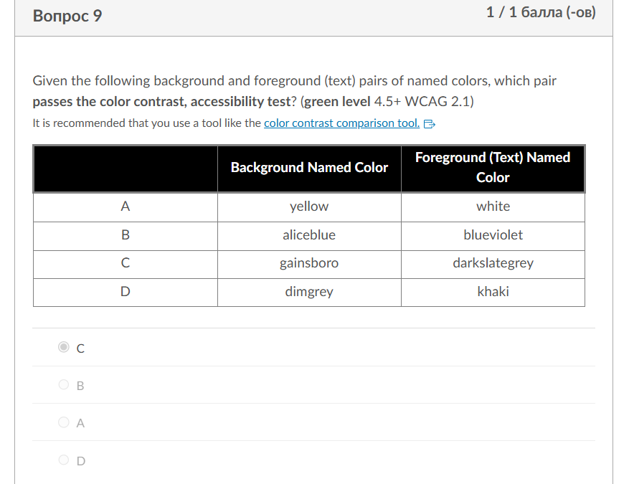

|  | **Background Named Color** | **Foreground (Text) Named Color** |
| --- | --- | --- |
| A | yellow | white |
| B | aliceblue | blueviolet |
| C | gainsboro | darkslategrey |
| D | dimgrey | khaki |



C



B



A



D

**Вопрос 10**

**1 / 1 балла (-ов)**

You wish to run the **Web Developer** HTML validation service tool on your web page which you have launched in your local browser using **Live Server** in Visual Studio Code.  
However, when you click **Tools->Validate HTML**, it does not work and returns an error saying, "Sorry! This document cannot be checked."  
What should you do?



You actually cannot use the Web Developer browser extension until your page is loaded on GitHub Pages, which is public.



You just need to run the Web Developer tool again because the page is running locally and the service needs to restart.



You need to change the security settings on your operating system to allow local asset checks using third-party validation services.



In the Web Developer tool, use Tools->Validate Local HTML because the service will not check non-public addresses such as your localhost (127.0.0.1)

Оценка контрольной работы: **10** из 10