**Whitewater Rafting Site Plan**

Purpose

To create an immersive and user-friendly online platform that showcases the thrill of whitewater rafting, while providing a seamless experience for customers to plan and book their adventures. The main message is that rafting is a fun activity and to come and experience it for yourself and bring your family.

Goals

• **Increase Online Visibility**: Establish a strong web presence to attract new customers and increase brand awareness.

• **Showcase Adventures**: Highlight the excitement and beauty of whitewater rafting through engaging visuals, videos, and testimonials.

• **Provide Essential Information**: Offer clear and concise details on trips, pricing, safety guidelines, and company policies.

• **Build Community**: Foster a sense of community among customers and guides through social media integration and customer reviews.

**• Drive Sales**: Convert website visitors into paying customers through targeted promotions, special offers, and loyalty programs.

Target Audience

• **Demographics**: Adventure-seekers, outdoor enthusiasts, and nature lovers

• **Psychographics:** Individuals seeking excitement, challenge, and connection with nature

• **User personas**: First-time rafters, experienced rafters, families, and corporate groups

Scenarios

The website should answer the following scenario questions:

• Information on trip levels and difficulty

• Detailed descriptions of what to expect during the trip

• Testimonials and reviews from previous customers

• Information on family-friendly trips and age restrictions

• Details on safety measures and equipment provided

• Options for booking a private guide or group trip

• Recommendations for nearby activities and attractions for non-rafters

• High-quality photos and videos showcasing the trip

• Options for customizing the trip (e.g., private guides, camping)

Site Map

Branding

Logo

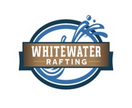

Style Guide

Color Schema

Color palette URL: coolors.co/505033-264969-cfcfb4-b4cde4 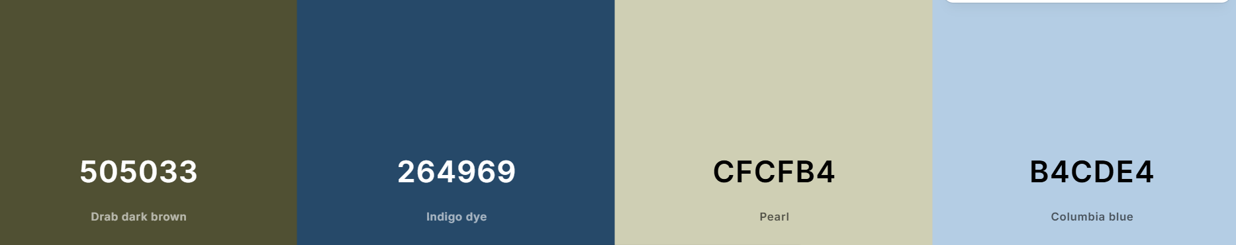

Typography

|  |  |  |  |
| --- | --- | --- | --- |
|  |  |  |  |

**Headings:** **Georgia 400, 700, and Black**

**Body**: **Roboto** 400 and 700

Wireframes

**About** **page**

|  |  |  |
| --- | --- | --- |
| Promotion | History | Contact  Contact us  Trips |

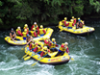 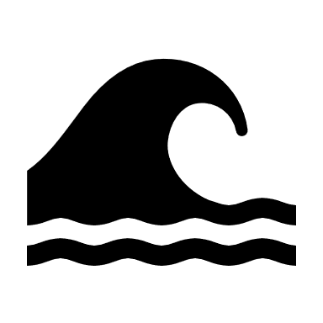

About us

Home



ipsum dolor sit amet, consectetur adipiscing elit, sed do eiusmod tempor incididunt ut labore et dolore magna aliqua. Ut enim ad minim veniam, quis nostrud exercitation ullamco laboris nisi ut aliquip ex ea commodo consequat. 

**White Water Rafting**

**History**

**Adventure Awaits You**

Footer Content Including Social Media Icons/Links 