**Whitewater Rafting Site Plan**

Purpose

To create an immersive and user-friendly online platform that showcases the thrill of whitewater rafting, while providing a seamless experience for customers to plan and book their adventures. The main message is that rafting is a fun activity and to come and experience it for yourself and bring your family.

Goals

• **Increase Online Visibility**: Establish a strong web presence to attract new customers and increase brand awareness.

• **Showcase Adventures**: Highlight the excitement and beauty of whitewater rafting through engaging visuals, videos, and testimonials.

• **Provide Essential Information**: Offer clear and concise details on trips, pricing, safety guidelines, and company policies.

• **Build Community**: Foster a sense of community among customers and guides through social media integration and customer reviews.

**• Drive Sales**: Convert website visitors into paying customers through targeted promotions, special offers, and loyalty programs.

Target Audience

• **Demographics**: Adventure-seekers, outdoor enthusiasts, and nature lovers

• **Psychographics:** Individuals seeking excitement, challenge, and connection with nature

• **User personas**: First-time rafters, experienced rafters, families, and corporate groups

Scenarios

The website should answer the following scenario questions:

• Information on trip levels and difficulty

• Detailed descriptions of what to expect during the trip

• Testimonials and reviews from previous customers

• Information on family-friendly trips and age restrictions

• Details on safety measures and equipment provided

• Options for booking a private guide or group trip

• Recommendations for nearby activities and attractions for non-rafters

• High-quality photos and videos showcasing the trip

• Options for customizing the trip (e.g., private guides, camping)

Site Map

Branding

Logo



Style Guide

Color Schema

Color palette URL: coolors.co/505033-264969-cfcfb4-b4cde4 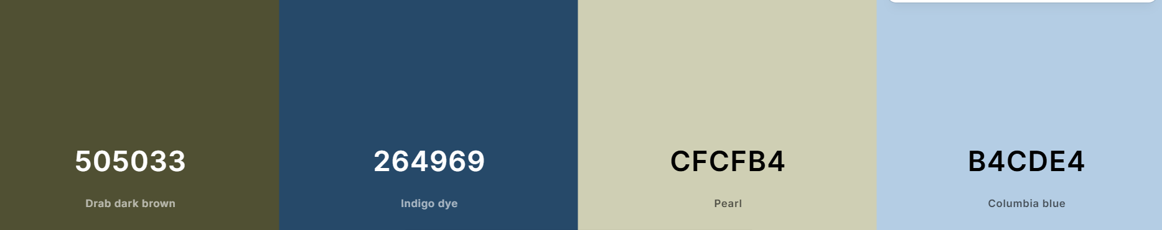

Typography

|  |  |  |  |
| --- | --- | --- | --- |
|  |  |  |  |

**Headings:** **Georgia 400, 700, and Black**

**Body**: **Roboto** 400 and 700

Wireframes

**Contact** **Us page**

|  |  |  |
| --- | --- | --- |
| Promotion | History | Contact  Contact us  Trips |

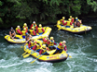

About us

Home

**Send Us a Message**

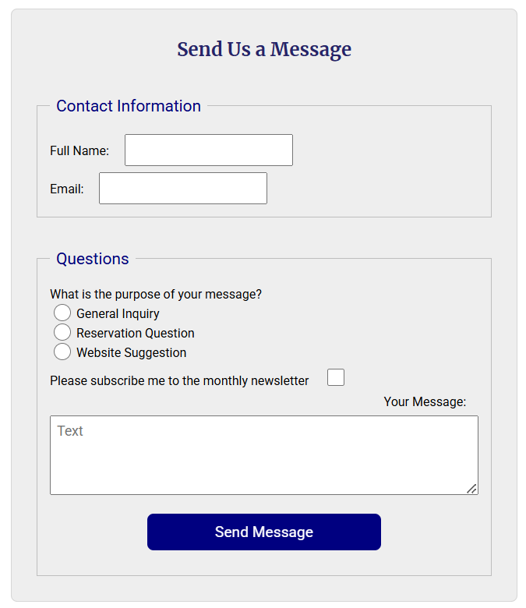

**Our Contacts**

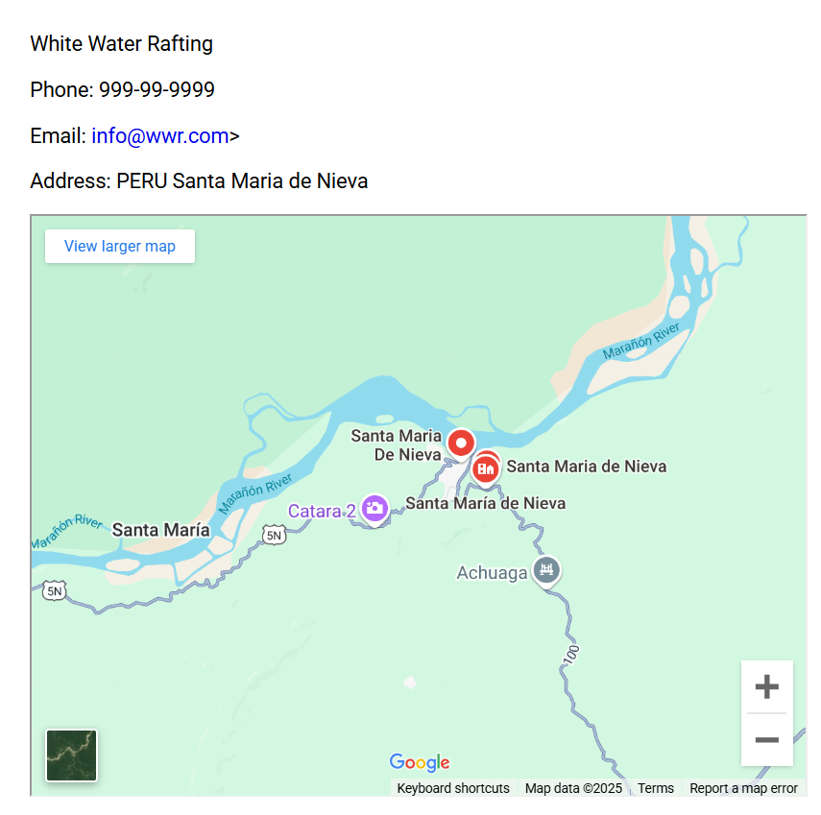

**Our Team** (3 photo with captions)

**  **

Footer: Content Including Social Media Icons/Links 