**W01 Learning Activities**

* **Due** Mar 6 at 11:59pm

* **Points** 12

* **Questions** 12

* **Available** until Mar 20 at 11:59pm

* **Time Limit** None

* **Allowed Attempts** 3

**Instructions**

Complete the [Learning ActivitiesLinks to an external site.](https://byui-cse.github.io/wdd131-ww-course/week01) and then return to this quiz to report on your work and check your understanding.

**Conditions**

* The quiz is open note, application, and internet.
* Your latest score will be recorded in the gradebook.

[Take the Quiz Again](https://byupw.instructure.com/courses/7893/quizzes/54862/take?user_id=31534)

Attempt History

|  | **Attempt** | **Time** | **Score** |
| --- | --- | --- | --- |
| **LATEST** | [Attempt 1](https://byupw.instructure.com/courses/7893/quizzes/54862/history?version=1) | 32 minutes | 11 out of 12 |

 Correct answers are hidden.

Score for this attempt: **11** out of 12

Submitted Mar 4 at 7:31pm

This attempt took 32 minutes.

**Question 1**

**1 / 1 pts**

Which of the following **file and folder names** are appropriate given the naming **standards** documented for this class?  
***Check all that apply.***



scripts/weather.js



images/temple.webp



scripts/#counter.js



chamber/home page.html



Images/temple.JPG

**Question 2**

**1 / 1 pts**

Which of the following folder names does this course use as the **standard folder names** to contain images, CSS files, and JavaScript files?  
***Check all that apply.***



js



styles



images



css



scripts



img

**IncorrectQuestion 3**

**0 / 1 pts**

A fellow student is frustrated because their navigation menu does not distribute the links evenly in the navigation bar as intended.  
The first image is what they are getting and the second image is what they want it to look like.

**What feedback should you provide to help them?**

Current:

Intended:

The student posted the relevant HTML and associated CSS for review.

<nav class="navigation">  
 <a href="index.html">Home</a>  
 <a href="products.html">Products</a>  
 <a href="services.html">Services</a>  
</nav>

.navigation {   
 display: flex;  
 align-items: center;  
 flex: 1 1 auto;  
 }  
  
.navigation a {  
   display: block;  
    color: #eee;  
    padding: 0.75rem;  
    text-decoration: none;  
    text-align: center;  
}



The 'flex' property must be applied to the immediate children a of the flex container (.navigation).



The CSS declarations in for the anchor tags (a) are out of order.



You cannot apply the CSS Flex display property to a nav element.



A width: 100% declaration is needed within the .navigation CSS rule.

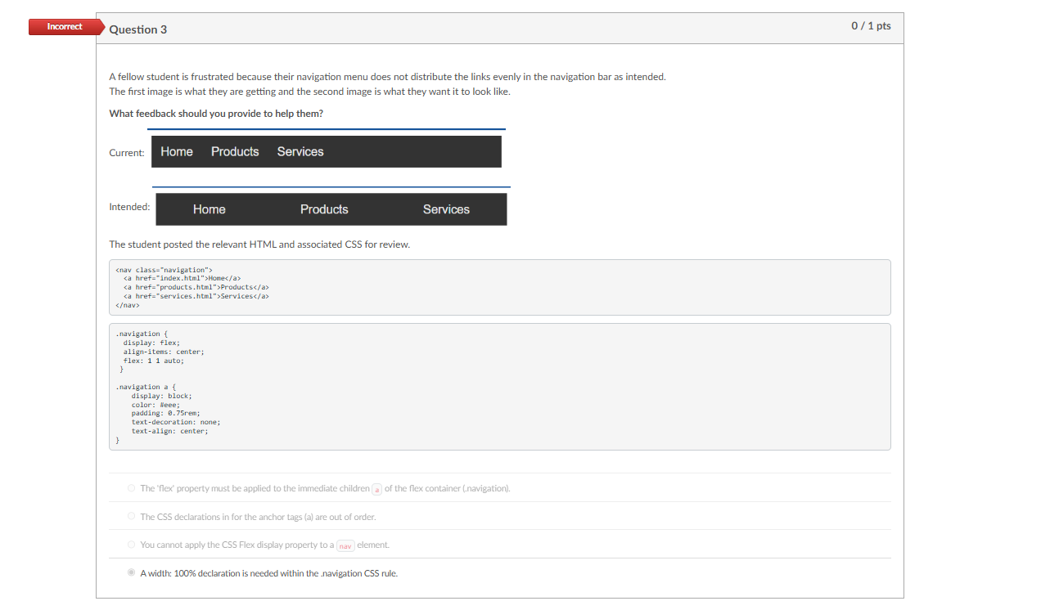

**Question 4**

**1 / 1 pts**

*Select the correct answer to complete the following statement.*  
To apply CSS Grid, you can define a grid container using the                                property on the parent element.



cssgrid: 100%;



media: css-grid;



display: grid;



grid: 100%;

**Question 5**

**1 / 1 pts**

What is the correct HTML markup to reference an external JavaScript file name **util.js** which is located in the **scripts**folder?



<script src="scripts/util.js"></script>



<script src="../scripts/util.js"></script>



<javascript>util.js</javascript>



<link src="./scripts/util.js">

**Question 6**

**1 / 1 pts**

What is the key difference between JavaScript's let and const for variable declarations?



let allows variable reassignment, while const enforces immutability.



let is used for global variables, while const is recommended for local variables.



let can only be used for primitive types, while const is reserved for objects and arrays.



let is block-scoped, while const is function-scoped.

**Question 7**

**1 / 1 pts**

Given that the parent item for aside is a CSS grid, how many columns will the aside element span?

aside {   
 border: 1px solid #eee;  
  padding: 2rem;  
  text-align: center;  
  grid-column: 1 / 3;  
}



4



5



1



3



2

**Question 8**

**1 / 1 pts**

A member of your team is getting an **HTML validation error** on this page. What feedback would you provide?  
Check all that apply.

<link href="styles/base.css">



A link element is missing the name attribute.



You have a spelling error in your path.



The link element is missing the rel attribute.



Looks like you fixed the problem, your code looks good now.

**Question 9**

**1 / 1 pts**

A student uses this image on an assignment. You **Inspect** the image using the browser's DevTools by hovering over the <img> src attribute. What feedback should you provide given the data provided?  
***Check all that apply.***



The rendered aspect ratio of the image is not correct. The image is stretched, blurry, and/or pixelated (this is not shown in the popup). Keep the aspect ratio the same.



Your image file size is too large, try reducing the quality using an image editing program.



Good job, everything looks fine.



Your image pixel dimensions are way too large for what is actually needed on the page. Reduce the image's dimensions to a more manageable size.

**Question 10**

**1 / 1 pts**

How many points are deducted when you submit an assignment after the due date?  
*Check all that apply.*



You can turn in assignments until the UNTIL date.



No points are deducted for late assignments submitted by the UNTIL date.



You lose 10 points for a late assignment.



Late assignments are not penalized for being submitted by the UNTIL date.

**Question 11**

**1 / 1 pts**

Which of the following JavaScript statements correctly declares and instantiates a variable that can be changed named "firstName" that holds the string "Antonia Francesca"?



firstName = "Antonia Francesca";



const firstName = "Antonia Francesca";



let firstName = "Antonia Francesca";



firstName = {Antonia Francesca};

**Question 12**

**1 / 1 pts**

Which of the following technologies or service is used to host your work as rendered web pages in this class?



git



I-Learn



Visual Studio Code



GitHub Pages

Quiz Score: **11** out of 12

