**W02 Learning Activities**

* **Due** Mar 13 at 11:59pm

* **Points** 13

* **Questions** 11

* **Available** until Mar 27 at 11:59pm

* **Time Limit** None

* **Allowed Attempts** 3

**Instructions**

1. **Complete**the [learning activities.Links to an external site.](https://byui-cse.github.io/wdd131-ww-course/week02/)
2. **Complete**this quiz to check your understanding.
3. Conditions
   * The quiz is open note, application, and internet.
   * Your latest score will be recorded in the gradebook.

[Take the Quiz Again](https://byupw.instructure.com/courses/7893/quizzes/54814/take?user_id=31534)

Attempt History

|  | **Attempt** | **Time** | **Score** |
| --- | --- | --- | --- |
| **LATEST** | [Attempt 1](https://byupw.instructure.com/courses/7893/quizzes/54814/history?version=1) | 22 minutes | 11 out of 13 |

 Correct answers are hidden.

Score for this attempt: **11** out of 13

Submitted Mar 13 at 7:11pm

This attempt took 22 minutes.

**Question 1**

**3 / 3 pts**

I completed all of the learning activities assigned this week and posted my work to my GitHub Pages repository, if it was requested.



True



False

**Question 2**

**1 / 1 pts**

In your **base.css** file you have the following CSS rule:

span {background-color: red}

In the **larger.css** file you have the following rule:

@media only screen and (min-width: 32rem) {  
     span {background-color: green}  
}

In what color will span tags be rendered, given that the root element font size is the default size of 16px?



Screens wider than 576px, the span background color will be green.



Screens wider than 32px, the span background color will be green.



Screens wider than 512px, the span background color will be green.



Screens wider than 608px, the span background color will be green.

**Question 3**

**1 / 1 pts**

If you have several child items and you want them to display in multiple rows and columns, depending on the browser screen width, you could display the parent tag as a flex item.

div.parent {display: flex;}

What additional CSS declaration would you need to add to the above rule to get the child items to display on multiple rows?  
Check all that apply.



flex-wrap: wrap;



warp: flex-wrap;



flex-template-columns: auto;



justify-content: multiple;

**Question 4**

**1 / 1 pts**

The intent of the JavaScript here is to add or remove (in other words, toggle) a class named  "**open**" when a **menubutton**element is clicked.  
Complete the code block by filling in the three blanks.

menubutton.addEventListener(' ', () => {  
  menuitems. .toggle(' ');  
});

**Answer 1:**

click

**Answer 2:**

classlist

**Answer 3:**

open

**Question 5**

**1 / 1 pts**

Given the following JavaScript statement,

const msg = document.querySelector('span');

what element does this statement reference and assign to the msg variable?



The last span element found on the document.



The first span element found on the document.



A random one from the NodeList.



No answer text provided.

**Question 6**

**1 / 1 pts**

In JavaScript, to assign a variable identified as '**msg**' a document element with an id named '**message**', which of the following would you use?  
*Select all the apply.*



const msg = document.getElementById('message');



const msg = document.querySelector('message');



const msg = document.querySelector('.message');



No answer text provided.



const msg = document.querySelector('#message');

**IncorrectQuestion 7**

**0 / 1 pts**

In JavaScript, to set the text node of a preselected div element assigned to a variable identified as "reveal" as intended by the code, which of the following could you use?  
*Check all that apply.*



reveal.innerHTML = `🎉 Congratulations! You are having a <strong>${babygender}</strong>!`;



reveal.text = `🎉 Congratulations! You are having a <strong>${babygender}</strong>!`;



reveal.textContent = `🎉 Congratulations! You are having a <strong>${babygender}</strong>!`;



reveal.HTMLvalue = `🎉 Congratulations! You are having a <strong>${babygender}</strong>!`;

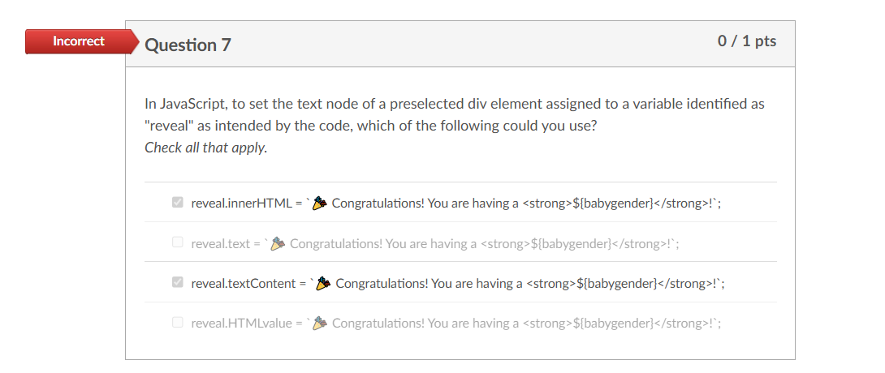

**Question 8**

**1 / 1 pts**

Which web design element is crucial for effective **wayfinding**on a website?



Font size



Background color



Image resolution



Navigation menu

**Question 9**

**1 / 1 pts**

What does the :: syntax in the CSS rule selector do?  
Example:

p::first-line {  
 ...  
}



Selects a pseudo-element



Selects a JSON value



Increases the specificity of the element



Selects a pseudo-class

**IncorrectQuestion 10**

**0 / 1 pts**

One way to change the inline CSS style of an element is by using the setProperty method such as

// Assuming 'articleElement' is the reference to a valid HTML element of coursearticleElement.style.setProperty('font-weight', '700');

Which of the following is a valid alternative to the code above?



articleElement.cssstyle-font-weight = '700';



articleElement.style.fontWeight = 700;



articleElement.style.font-weight('700');



articleElement.style.font-weight = 700;

The valid alternative to the code **articleElement.style.setProperty('font-weight', '700');** is:

Copy

articleElement.style.fontWeight = '700';

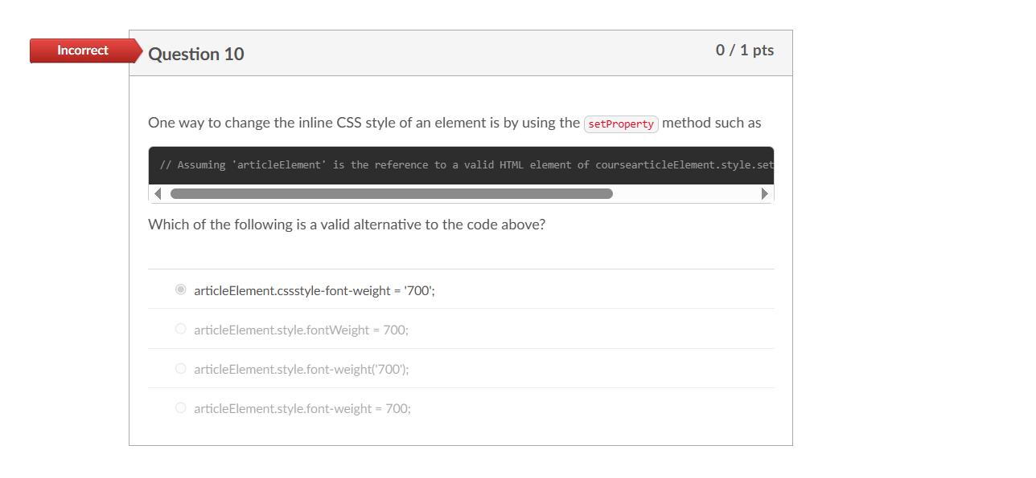

**Question 11**

**1 / 1 pts**

Which of the following accurately describes the **DOM**(Document Object Model)?



A security protocol for encrypting data transmitted between the web server and the client.



A standardized interface allowing programs to dynamically access and manipulate the content of a web page.



A programming language used for styling web pages.



A browser-specific rendering engine for HTML and CSS.