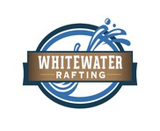

Style Guide

Color Schema

Color palette URL: coolors.co/505033-264969-cfcfb4-b4cde4 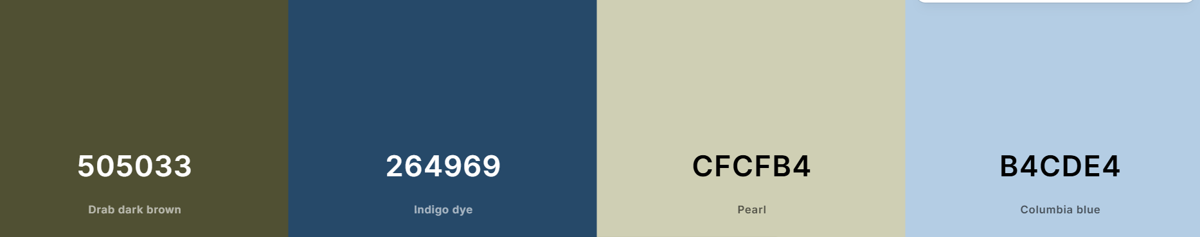

Typography

|  |  |  |  |
| --- | --- | --- | --- |
|  |  |  |  |

**Headings:** **Georgia 400, 700, and Black**

**Body**: **Roboto** 400 and 700

Wireframes

**Index** **page**

|  |  |  |
| --- | --- | --- |
| Promotion | History | Contact  Contact us  Trips |

About us

Home



**White Water Rafting**



Footer Content Including Social Media Icons/Links 

**Adventure Awaits You**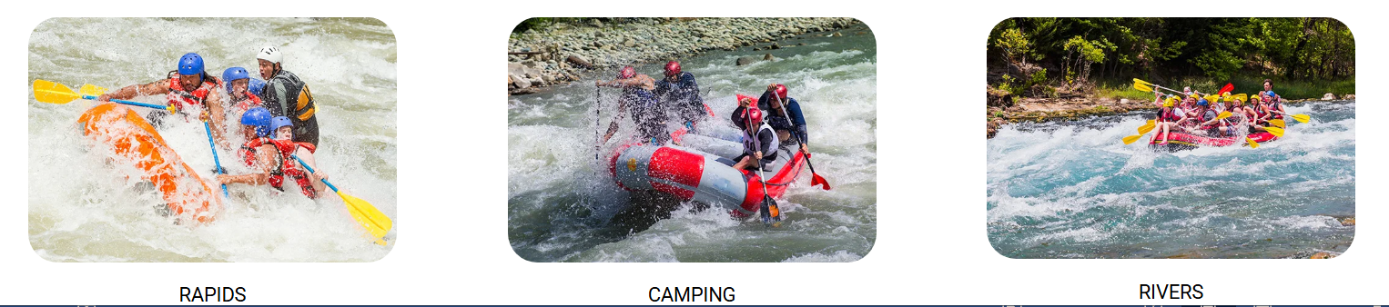

Join our expert guides on thrilling white water rafting tours tailored to all skill levels. Whether you're a beginner or an experienced rafter, we offer a variety of trips to suit your adventure needs.