|  |  |  |
| --- | --- | --- |
| Promotion | History | Contact  Contact us  Trips |

About us

Home



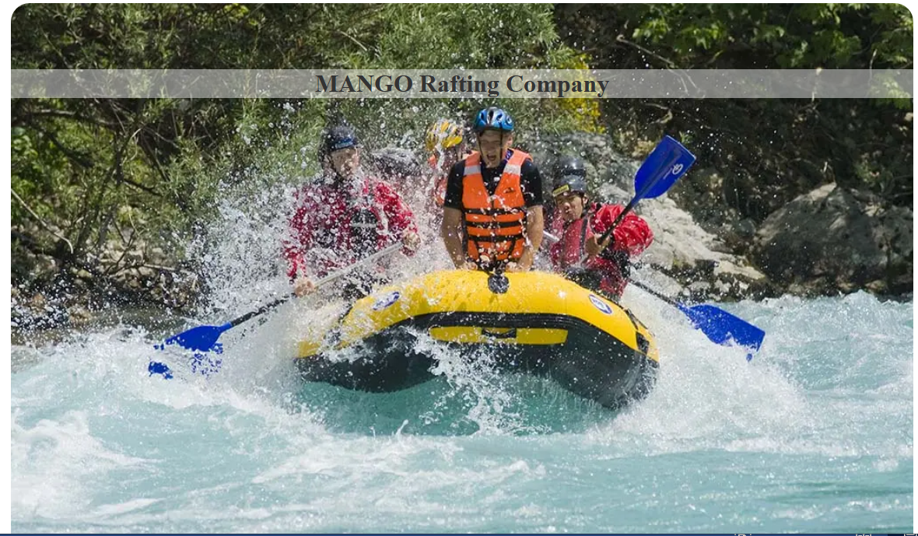

**Trips and Adventures** 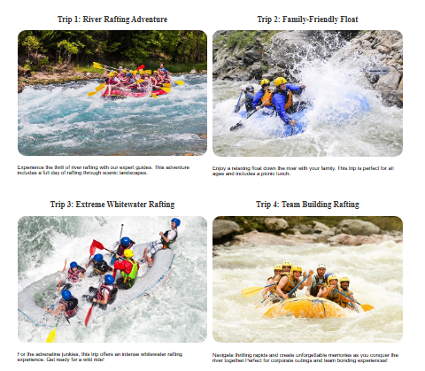

**Available Trips**

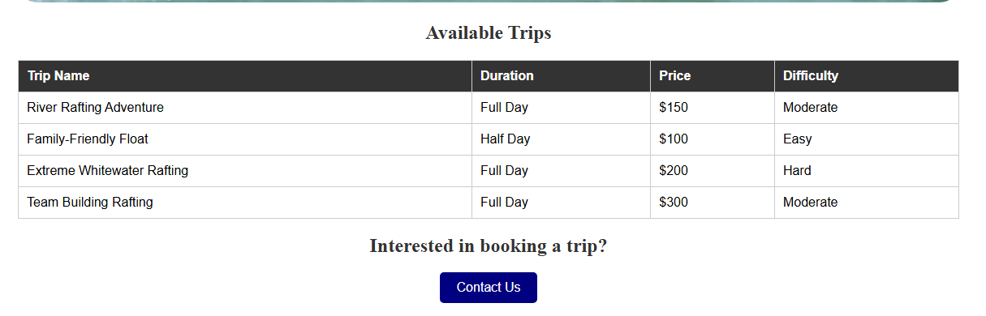

Footer: Content Including Social Media Icons/Links 