**W03 Learning Activities**

* **Срок** 20 Мар в 23:59

* **Баллы** 13

* **Вопросы** 13

* **Доступно** до 3 Апр в 23:59

* **Ограничение времени** Нет

* **Разрешенные попытки** 3

**Инструкции**

**Complete**the [W03 Learning ActivitiesLinks to an external site.](https://byui-cse.github.io/wdd231-ww-course/week03) and then return to this quiz to report on your work and check your understanding.

**Conditions**

* The quiz is open note, application, and internet.
* Your latest score will be recorded in the gradebook.

[Снова Пройти тест](https://byupw.instructure.com/courses/7127/quizzes/45037/take?user_id=31534)

История попыток

|  | **Попытка** | **Время** | **Оценка** |
| --- | --- | --- | --- |
| **ПОСЛЕДНЯЯ** | [Попытка 1](https://byupw.instructure.com/courses/7127/quizzes/45037/history?version=1) | 18 минут(ы) | 12 из 13 |

 Правильные ответы скрыты.

Оценка за эту попытку: **12** из 13

Отправлено 20 Мар в 18:38

Эта попытка длилась 18 минут(ы).

**Вопрос 1**

**1 / 1 балла (-ов)**

Write the CSS declaration that applies the grid layout to the selector.

Note that the standard way to write a declaration in this class is to use one space after the colon and be sure to include the semi-colon in your declaration.



**Вопрос 2**

**1 / 1 балла (-ов)**

Write the CSS declaration that applies the flex box layout to the selector.

Note that the standard way to write a declaration in this class is to use one space after the colon and be sure to include the semi-colon in your declaration.



**Вопрос 3**

**1 / 1 балла (-ов)**

A CSS comment is used to add explanatory notes to the code or to prevent the browser from interpreting specific parts of the style sheet. CSS comments have no effect on the layout and style of the document. - MDN

True or False? CSS comments can be used to traverse multiple lines as shown here:

/* The comment below is used to

disable specific styling */

/*

span {

color: blue;

font-size: 1.5em;

}

*/



True



False

**Вопрос 4**

**1 / 1 балла (-ов)**

HTML comments are not displayed in the generated browser document, but they can help provide explanatory, development references in your HTML markup.

Make the text *** Call to Action *** in the following HTML example snippet a valid HTML comment.

*** Call to Action ***  
<aside class="cta">Join Now!</aside>



**Вопрос 5**

**1 / 1 балла (-ов)**

Consider the following HTML markup snippet.

<div class="parent">  
    <p>Immediate child 1</p>  
    <p>Immediate child 2</p>  
    <div>  
        <p>Nested child</p>  
    </div>  
</div>

Which of the following CSS selectors would correctly select the first two p elements but not the nested paragraph?



.parent > p



.parent + p



.parent ~ p



.parent p

**НеверноВопрос 6**

**0 / 1 балла (-ов)**

What is the name of the UX accessibility and design principle of providing visual or other media clues to make it easy for users to navigate a site or application and locate the information they need? **Hint:**Review the activity instructions in the responsive menu learning activity.  
Here is an example showing the **Solutions** menu item as underlined and blue:



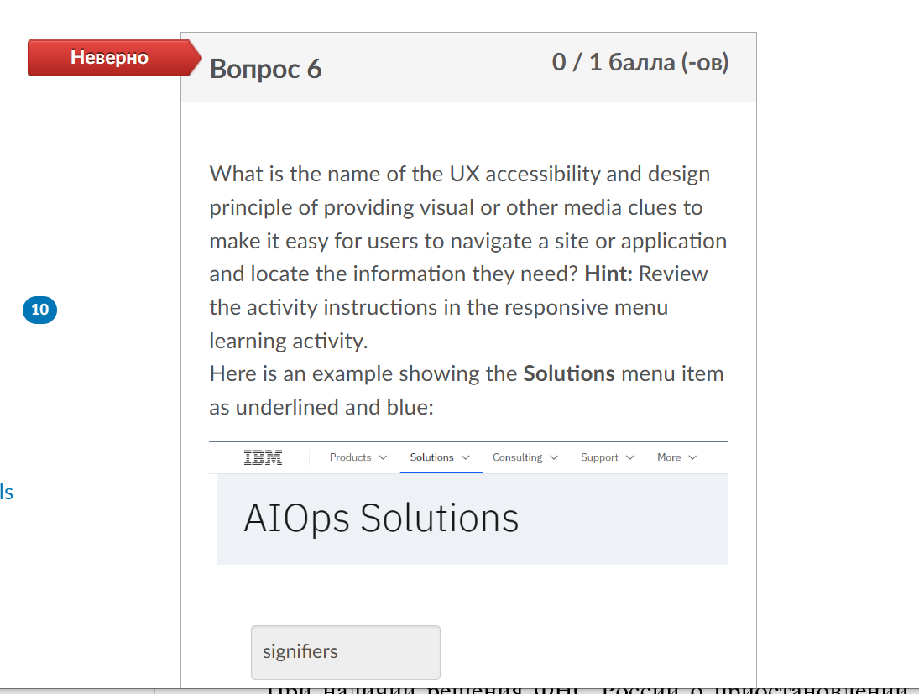

**Вопрос 7**

**1 / 1 балла (-ов)**

What does the :: syntax in the CSS rule selector do? For example:

.active::before {  
  content: "⚙️";  
  margin-top: .5rem;  
}



Separates two properties in order for JavaScript to reference one or the other.



Selects the next sibling element as a CSS combinator.



References a data source of the element that is selected.



Selects a pseudo-element of the selected element.

**Вопрос 8**

**1 / 1 балла (-ов)**

Which of the following **document titles** is the most meaningful and relevant for the landing page of a chamber of commerce site from San Miguel, El Salvador?



Chamber Home - Landing Page



Home Page



Antonia Francesca - WDD 231 - San Miguel Chamber of Commerce Website



San Miguel Chamber of Commerce



WDD 231 - Chamber Home Page

**Вопрос 9**

**1 / 1 балла (-ов)**

Which of the following is **not**checked by the DevTools Lighthouse **accessibility**tool?



Touch targets have sufficient size and spacing.



Document has a <title> element



Page download time and first paint.



Heading elements appear in a sequentially-descending order.



Background and foreground colors do not have a sufficient contrast ratio.

**Вопрос 10**

**1 / 1 балла (-ов)**

Which of the following is the attribute needed in order for a script reference to function as a module?



defer



script="mod"



@import "module"



type="module"

**Вопрос 11**

**1 / 1 балла (-ов)**

Consider the following JavaScript code snippets:

// moduleA.js file  
const message = "Hello, world!";  
function greet() {   
 console.log(message);  
}  
export { greet };

// index.js file  
import { greet } from './moduleA.js';  
  
greet();

Upon execution, an error is encountered, and the greet() function fails to be imported. Which of the following statements best describes the potential issue in this scenario?



The import statement should be using single quotes ('') instead of double quotes ("").



The 'export' keyword should be replaced with 'export default' in the file 'moduleA.js'.



The type="module" attribute should be added to the script tag in the HTML file importing the JavaScript modules.



The file extension in the import statement should be '.mjs' instead of '.js'.

**Вопрос 12**

**1 / 1 балла (-ов)**

Which of the following is a common format used to exchange data between a client and API service?



CSV



JSON



TXT



HTML

**Вопрос 13**

**1 / 1 балла (-ов)**

If you wanted to change the reported temperatures coming from the OpenWeatherMaps API from the default value to Fahrenheit values, which of following would you add to your API call?



&units= imperial



&temp = fahrenheit



&temp = imperial



&temperature-units = fahrenheit

Оценка контрольной работы: **12** из 13