

Data Technician

Name: Harry Richards
Course Date: 15/12/2025
Table of contents
Day 1: Task 1 2
Day 2: Task 1 2
Day 2: Task 2 3
Day 2: Task 3 4
Day 3: Task 1 4
Day 3: Task 2 5
Dataset: 5
Step 1: Create a Pivot Table 5
Step 2: Use the SWITCH Function 5
Submission: 6
Day 3: Task 3 6
Day 4: Task 1 7
Course Notes 9
Additional Information 10

Day 1: Task 1

Please complete the below boxes on commons laws and regulations that must be followed when working with customers data, use the below bulleted list to support your answers.

- What is it
- Why is it important
- Provide a real-world example of how you can follow it
- How does it impact working with data
- What could happen if you breached it

Data Protection Act | - A law that controls how personal information is stored, collected, and used.  - It protected people’s privacy and rights and prevents the misuse of information.  - A school would store student records. They would password protect them, only allow authorised members of staff to see it, and delete it when it is no longer needed.  - You must only collect data that you need and it must be accurate.  - Fined by the ICO or legal action from individuals.
GDPR | - A regulation that strengthens data protection for individuals and regulates the handling of personal data.  - It gives individuals control over their personal data and encourages responsible data handling.  - An online shop may ask for consent before sending marketing emails.  - You must have a lawful reason to collect data and individuals can request access to their data.  - Very large fines and mandatory reporting for serious data breaches.
Freedom of Information Act | - Allows the public to request information held by the public authorities.  - It promotes transparency and accountability. It helps to prevent misuse of public funds.  - A local council could receive a request for spending data. They would respond within 20 days.  - Public organisations must keep records organised, it protects sensitive data, and data must be shared when requested.  - You could receive enforcement notices from the ICO, damage to reputation, and legal action could be taken against the company.
Computer Misuse Act | - Makes it illegal to access computers without permission, hack systems, spread malware or viruses, and modify data without permission.  - Protects systems, keeps data safe, and supports trust in digital systems.  - An employee would only use their login details, doesn’t access files they are not authorised to see, and doesn’t attempt to bypass security controls.  - You must only access data you are permitted to see and sharing passwords is not allowed.  - There could be criminal prosecution or fines. There could be prison sentences and permanent criminal records.

Day 2: Task 1

Please research and complete the following tasks within the retail-sales_dataset.xlsx document, paste a print screen into the provided boxes below:

- In the sheet ‘retail_sales_dataset’ add all available data between columns A – H into a ‘table’
- Using the ‘filter’ function, filter ‘Age’ to ‘largest to smallest’
- Using the ‘SUM’ function, show me the commission total in cell ‘P10’
- Using the ‘AVERAGE’ function, show me the average commission in cell ‘P11’

Print screen 1 | 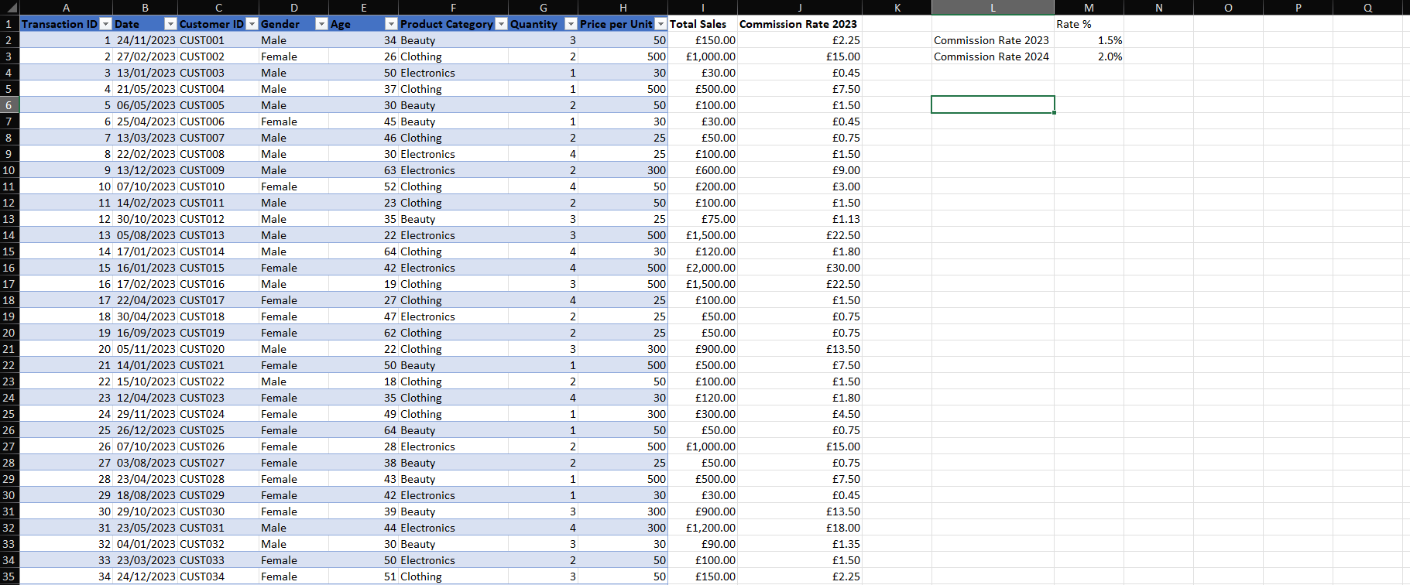
Print screen 2 | 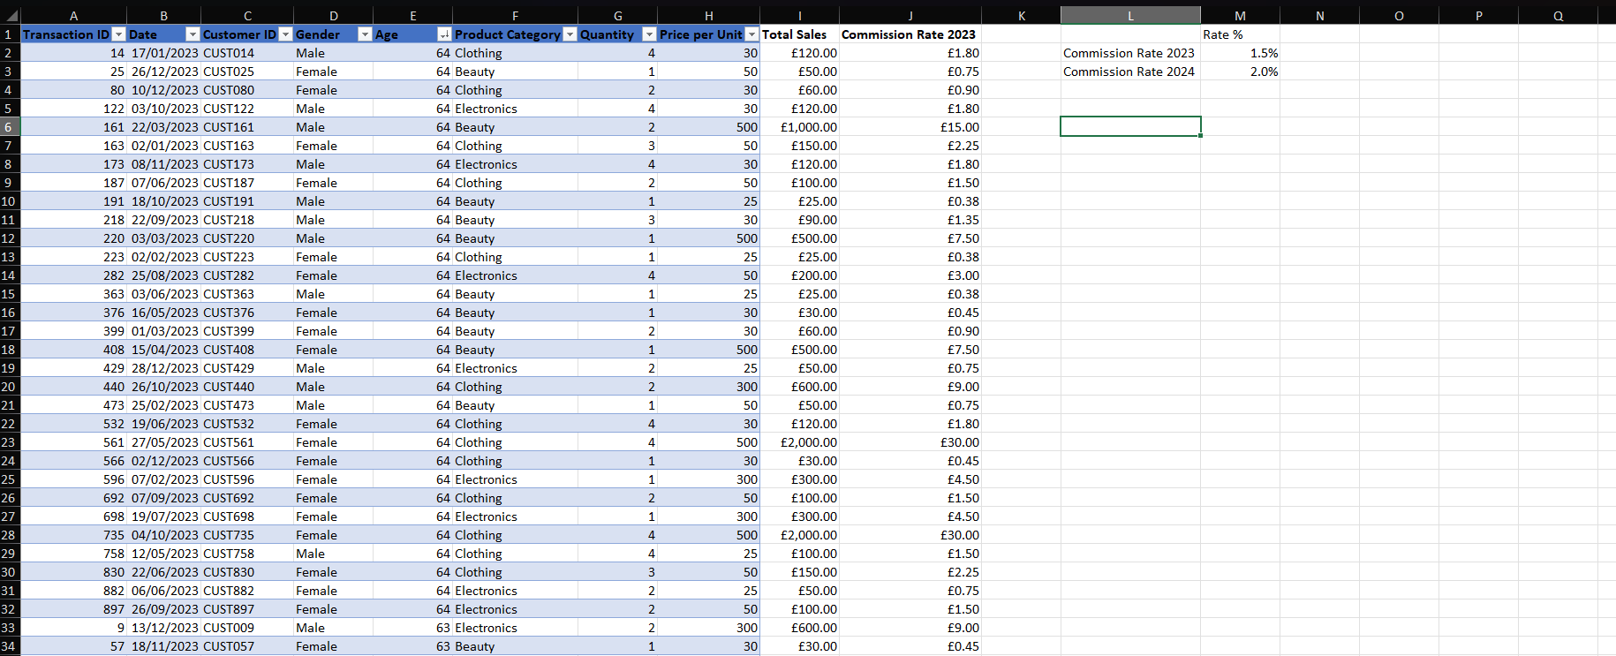
Print screen 3 | 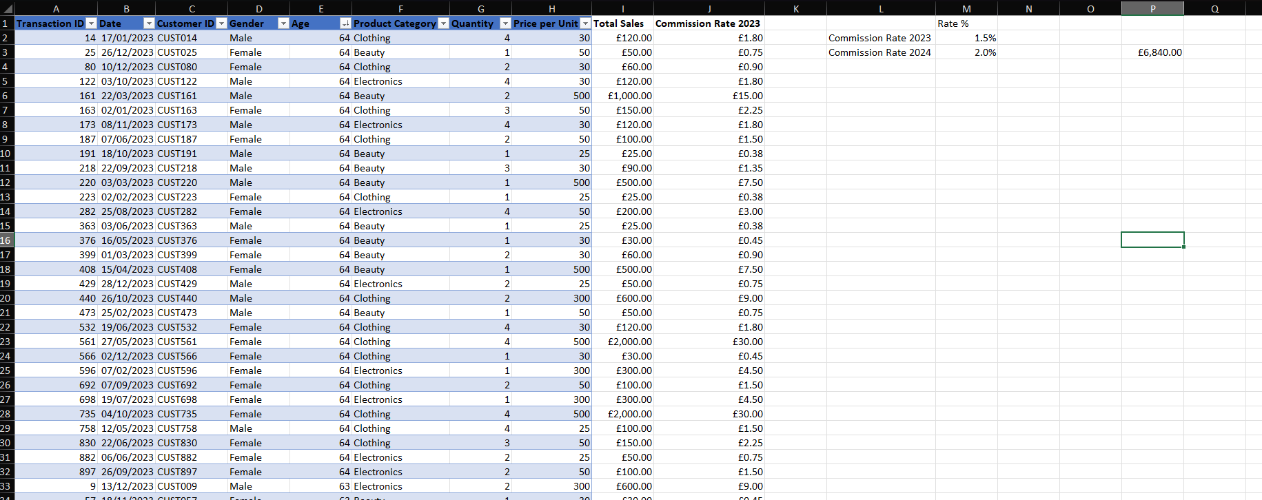
Print screen 4 | 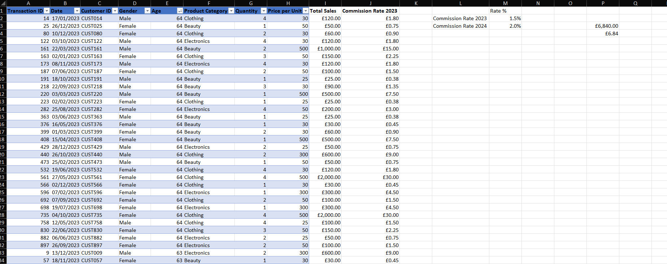

Day 2: Task 2

Please research and complete the following tasks within the retail-sales_dataset.xlsx document, paste print screens into the provided box below:



Print screen 1 | 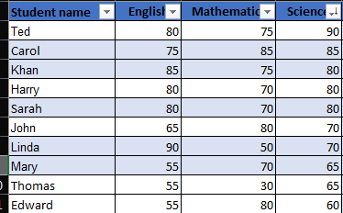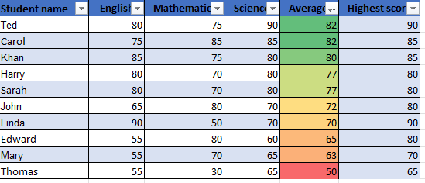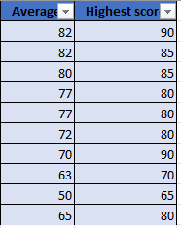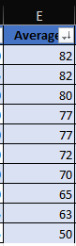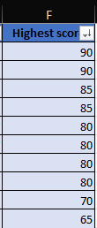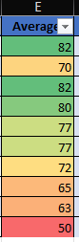

Day 2: Task 3

Using the skills developed today, have some fun with the data set you have imported. Paste your work below and enjoy!

Print screen 1

Day 3: Task 1

Please download the dataset ‘Day_3_Task_1_Bike_Sales_Pivot_Lab.xlsx’ from here.

The lab instructions can be found here. Do not worry if you do not complete the lab, just working with data and playing with the pivot table will be good experience.

Please paste your final pivot table below and complete the reflection questions:

Print screen 1 | 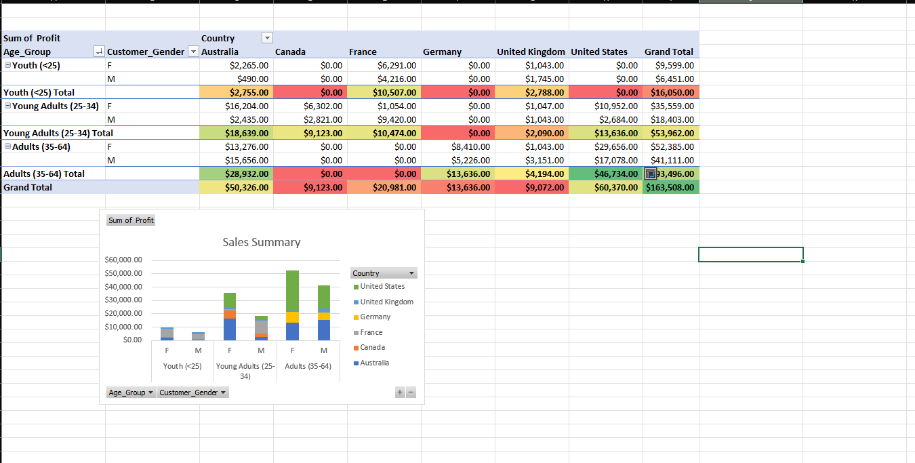
In which markets does Germany have customers? | Adults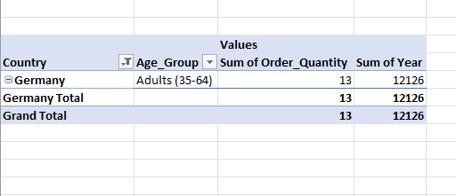
What country has sales in all markets? | - United Kingdom  - Australia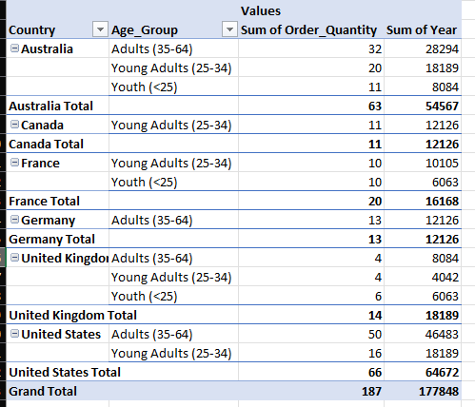
What are the most profitable markets by country, age group, and gender?
Any other findings?

Day 3: Task 2

The dataset below tracks the sales performance of different products in various counties in England. Please paste the dataset into a blank Excel workbook. Your task is to:
- Create a Pivot Table to summarise the data by county and product.
- Use the SWITCH function to categorise products based on their sales volume.

Dataset:
County | Product | Sales Volume
Yorkshire | Laptops | 500
Yorkshire | Smartphones | 200
Cornwall | Laptops | 700
Cornwall | Printers | 400
Lancashire | Smartphones | 150
Lancashire | Laptops | 600
Essex | Printers | 800
Essex | Smartphones | 300
Durham | Laptops | 250
Durham | Printers | 300
Greater Manchester | Smartphones | 600
Greater Manchester | Laptops | 400

Step 1: Create a Pivot Table
- Select the dataset (columns A to C).
- Insert a Pivot Table to summarise the data by County in the rows and Products in the columns. Use Sales Volume as the value to be summarised.

Step 2: Use the SWITCH Function
In a new column next to your data, use the SWITCH function to categorise products based on Sales Volume as follows:
  - For sales greater than 600: "High"
  - For sales between 300 and 600: "Medium"
  - For sales less than 300: "Low"
SWITCH Function Example:
=SWITCH(TRUE, C2 > 600, "High", C2 >= 300, "Medium", "Low")
- Apply this formula to each row, and check if the products are categorised correctly.

Submission:
- A completed Pivot Table summarising sales by county and product.
- A new column in the dataset categorising products by sales volume using the SWITCH function.
  - Please paste your completed work below

Print screen 1 | 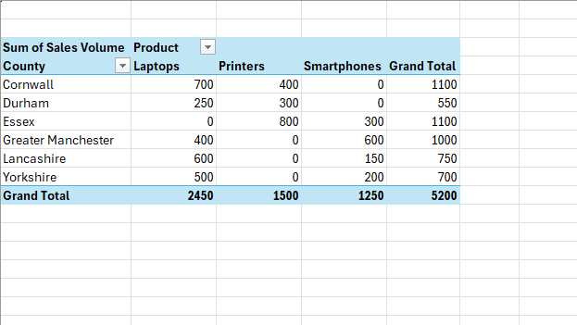  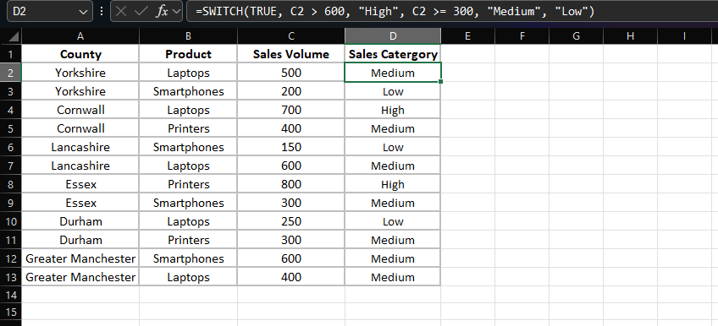

Day 3: Task 3

Please download the dataset ‘Day_3_Task_3_Bike_Sales_Visualisations_Lab.xlsx’ from here.

The lab instructions can be found here. Do not worry if you do not complete the lab, just working with data and playing with the charts will be good experience.

Please paste your results below:

Print screen 1 | 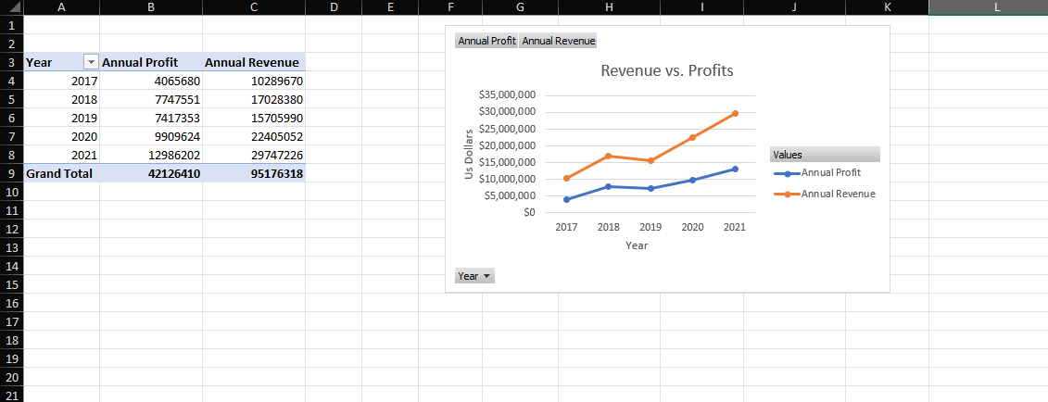  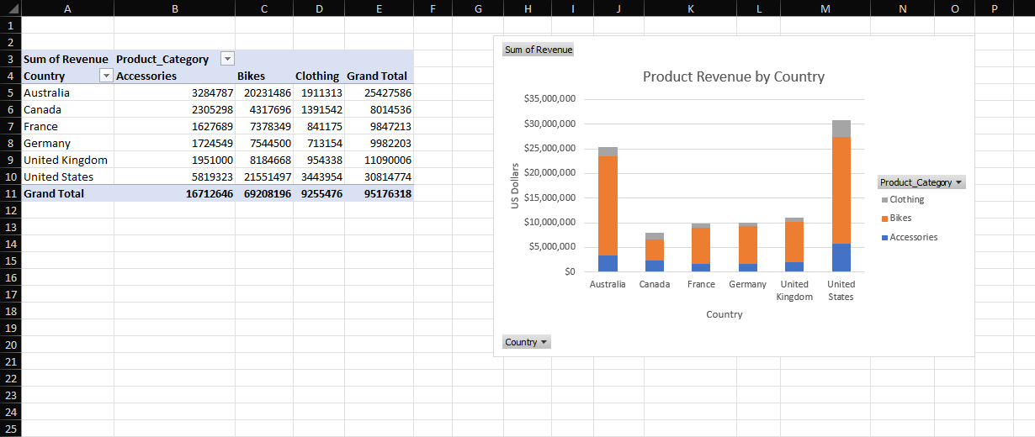  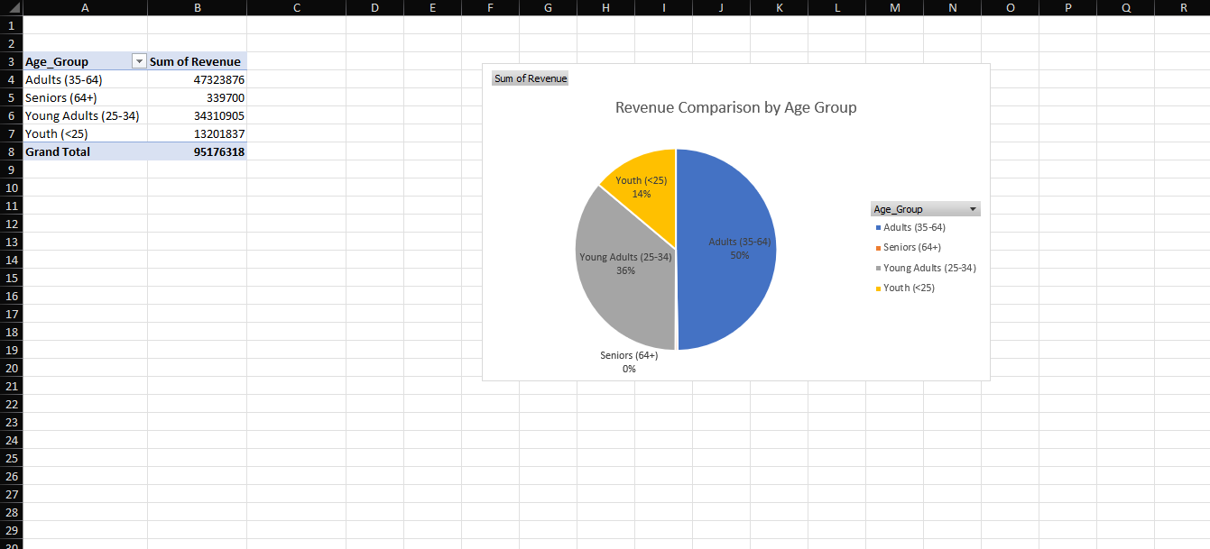

Day 4: Task 1

You have been asked to deliver your analysis findings to the board of directors, within your analysis you have identified that customers are leaving your company at the 12-month point, this is typically when they receive their renewal price.

Conduct research and complete the below questions:

How would you prepare for the delivery?
What tools would you use for the delivery?
What is prospecting and why would you complete this before your delivery?
Tell me best practices for public speaking and providing updates to senior leaders
What will you show the board in your delivery?
How will you articulate the changes that are needed?
Provide a list of online resources and videos that will support your preparation for public speaking
Evaluate tools that provide visualisation.

Tell me what they are.

Tell me what you would choose when delivering your presentation and why

Course Notes

It is recommended to take notes from the course, use the space below to do so, or use the revision guide shared with the class:

Additional Information

We have included a range of additional links to further resources and information that you may find useful, these can be found within your revision guide.

END OF WORKBOOK

Please check through your work thoroughly before submitting and update the table of contents if required.

Please send your completed work booklet to your trainer.

