

Data Technician

Name:
Course Date:
Table of contents
Day 1: Task 1 2
Day 1: Task 2 2
Day 2: Task 1 3
Day 2: Task 2 3
Day 3: Task 1 4
Day 3: Task 2 5
Day 4: Task 1 6
Day 4: Task 2 7
Course Notes 7
Additional Information 8

Day 1: Task 1

Please research the different versions of Tableau, compare and contrast them below and explain the limited functionality on ‘Tableau Public’.

Different Tableau versions | Tableau Public – This is the free to use version of tableau which offers the use of their public server, meaning it can be accessed by anyone and cannot be stored locally. It has various limitations such as it supports a limited set of data sources. Users are limited in the number or rows available, making it harder to analyse large datasets. Ultimately, it offers a lot of the same functionality but has limited storage and cannot save workbooks locally.  Tableau Desktop – This a licensed software that offers feature suitable for professional use. This means that it can store files locally ensuring confidentiality of sensitive data. It supports a wider range of data connections such as SQL databases which allows for more detailed analysis. It also has no limitations on the amount of data that it can handle. To summarize, it is not limited compared to tableau public and it provides sophisticated analytical capabilities.

Day 1: Task 2

Using the EMSI_JobChange_UK dataset, create your own dashboard, I want to see a bar chart showing percentage change and a UK based map showing the key city locations impacted.

Paste your print screen here | 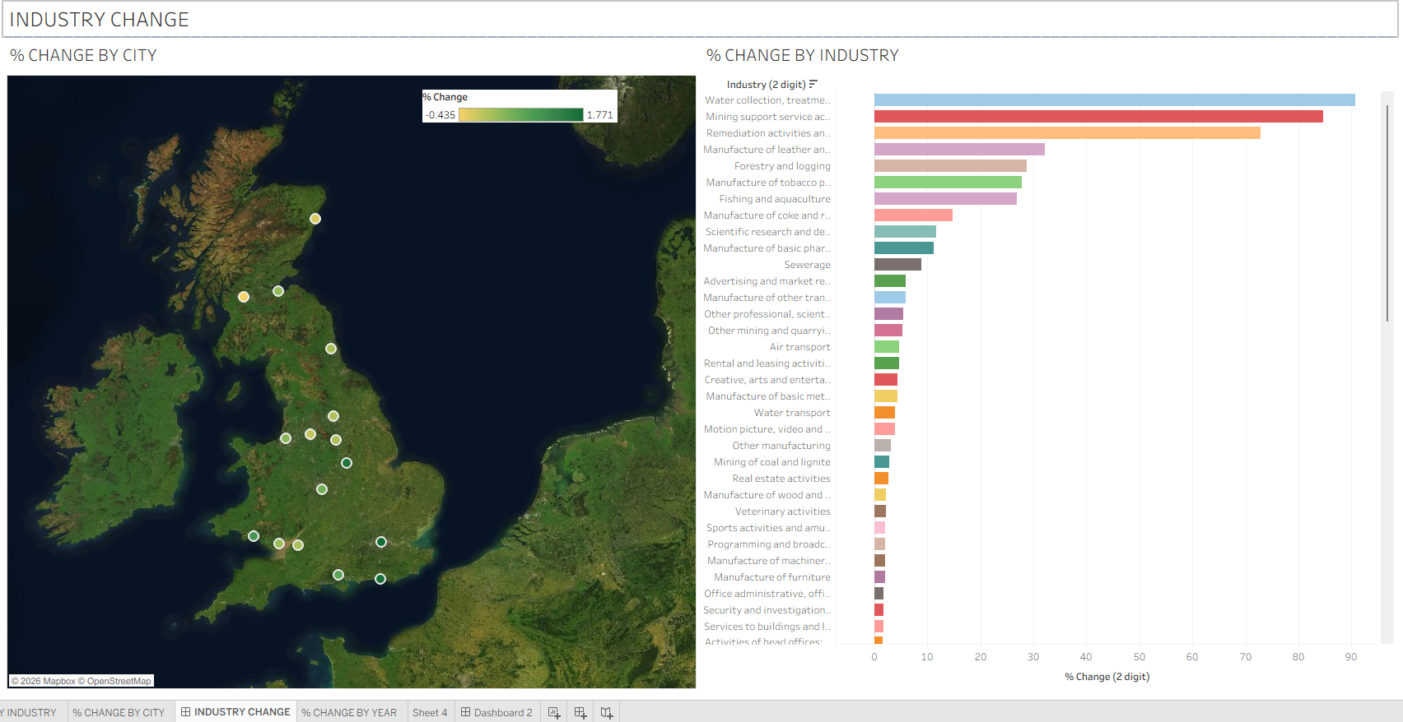

Day 2: Task 1

Using the Spotify data set, conduct an analysis to find trends and key information that could be used by an organisation for future projects.

There is no set scope for the analysis, simply to find trends and document them below:

Paste your print screens here | 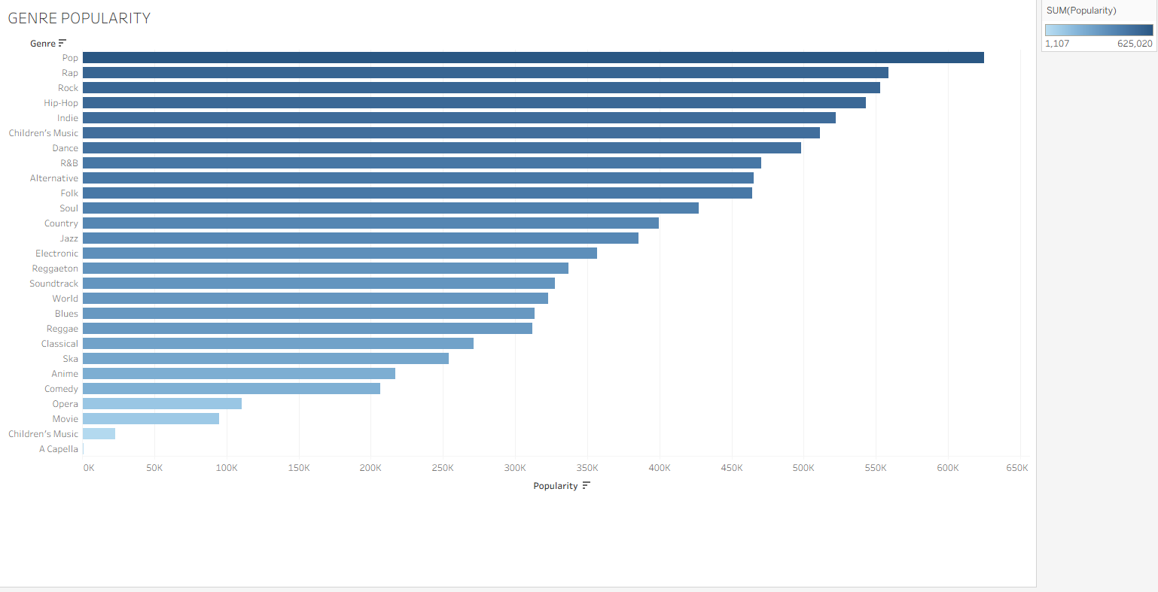  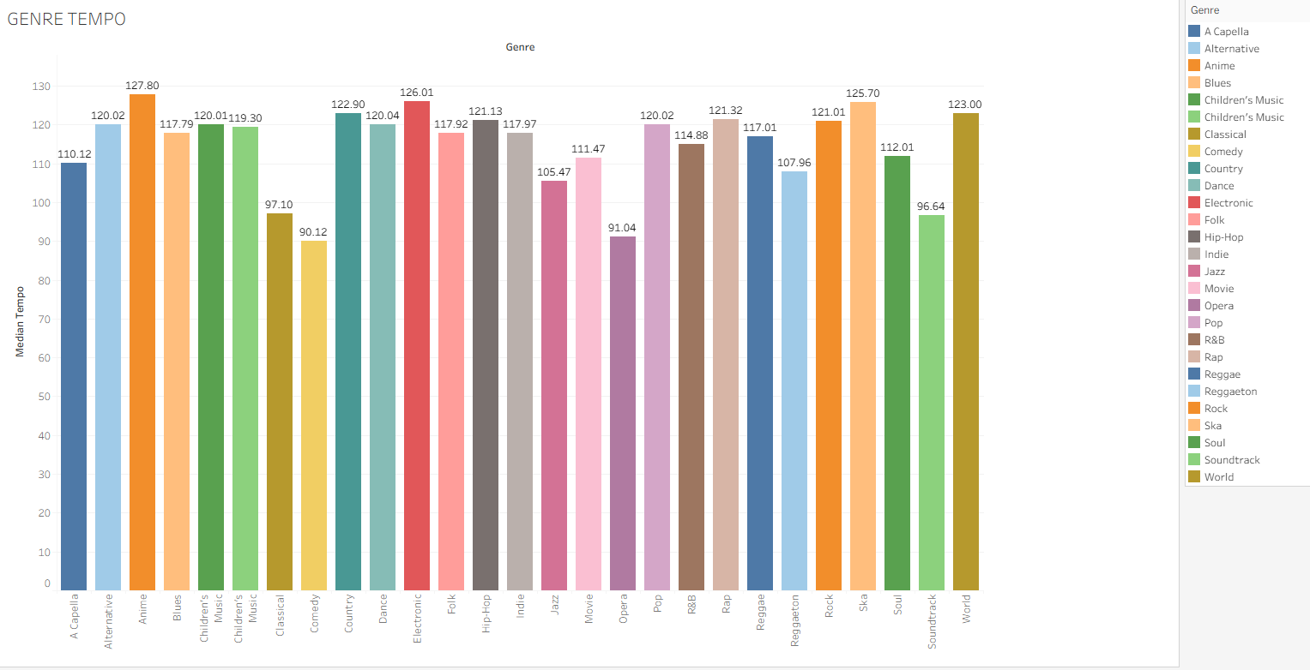  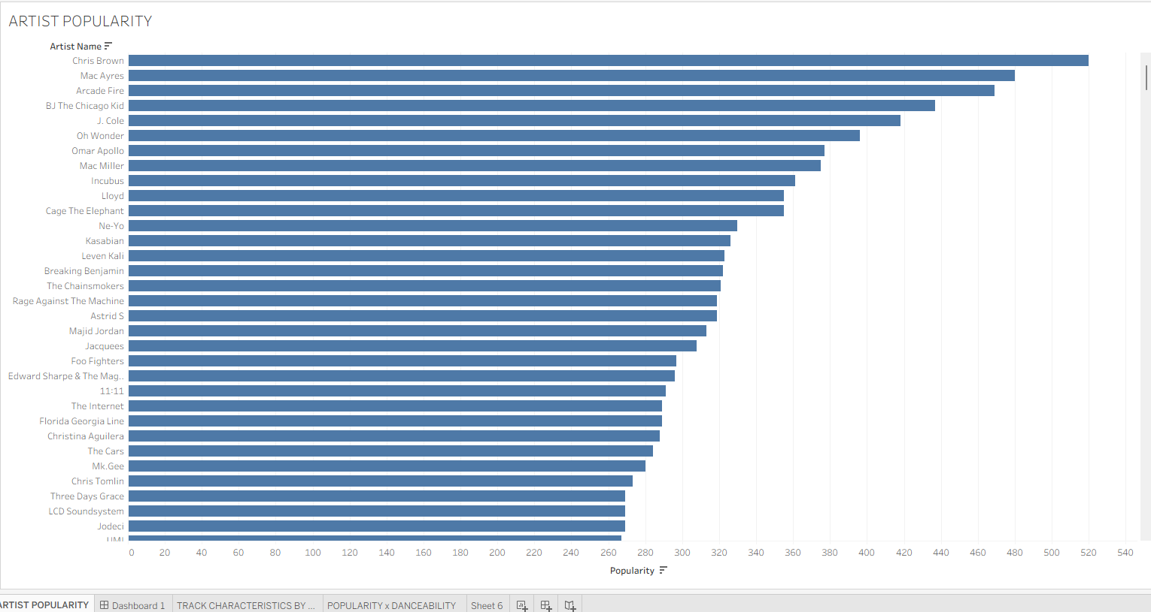

What did you find? | - Screenshot 1 tells me that pop music is the most popular genre on this database whilst children’s music is the least popular.  - Screenshot 2 tells me about the average tempo per genre. For example, opera is the slowest genre on average at 91.04 bpm and anime music is the fastest on average at 127.80 bpm.  - Screenshot 3 tells me the artists popularity. This tells me that Chris brown is the most popular artist across the whole database.

Day 2: Task 2

Using the Health data set, conduct an analysis to find trends and key information that could be used by an organisation for future support.

There is no set scope for the analysis, simply to find trends and document them below.

- Data can be lifesaving and is being used more within the NHS, reflect on how this data could support decision making for the NHS.

Paste your print screens here | 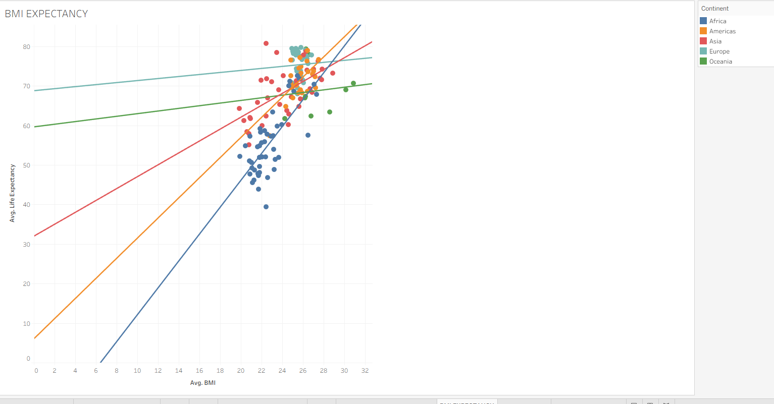  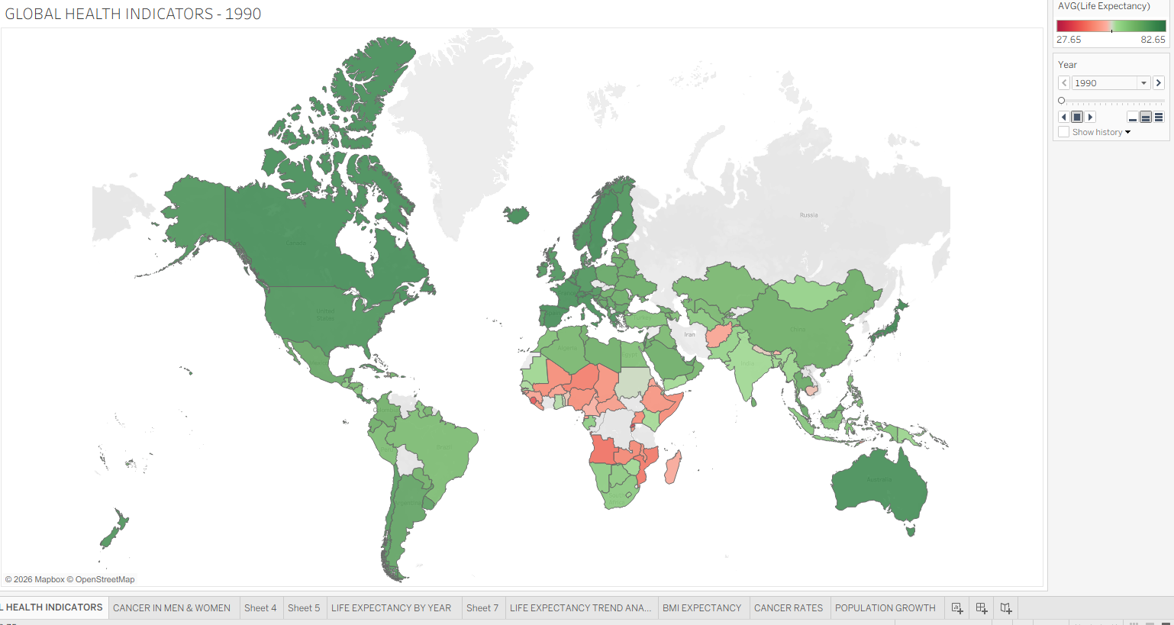  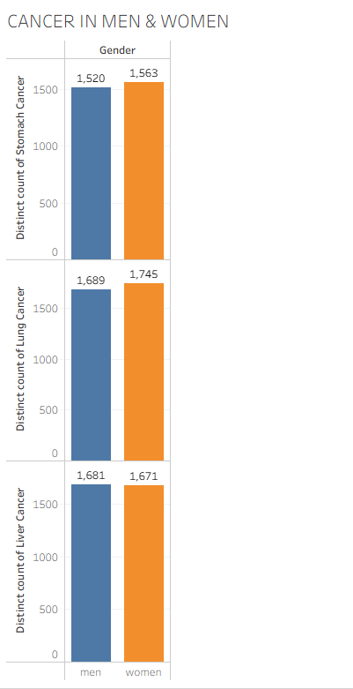  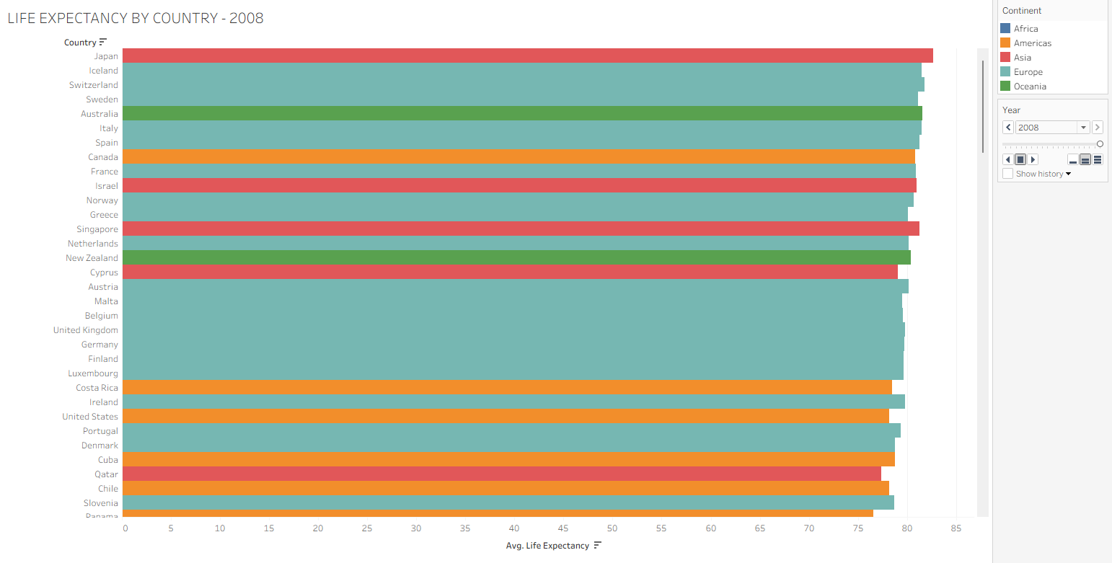
What did you find and any reflections on how the NHS could use this? | - The data tells us that life expectancy had gone up as years have progressed.  - Japan has the highest life expectancy rates from 1990-2008  - The NHS can use data from health survey’s for to aid in medical research.  - It could be used to track the spread of diseases  - Graphs that display cancer rates in men and women could be used for supporting research, raising awareness, and monitoring performance of treatment.

Day 3: Task 1

Please complete Lab 1 ‘Get Data in Power Bi Desktop’. Once complete, paste a print screen below and in the collaboration board.

“Teaching is the best way to learn, so please listen out for support requests from the class and we’ll work through the challenges together”

Paste your completed lab here | 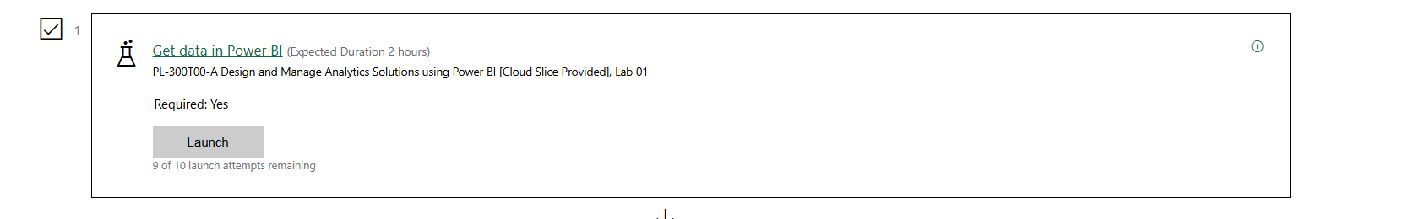  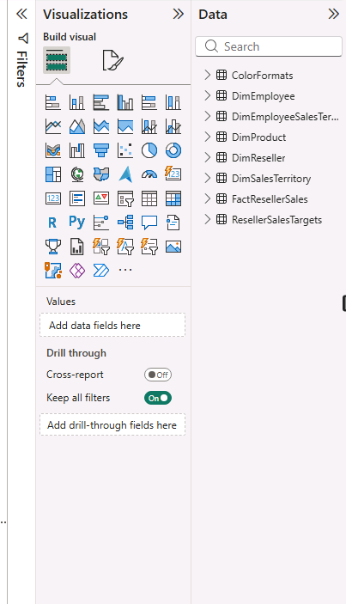

Day 3: Task 2

Please complete Lab 2 ‘Load Transformed Data in Power BI Desktop’. Once complete, paste a print screen below and in the collaboration board.

“Teaching is the best way to learn, so please listen out for support requests from the class and we’ll work through the challenges together”

Paste your completed lab here | 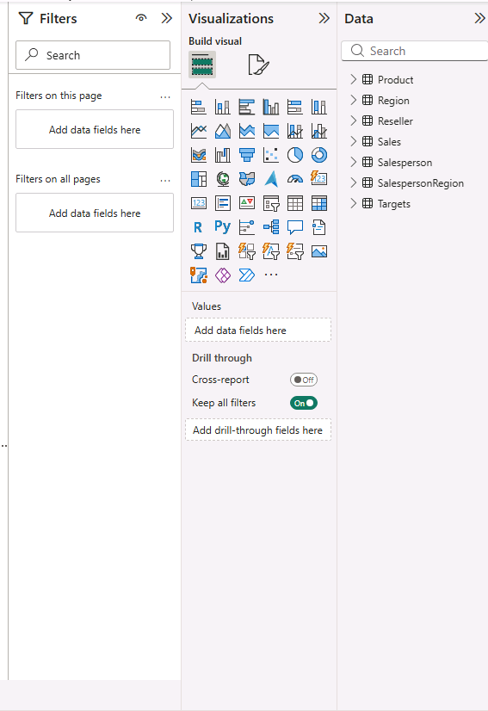

Day 4: Task 1

Please complete Lab 6 ‘Design a Report in Power BI Desktop’. Once complete, paste a print screen below and in the collaboration board.

“Teaching is the best way to learn, so please listen out for support requests from the class and we’ll work through the challenges together”

Paste your completed lab here | 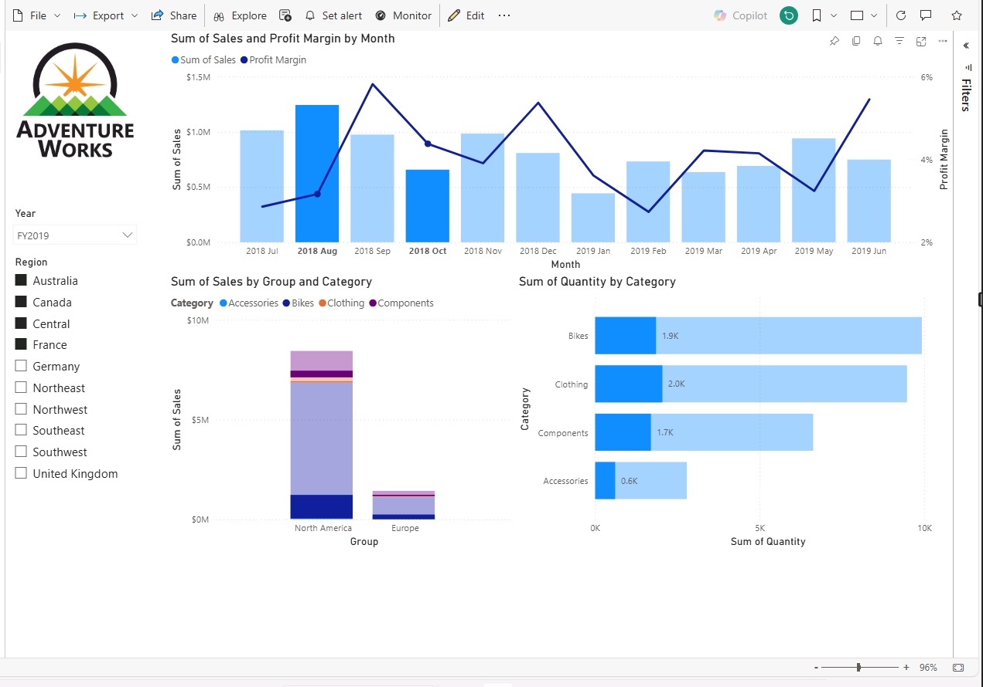

Day 4: Task 2

Please complete Lab 9 ‘Create a Power BI Dashboard’. Once complete, paste a print screen below and in the collaboration board.

“Teaching is the best way to learn, so please listen out for support requests from the class and we’ll work through the challenges together”

Paste your completed lab here | 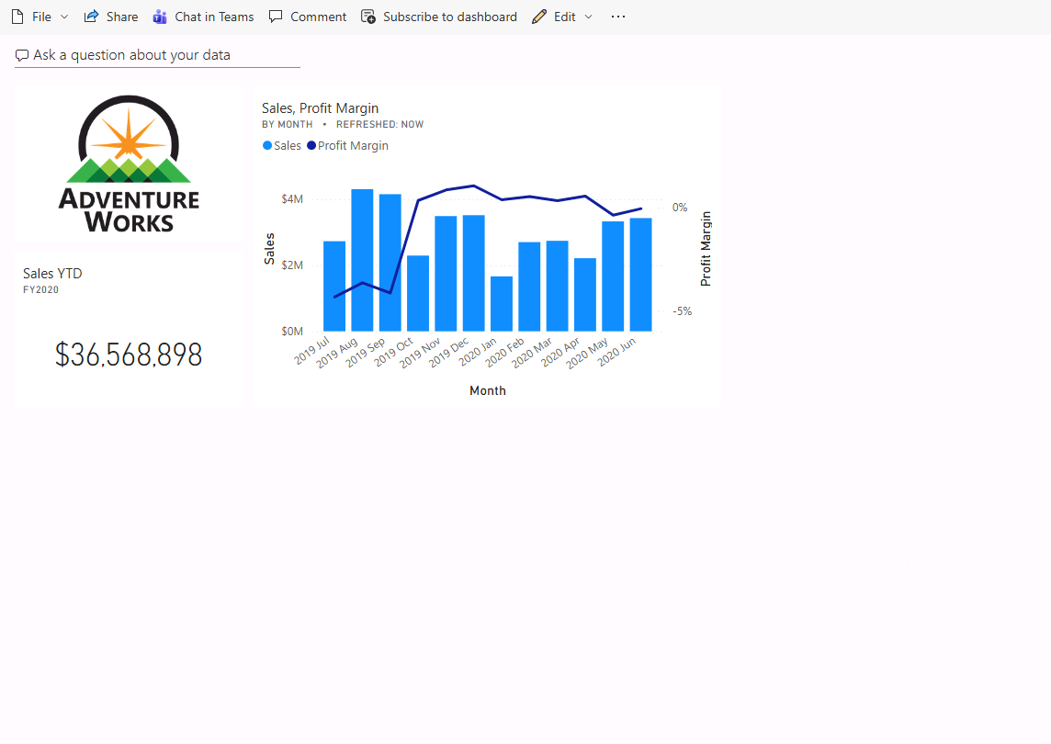

Course Notes

It is recommended to take notes from the course, use the space below to do so, or use the revision guide shared with the class:

Additional Information

We have included a range of additional links to further resources and information that you may find useful, these can be found within your revision guide.

END OF WORKBOOK

Please check through your work thoroughly before submitting and update the table of contents if required.

Please send your completed work booklet to your trainer.

