

Data Technician

Name:
Course Date:
Table of contents
Day 1: Task 1 3
Day 1: Task 2 3
Day 3: Task 1 4
Day 4: Task 1: Written 6
Day 4: Task 2: SQL Practical 9
Course Notes 19
Additional Information 19

Day 1: Task 1

Please research and complete the below questions relating to key concepts of databases.

What is a primary key? | A primary key is a unique identifier used to identify each record in a table.
How does this differ from a secondary key? | A secondary key is any index that isn’t the primary key of a table. It is as a filter or a way to lookup data. Primary keys and secondary keys still must be related to each other.
How are primary and foreign keys related? | A foreign key is a primary key being referenced in another table. A foreign key links data in one table in another table. It is used as a way of cross-referencing between two tables.
Provide a real-world example of a one-to-one relationship | User Account / Profile: A single user account has one associated detailed profile.
Provide a real-world example of a one-to-many relationship | Departments / Employees: One department employs many employees, but each employee only works in one department.
Provide a real-world example of a many-to-many relationship | Customers / Orders: A customer can place many orders, and one order can contain multiple products.

Day 1: Task 2

Please research and complete the below questions relating to key concepts of databases.

What is the difference between a relational and non-relational database? | Relational: This is data organised in a tabular format, organised in rows and columns. Each table has a predefined schema, including data types and relationships. Relational databases have constraints such as primary keys and foreign keys that enforce data integrity.  Non-relational: This is unstructured data that can be stored in various formats. This can handle large scales of data making it suitable for real-time analytics and big data applications. It also offers flexible data models that can handle unstructured data.
What type of data would benefit off the non-relational model?  Why? | Semi-structured or unstructured data because of the schemaless design; fields can vary between records. Data that is constantly changing because new fields can be added without downtime or complex migrations. High-volume data which is designed for horizontal scaling. Offers seamless scalability as data volume increases.

Day 3: Task 1

Please research the below ‘JOIN’ types, explain what they are and provide an example of the types of data it would be used on.

Self-join | A self-join is for when you want one table to reference itself, compare different rows within the same table. For it to work a table must have a unique identifier. They are often used in hierarchical data (employee-manager). They could be used to get all the names of the employees and the names of the managers that they report to.
Right join | Right join returns all records from the right table, and the matching records from the left table. If there are no matching records NULL values are included for those columns. They could be used in displaying all items from a table.
Full join | Full join retrieves all records from both tables, including matching and non-matching records. NULL values will be included if there are no matching records in one or both tables. Full join can provide a comprehensive view of data from multiple tables. It can be used in merging data. You may need to combine data from two tables into a single result set.
Inner join | An inner join combines rows from two tables where there is a match in the specified column. It is commonly used for integer or numeric data types such as in IDS and keys.
Cross join | A cross join returns every possible combination of rows from both tables. It could be used in customer data to combine the order information and the customer information.
Left join | A left join retrieves all the records from the left table and only the matching records from the right table, if there are no matching records it will appear as a null value. It could be used in employee data relating to the department they work in.

Day 4: Task 1: Written

In your groups, discuss and complete the below activity. You can either nominate one writer or split the elements between you. Everyone however must have the completed work below:

Imagine you have been hired by a small retail business that wants to streamline its operations by creating a new database system. This database will be used to manage inventory, sales, and customer information. The business is a small corner shop that sells a range of groceries and domestic products. It might help to picture your local convenience store and think of what they sell. They also have a loyalty program, which you will need to consider when deciding what tables to create.

Write a 500-word essay explaining the steps you would take to set up and create this database. Your essay should cover the following points:
- Understanding the Business Requirements:
  - What kind of data will the database need to store?
  - Who will be the users of the database, and what will they need to accomplish?
- Designing the Database Schema:
  - How would you structure the database tables to efficiently store inventory, sales, and customer information?
  - What relationships between tables are necessary (e.g., how sales relate to inventory and customers)?
- Implementing the Database:
  - What SQL commands would you use to create the database and its tables?
  - Provide examples of SQL statements for creating tables and defining relationships between them.
- Populating the Database:
  - How would you input initial data into the database? Give examples of SQL INSERT statements.
- Maintaining the Database:
  - What measures would you take to ensure the database remains accurate and up to date?
  - How would you handle backups and data security?

Your essay should include specific examples of SQL commands and explain why each step is necessary for creating a functional and efficient database for the retail business.

Please write your 500-word essay here | The database will need to store inventory, sales, and customer information as outlined in the brief. It will contain confidential customer information, so the database will be secured with a password. The shop owner and any other staff working in the shop would need access, so they can keep control of stock and know when to order more stock, and to know how much money they’ve generated from sales.  Tables would need to be structured with unique identifiers with each category, ie, product_id for inventory, customer_id for customers and sale_id for sales.  The relationships between tables are necessary, so for example inventory would need to be linked to sales, so you would know when to order stock, and sales would be linked to customers, so the shop would know what the customers are buying and how much they are spending.  Possible columns for each of the tables would be;  - Inventory- product_ID, price, category, quantity_in_stock  - Sales- sale_id, date & time, customer_id, product_id, amount in sales  - Customers- customer_id, loyalty_number, first_name, last_name, phone_number, amount spent, products purchased  Syntax for creating these table could look like  CREATE TABLE Inventory(  product_id INT PRIMARY KEY,  price INT,  catergory VARCHAR(255),  quantity_in_stock INT  );  CREATE TABLE Sales(  sale_id INT PRIMARY KEY,  time_of_sale datetime,  customer_id INT,  product_id INT,  revenue INT,  FOREIGN KEY (customer_id) REFERENCES Customers(customer_id),  FOREIGN KEY (product_id) REFERENCES Inventory(product_id)  );  CREATE TABLE Customer(  customer_id INT PRIMARY KEY,  loyalty_id INT,  first_name VARCHAR (100),  last_name VARCHAR (100),  phone_number VARCHAR(15)  ) ;  After the CREATE TABLE, is the name of the table, so it is unique and the table can easily be referenced.  The use of INT means it ensures the data is an integer, ie, a whole number, you cannot have half a can of beans in stock for example.  The use of PRIMARY KEYs mark these columns as the unique identifier in each table.  The use of VARCHAR to is store strings of characters, up to the number of digits in the brackets. This stops too much data being stored and slowing down the database.  The initial data would inputted into the database by INSERT INTO statements.  So for example, for Inventory,  INSERT INTO Inventory (product_id, price, category, quantity_in_stock) VALUES (“154”, “20.15”, “bread”, “15”)  This allows the data to be entered into the relevant table, with all the information entered for each column in the table.  To maintain the database and ensure it remains up to date, you can do a monthly stock check by physically checking the items you have in store matches to what’s in the database.  You can also get another employee to check the data if you have updated it yourself, to ensure accuracy and you haven’t overlooked something.  Ensure the data being entered has been cleaned, as the expression goes, garbage in equals garbage out.  In terms of sales, all transactions would go through the till. Make sure the till’s data matches that in the database.  Double check or triple check the data you are uploading, looking for any obvious anomalies, for example if a can of beans has mistakenly been priced at £200 instead of £2.00. Ensure that only people who know how to code to the SQL database have access, ie through the use of passwords. Someone who doesn’t know what they are doing could really mess up the database.  The database could potentially be hacked by cybercriminals. Ensuring IT best practices are followed, ie, not downloading a link from a random email without checking it first, otherwise they could potentially download malware on your computer to get to your confidential information held in the database.  Databases should be backed up, preferably to a secure cloud environment, so in the case of computer failure, the whole database is not lost.

Day 4: Task 2: SQL Practical

In your groups, work together to answer the below questions. It may be of benefit if one of you shares your screen with the group and as a team answer / take screen shots from there.

Setting up the database:

- Download world_db(1) here
- Follow each step to create your database here

For each question I would like to see both the syntax used and the output.

- Count Cities in USA: Scenario: You've been tasked with conducting a demographic analysis of cities in the United States. Your first step is to determine the total number of cities within the country to provide a baseline for further analysis.

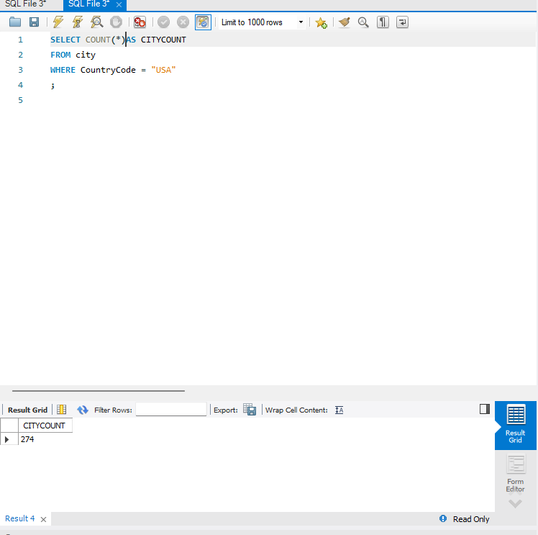

- Country with Highest Life Expectancy: Scenario: As part of a global health initiative, you've been assigned to identify the country with the highest life expectancy. This information will be crucial for prioritising healthcare resources and interventions.

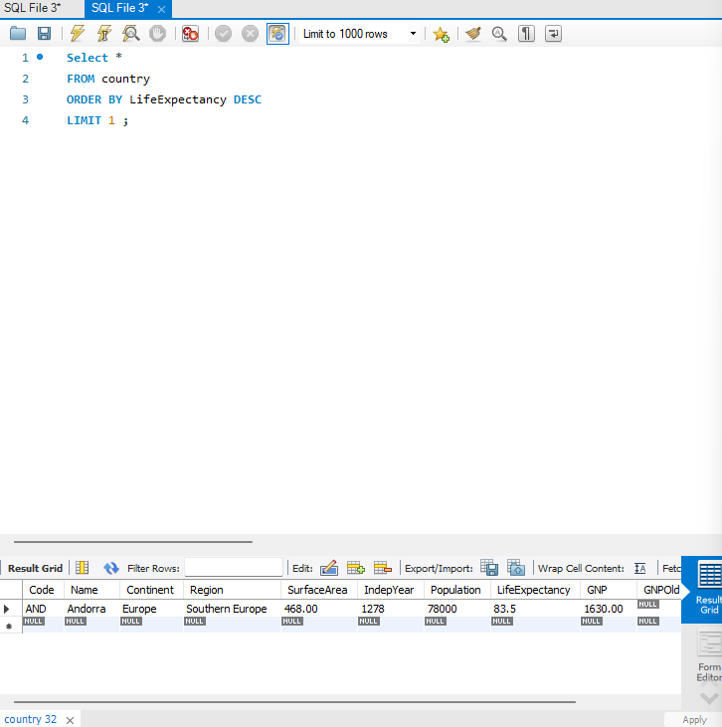

- "New Year Promotion: Featuring Cities with 'New : Scenario: In anticipation of the upcoming New Year, your travel agency is gearing up for a special promotion featuring cities with names including the word 'New'. You're tasked with swiftly compiling a list of all cities from around the world. This curated selection will be essential in creating promotional materials and enticing travellers with exciting destinations to kick off the New Year in style.

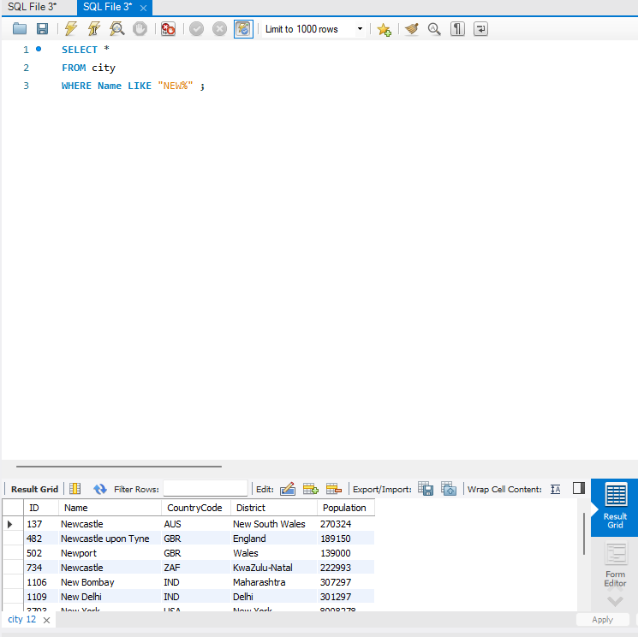

- Display Columns with Limit (First 10 Rows): Scenario: You're tasked with providing a brief overview of the most populous cities in the world. To keep the report concise, you're instructed to list only the first 10 cities by population from the database.

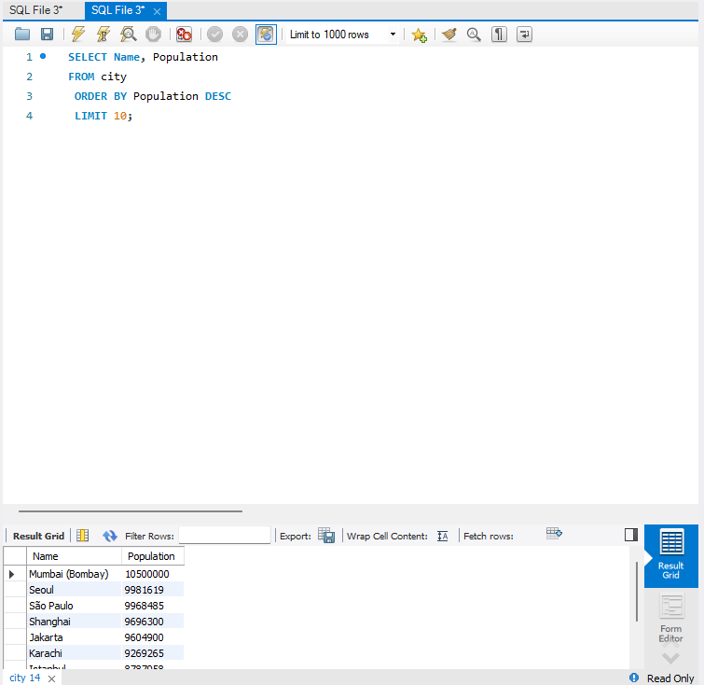

- Cities with Population Larger than 2,000,000: Scenario: A real estate developer is interested in cities with substantial population sizes for potential investment opportunities. You're tasked with identifying cities from the database with populations exceeding 2 million to focus their research efforts.

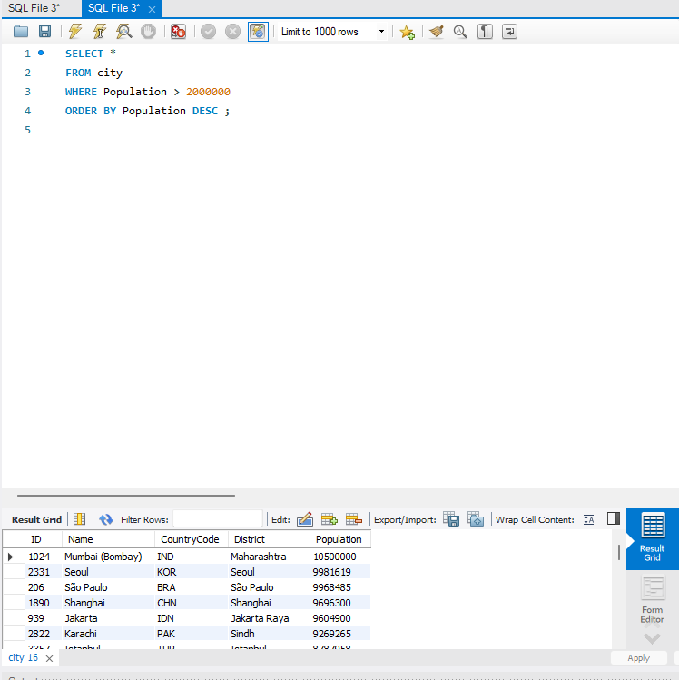

- Cities Beginning with 'Be' Prefix: Scenario: A travel blogger is planning a series of articles featuring cities with unique names. You're tasked with compiling a list of cities from the database that start with the prefix 'Be' to assist in the blogger's content creation process.

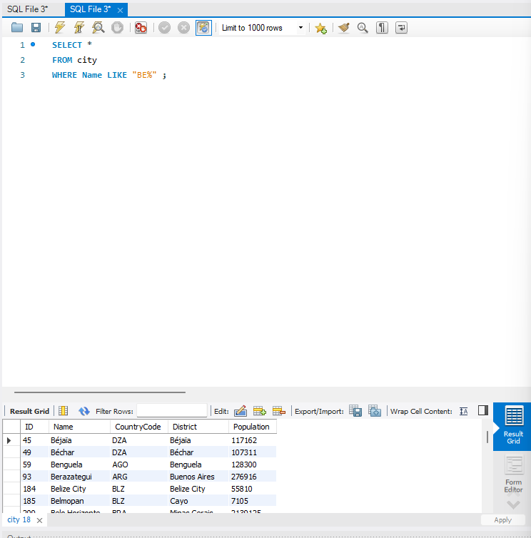

- Cities with Population Between 500,000-1,000,000: Scenario: An urban planning committee needs to identify mid-sized cities suitable for infrastructure development projects. You're tasked with identifying cities with populations ranging between 500,000 and 1 million to inform their decision-making process.

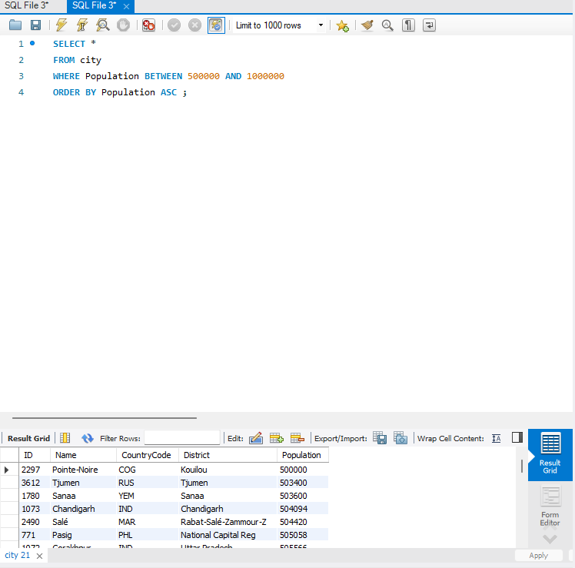

- Display Cities Sorted by Name in Ascending Order: Scenario: A geography teacher is preparing a lesson on alphabetical order using city names. You're tasked with providing a sorted list of cities from the database in ascending order by name to support the lesson plan.

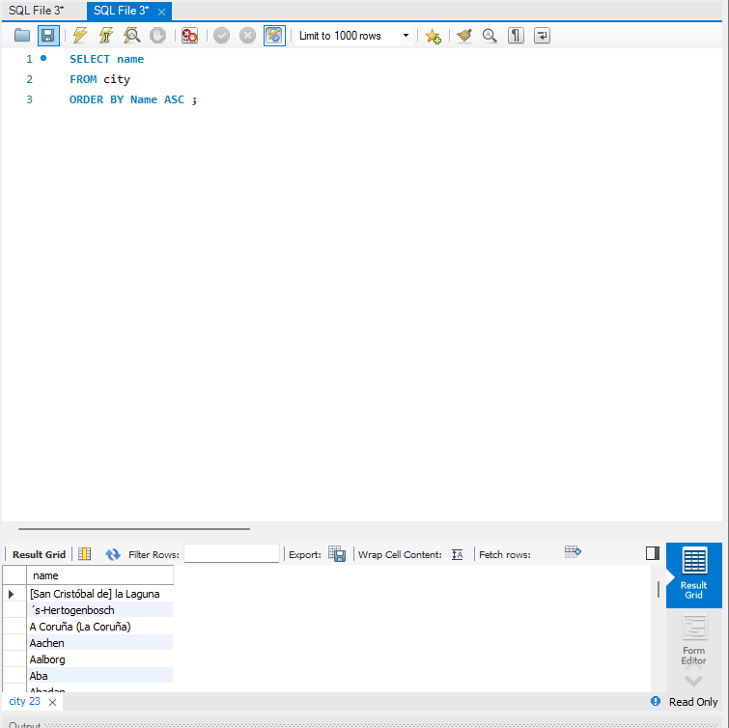

- Most Populated City: Scenario: A real estate investment firm is interested in cities with significant population densities for potential development projects. You're tasked with identifying the most populated city from the database to guide their investment decisions and strategic planning.

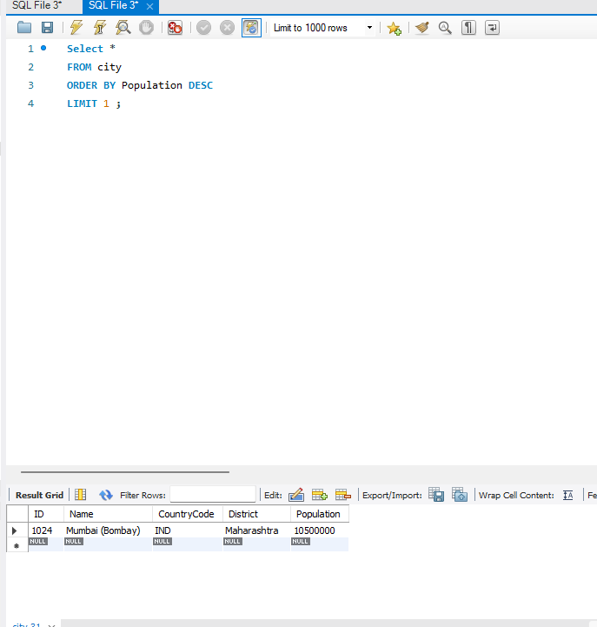

- City Name Frequency Analysis: Supporting Geography Education Scenario: In a geography class, students are learning about the distribution of city names around the world. The teacher, in preparation for a lesson on city name frequencies, wants to provide students with a list of unique city names sorted alphabetically, along with their respective counts of occurrences in the database. You're tasked with this sorted list to support the geography teacher.

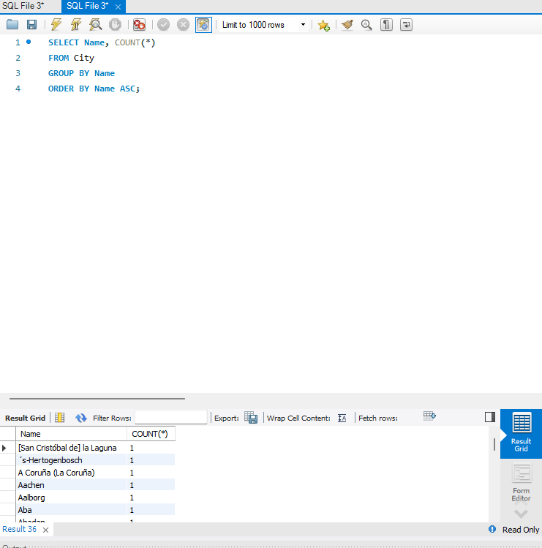

- City with the Lowest Population: Scenario: A census bureau is conducting an analysis of urban population distribution. You're tasked with identifying the city with the lowest population from the database to provide a comprehensive overview of demographic trends.

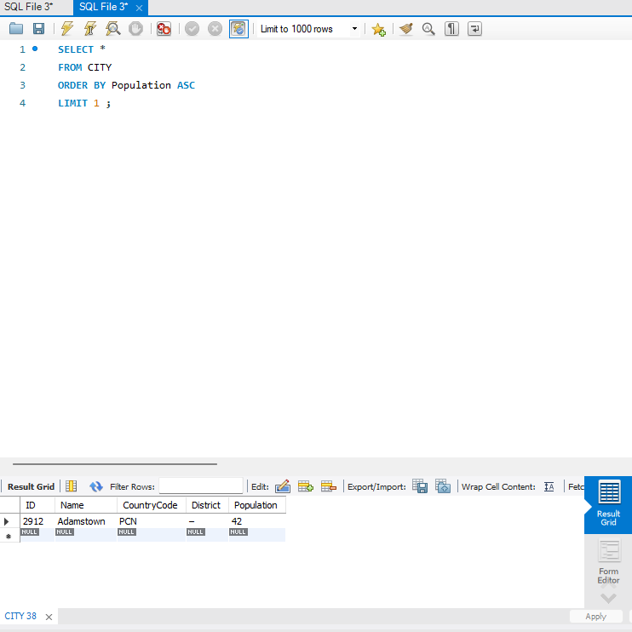

- Country with Largest Population: Scenario: A global economic research institute requires data on countries with the largest populations for a comprehensive analysis. You're tasked with identifying the country with the highest population from the database to provide valuable insights into demographic trends.

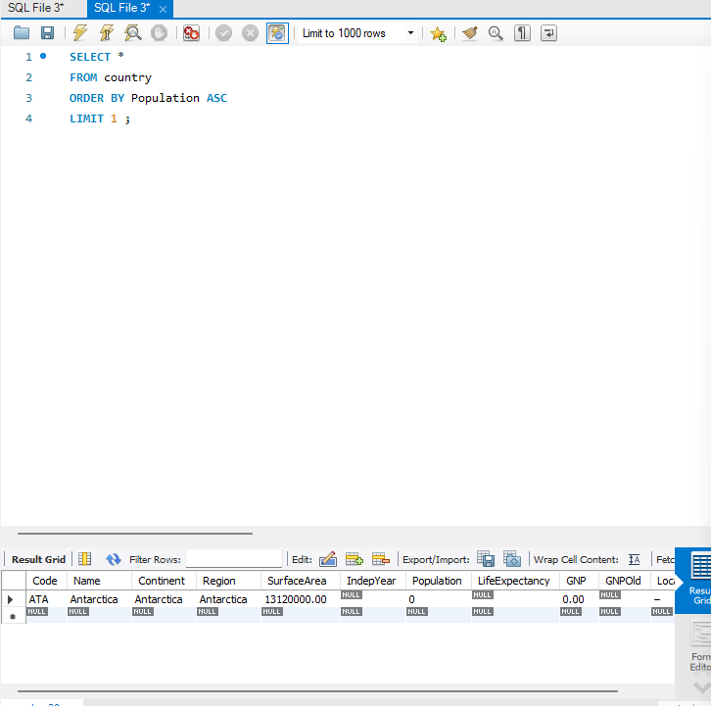

- Capital of Spain: Scenario: A travel agency is organising tours across Europe and needs accurate information on capital cities. You're tasked with identifying the capital of Spain from the database to ensure itinerary accuracy and provide travellers with essential destination information.

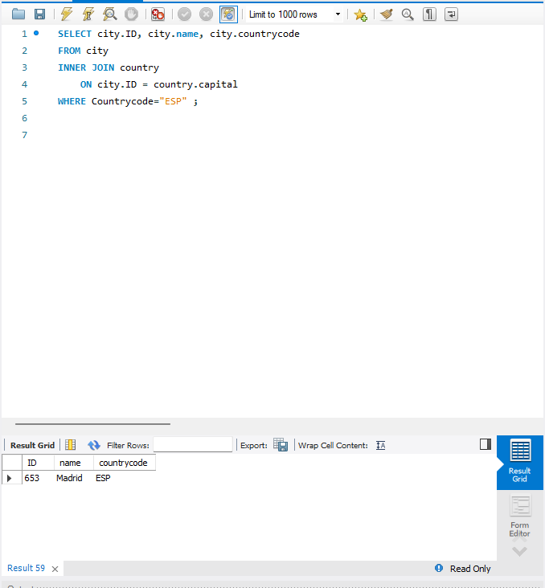

- Cities in Europe: Scenario: A European cultural exchange program is seeking to connect students with cities across the continent. You're tasked with compiling a list of cities located in Europe from the database to facilitate program planning and student engagement.
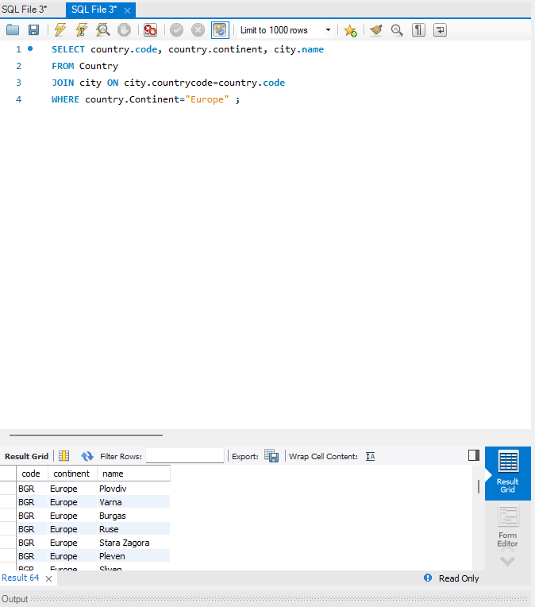

- Average Population by Country: Scenario: A demographic research team is conducting a comparative analysis of population distributions across countries. You're tasked with calculating the average population for each country from the database to provide valuable insights into global population trends.

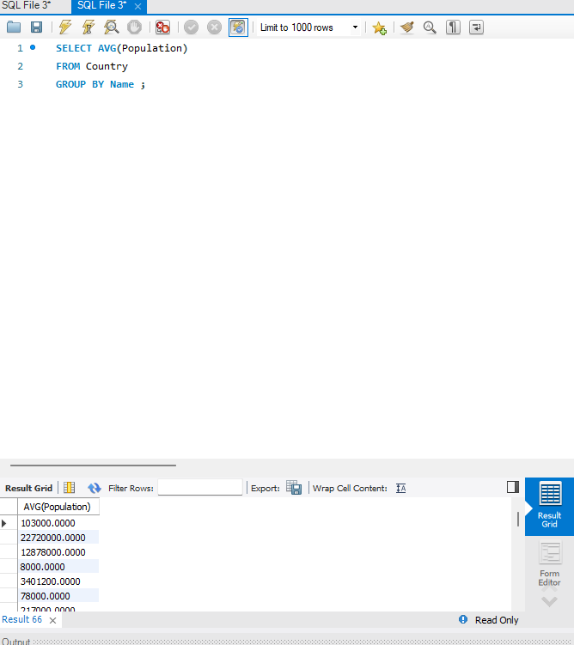

- Capital Cities Population Comparison: Scenario: A statistical analysis firm is examining population distributions between capital cities worldwide. You're tasked with comparing the populations of capital cities from different countries to identify trends and patterns in urban demographics.

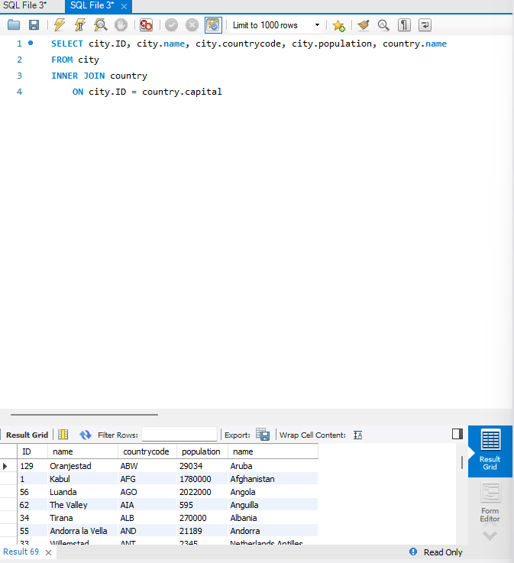

- Countries with Low Population Density: Scenario: An agricultural research institute is studying countries with low population densities for potential agricultural development projects. You're tasked with identifying countries with sparse populations from the database to support the institute's research efforts.

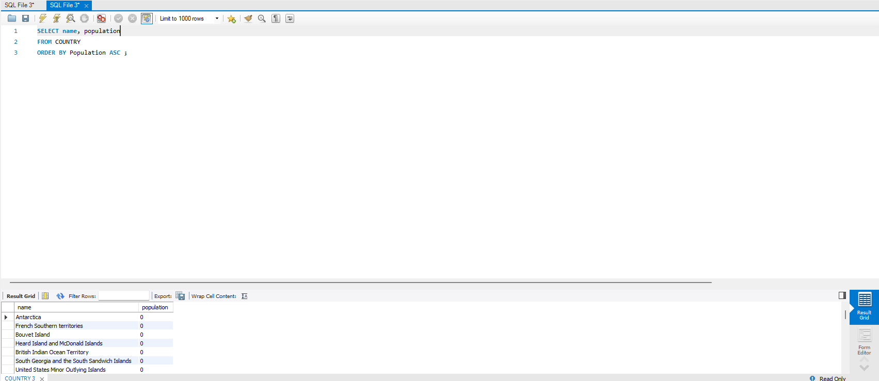

- Cities with High GDP per Capita: Scenario: An economic consulting firm is analysing cities with high GDP per capita for investment opportunities. You're tasked with identifying cities with above-average GDP per capita from the database to assist the firm in identifying potential investment destinations.

- Display Columns with Limit (Rows 31-40): Scenario: A market research firm requires detailed information on cities beyond the top rankings for a comprehensive analysis. You're tasked with providing data on cities ranked between 31st and 40th by population to ensure a thorough understanding of urban demographics.

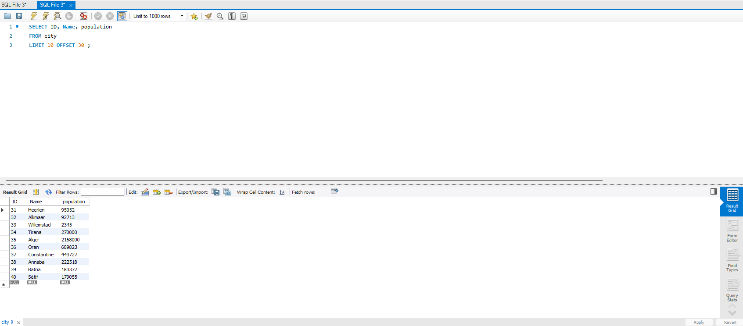

Course Notes

It is recommended to take notes from the course, use the space below to do so, or use the revision guide shared with the class:

Additional Information

We have included a range of additional links to further resources and information that you may find useful, these can be found within your revision guide.

END OF WORKBOOK

Please check through your work thoroughly before submitting and update the table of contents if required.

Please send your completed work booklet to your trainer.

