

Deep Learning

Objectives

Objectives

The aim of this lab is to setup a Linux Data Science Virtual Machine to perform the hands-on labs in the course.

Setup

1. Login to the portal at portal.azure.com and create a Data Science Virtual Machine for Linux. Follow the steps shown below.

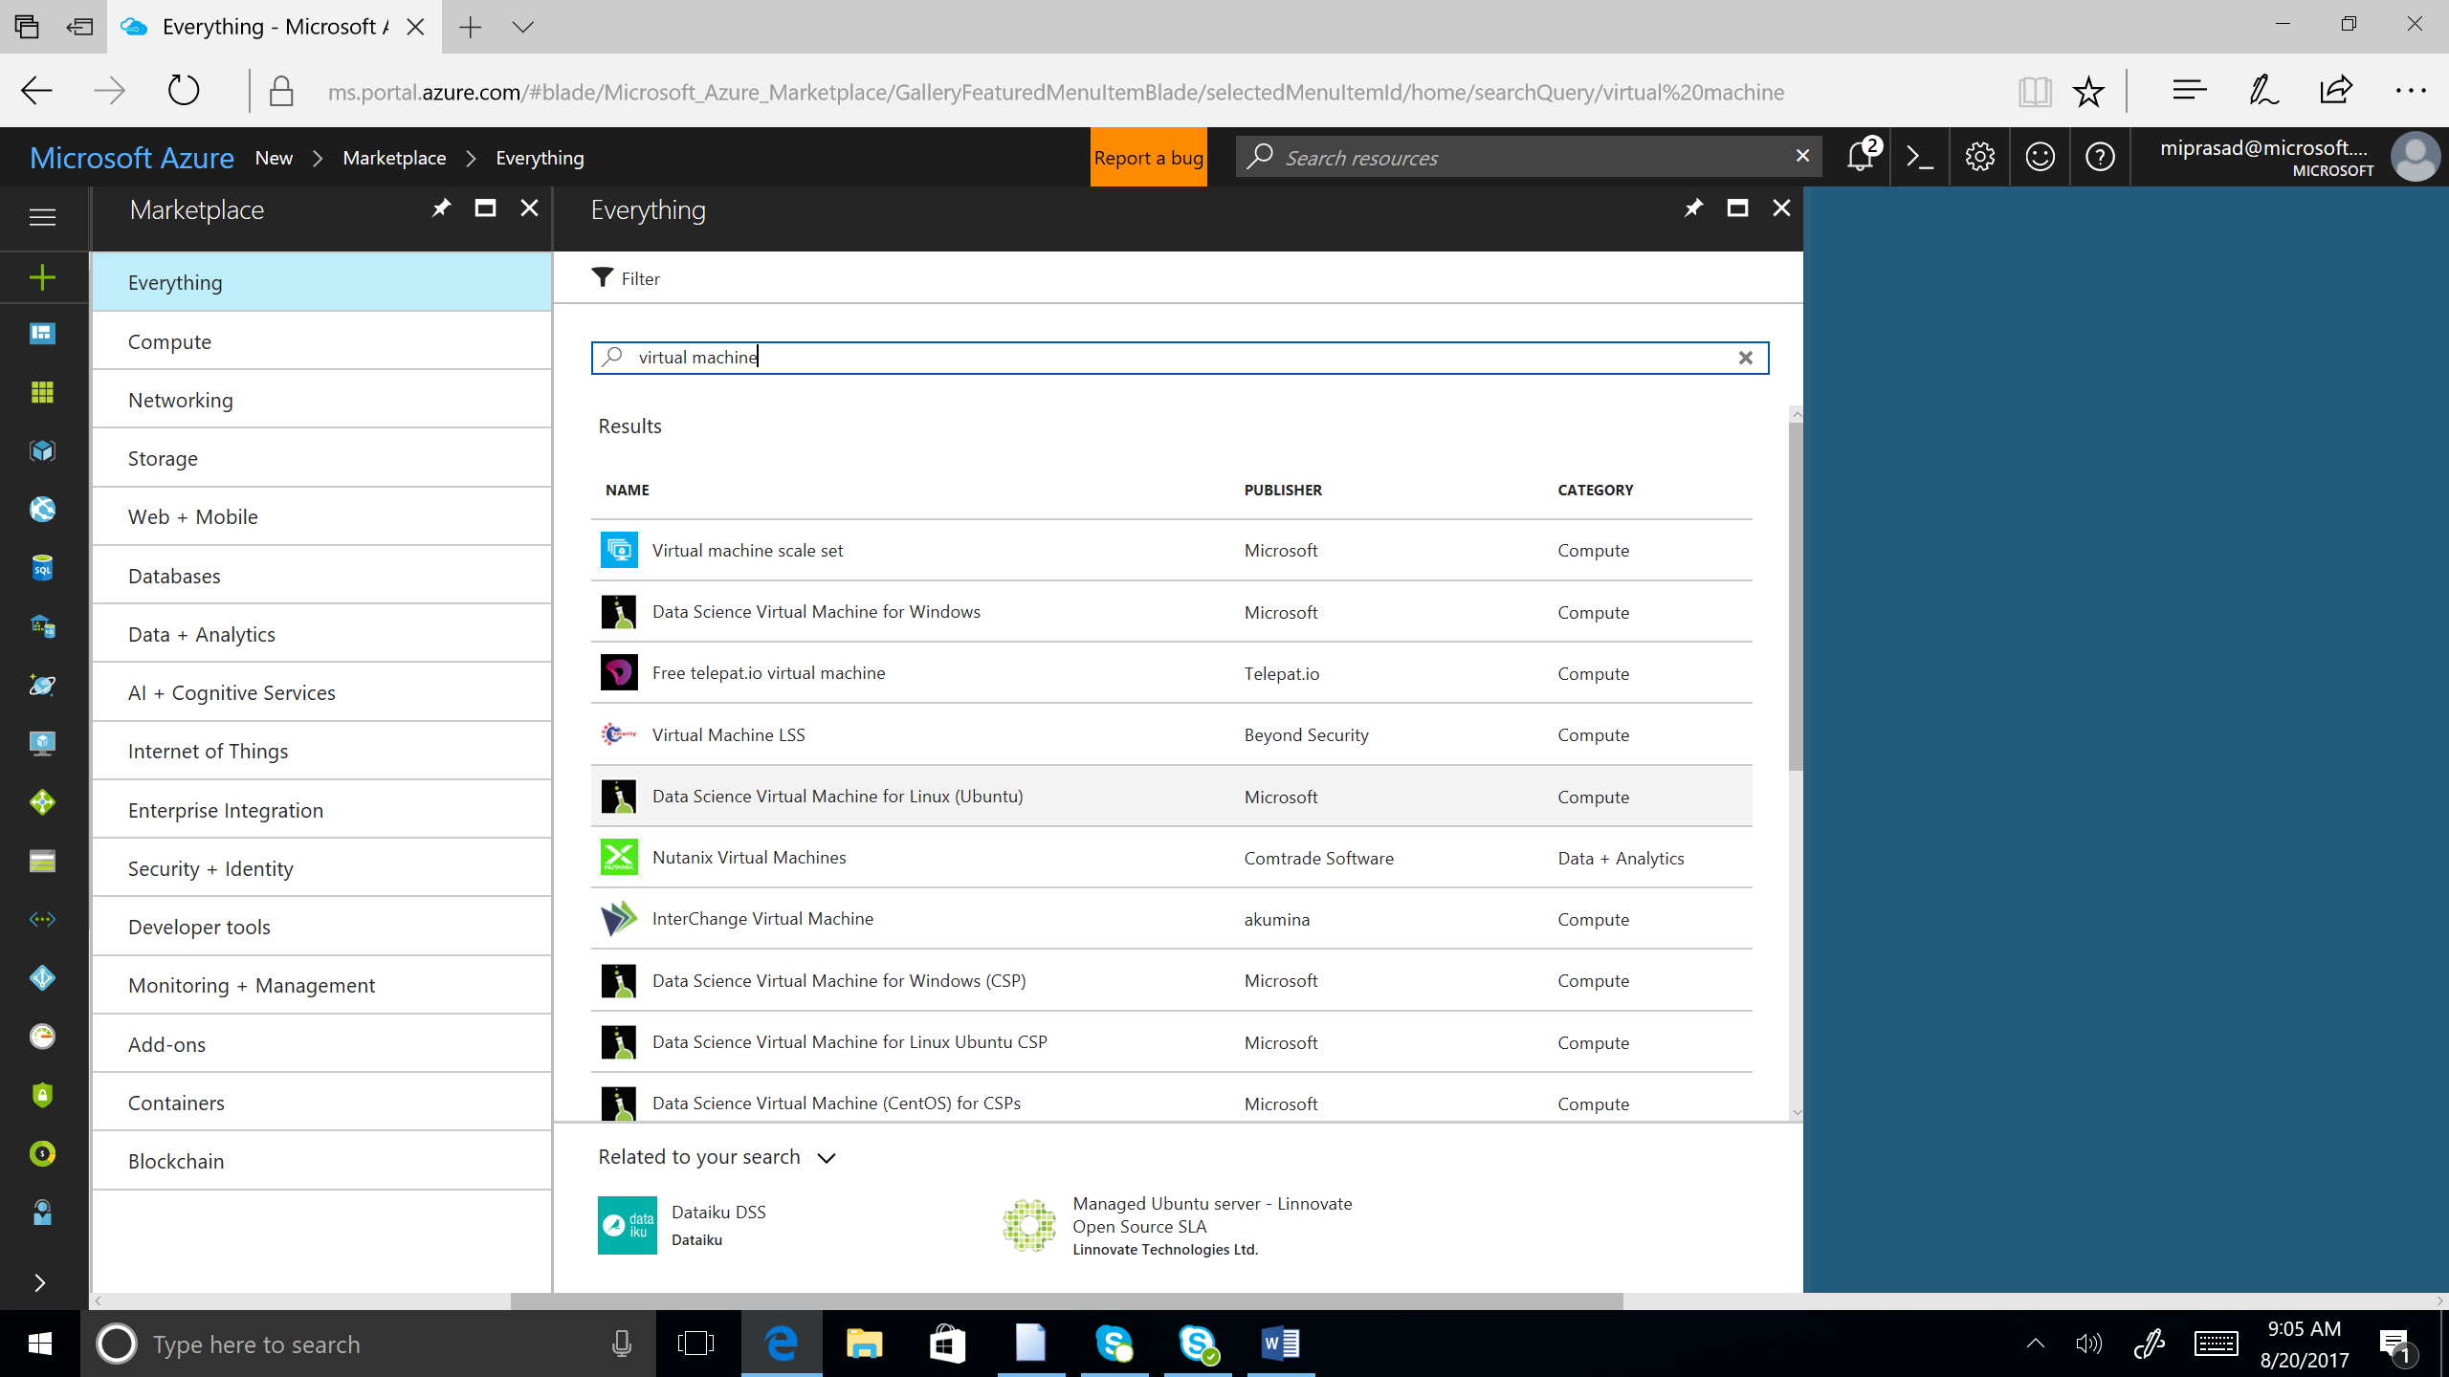

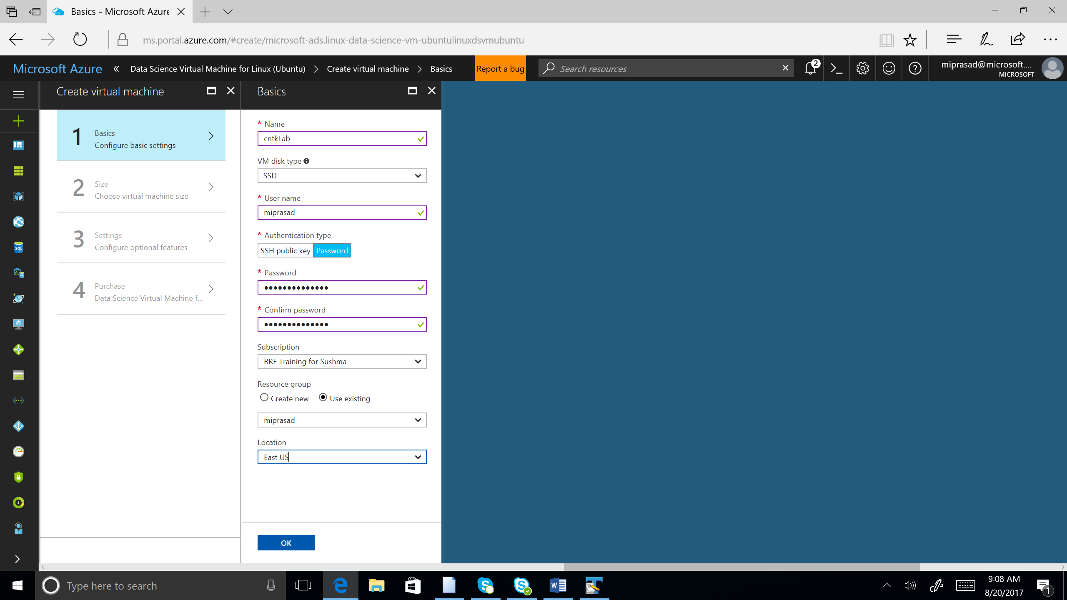

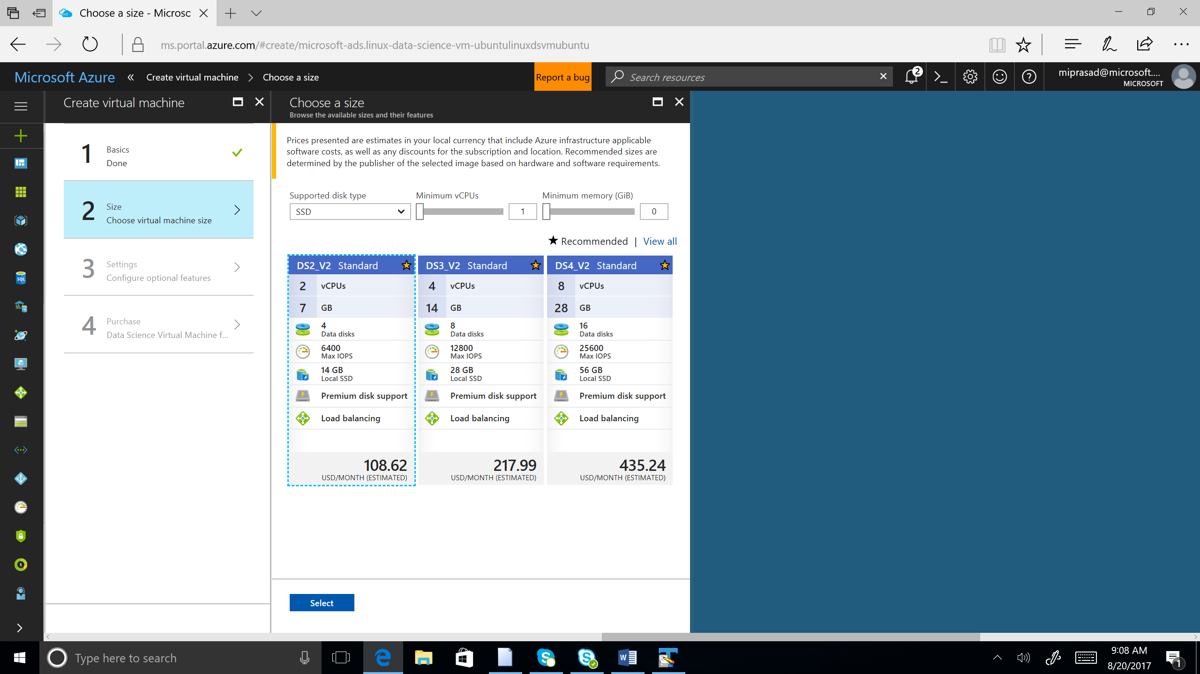

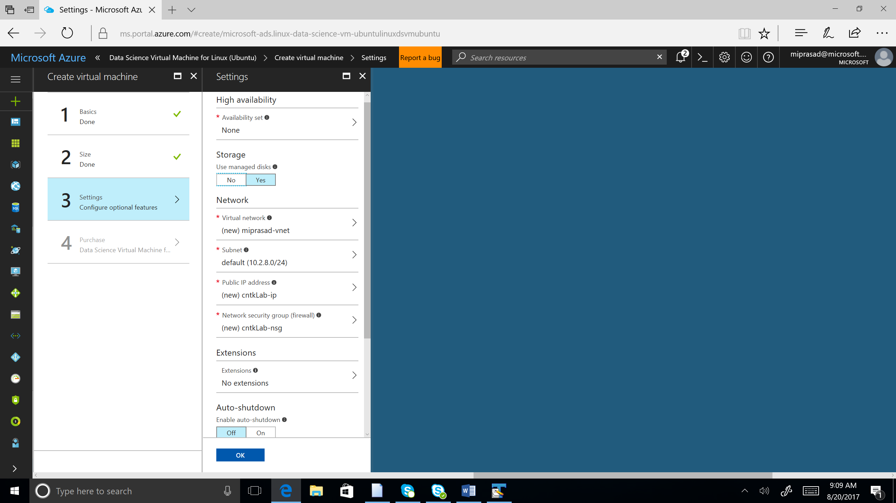

1. On successful creation of the virtual machine, you will see a public ip address as shown below.

. 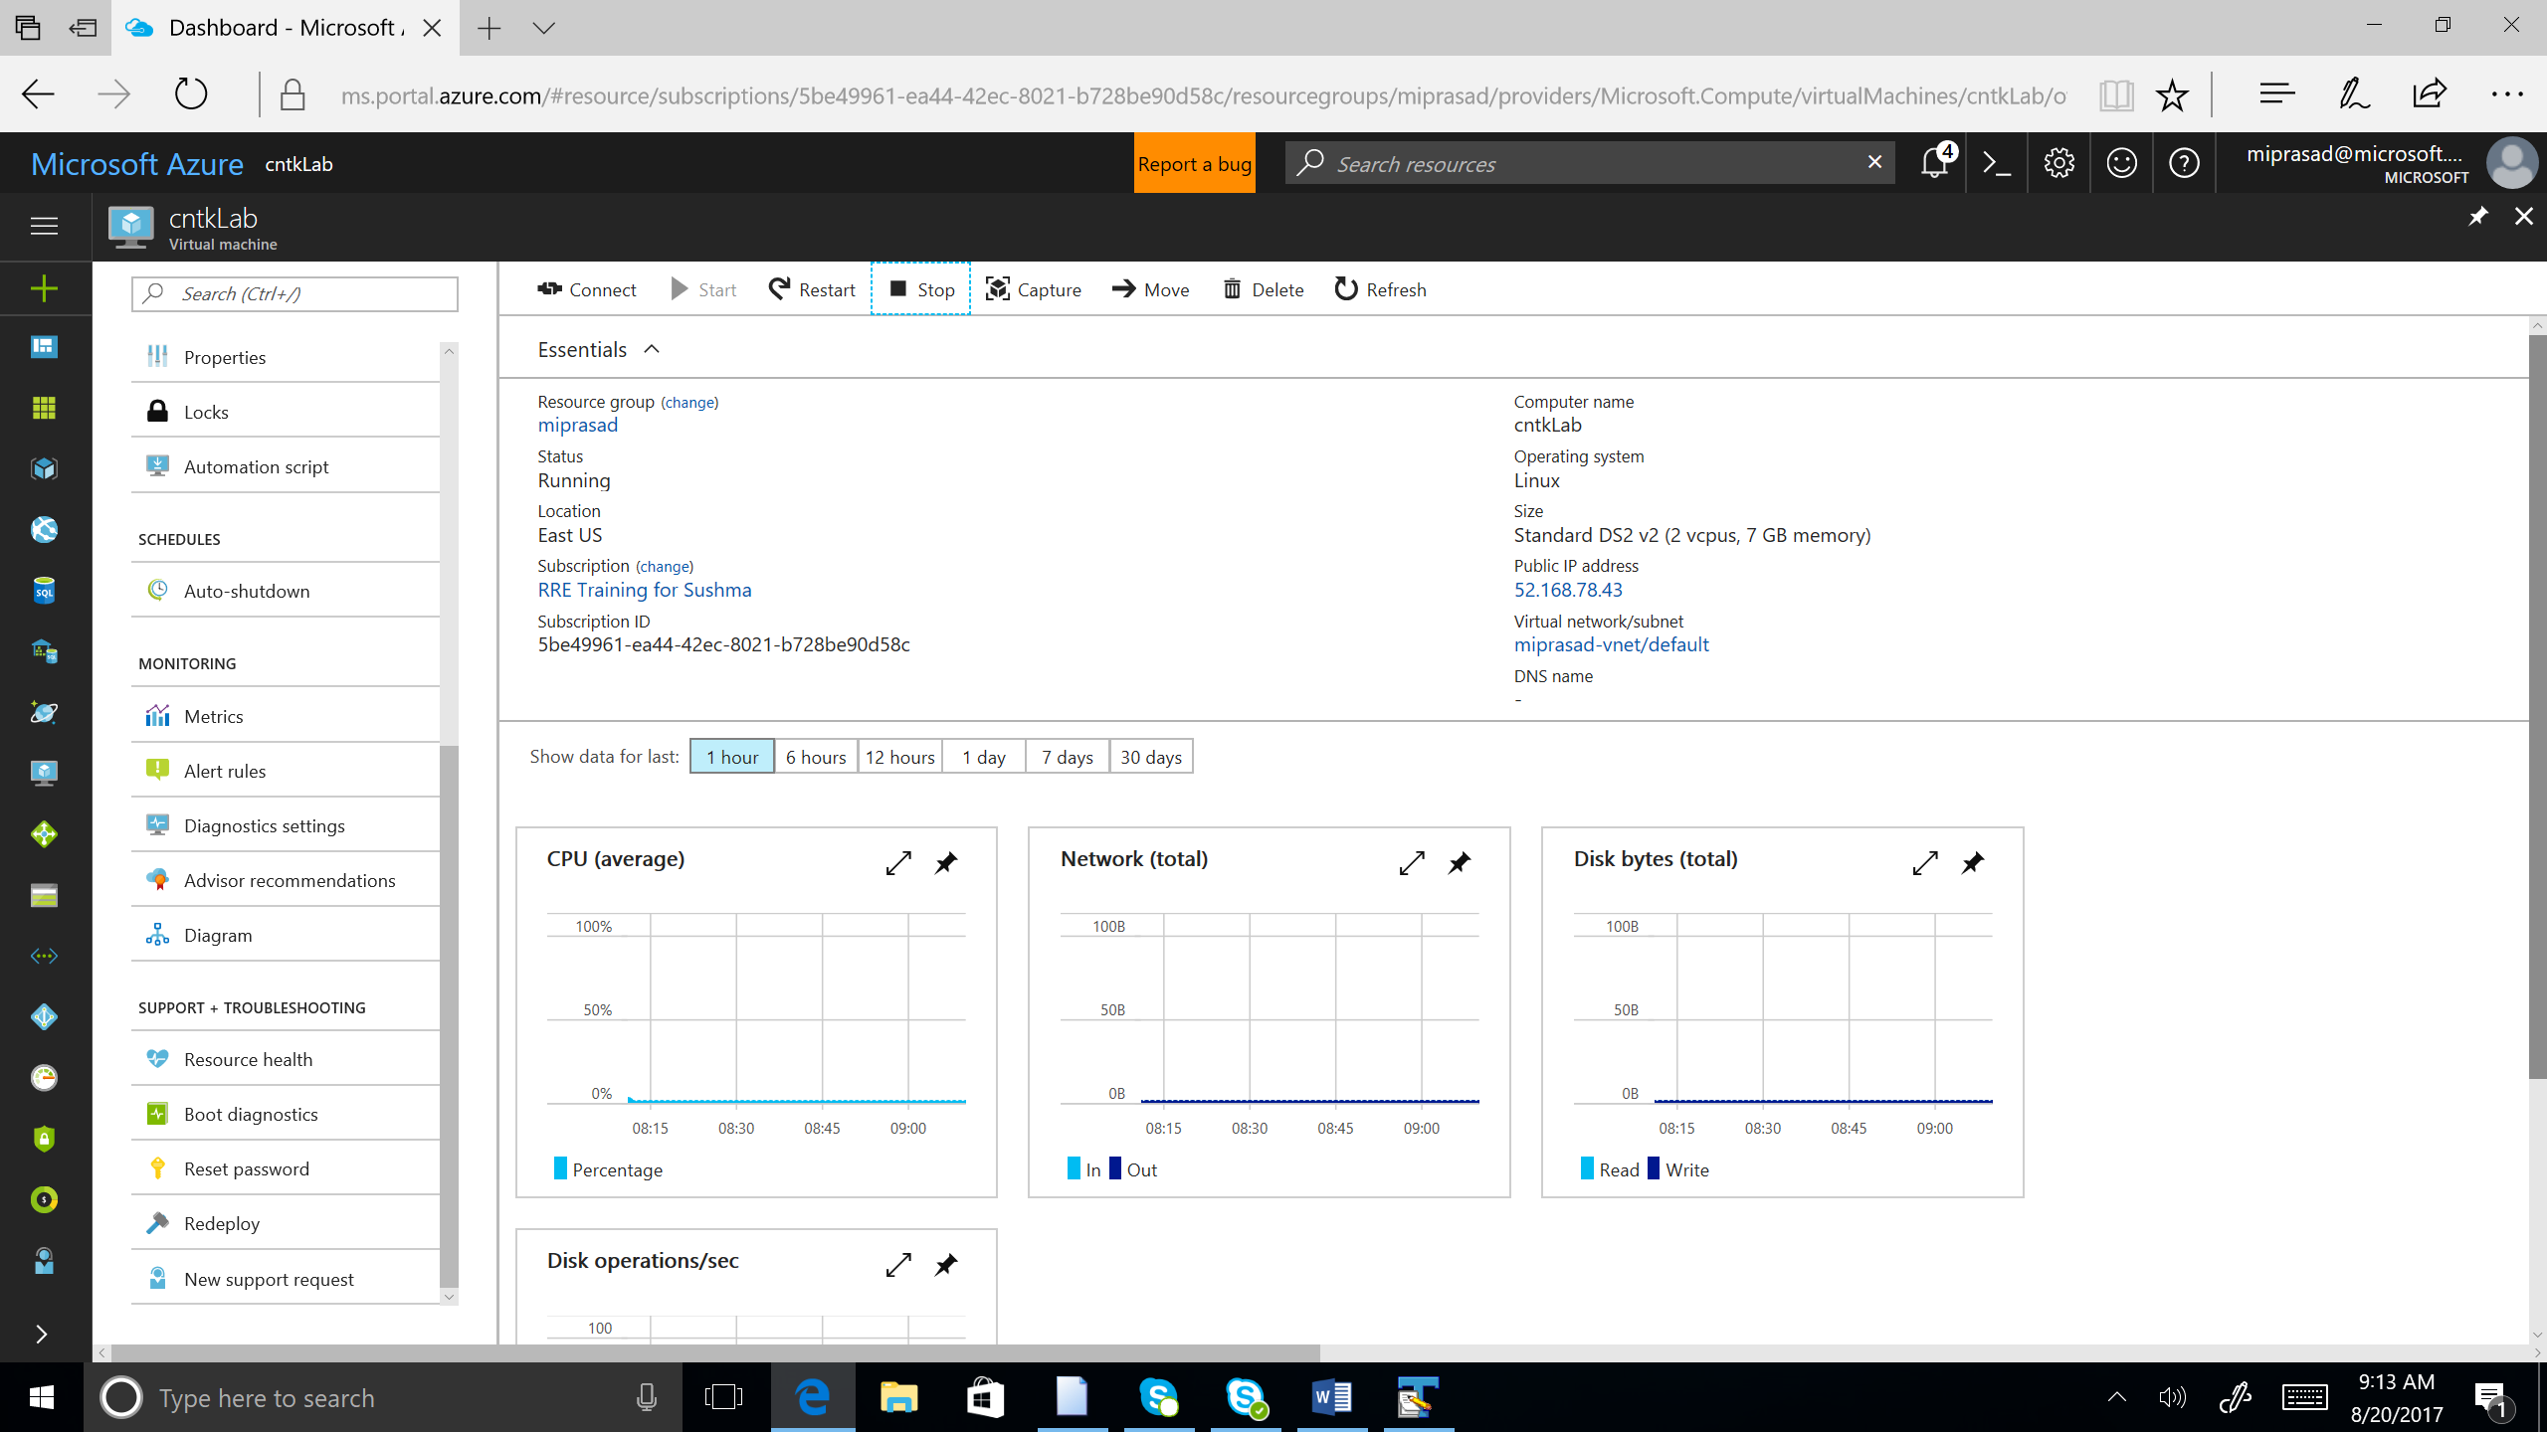

1. ssh into the virtual machine using the username and ip address

(for example, ssh [miprasad@52.179.15.126](mailto:miprasad@52.179.15.126))

You should see the below screen.

