Ha Tran

EE104

04/23/2023

Lab 7 Documentation

In this documentation, I will go over the AI we trained as well as the game creation – Balloon flight.

I utilize YOLO to train our computer to recognize individuals and objects for the YOLO5 model training. I take images of ourselves for the AI to recognize us. In the end, I also train my calculator. As a result, when we run the code, our computer will recognize me and my calculator, as shown in the figures below.

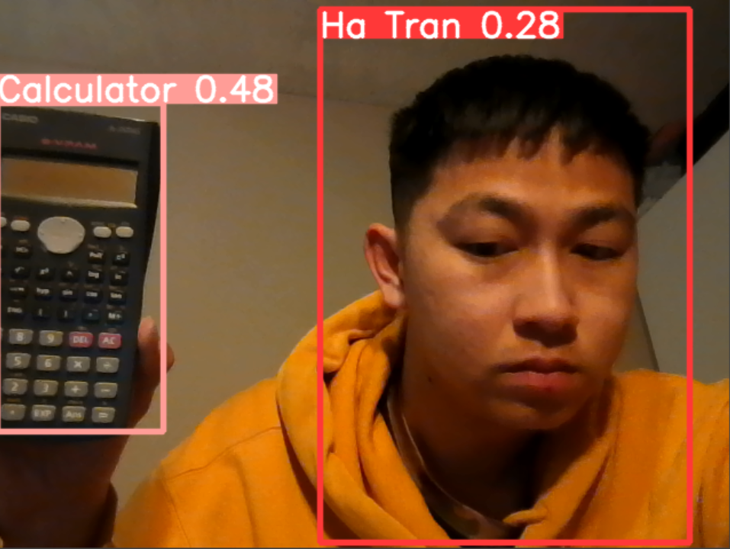

Finally, we are going to explain the game part. The game for lab 8 is about developing a Balloon flight. For Hacks and Tweaks, I choose Lives, Speed it up, More high scores, and Add in Multiples of Each obstacle.

As shown in the figure below, every time the balloon hit any obstacles, the HP will decrease.

As the figure below shows that there are 5 highest scores

Yolov8 youtube link: <https://youtu.be/HWqenHtFAS8>

Balloon Flight youtube link: <https://youtu.be/XlEoJAAwHeM>

GitHub: