Flask Othello user manual

Author: Harry Williams - 750016639

License: MIT, see LICENSE.txt in this directory or the repository for more details

Installations

All programming files apart from the templates have been created using Python 3.13.7, which can be installed here:
https://www.python.org/downloads/release/python-3137/

This can be run in IDLE, the default environment for python however I would recommend another IDE such as Visual Studio code, as this also allows access to the template files.

If Visual Studio code is your chosen IDE, it can be installed here:
https://code.visualstudio.com/

To run the command line 2-player version of the game, the components.py and game_engine.py need to be downloaded, either from Stage 1 or the repository.

To run the flask implementation of the game, components.py and either flask_game_engine.py from Stage 3 or flask_game_engine_ai.py from the repository need to be downloaded. For either .py file install the templates folder in the corresponding directory e.g. if downloading the game engine from Stage 3, download the templates folder in Stage 3.

Libraries

For the command line game, no extra libraries are needed to run the code.

For the flask implementation, a number of libraries are required:

- The Flask library, which can be installed by running the command pip install Flask in the command line interface – if you have issues using pip check this website: https://pip.pypa.io/en/stable/installation/

- The libraries random, json, time and logging are also required however these libraries are built-in packages so no extra installations are required.

Running the project

The flask version of the game can be played here without needing the source code:
https://harrywilliams.pythonanywhere.com/
This requires an internet connection and a web browser.

The command line version can be used by running the installed game_engine.py file with an open terminal to see the board, input coords etc.

The flask version of the game can be used by running the installed file flask_game_engine.py or flask_game_engine_ai.py. Whilst the file is running go to the localhost port: http://127.0.0.1:5000 to play the game. This link should appear in the terminal when the file is running or can be accessed by simply following the link here. Refreshing the page will reset the current game and board state.

API / Web Framework

The API used, Flask, is a web framework that maps python functions to URLs that are called on the HTML webpage. Flask is a WSGI framework which simply means it forwards requests to back-end applications from front end web servers. When a URL is called in the frontend, Flask handles the request by running the specified function in python and returning a response. The HTML files use jinja syntax to allow them to act as templates for the python files. Both GET and POST requests can be handled using Flask. A different GUI could be implemented by changing the templates but calling the python functions with the same URLs.

Unit Testing

For the unit testing for this project, I have used pytest to create automated tests for components.py and some of the functions in flask_game_engine.py. These tests cover a range of cases from normal usage to edge cases and some erroneous inputs. The functions embedded within app routes have not been tested with pytest, so they will be tested manually here.

Note: View test_components.py and test_flask_game_engine.py in either stage 3 or the repository to see the full automated testing code. Pytest can be performed by installing pytest with pip install pytest and running the command pytest file_name.py
or python -m pytest file_name.py.

Components.py

Initialise_board() function

Normal tests

For the normal test, I have tested if the board is made as it should be with the default parameter size = 8. The board produced should look like this:
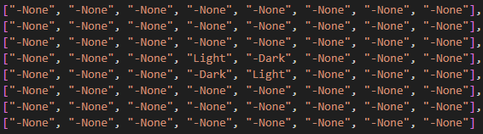

As we can see here the test has passed:

Edge cases

For the first edge case, I have checked whether the board works for an extremely small board, like 2x2. The expected outcome of this should be:
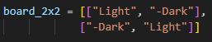

This is because the middle 4 elements of the board are changed to “Light” and “-Dark” accordingly to get the initial board state.

For the next edge case, I have checked whether the board works for a small board with an odd number of elements. This is because the functions behaviour could change with odd board sizes, like not setting the initial 4 tiles correctly. To test this, I have set size to 3 and the output should be:
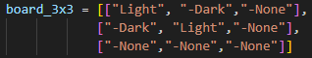

An output like this is expected as I have casted centre values to integers when calculating them, which always rounds down. I believe this is a valid solution as a board with odd x odd dimensions will not have a fully central 4x4 subspace.

Finally, I have tested the function with a board that has large dimensions. Setting the size parameter to 15 should produce a board with the dimensions 15x15, with the 4 central points set to the starting tiles. I have made a board for this but it is too large to screenshot here. It can be viewed in test_components.py.

As we can see here all of these tests have passed:

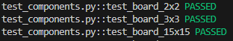

Erroneous tests

For the first erroneous test I have set the size parameter to 0. This should return None as a ZeroError has occurred. A board with 0x0 dimensions cannot be made and the function should reflect this by not returning a board.

For the second erroneous test I have set the size parameter to “abcd”. This should be caught as an exception by the function and None should be returned.

Both of these tests have passed:

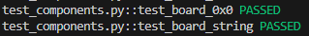

Legal_move() function

Normal tests

For the first two normal tests, I have checked whether both colours return True for the starting board with specific coordinates, that looks like the 8x8 board mentioned in previous testing. Both of these should return True. The specific coords I have used ( starting at (0,0) ) are (3,2) for dark and (3,5) for light. I have used these as both of should return just one valid direction on the starting board. Dark (0,1) as the valid move is vertical downwards and light (0,-1) as the move is vertical upwards. These tests are significant as this is how the function should act for valid moves.

The other normal tests I have performed aim to test whether the function returns False when moves are invalid. I have used the starting board again for both colours however I have set both coord parameters as (0,0). Both of these should return False as the moves are invalid by the rules of othello. None is also returned as no directions are to be returned.

All of these tests have passed:

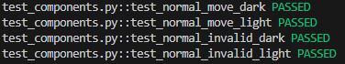

Edge cases – valid moves

For the first edge cases, I have tested both colours on a board where there is only one valid possible move. This ensures that if a move is legal, it must be found. Both of these cases use boards with one “None” space, one space of the chosen colour and every other space of the opposite colour. For example here is the board for testing dark:
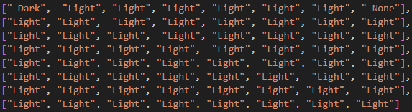

Using these boards means that there is only one valid move for the colour. Both tests should return True with the direction (-1,0) as the move goes horizontally left.

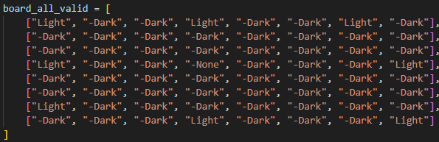
The next set of edge cases have been performed on a board where all directions for Light are valid for a given move:

As we can see here at the empty coord (3,3) Light has a valid move in every direction. It’s significant to check if this works as intended as if a move has more than one valid direction, every tile in those directions should be considered in later flipping. The expected result should be True with the directions returned being every possible direction i.e. [ (0, 1), (1, 1), (1, 0), (1, -1), (0, -1), (-1, -1), (-1, 0), (-1, 1) ]

All of these tests have passed:

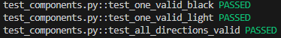

Edge cases – invalid moves

The first edge case that should return (False, None) is when the board is full. This test has been run for Dark with a board full of Dark tiles and vice versa for Light. This should obviously return False as there are no empty spaces for a tile to be placed and no Light tiles to outflank.

Another edge case I have considered is when the coord inputted is out of bounds of the board, for example (9,9) on the 8x8 starting board. This should return False as the tile placed must be on the board. It is worth testing this in case a logic error in the code causes an invalid coord to go unnoticed up to this point.

Both cases have passed:

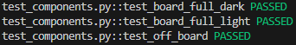

Flask_game_engine.py

Player_swap() function

Normal tests

For these tests I have simply checked whether inputting Dark outputs Light, and vice versa.

Both of these have passed:

There are no edge or erroneous cases for this function as it is not possible for it to take any other value in the code.

Check_all_moves() function

Normal tests

The first set of normal tests are designed to check whether the function returns True when moves are valid for both Light and Dark seperately. I have passed the starting board state through as a parameter. This function should return true for both cases as both players should have valid moves at the start of the game.

The second set of normal tests check if the function returns False when both colours do not have any valid moves. For each case, I have made a board with no valid moves for that colour and passed it through. Both cases should return False as no valid moves are present

All of these normal tests have passed:

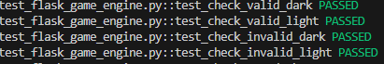

Edge cases – valid moves

The only edge case to consider is when the current colour only has one valid move. To test this, I have created boards with only one valid move for either colour. The cases for both colours should return True as the function cares if one or more moves are valid.

This test passes for both colours:

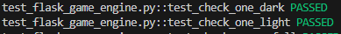

Edge cases – invalid moves

The first case to consider here is where the board is full. If the board is full, this function should return False regardless of the colour passed through as there are no empty spaces for a tile to be placed.

The second case is when the board is empty. This should also return False regardless of colour as there are no tiles that can be outflanked.

Both of these test cases pass:

Tile_counts() function

Normal tests

The first normal test is designed to see if the function outputs (2,2) when the starting board is passed through. This is because the starting board consists of 2 light tiles and 2 dark tiles only.

Another normal test that I have designed is when the board is relatively full, with 30 nonempty tiles of 15 light and 15 dark. This function should return (15,15). I have decided to test this as it is common for boards with higher tilecounts to be passed through.

Both of these pass:

Edge cases

The first edge case to consider is when the function is called on an empty board. This should return (0,0) as no light or dark tiles are on the board.

Another edge case to consider is when the board is full, in this instance, I have filled the board with dark tiles. This should return (0,64) as the board has 64 tiles that are each dark. The return should be formatted this way as the function returns ( light count, dark count)

Both of these cases pass:

Ai_move() function

Normal tests

The first test for this function is running it on the starting board. This should return the coord (4,2) as the AI player is always light. Interestingly, all of the moves the AI has access to at this point flip the same number of tiles so the first one that is iterated to is picked as the best move.

The next test passes through a board that has multiple valid moves for light that each flip a different number of tiles:
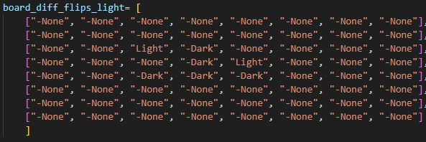

Here, one move flips one tile, one flips two and so on. The coord that should be returned is (5,5) as the returns a move that flips the most tiles (three). I have tested this as it will be common for the AI player to have access to multiple moves at once. Determining the best one is the whole point of this function.

Both of these pass:

Edge cases

The first edge case for this function is passing through an empty board function. This should return None as a best coordinate will not be chosen as no coordinates are valid moves.

Another edge case for this function is when the board is full. This should also return None as there are no free tiles for a move to be valid, hence no best coord is chosen.

Finally, I have checked a case where the board passed through has only one valid move for light:

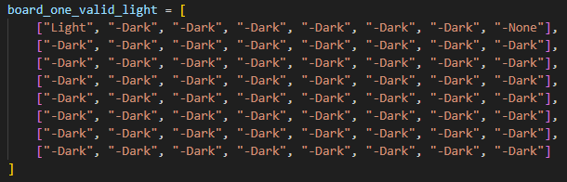

This should return the coord (7,0) as it is the only move available, therefore it is the best coordinate by default.

These edge cases pass:

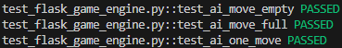

Flask App Routes Manual Testing

