##################################################################################

API Documentation for Product module in MyToysGroup

Total API’s - 3

##################################################################################

**API - 1**

**API Description**: API to upload the products as CSV into the datastore in MyToysGroup

**API URL**: http://{BASE_URL}/product/upload

**API Method Type**: POST

**API Content Type**: text/csv

**Upload Field Name**: productcsv

**Response**: Json

**Also added the validation for invalid headers / no input etc.,**

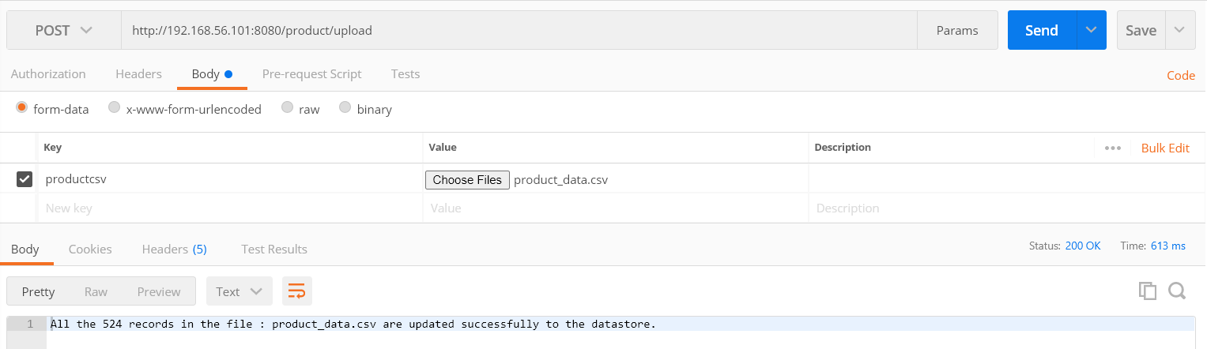

##################################################################################

**API – 2**

##################################################################################

**API Description**: API to GET / GLOBAL / EXTENSIVE SEARCH on the products of MyToysGroup

**API URL**: http://{BASE_URL}/product

**API Method Type**: GET

**Response**: Json

{

"data": [XXXX],

"total": 1200,

"totalRecordInCurrentSearch": 20,

"scrollId": "XXXX"

}

**Possible Inputs**:

This service is used to get all the products based on the following criteria

- Search Keyword on the field like ID, NAME, BRAND, STOCK

- Sort on all the fields

- Limit by Size

- Pagination

**Search Criteria 1**: API to get all the data of the product

**Search Criteria 2:** API to get all the data which matches to the search text

**Search Criteria 3:** API to get all the data which will be sorted by accepted fields

**Search Criteria 4:** API to get only the limited sets of data based on limit size

**Search Criteria 5:** API to get data based on pagination.

**Search Criteria 6:** API to get data based on all the combinations of search, sort by field, limit

Case 1

**Search Criteria 1**: API to get all the data

<http://192.168.56.101:8080/product>

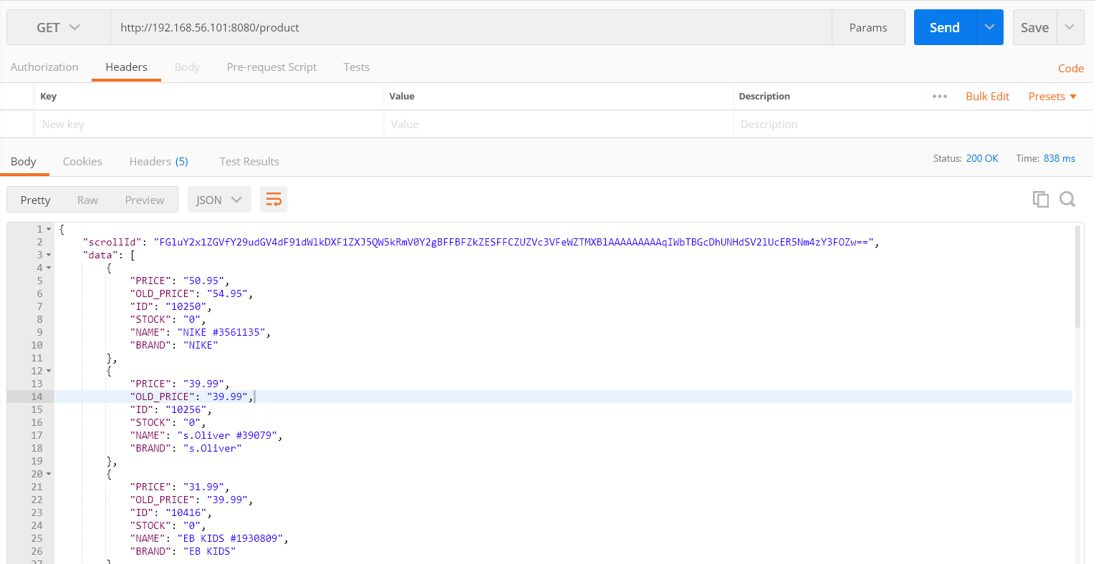

**Case 2**

**Search Criteria 1**: API to get all the data

<http://192.168.56.101:8080/product?search=Tommy>

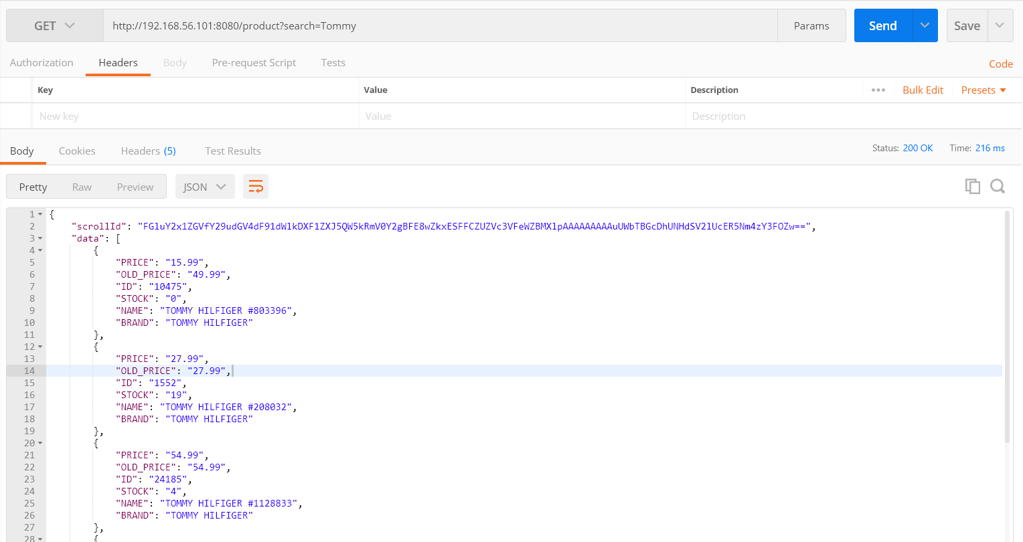

**Case 3**

**Search Criteria 3:** API to get all the data which will be sorted by accepted fields

<http://192.168.56.101:8080/product?sort=NAME>

Accepted Fields : "ID", "NAME", "PRICE", "OLD_PRICE", "STOCK", "BRAND"

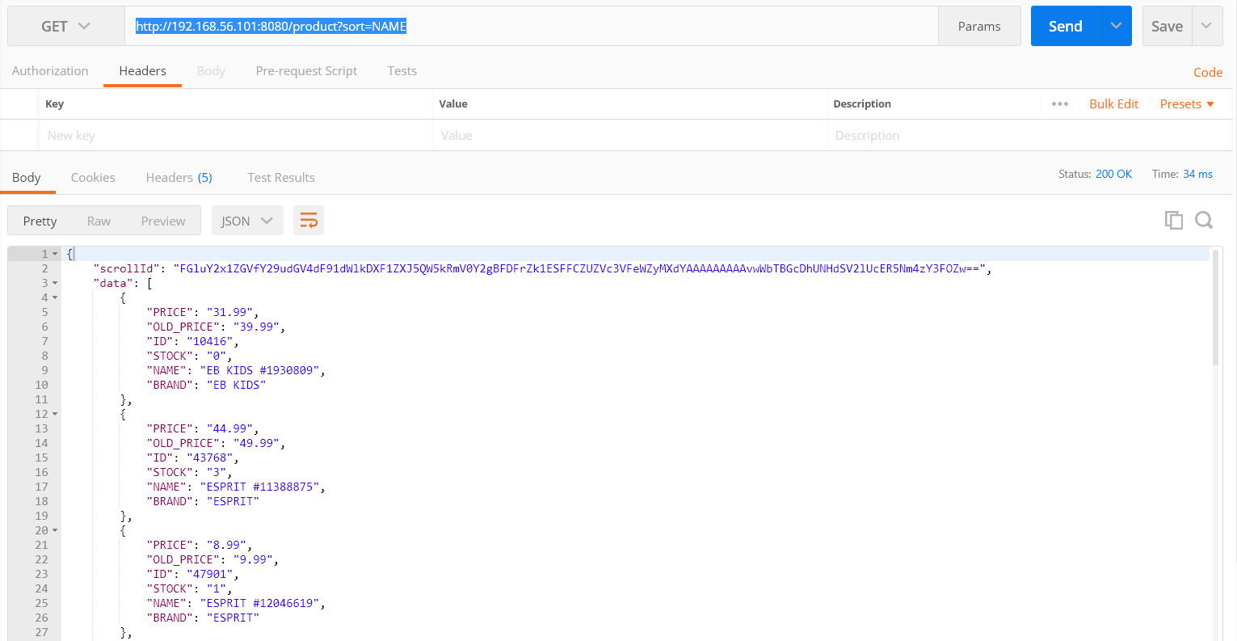

Case 4

**Search Criteria 4:** API to get only the limited sets of data based on limit size

<http://192.168.56.101:8080/product?size=20>

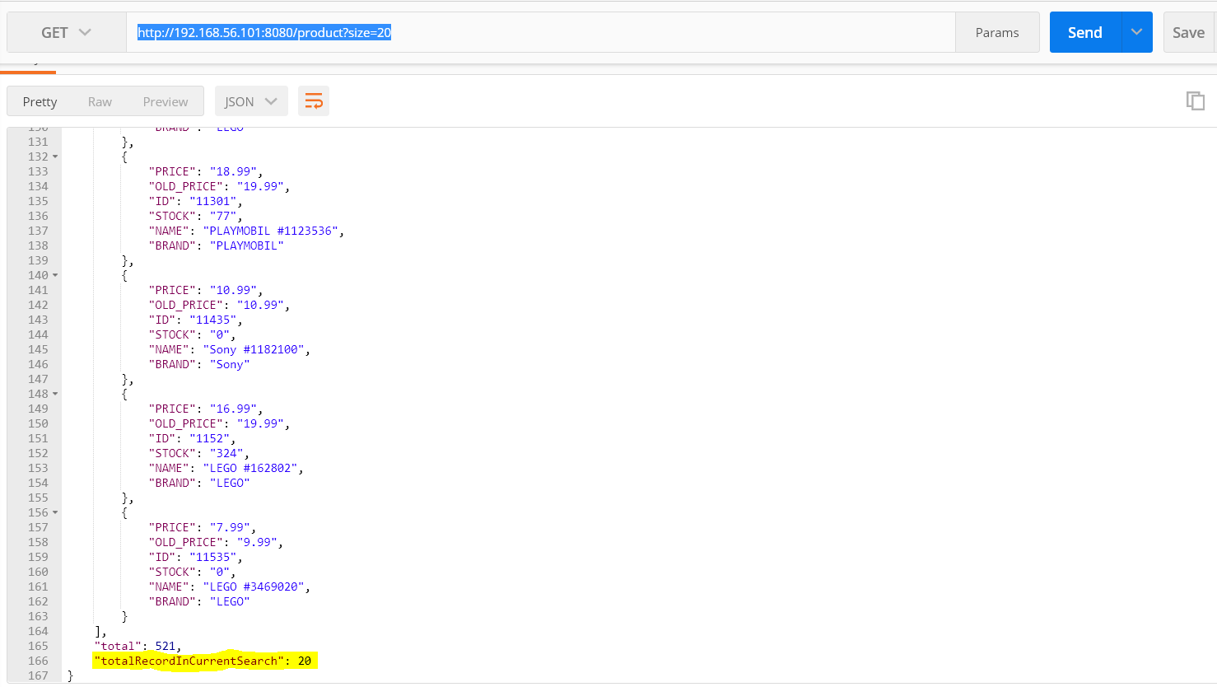

**Search Criteria 5:** API to get data based on pagination.

In any search call, we will have scroll id used for pagination

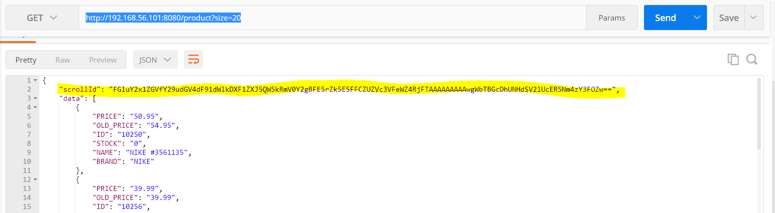

[http://192.168.56.101:8080/product?scrollId=FGluY2x1ZGVfY29udGV4dF91dWlkDXF1ZXJ5QW5kRmV0Y2gBFE5rZk5ESFFCZUZVc3VfeWZ4RjFTAAAAAAAAAwgWbTBGcDhUNHdSV2lUcER5Nm4zY3FOZw==](http://192.168.56.101:8080/product?scrollId=FGluY2x1ZGVfY29udGV4dF91dWlkDXF1ZXJ5QW5kRmV0Y2gBFE5rZk5ESFFCZUZVc3VFeWZ4RjFTAAAAAAAAAwgWbTBGcDhUNHdSV2lUcER5Nm4zY3FOZw==)

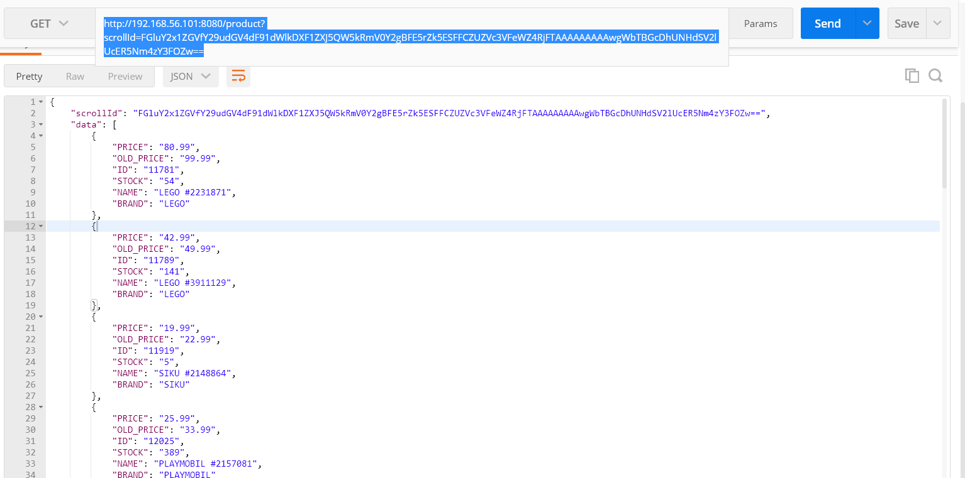

**Search Criteria 6:** API to get data based on all the combinations of search, sort by field, limit

<http://192.168.56.101:8080/product?search=Tommy&sort=NAME&size=30>

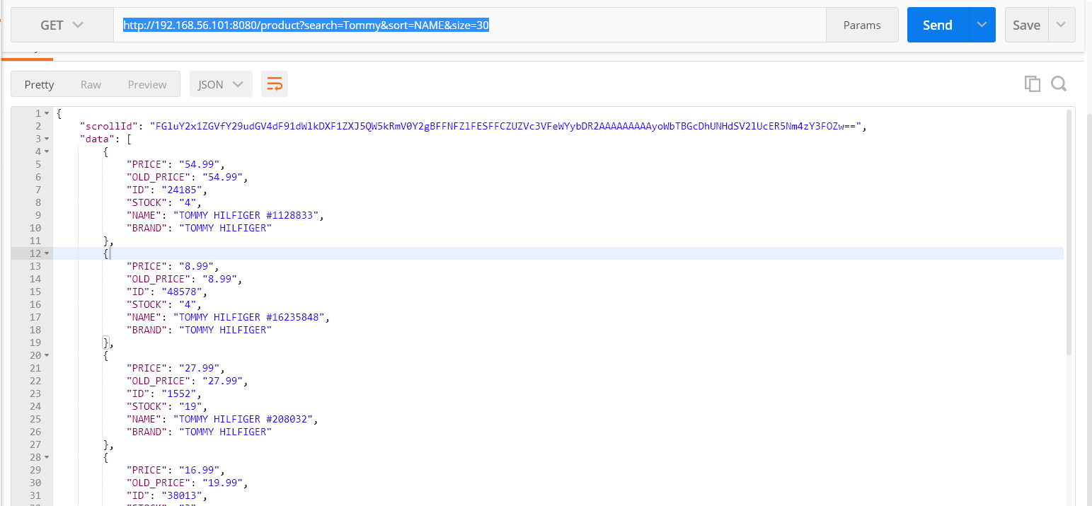

##################################################################################

**API - 3**

**API Description**: API to GET / GLOBAL / EXTENSIVE SEARCH on the products of MyToysGroup using RANGE Query

**API URL**: http://{BASE_URL}/product

**API Method Type**: POST

**Response**: Json

{

"data": [XXXX],

"total": 1200,

"totalRecordInCurrentSearch": 20,

"scrollId": "XXXX"

}

**Possible Input** :

{

"field”: "PRICE",

"startvalue”: 10,

"endvalue”: 20

}

**Accepted Values in field**: PRICE and OLD_PRICE

**Search Criteria 7:** API to get filter the data by range

<http://localhost:8080/product>

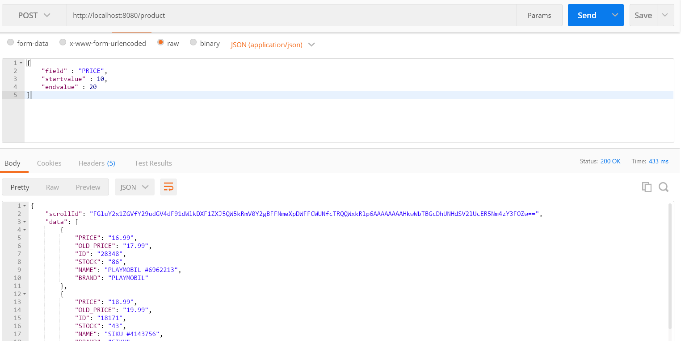

Pagination can also be done using the scrollId (as described in API 2 for Range Query too)