同济大学计算机系

数字逻辑课程实验报告



学 号 1651574
姓 名 贾昊霖
专 业 计算机科学与技术
授课老师 张冬冬

- 实验内容
练习使用 Verilog HDL 语言，并采用三种不同的描述方式设计基本门电路，实现数据扩展,完成五个实验，分别为：extend(通过信号选择有或无符号扩展16位数字)、三种建模（分别为门级建模，数据流级建模，行为级建模）完成简单逻辑运算、三态门输入与输出
- 硬件逻辑图
- 1-2，1-3，1-4的硬件逻辑图
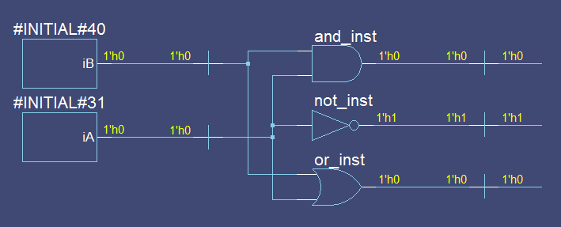
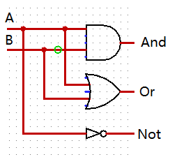
左侧是用logisim做的电路图，右侧是用Vivado “”生成的电路图
- 1-5的硬件逻辑图
左侧是用logisim做的电路图，右侧是用Vivado “”生成的电路图
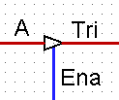
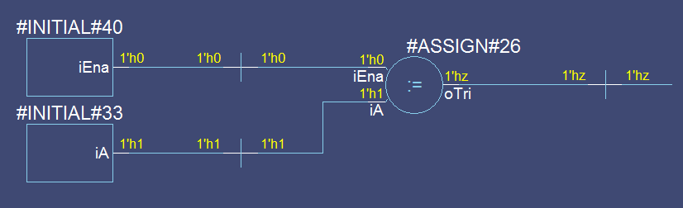

- 模块建模
- 1-1
module extend #(parameter WIDTH = 16)(
input [WIDTH-1:0] a,
input sext, //sext 有效是为符号扩展，否则为 0 扩展
output [31:0] b
);
assign b=sext? {{(32-WIDTH){a[WIDTH-1]}},a} : {16'b0,a};
endmodule
- 1-2
module logic_gates_1(iA,iB,oAnd,oOr,oNot);
input iA, iB;
output oAnd,oOr,oNot;
and and_inst(oAnd, iA,iB);
or or_inst(oOr, iA,iB);
not not_inst(oNot, iA);
endmodule
- 1-3
module logic_gates_2(iA,iB,oAnd,oOr,oNot);
input iA, iB;
output oAnd,oOr,oNot;
assign oAnd = iA & iB;
assign oOr = iA | iB;
assign oNot = ~iA;
endmodule
- 1-4
module logic_gates_3(iA,iB,oAnd,oOr,oNot);
input iA, iB;
output oAnd,oOr,oNot;
reg oAnd, oOr, oNot;
always @ (*)
begin
oAnd = iA & iB;
oOr = iA | iB;
oNot = ~iA;
end
endmodule
- 1-5
module three_state_gates(iA,iEna,oTri);
input iA;
input iEna;
output oTri;
assign oTri = (iEna==1)? iA:'bz;
endmodule

- 测试模块建模
- 1-1
`timescale 1ns/1ns
module extend_tb;
reg [15:0] a;
reg sext;
wire [31:0] b;
// Instantiate the Unit Under Test (UUT)
extend uut(.a(a),.sext(sext),.b(b));
initial
begin
// Initialize Inputs
a = 0;
sext = 0;
// Wait 100 ns for global reset to finish
#100;
// Add stimulus here
sext = 1;
a = 16'h0000;
#100;
sext = 0;
a = 16'h8000;
#100;
sext = 1;
a = 16'h8000;
#100;
sext = 0;
a = 16'hffff;
#100;
sext = 1;
a = 16'hffff;
#100;
end
endmodule

- 1-2
`timescale 1ns/1ns
module logic_gates_tb;
reg iA;
reg iB;
wire oAnd;
wire oOr;
wire oNot;

initial
begin
iA = 0;
#40 iA = 1;
#40 iA = 0;
#40 iA = 1;
#40 iA = 0;
end

initial
begin
iB = 0;
#40 iB = 0;
#40 iB = 1;
#40 iB = 1;
#40 iB = 0;
end

logic_gates_1
logic_gates_inst(
.iA(iA),
.iB(iB),
.oAnd(oAnd),
.oOr(oOr),
.oNot(oNot)
);
endmodule

- 1-3
`timescale 1ns/1ns
module logic_gates_tb;
reg iA;
reg iB;
wire oAnd;
wire oOr;
wire oNot;

initial
begin
iA = 0;
#40 iA = 1;
#40 iA = 0;
#40 iA = 1;
#40 iA = 0;
end

initial
begin
iB = 0;
#40 iB = 0;
#40 iB = 1;
#40 iB = 1;
#40 iB = 0;
end

logic_gates_2
logic_gates_inst(
.iA(iA),
.iB(iB),
.oAnd(oAnd),
.oOr(oOr),
.oNot(oNot)
);
endmodule

- 1-4
`timescale 1ns/1ns
module logic_gates_tb;
reg iA;
reg iB;
wire oAnd;
wire oOr;
wire oNot;
initial
begin
iA = 0;
#40 iA = 1;
#40 iA = 0;
#40 iA = 1;
#40 iA = 0;
end

initial
begin
iB = 0;
#40 iB = 0;
#40 iB = 1;
#40 iB = 1;
#40 iB = 0;
end

logic_gates_3
logic_gates_inst(
.iA(iA),
.iB(iB),
.oAnd(oAnd),
.oOr(oOr),
.oNot(oNot)
);
endmodule
- 1-5
`timescale 1ns/1ns
module three_state_gates_tb;
reg iA;
reg iEna;
wire oTriState;
three_state_gates uut(
.iA(iA),
.iEna(iEna),
.oTri(oTriState)
);
initial
begin
iA = 0;
#40 iA = 1;
#40 iA = 0;
#40 iA = 1;
end
initial
begin
iEna = 1;
#20 iEna = 0;
#40 iEna= 1;
#20 iEna = 0;
end
endmodule
- 实验结果
（该部分可截图说明，要求logisim逻辑验证图、modelsim仿真波形图、以及下板后的实验结果贴图（实验步骤中没有下板要求的实验，不需要下板贴图））
- 1-1
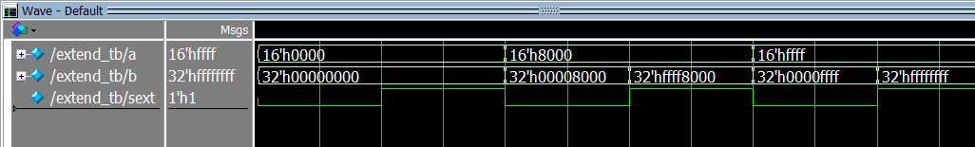
- 1-2,1-3,1-4
Logisim逻辑验证：
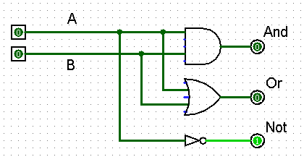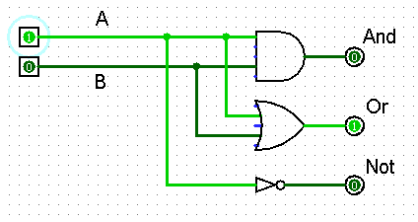
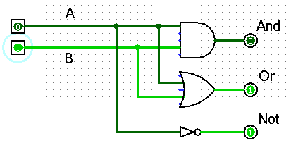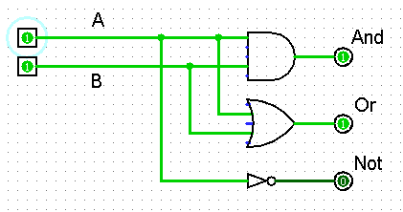
三个实验下板操作结果均为下图：
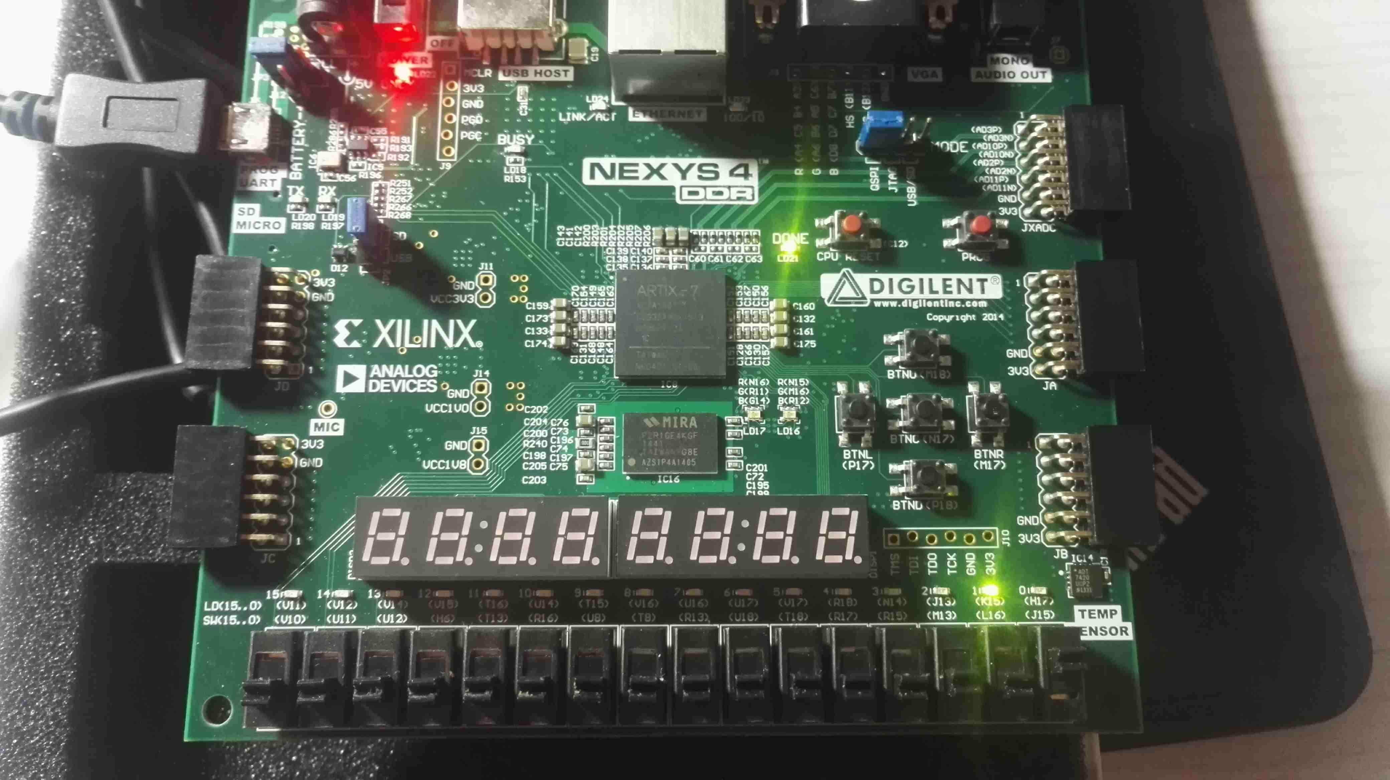
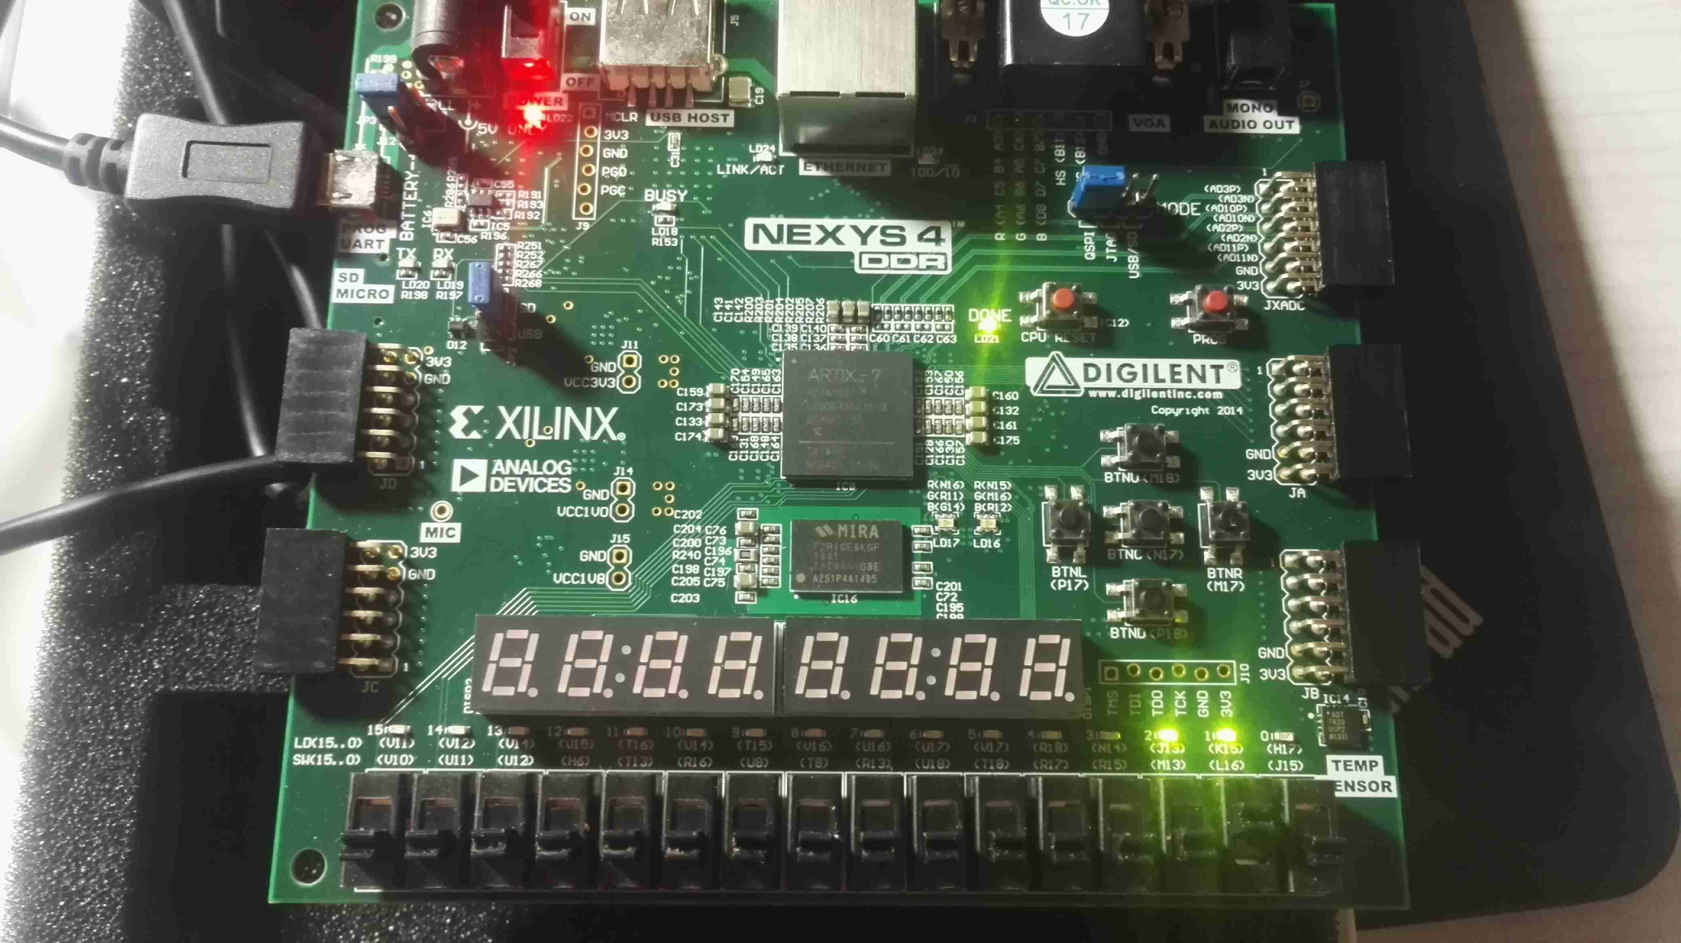
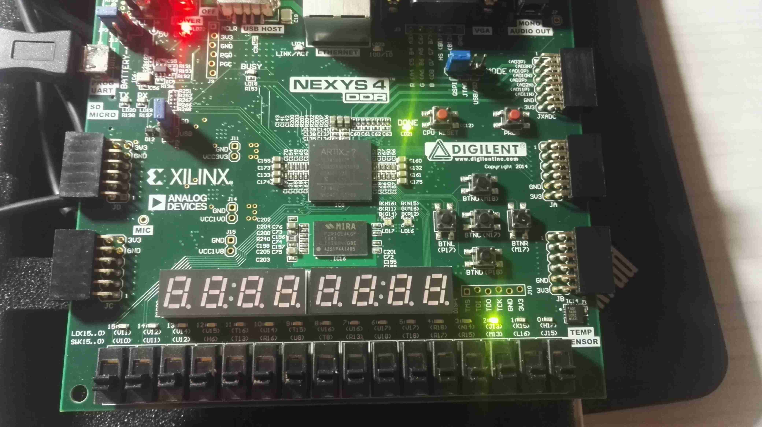
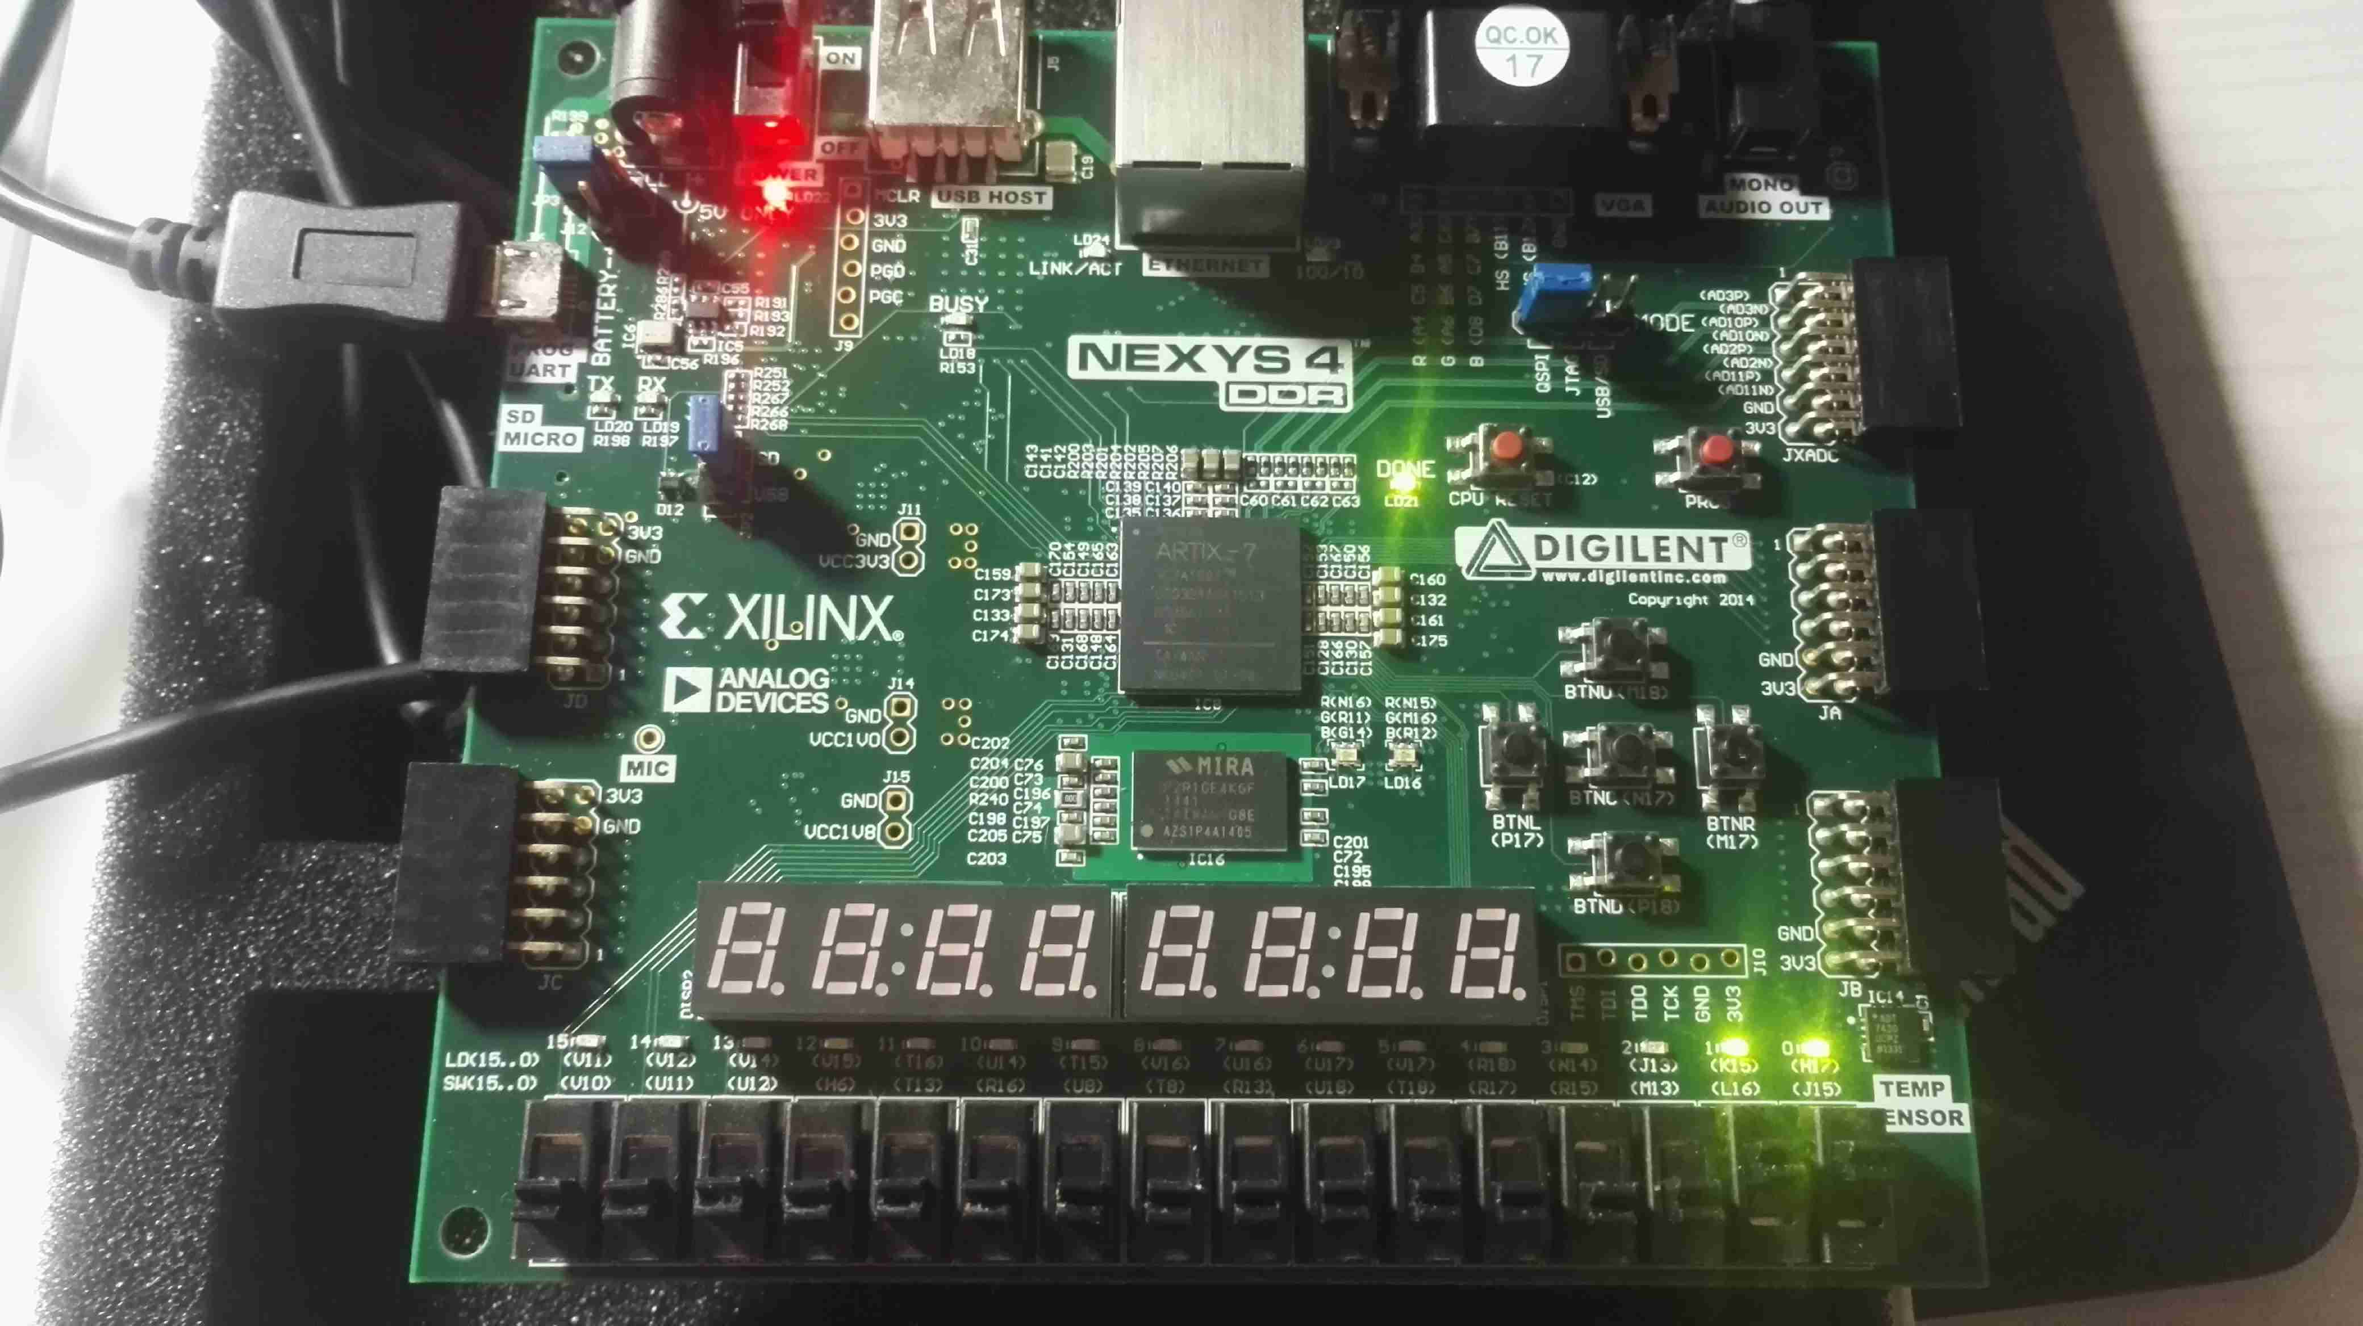
a开b关，and：0
or：1，not：0
b开a关，and：0
or：1，not：1
a开b开，and：1
or：1，not：0
a关b关，and：0
or：0，not：1

三个实验Wave均为下图
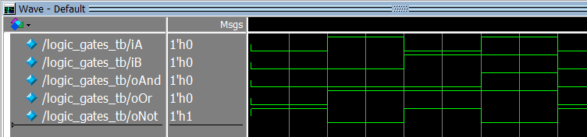
- 1-5
Modelsim的wave如下图：
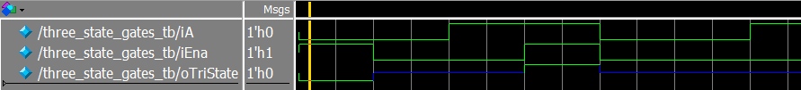
Logisim逻辑验证：
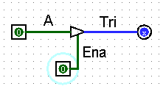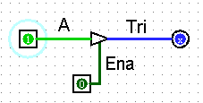
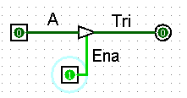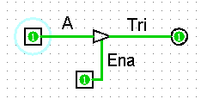
实验操作如下图：
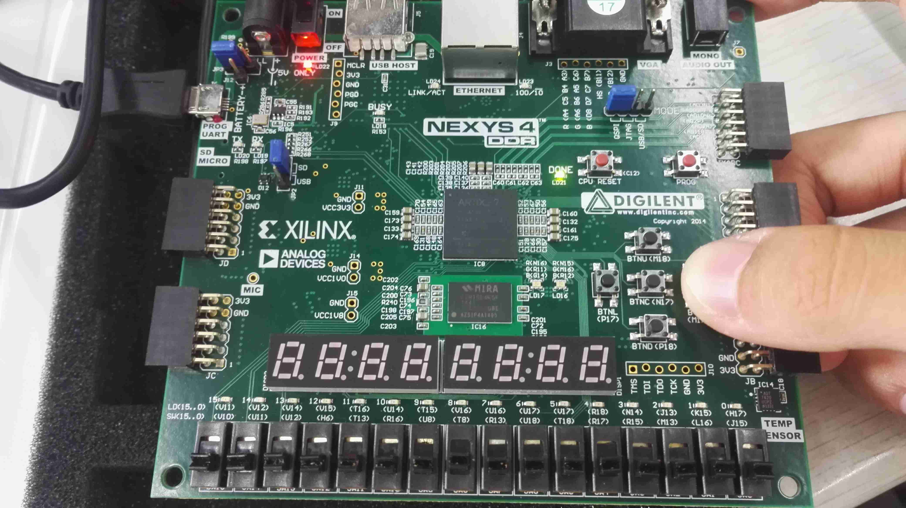
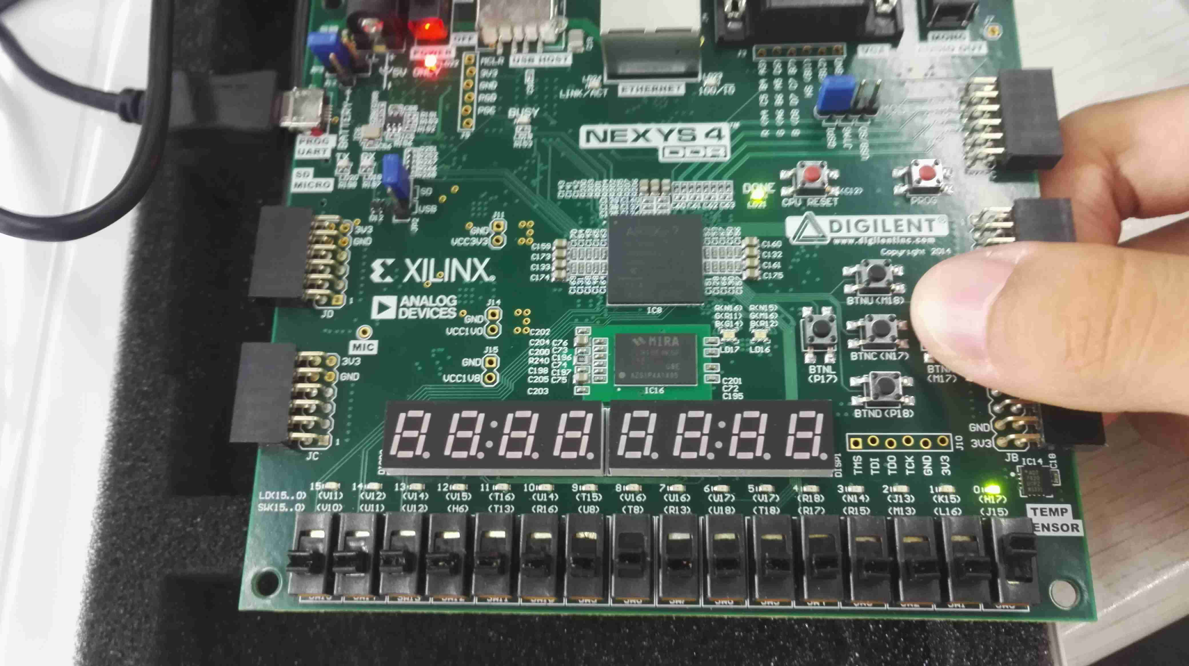
A=0时
Ena=0/1
Tri=z/0
A=1时
Ena=0/1
Tri=z/1

