**GROUP PROJECT FRONT SHEET**

|  |  |  |  |
| --- | --- | --- | --- |
| **Qualification** | **BTEC Level 5 HND Diploma in Computing** | | |
| **Unit number and title** | WEBG301 - Project Web | | |
| **Submission date** |  | **Date Received 1st submission** |  |
| **Re-submission Date** |  | **Date Received 2nd submission** |  |
| **Student Name** |  | **Student ID** |  |
| **Class** |  | **Assessor name** | Nguyen Dinh Tran Long |
| **Student declaration**  I certify that the assignment submission is entirely my own work and I fully understand the consequences of plagiarism. I understand that making a false declaration is a form of malpractice. | | | |
|  |  | **Student’s signature** |  |

|  |
| --- |
|  |

**Grade**

|  |  |  |
| --- | --- | --- |
| **❒ Summative Feedback:                                                                 ❒ Resubmission Feedback:** | | |
| **Grade:** | **Assessor Signature:** | **Date:** |
| **Signature & Date:** | | |

Contents

# User requirements

## User Stories

|  |  |  |  |
| --- | --- | --- | --- |
| No | User story | Functional/Nonfunctional | Explanation |
| 1 | As a customer, I want to be able to create an account so I can put products into a cart and checkout with them | Functional | This is important because the customer might want to pick up products at one time and checkout at another. As developers of this project, this feature should absolutely implemented to accommodate for the good experience of the customer. |
| 2 | As a customer, I want to be directed to the login page if I happen to click on the "Cart" button when I am not logged in | Functional | Each cart is attached to a different customer profile. So in order to add an item into a cart, the user needs to login with a customer account |
| 3 | As a customer, when I click on the "Checkout" button, I want a receipt to be generated based on the items I have added into my cart and the information on my account | Functional | This feature is what brings the revenue to the online store, making it an essential part of the website. |
| 4 | As a customer, when I hover over the picture of a product, I want brief information about the product to be displayed | Functional | In the product index page, the list of products would only display images of the products, implementing this feature would let the visitor know more about the product without cluttering the page with pieces of text, ruining the aesthetics of the website |
| 5 | As a customer, when I click on a product, I want to be taken to a detail page that presents all of the product's information along with a "Add to cart" button | Functional | The brief information on the product list page is not enough to give the visitor all the information about the product along with all of its pictures. A detail page is needed to give the visitor more details about the product. After reading and considering the product, the customer can add the product to their cart. |
| 6 | As the operation manager, I want the website to have aesthetics that suit the store's theme, which is artistic hand-made crafts | Non-Functional | A website with aesthetics that matches the store's products and is unique is an important aspect of a website as it improves the shopping experience for the customer and from there increase sales. |
| 7 | As a system admin, I want additional links to appear on the navigation bar when an admin is logged into the website | Functional | This feature would help the admins navigate through the admin functions from the homepage. |
| 8 | As a system admin, I want to be able to perform CRUD on different information of the database without having to directly interact with the database | Functional | This feature allows admins who are not able to program to modify the data on the system without having to work directly with the database as doing so would require programming skills and could lead to human error. Furthermore, implementing CRUD sites with UI gives the admin a more intuitive user experience in performing the task |
| 9 | As the operation manager, I want the system to encrypt the login information when a new user is created in order to protect the information of everyone | Non-Functional | This feature is a step in cyber security. Should a hacker have breached through the firewall and hacked into the system, the encrypted data would be able to protect it from being brute forced for up to hundreds of years |
| 10 | As a customer, I want my account to be automatically logged in after I registered for a new account | Functional | This feature improves the user interaction of the user with the system. Instead of having to navigate to the login page and enter the account information again to log in, wasting the customer time. |

## Use-case diagram

Figure Use-case diagram

# System Design

# Implementation

## Source code

### MVC design pattern

Model-View-Controller (MVC) design is a practice where the developers split up the code into multiple files. Each file handles a number of certain tasks.

Controller is what the client would be directly interacting with. It determines what data, what file is delivered to the client, and what input to take from them. It modifies the View component to display appropriate information to the client and creates/modifies data based on the logical design provided by the Model.

View is the User Interface design for the user/client to look at and interact with visually. The View file takes data from the Controller to display to the user and takes the data from the user and passes it to the Controller

Model is the component where the structure of the data is defined. It also contains methods that allow access to modify or view its data so that it can be called by either the View or the Controller.

### MVC in the project

#### Model

In this project, the Model is used to define the data structure of these entities along with methods to manipulate their data:

* Cart
* Category
* Customer
* Employee
* Image
* OrderInfo
* Product
* User

For example, the entity Image consists of three variables, they are id, imageID, and productID.

Figure Image Entity

The variable “id” is an identifier automatically generated by Symfony when the Entity is created, its data type integer and is automatically incremented when a new instance is added into its table in the database.

“imageID” is a user-defined variable that would be used as the name for the image files that are added to the system, hence the data type of string with a maximum length of 255.

“productid” is the variable that establishes the relationship between the entity “Image” and entity “Product”. The relation between these two is Many To One, meaning that every image is associated with only one product while one product can be associated with multiple images.

After the variables, there are the getters and setter methods used to return and modify the data of an instance of this entity.

Figure Getters and Setters for Image entity

#### Controller

There are two main components of a Controller, they are routes and functions. Routes are the trigger that defines the conditions in which certain functions would be executed. For example:

Figure Homepage route

When the user enters the domain of the store without any extension, the function “index” is executed. In this function, the controller takes the data of every image, product, and category inside the database and assign it to appropriate variables

### Website design

To design the front-end of the website, a design language called “Neu Brutalism” is applied. Neu Brutalism is a design language that is trending in recent years. One of the most notable characteristics of Neu Brutalism is its contrast using solid borders and bold text, making everything pop.

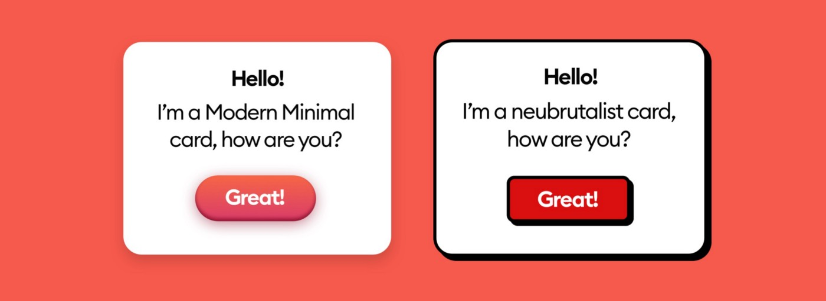

Figure Modern Minimal and Neubrutialist design (Malewicz, 2022)

To come up with the final design decision for the website, many online stores have been studied as a reference and some of their components are recreated using Bootstrap 5, a CSS and JavaScript library free for everyone. The websites studied are <https://negativecollection.bigcartel.com/>, and <https://paulinamocna.bigcartel.com/>.

Figure Negative Collection

Figure Paulina Mocna

These two websites were chosen because they followed the Neubrutalist design, which is the goal for this project. After they were studied, an html interface is created using an application called Bootstrap Studio 6. Bootstrap Studio is a tool that visualizes the process of creating a website design in order to help the developer create a layout more easily and mitigate human error while trying to design a website.

Figure Bootstrap Studio

## Screenshots

# Conclusion

# References

**There are no sources in the current document.**