WEEK 1: DESIGN PATTERNS AND DATA STRUCTURES & ALGORITHMS
Design Patterns
EXERCISE 1: IMPLEMENTING THE SINGLETON PATTERN
Source Code:
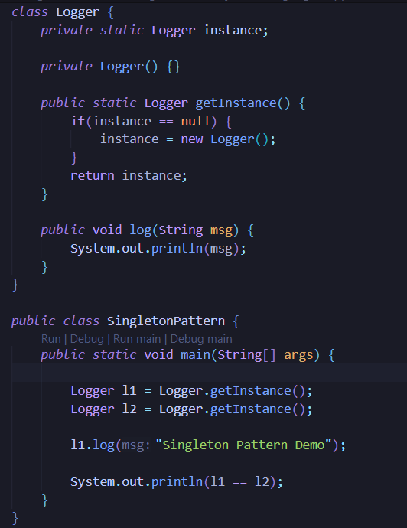
Output:
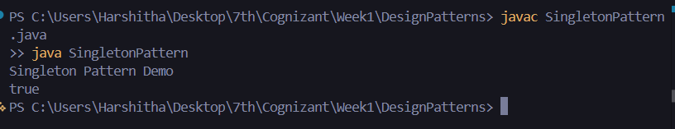
Result:
Thus the Singleton Pattern was implemented and executed successfully.

EXERCISE 2: IMPLEMENTING THE FACTORY METHOD PATTERN
Aim:
To implement the Factory Method Design Pattern in Java.
Source Code:

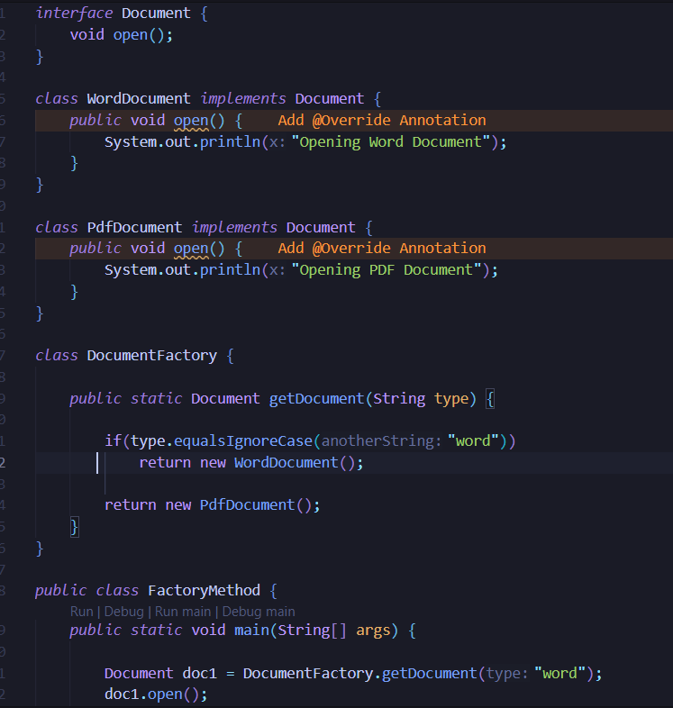
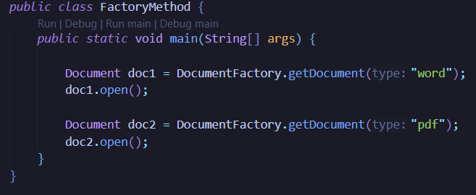

Output:
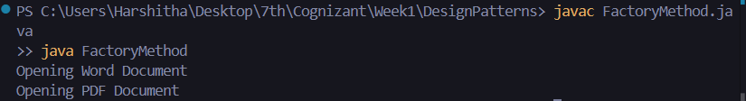
Result:
Thus the Factory Method Pattern was implemented and executed successfully.

DSA
EXERCISE 2: E-COMMERCE PLATFORM SEARCH FUNCTION
Aim:
To implement Linear Search and Binary Search for product searching.
Source Code:
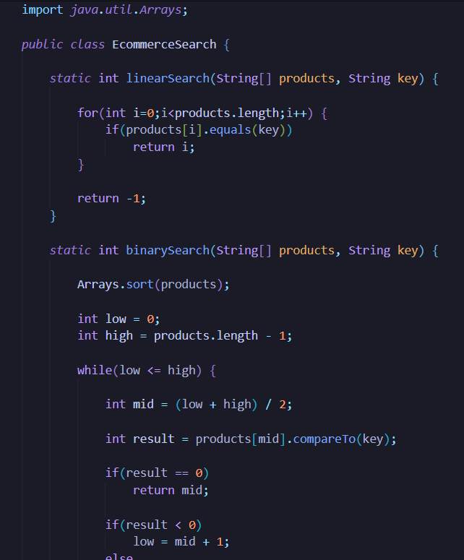
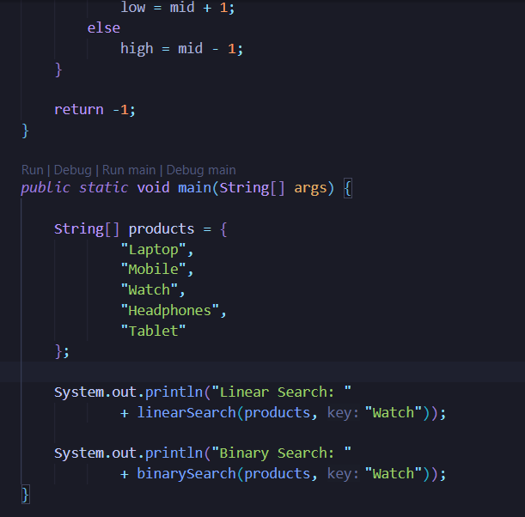

Output:
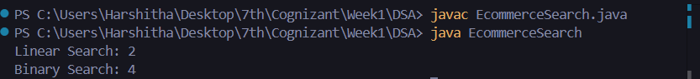
Result:
Thus the search operations were implemented and executed successfully.

EXERCISE 7: FINANCIAL FORECASTING
Aim:
To implement recursive financial forecasting in Java.
Source Code:
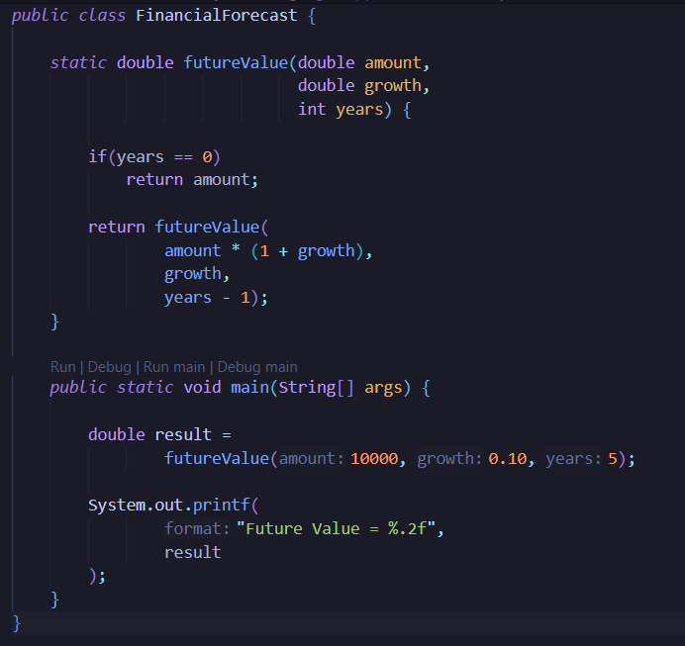
Output:
Result:
Thus the financial forecasting program was implemented and executed successfully.

