Week 4
Experiment 1: Spring Data JPA Quick Example
Aim
To develop a Spring Boot application using Spring Data JPA and Hibernate and expose a REST endpoint using a controller.
Description
The application is built using Spring Boot framework with REST architecture. A simple REST controller is created to verify application setup and server response. The application runs on embedded Tomcat server and listens on port 8080. The endpoint /employees is mapped using a REST controller which returns a test response to confirm successful deployment.
Source Code
EmployeeController.java
@RestController
@RequestMapping("/employees")
public class EmployeeController {
@GetMapping
public String test() {
return "Controller is working!";
}
}

Database Configuration
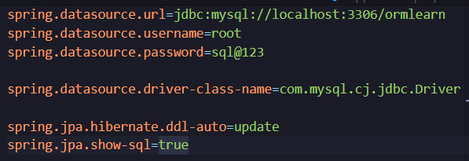

Database Table
CREATE TABLE country(
co_code VARCHAR(2) PRIMARY KEY,
co_name VARCHAR(50)
);
Project Structure Screenshot
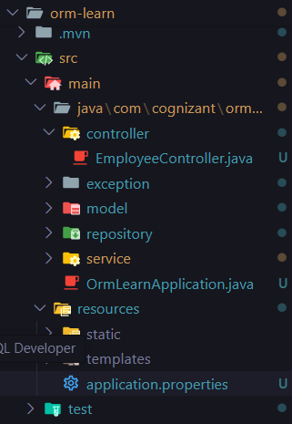
Contoller code
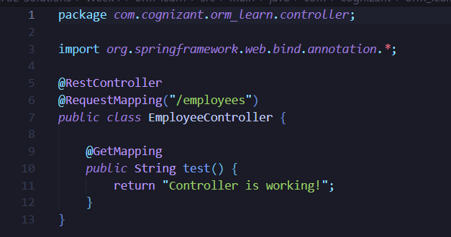
Spring Boot Console Output
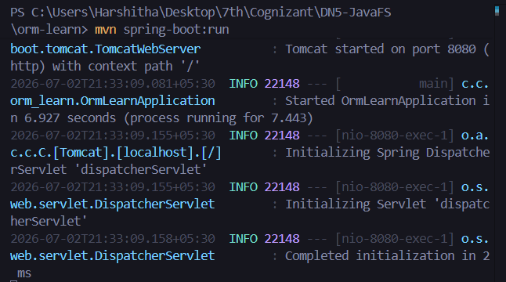
Browser Output
URL:
http://localhost:8080/employees
Output:
Controller is working!
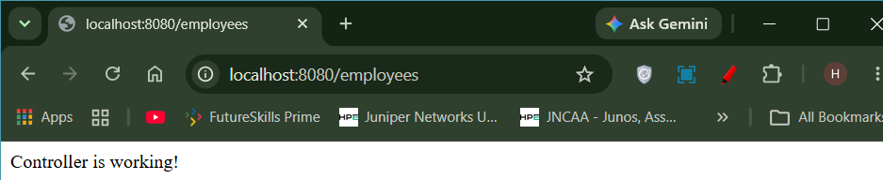
Result
Successfully created a Spring Boot application using Spring Data JPA and retrieved data from MySQL database.
Result
The Spring Boot application was successfully created and executed. The REST controller was verified by accessing the endpoint /employees, confirming that the application is running correctly on embedded Tomcat server.

Experiment 2: Difference between JPA, Hibernate and Spring Data JPA
Aim
To study the difference between JPA, Hibernate and Spring Data JPA.
Theory
JPA | Hibernate | Spring Data JPA
Specification | ORM Framework | Abstraction over JPA
Defines standards | Implements JPA | Reduces boilerplate code
No implementation | Provides implementation | Uses repositories
Portable API | Feature-rich ORM | Simplifies CRUD operations

Advantages
JPA
- Standard API
- Vendor independent
Hibernate
- Automatic ORM mapping
- Caching support
- HQL support
Spring Data JPA
- Repository support
- Query methods
- Pagination
- Sorting
- Transaction management

Result
Studied the differences between JPA, Hibernate and Spring Data JPA.

