Week 3: SLF4J Logging & Spring Core (Maven Project)

Objective
To implement logging using SLF4J and build a Spring Core application using Dependency Injection (DI) and Inversion of Control (IoC) principles with Maven-based project setup.

SLF4J Logging Implementation
SLF4J is used as a logging abstraction layer with Logback as the implementa
Code (AppenderDemo.java)
package com.logging;
import org.slf4j.Logger;
import org.slf4j.LoggerFactory;
public class AppenderDemo {
private static final Logger logger =
LoggerFactory.getLogger(AppenderDemo.class);
public static void main(String[] args) {
logger.info("Application started");
logger.warn("This is a warning");
logger.error("This is an error");
logger.debug("Debugging app flow");
}
}

Parameterized Logging
Parameterized logging improves performance by avoiding string concatenation.
Code
logger.info("User {} has logged in at {}", "Harshitha", "10:30 AM");
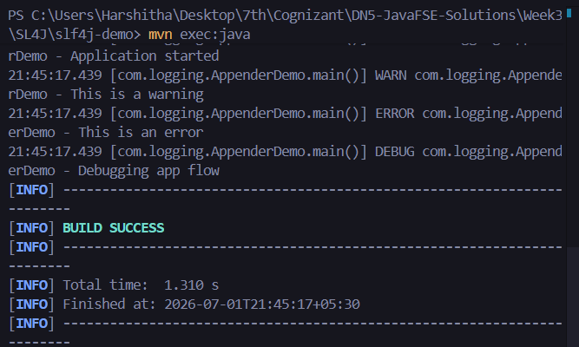

Spring Core Application (Library Management)
This application demonstrates:
- IoC (Inversion of Control)
- Dependency Injection using XML configuration
- Bean lifecycle management using Spring Container

Spring Configuration (applicationContext.xml)
Code
<beans xmlns="http://www.springframework.org/schema/beans"
xmlns:xsi="http://www.w3.org/2001/XMLSchema-instance"
xsi:schemaLocation="
http://www.springframework.org/schema/beans
http://www.springframework.org/schema/beans/spring-beans.xsd">

<bean id="bookRepository" class="com.library.repository.BookRepository"/>

<bean id="bookService" class="com.library.service.BookService">
<property name="bookRepository" ref="bookRepository"/>
</bean>

</beans>

Main Application
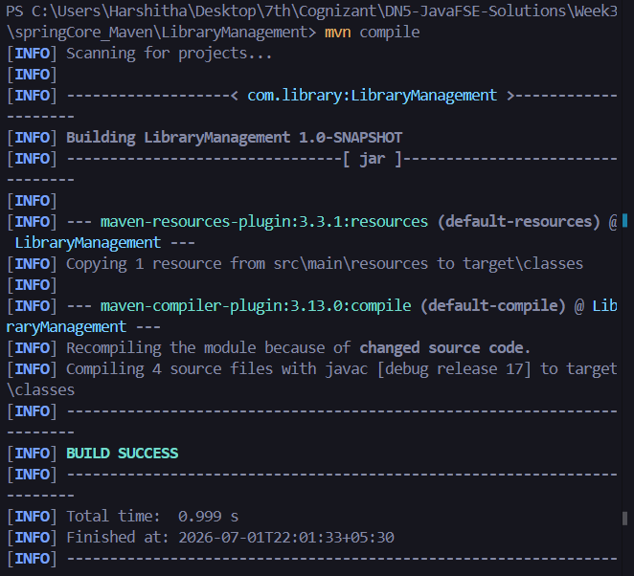
package com.library;
import org.springframework.context.ApplicationContext;
import org.springframework.context.support.ClassPathXmlApplicationContext;
public class LibraryManagementApplication {
public static void main(String[] args) {
ApplicationContext context =
new ClassPathXmlApplicationContext("applicationContext.xml");
BookService service =
context.getBean("bookService", BookService.class);
service.showBook();
}
}

