PSQL
Exercise 1
Aim: Apply 1% interest-rate discount to senior citizens.
Code:
CREATE TABLE Customers (
CustomerID INT PRIMARY KEY,
Name VARCHAR(100),
DOB DATE,
Balance DECIMAL(10,2)
);

CREATE TABLE Loans (
LoanID INT PRIMARY KEY,
CustomerID INT,
LoanAmount DECIMAL(10,2),
InterestRate DECIMAL(5,2)
);

INSERT INTO Customers
VALUES
(1,'John','1950-01-01',10000);

INSERT INTO Loans
VALUES
(1,1,5000,5);

SELECT * FROM Loans;

UPDATE Loans
SET InterestRate = InterestRate - 1
WHERE CustomerID IN
(
SELECT CustomerID
FROM Customers
WHERE (2026 - CAST(strftime('%Y', DOB) AS INT)) > 60
);

SELECT * FROM Loans;

Exercise 3 Stored Procedure

CREATE TABLE Accounts(
AccountID INT PRIMARY KEY,
CustomerID INT,
AccountType VARCHAR(20),
Balance DECIMAL(10,2)
);

INSERT INTO Accounts
VALUES
(1,1,'Savings',1000);

SELECT * FROM Accounts;

UPDATE Accounts
SET Balance = Balance + (Balance * 0.01)
WHERE AccountType='Savings';

SELECT * FROM Accounts;

JUnit
Exercise 1: Setting Up JUnit
A Calculator class was created and tested using JUnit 5. The test verified the addition functionality.
Result:
The JUnit test executed successfully without errors.
Exercise 3: Assertions
Various assertions such as assertEquals(), assertTrue(), assertFalse(), assertNull(), and assertNotNull() were implemented and verified.
Result:
All assertions passed successfully.
Exercise 4: AAA Pattern
The test case was structured into Arrange, Act, and Assert phases to improve readability and maintainability.
Result:
The test executed successfully following the AAA pattern.
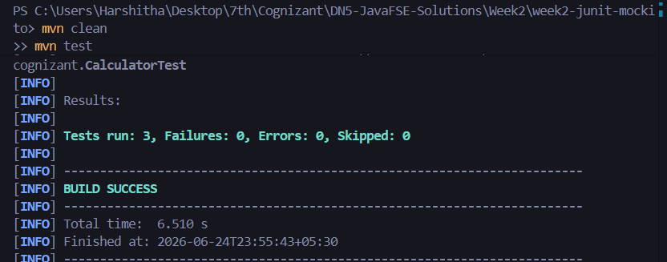
Exercise 1: Mocking and Stubbing
A mock object was created for an external dependency and predefined responses were returned using stubbing.
Result:
Mocking and stubbing were implemented successfully.
Exercise 2: Verifying Interactions
Mockito's verify() method was used to ensure that the expected method was invoked during execution.
Result:
Method interactions were verified successfully.
