Supermarket Sales Analysis
Data Analytics Capstone Project Report
Author: Harsh Agrawal | Program: IBM SkillsBuild Internship
Domain: Retail Data Analytics | Dataset: SUPER MARKET DATA.xlsx (500 Records)

1. Problem Statement
Supermarkets operate in dynamic retail environments with thousands of daily customer transactions. Understanding sales dynamics, product popularity, branch efficiency, customer purchasing habits, payment methods, and service quality is crucial for profitable store operations.
The objective of this project is to perform an end-to-end data analysis on supermarket transactional logs to evaluate revenue drivers, compare regional branch efficiency, determine product demand, evaluate membership customer value, and assess customer satisfaction ratings. The final goal is to translate raw transactional data into practical, data-backed business decisions.
2. Dataset Overview
The dataset analyzed in this project ('SUPER MARKET DATA.xlsx') consists of 500 sales transaction records captured between January 1, 2026 and July 1, 2026 across four regional supermarket branches in India. The dataset contains 13 features capturing operational, demographic, and financial details for each purchase.
Column Name | Data Type | Description | Sample Values
Invoice ID | Categorical / String | Unique transaction identifier | INV0001, INV0002
Date | Datetime | Date on which transaction took place | 2026-01-01 to 2026-07-01
Branch | Categorical | Store branch code | A, B, C, D
City | Categorical | City where supermarket branch is located | Jaipur, Delhi, Mumbai, Bengaluru
Customer Type | Categorical | Loyalty membership status of shopper | Member, Normal
Gender | Categorical | Gender of the customer | Female, Male
Product | Categorical | Specific product SKU purchased | Cheese, Coffee, Shampoo, Cooking Oil, etc.
Category | Categorical | Departmental merchandise group | Beverages, Personal Care, Dairy, Grocery, etc.
Quantity | Integer | Number of units purchased in the order | 1 to 10 units
Unit Price | Numeric (Float) | Unit price per product in INR | ₹28.61 to ₹250.00
Payment | Categorical | Payment mechanism used at checkout | UPI, Net Banking, Card, Cash
Rating | Numeric (Float) | Customer feedback rating (scale: 1.0 to 5.0) | 3.0 to 5.0 (Average: 3.99)
Sales | Numeric (Float) | Total revenue for the transaction (₹) | Quantity × Unit Price
Table 1: Supermarket Sales Dataset Schema and Data Dictionary
3. Steps Used for Analysis
To conduct a systematic and reliable investigation, the analysis followed a six-step analytical workflow:
• Step 1: Data Collection & Ingestion: Loaded the transactional records from 'SUPER MARKET DATA.xlsx' into a Pandas DataFrame, handling environment-specific paths for both local and cloud-based (Google Colab) execution.
• Step 2: Data Audit & Cleansing: Inspected the dataset for missing/null values and duplicate rows. Verified that the data is 100% complete with 0 missing values and 0 duplicate rows across all 500 records.
• Step 3: Verification & Feature Extraction: Programmatically verified the core identity Sales = Quantity × Unit Price across all rows (maximum discrepancy = 0.0000). Parsed transaction dates to datetime objects and extracted Month, Month-Year, and Day attributes.
• Step 4: Grouping & Aggregation: Grouped and summarized transactional data using totals, counts, and averages to answer specific business questions regarding products, branches, categories, payments, and customer tiers.
• Step 5: Visual Exploration & Comparison: Generated focused visual charts (bar charts, line plots, and dual-axis subplots) using Matplotlib and Seaborn to clearly depict differences across dimensions.
• Step 6: Business Decision Formulation: Synthesized the quantitative findings into realistic, actionable operational recommendations for store managers.
4. Live Analysis & Core Business Findings
The project guidelines formulate six primary business questions. The table below presents the direct findings calculated from the dataset:
# | Business Question | Analytical Finding & Exact Metrics
1 | Which product generates the highest sales? | Cheese generated the highest sales: ₹27,906.30 (126 units across 26 transactions). Closely followed by Coffee (₹27,694.87) and Shampoo (₹27,497.48).
2 | Which branch performs best? | Branch C (Mumbai) performed best with sales of ₹72,469.45 across 143 transactions and an average order value of ₹506.78.
3 | Which category sells the most? | Beverages had the highest sales with ₹56,108.24 (465 units sold across 82 transactions), followed by Personal Care (₹45,943.96).
4 | What is the most popular payment method? | UPI was the most used payment method with 127 transactions (generating ₹67,910.33), followed by Net Banking (126 transactions).
5 | Do Members spend more than Normal customers? | No. The average Member transaction was ₹483.14, while Normal customers averaged ₹497.07. However, Members generated 58.5% of total sales (₹143,009.30) due to higher order volume (296 vs 204).
6 | What is the average customer rating? | The average customer rating was 3.99 out of 5.0 across all 500 transactions. Branch D recorded the highest rating (4.09), while Branch A had the lowest (3.84).
Table 2: Summary of Core Live Analysis Questions and Answers
4.1 Top Performing Products
Analysis of product-level sales shows that high-unit-value items drive store revenues. Cheese, Coffee, and Shampoo form the top revenue tier, each contributing over ₹27,000. Conversely, items like Biscuits (₹3,908.87) and Tomato (₹4,324.79) contributed the lowest revenues despite moderate purchase counts.
4.2 Branch and Regional Performance
Performance varies significantly across the four supermarket branches:
Branch | City | Total Sales (₹) | Orders | Avg Order Value (₹) | Avg Rating
Branch C | Mumbai | ₹72,469.45 | 143 | ₹506.78 | 4.05 / 5.0
Branch B | Delhi | ₹64,116.26 | 133 | ₹482.08 | 3.98 / 5.0
Branch D | Bengaluru | ₹55,468.29 | 119 | ₹466.12 | 4.09 / 5.0
Branch A | Jaipur | ₹52,357.08 | 105 | ₹498.64 | 3.84 / 5.0
Table 3: Branch Performance Comparison across Key Metrics
Branch C in Mumbai clearly leads in both transaction volume (143 orders) and total revenue (₹72,469.45). Branch A in Jaipur has the lowest transaction count (105 orders) and the lowest customer rating (3.84), identifying it as the prime candidate for operational intervention.
4.3 Customer Type Dynamics (Member vs. Normal)
A common business hypothesis is that loyalty program members spend more per purchase. The analysis reveals an important nuance:
• Normal Customers spend an average of ₹497.07 per transaction across 204 transactions, totaling ₹101,401.78.
• Members spend an average of ₹483.14 per transaction across 296 transactions, totaling ₹143,009.30.
While Normal customers spend slightly more per individual basket (+₹13.93), Members visit with 45% greater frequency and contribute 58.5% of overall store revenue. The primary commercial value of the membership program is purchase frequency and customer retention rather than basket size expansion.
4.4 Payment Preferences
Payment distribution is balanced across all four available methods, with digital methods leading:
• UPI: 127 orders (₹67,910.33) — Highest transaction volume and highest average spend (₹534.73).
• Net Banking: 126 orders (₹65,194.93) — Second most frequent (Avg spend: ₹517.42).
• Card Payments: 125 orders (₹57,265.64) — Consistent usage (Avg spend: ₹458.13).
• Cash: 122 orders (₹54,040.18) — Lowest volume and lowest average spend (₹442.95).
Digital transactions (UPI + Net Banking + Card) account for 75.6% of transactions and 77.9% of total revenue.
5. Data Visualizations & Graphical Insights
To substantiate the findings, high-resolution visual charts were generated. Each chart provides an intuitive perspective on store operations:
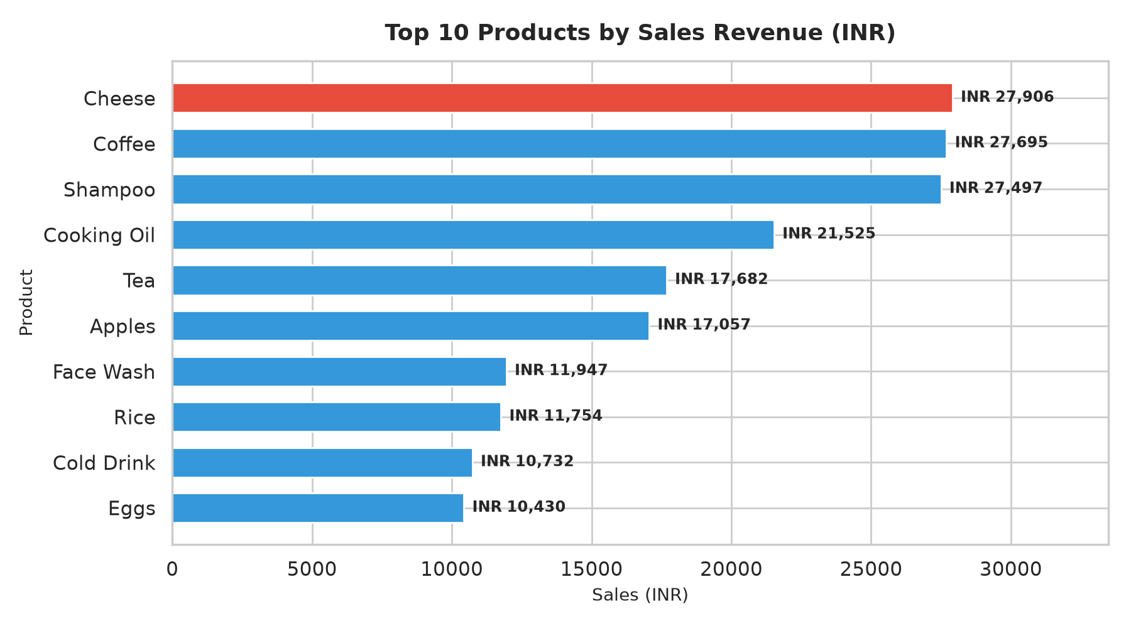
Figure 1: Top 10 Products by Sales Revenue (INR)
Observation: Cheese, Coffee, and Shampoo generate the highest total revenues, each exceeding ₹27,000.
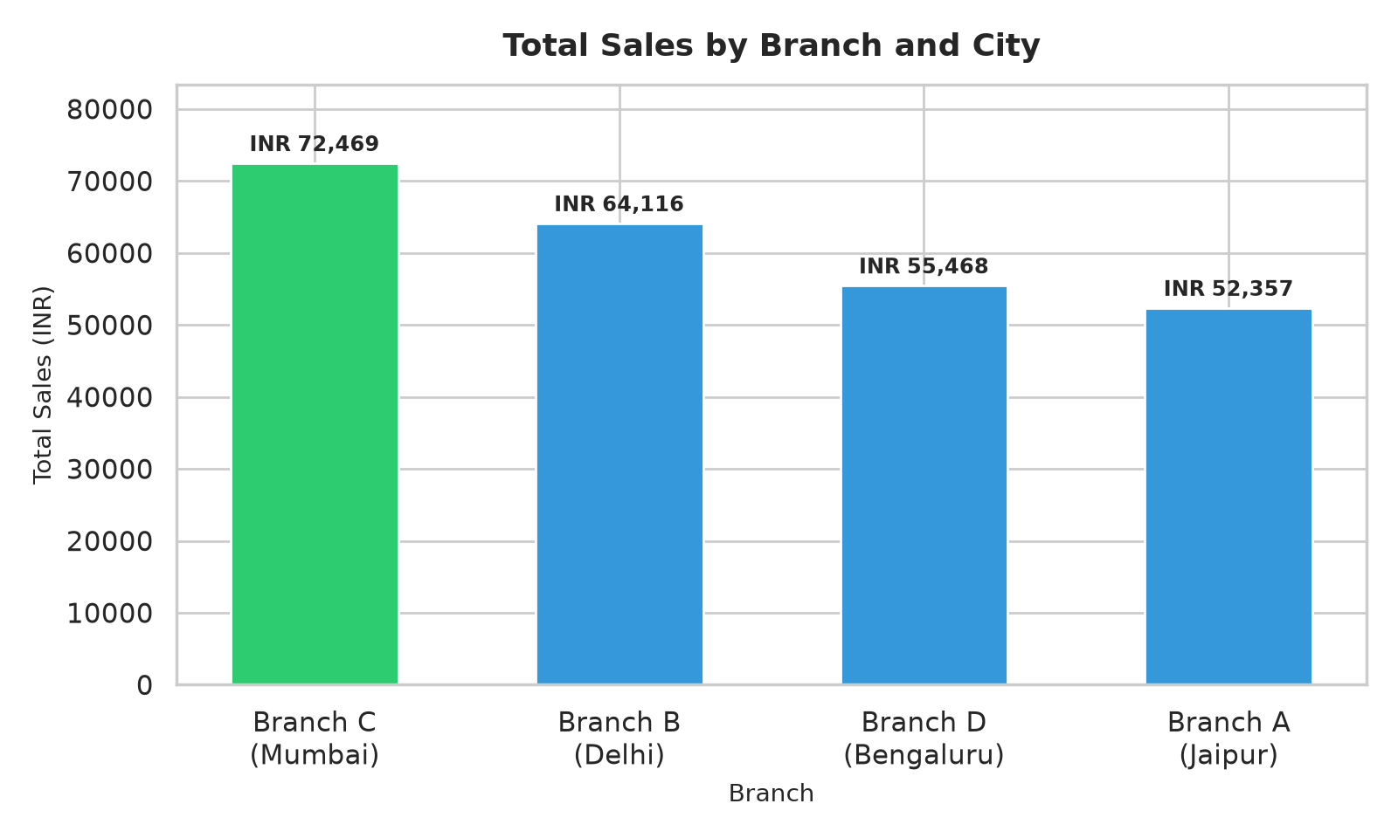
Figure 2: Total Sales across Supermarket Branches
Observation: Branch C (Mumbai) generates the highest sales (₹72,469), followed by Delhi, Bengaluru, and Jaipur.
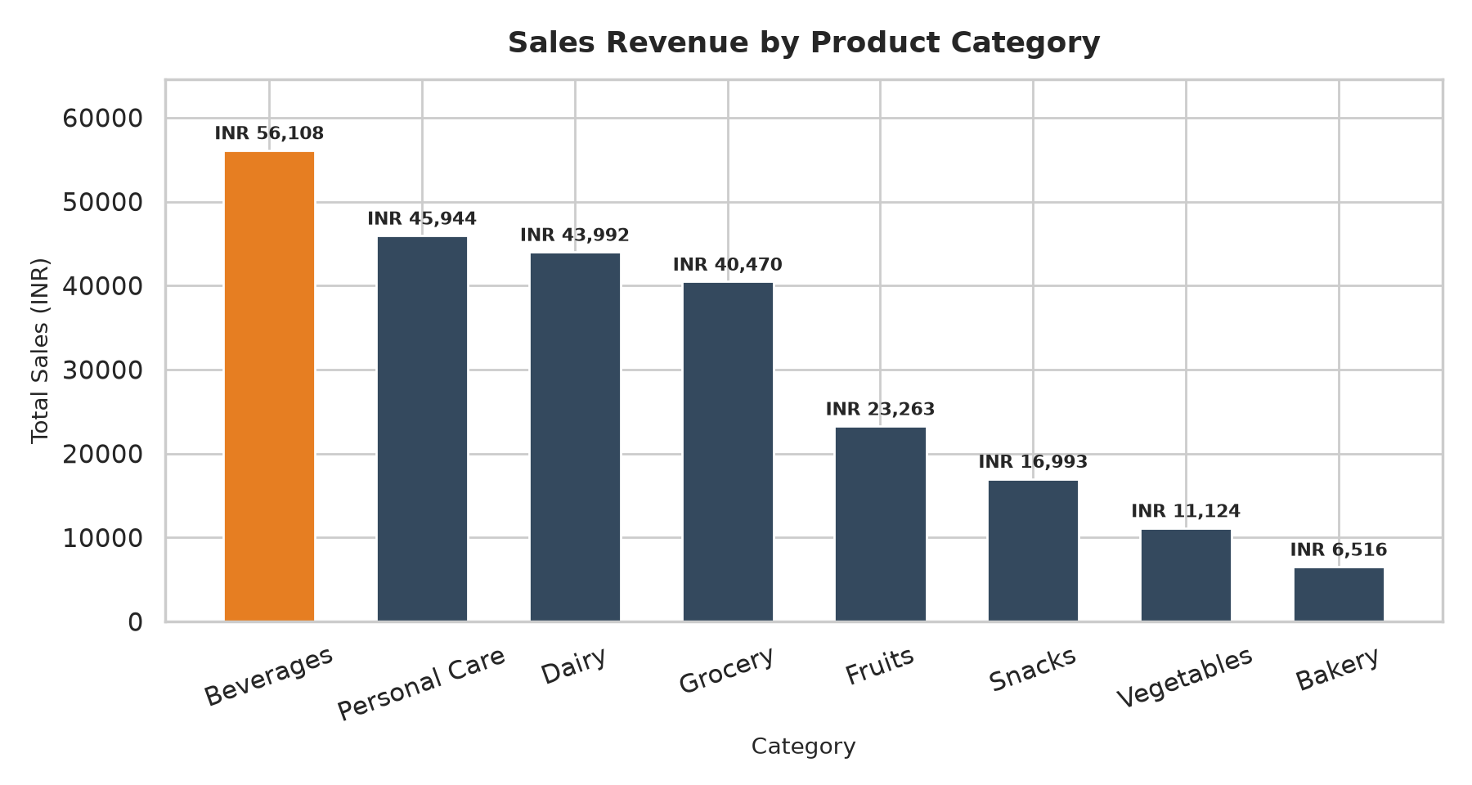
Figure 3: Sales Revenue by Product Category
Observation: Beverages, Personal Care, Dairy, and Grocery generate over 76% of total supermarket turnover.
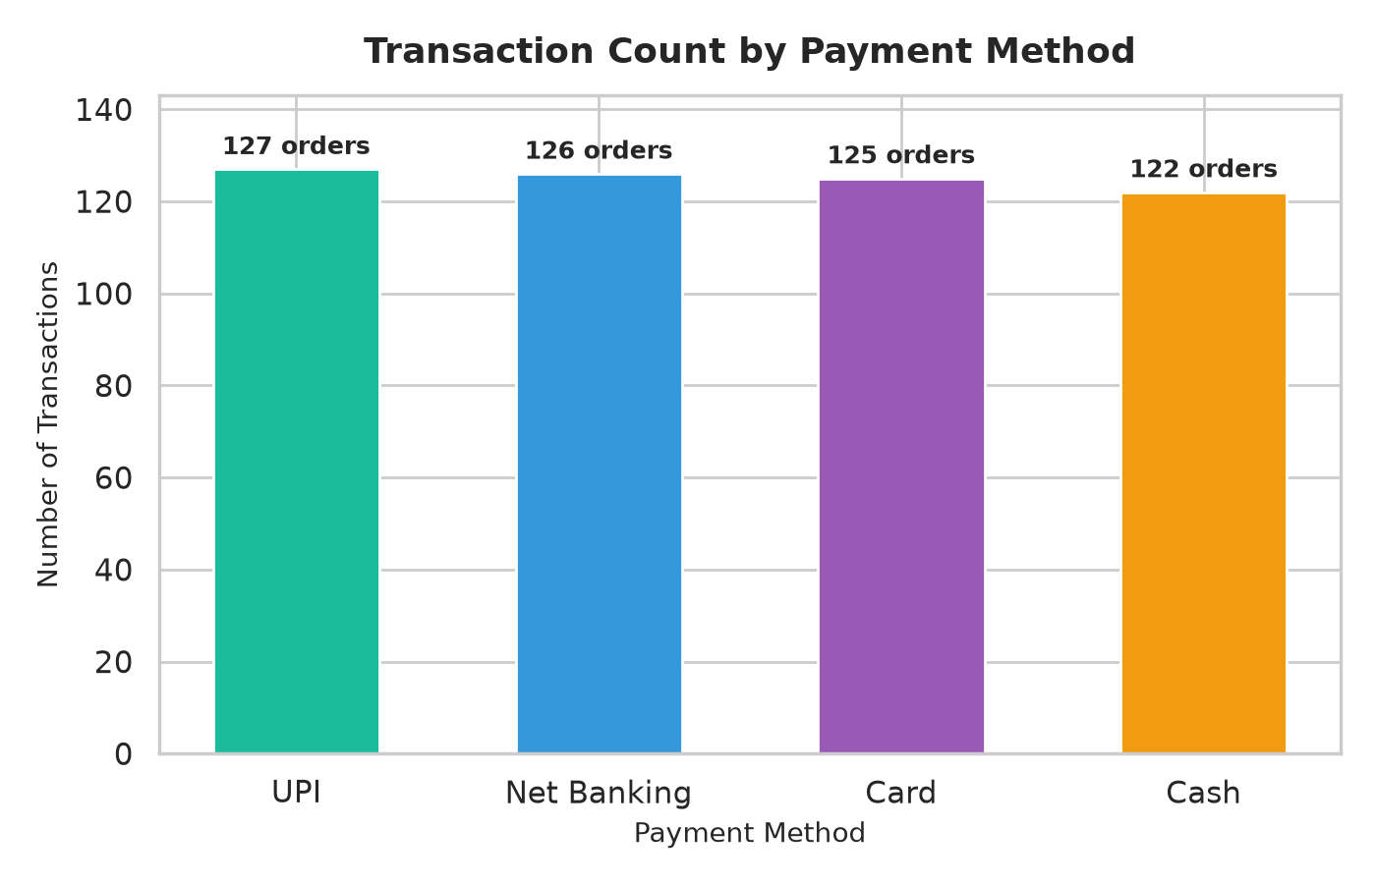
Figure 4: Transaction Count by Payment Method
Observation: UPI leads with 127 orders, but payment adoption is well-distributed across modern channels.
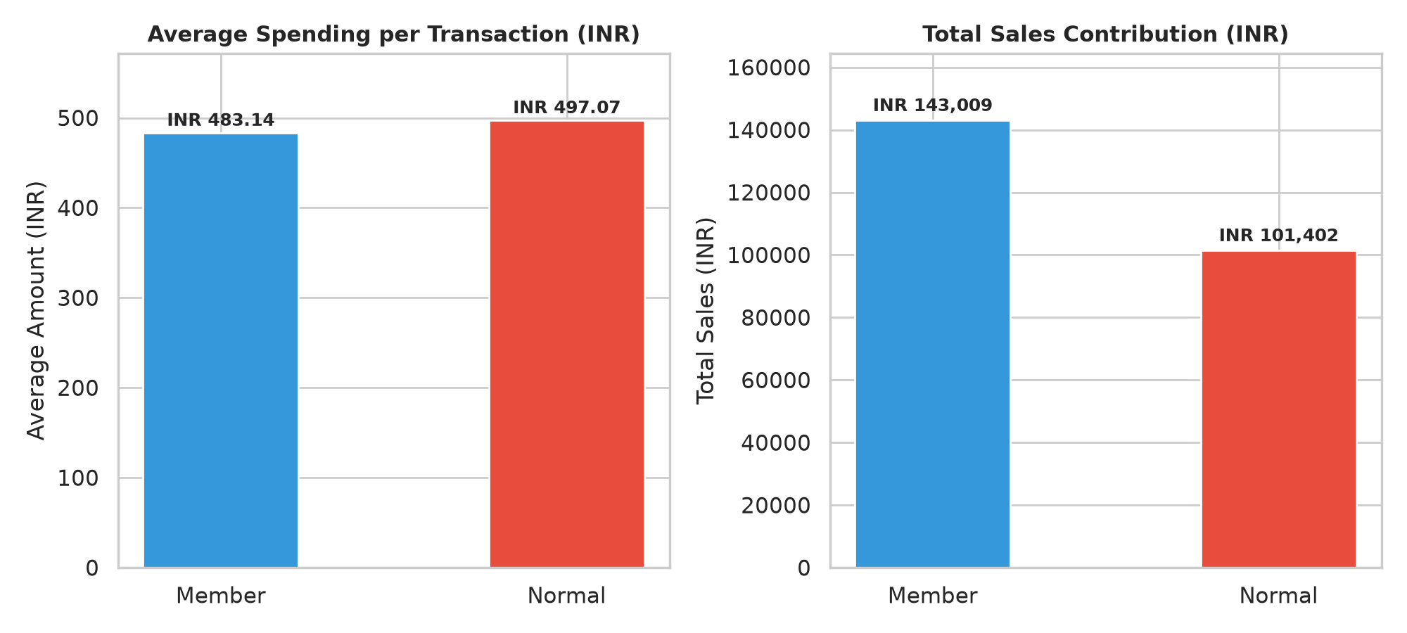
Figure 5: Customer Type Comparison: Average Spend vs. Total Revenue
Observation: Normal customers maintain a slightly higher basket size, but Members drive 58.5% of total sales revenue.
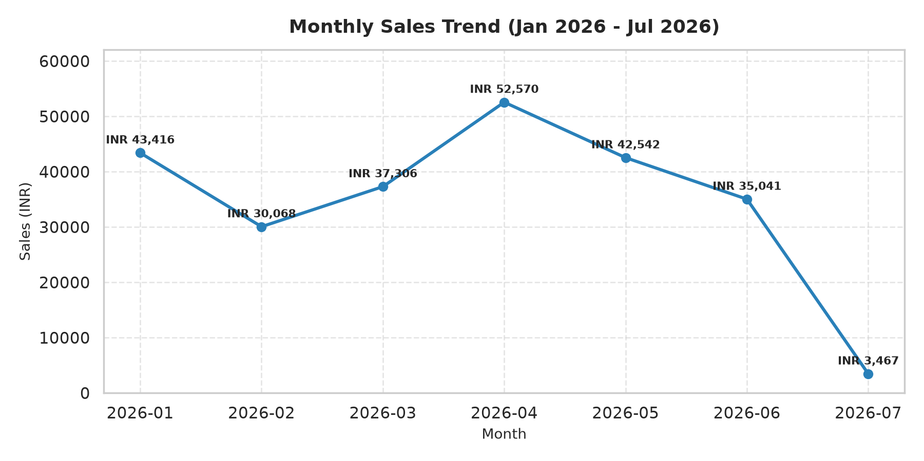
Figure 6: Monthly Sales Trend (Jan 2026 - Jul 2026)
Observation: Sales peaked in April 2026 (₹52,570), with February representing the lowest full calendar month.
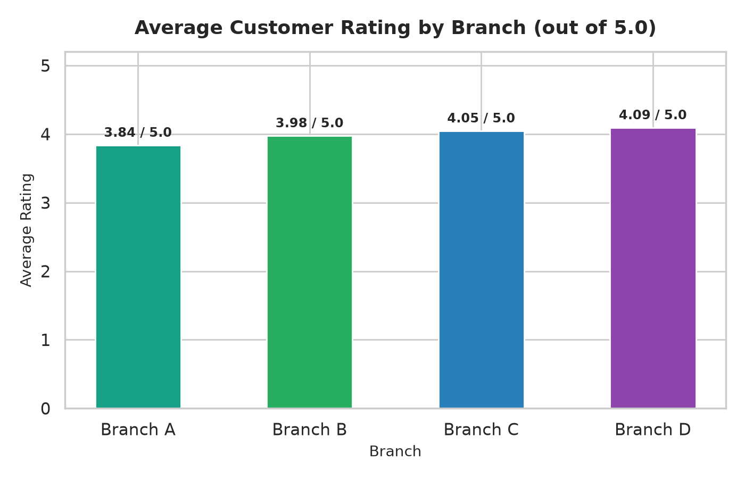
Figure 7: Average Customer Rating by Branch (out of 5.0)
Observation: Branch D (Bengaluru) leads customer satisfaction at 4.09, while Branch A (Jaipur) trails at 3.84.
6. Business Decisions & Actionable Recommendations
Based on the rigorous empirical findings, supermarket management should implement the following targeted initiatives:
1. Inventory & Supply Chain Prioritization: Maintain safety stock and automated reorder triggers for Cheese, Coffee, and Shampoo to prevent stockouts. Ensure strong supplier relationships for the Beverages and Personal Care categories, which together account for over ₹102,000 in revenue.
2. Branch C Operational Benchmarking: Conduct an operational audit of Branch C (Mumbai) to identify best practices in shelf merchandising, promotional bundles, and staffing that can be transferred to Branch A (Jaipur) to elevate its order volume from 105 to parity with other stores.
3. Digital Payment Checkout Acceleration: Given that UPI and Net Banking customers generate the highest average spend (₹534 and ₹517), install dedicated express QR scanners and UPI tap-and-pay terminals at all billing points to accelerate cashier throughput.
4. Loyalty Program Basket-Size Incentives: Members visit frequently but have a slightly lower average basket value (₹483.14 vs ₹497.07). Launch minimum-spend tier promotions (e.g., 'Spend ₹600 or more to receive 10% bonus points or free delivery') to raise Member basket sizes.
5. Customer Experience Revamp at Branch A: Branch A has the lowest rating in the supermarket network (3.84 vs 4.09 at Branch D). Institute staff customer-service training, audit checkout wait times, and introduce on-the-spot feedback kiosks to raise satisfaction.
7. Conclusion
This capstone project delivered a comprehensive, end-to-end data analytics study on 500 supermarket sales records. By combining automated data validation, rigorous exploratory grouping, visual analytics, and strategic business interpretation, the project demonstrates how data analytics converts raw transactional logs into practical retail intelligence.
The analysis definitively resolved all six core business questions, provided clear performance comparisons across regional branches, and outlined an operational roadmap to optimize inventory, elevate branch performance, and maximize customer loyalty.
Project completed and submitted by Harsh Agrawal for the IBM SkillsBuild Academic Internship Capstone Project.

