IOT AND AI FOR SMART AGRICULTURE: ACHIEVING SUSTAINABLE AND EFFICIENT CROP PRODUCTION

ABSTRACT:
India's economy is mostly based on agriculture because there are many different types of agricultural regions with ideal climates. A total of 275 million tons of food goods were grown in all of India's states during 2017 and 2018. According to studies, Uttar Pradesh is a state renowned for its extraordinarily high rate of agricultural output. In addition to productivity, it is imperative that the nation's food needs be met nationwide. Based on the global assessment of food security and nutrition, about 189.2 million people in India are undernourished. Food waste is significantly rising as a result of plant diseases and a shortage of nutrients that boost plant development. In addition, variations in the soil's quality and climate can influence production levels. IoT and AI technology are used in this suggested solution to address this issue and boost productivity. The IoT system's many sensors gather vital information including temperature, CO2 concentration, PH value, and moisture level. The suggested ML classifier analyzes this data and recommends an appropriate course of action for raising crop yield.

CHAPTER-1
1.1 INTRODUCTION
A system is something that maintains its existence and functions as a whole through the interaction of its parts. E.g. Body, Mankind, Access Control, etc A system is a part of the world that a person or group of persons during some time interval and for some purpose choose to regard as a whole, consisting of interrelated components, each component characterized by properties that are selected as being relevant to the purpose.

- Embedded System is a combination of hardware and software used to achieve a single specific task.
- Embedded systems are computer systems that monitor, respond to, or control an external environment.
- Environment connected to systems through sensors, actuators and other I/O interfaces.
- Embedded system must meet timing & other constraints imposed on it by environment.

An embedded system is a microcontroller-based, software driven, reliable, real-time control system, autonomous, or human or network interactive, operating on diverse physical variables and in diverse environments and sold into a competitive and cost conscious market.
An embedded system is not a computer system that is used primarily for processing, not a software system on PC or UNIX, not a traditional business or scientific application. High-end embedded & lower end embedded systems. High-end embedded system - Generally 32, 64 Bit Controllers used with OS. Examples Personal Digital Assistant and Mobile phones etc. Lower end embedded systems - Generally 8,16 Bit Controllers used with a minimal operating systems and hardware layout designed for the specific purpose. Examples Small controllers and devices in our everyday life like Washing Machine, Microwave Ovens, where they are embedded in.

1.2 DESIGN OF EMBEDDED SYSTEM:
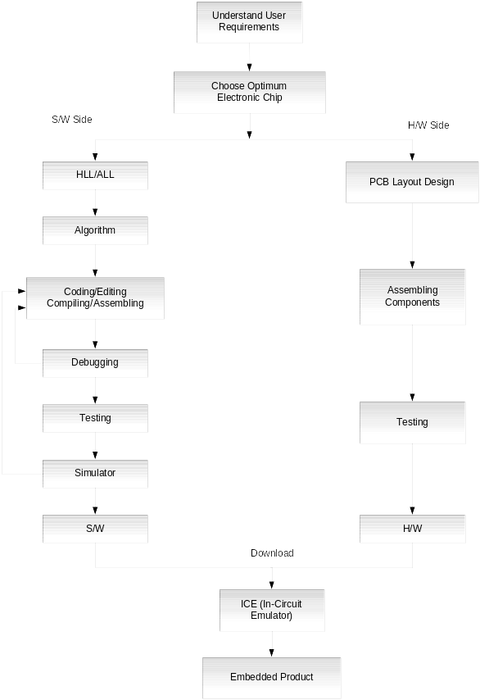
Like every other system development design cycle embedded system too have a design cycle. The flow of the system will be like as given below. For any design cycle these will be the implementation steps.
Figure 1.2 – Embedded Product Development Life Cycle
From the initial state of the project to the final fabrication the design considerations will be taken like the software consideration and the hardware components, sensor, input and output. The electronics usually uses either a microprocessor or a microcontroller. Some large or old systems use general-purpose mainframe computers or minicomputers.

1.3 CLASSIFICATION:
- Real Time Systems.
- RTS is one which has to respond to events within a specified deadline.
- A right answer after the dead line is a wrong answer
- RTS classification
  - Hard Real Time Systems
  - Soft Real Time System

Hard Real Time Systems
- "Hard" real-time systems have very narrow response time.
- Example: Nuclear power system, Cardiac pacemaker.

Soft Real Time System
- "Soft" real-time systems have reduced constrains on "lateness" but still must operate very quickly and repeatable.
- Example: Railway reservation system – takes a few extra seconds the data remains valid.

CHAPTER-2
LITERATURE SURVEY
1.Canopy temperature based system effectively schedules and controls center pivot irrigation of cotton, Water Management, S.A. O'Shaughnessy and S. R. Evett,.
Automated irrigation scheduling and control can be an important time management tool for a producer with multiple sprinkler irrigation systems or multiple systems relying on a single water source by prioritizing the order of irrigations field-by-field
2.Irrigation scheduling performance by evapotranspiration-based controllers, S. L. Davis and M. D. Dukes,
The field capacity and permanent wilting point were chosen for the theoretical irrigation requirement based on a soil survey. However, a controller program setting of “sand” and could mean different depths for individual controllers.
3.Establishing differential irrigation levels using temperature–time thresholds, Wanjura, D.E., Upchurch, D.R., Mahan
Data were analyzed from irrigation studies that measured the water application and cotton yield response to a range of average daily ST. All irrigation studies included a common control TT of 330 min/d above a canopy temperature threshold of 28°C as the criteria for the irrigation signal that maintained cotton in a well-watered status. In order to develop relationships between daily ST and final yield, or water input during the season, daily ST values were calculated and averaged over the irrigation season.
4. Water use efficiency regulated by automatic drip irrigation control, Evett, S.R., Howell, T.A., Schneider, A.D., Wanjura
An automatic irrigation system that allowed either high yields or high water u se efficiency to be chosen would be a useful farming tool. We tested a system that uses crop canopy temperature to automatically schedule

5. A wireless application of drip irrigation automation supported by soil moisture sensors, Mahir Dursun and Semih Ozden
The developed irrigation automation system can be proposed to be used in several commercial agricultural productions since it was obtained in low cost and in reliable operation. This application of sensor-based site Specific irrigation has some advantages such as preventing moisture stress of trees, diminishing of excessive water usage, ensuring of rapid growing weeds and derogating salification. If different kinds of sensors (that is, temperature, humidity, and etc.) are involved in such irrigation in future works, it can be said that an internet based remote control of irrigation automation will be possible. The developed system can also transfer fertilizer and the other agricultural chemicals (calcium, sodium, ammonium, zinc) to the field with adding new sensors and valves.
6. A survey of military applications of wireless sensor networks, Milica,Pejanović Đurišić,Zhilbert Tafa
This paper presents an overview of defense related applications of wireless sensor networks (WSNs). The operational context of modern military engagement has diversified into four scenarios, which set requirements and constraints upon applications of WSNs.
7. Wireless sensor based control system in agriculture field, K.S.Vijula ,GraceSilja KharimP,Sivasakthi
In an advanced agriculture the consumption of water is very high. Due to the developments in technology, efforts are being channeled into automation of irrigation systems to facilitate remote control of the irrigation to optimize crop production and cost effectiveness. In agriculture field, the current agricultural practices need to intensify the rate of food crop production for the rate of population growth with available resources. This proposed work describes the automated system to make effective utilization of water resources for agriculture and crop growth monitoring using GSM.

8. Study on precision water-saving irrigation automatic control system by plant physiology, Yandong ZhaoJunfu ZhangJinfeng Guan
Olympic Games in 2008 is not only a world sports event, but also a great opportunity to show our current level of economic development and modern science and technology strength. Precision water-saving irrigation automatic control system by plant physiology this paper described is one of the Olympic Games facilities projects, which takes standards of water plant physiologically need and soil water content as the basis, Through the combination of independent research and development of irrigation monitoring controller and wireless data transmission , implement a drip irrigation, sprinkler irrigation, micro-irrigation, and low-pressure pipelines, such as different modes of irrigation automatic control.
9. A WiFi based smart wireless sensor network for an agricultural environment, GerardRudolph Mendez,Mohd Amri,Md YunusSubhas Chandra,Mukhopadhyay
The main objective of the present work is to develop a smart wireless sensor network (WSN) for an agricultural environment. Monitoring of environmental factors have increased in importance over the last decade. In particular monitoring agricultural environments for various factors such as temperature and humidity along with other factors can be of significance. A traditional approach to measuring these factors in an agricultural environment meant individuals manually taking measurements and checking them at various times.

10. Study on Precision Water-saving Irrigation Automatic Control System by Plant Physiology, Yandong Zhao, Jinfeng Guan, Junfu Zhang, Weilun Yin
Precision water-saving irrigation automatic control system by plant physiology this paper described is one of the Olympic Games facilities projects, which takes standards of water plant physiologically need and soil water content as the basis, Through the combination of independent research and development of irrigation monitoring controller and wireless data transmission.

CHAPTER-3
EXISTING SYSTEM:
- Seasonal crops-crops can be planted during a season. e.g. wheat, cotton.
- Whole year crops-crops can be planted during the entire year. e.g. vegetable, paddy, Toor.
- Short time plantation crops- crops that take a short time for growing. e.g. potato, vegetables, ratio.
- Long-time plantation crops-These crops take a long time for growing. e.g. sugarcane, Onion.
- Accuracy is low.
Pro And Cons For Existing System:
Pros:
- The user provides the area & soil type as input.
- Machine learning algorithms allow choosing the most profitable crop list or predicting the crop yield for a user-selected crop.
Cons:
- The main challenge faced in agriculture sector is the lack of knowledge about the changing variations in climate.
- Each crop has its own suitable climatic features. This can be handled with the help of precise farming techniques.

PROPOSED SYSTEM:
Arduino Uno, a microcontroller is utilized to perform this process. A 12V power adaptor is connected with this microcontroller to maintain stable operating voltage at this phase. The sensor nodes namely NPK, PH sensor, Rain sensor, Humidity sensor are connected with this to tack and collect everyday data of the cultivable land which is then processed by the machine learning classifier. The purpose of NPK senor is to know the level of Nitrogen, Phosphorous and Potassium present on soil. These nutrients are essential for plant growth and development. It should be in the ratio of 4:2:1. Apart from that nearly 6 macro nutrients are required to balance plant growth. Following this, the water quality analysis and pH values are measured using pH sensor. The sensor measures value from 0-14. When the pH value is between 6.2- 6.8, the sol is suitable for cultivation. Furthermore the usage of rain sensor and humidity senor is to predict the level of moisture present on soli and air. This in turn determines how much amount of water required for the field. All the information collected is processed by the microcontroller. Then it is utilized by AI technology to improve the quality of corp.

BLOCK DIAGRAM:

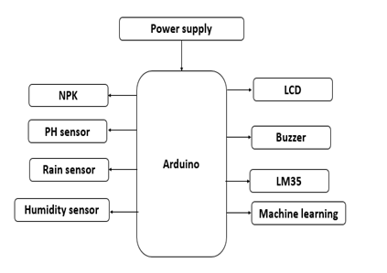

MachineLearning Block Diagram:
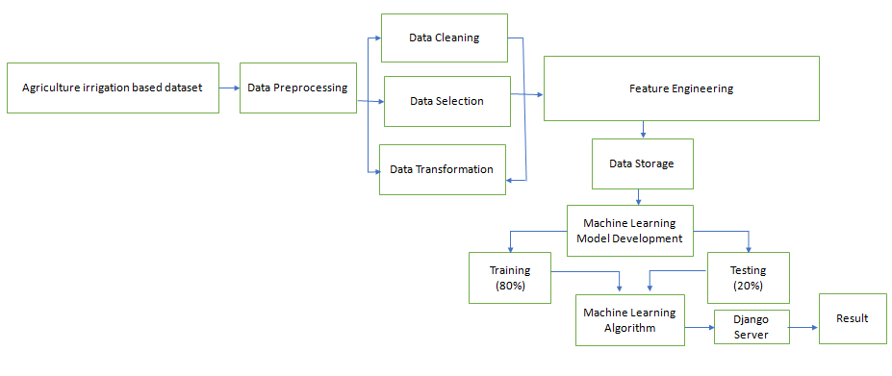

REQUIREMENTS:
Hardware Tools:
- Arduino controller
- UART RS232 CABLE
- Power supply unit
- Relay
- pump motor
- PH Sensor
- NPK Sensor
- Humidity Sensor
Software Tools:
- Embedded C
- HTML
- Python

APPLICATIONS:
- Agriculture applications
- Remote control industries

CHAPTER-4
MODULE DISCRIPTION

Creating an NPK (Nitrogen, Phosphorus, Potassium) sensor, pH sensor, Humidity sensor, temperature sensor with Arduino involves measuring the sensors values and electrical conductivity of a solution containing these nutrients. Here's a basic guide on how you can build an NPK sensor using Arduino.
Components Needed:
- Arduino board (e.g., Arduino Uno)
- Electrical conductivity (EC) sensor
- pH sensor (optional for more comprehensive soil analysis)
- NPK nutrient standards or solutions Peristaltic pump (optional for automated nutrient solution delivery)
- Display unit (e.g., LCD screen)
- Connecting wires
- Power supply
Steps:
Connect the Sensors:
Connect the EC sensor and pH sensor to the Arduino. Most sensors come with documentation explaining how to connect them. Connect the peristaltic pump if you're using one.
Calibrate the Sensors:
Calibrate the EC sensor using NPK standards. Immerse the sensor in known NPK concentrations and record the sensor readings. If you're using a pH sensor, calibrate it using pH buffer solutions.
Program the Arduino:
Write a program for the Arduino to read sensor values and display them. You can use the Arduino IDE and a compatible programming language.
Automate Nutrient Solution Delivery (Optional):
If you're using a peristaltic pump, write code to control the pump based on sensor readings.
Test and Calibrate:
Test your system in different nutrient solutions with known concentrations to ensure accurate readings. Adjust calibration values in your code if necessary.
Display Readings:
Display the readings on an LCD screen or another display unit for easy monitoring.

ARDUINO UNO AND ITS PROGRAMMING

Arduino is a tool for making computers that can sense and control more of the physical world than your desktop computer. It's an open-source physical computing platform based on a simple microcontroller board, and a development environment for writing software for the board.

Arduino can be used to develop interactive objects, taking inputs from a variety of switches or sensors, and controlling a variety of lights, motors, and other physical outputs. Arduino projects can be stand-alone, or they can be communicate with software running on your computer. The boards can be assembled by hand or purchased preassembled; the open-source IDE can be downloaded for free.

The Arduino programming language is an implementation of Wiring, a similar physical computing platform, which is based on the Processing multimedia programming environment.

Arduino Uno:
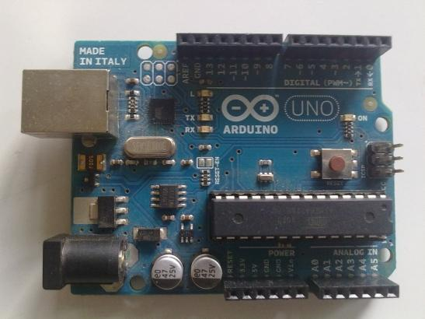

Fig 3.1 ARDUINO UNO

19

2.1 Overview
The Arduino microcontroller is an easy to use yet powerful single board computer that has gained considerable traction in the hobby and professional market. The Arduino is open-source, which means hardware is reasonably priced and development software is free. This guide is for students in ME 2011, or students anywhere who are confronting the Arduino for the first time. For advanced Arduino users, prowl the web; there are lots of resources.

This guide covers the Arduino Uno board (Spark fun DEV-09950, $29.95), a good choice for students and educators. With the Arduino board, you can write programs and create interface circuits to read switches and other sensors, and to control motors and lights with very little effort. Many of the pictures and drawings in this guide were taken from the documentation on the

This is what the Arduino board looks like.

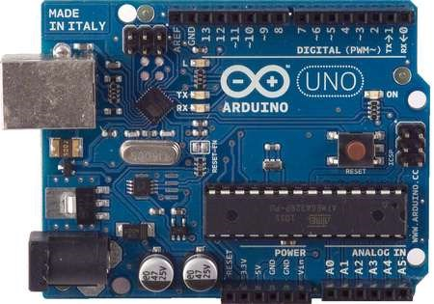

The Duemilanove board features an Atmel ATmega328 microcontroller operating at 5 V with 2 Kb of RAM, 32 Kb of flash memory for storing programs and 1 Kb of EEPROM for storing parameters. The clock speed is 16 MHz, which translates to about executing about 300,000 lines of C source code per second. The board has 14 digital I/O pins and 6 analog input pins. There is a USB connector for talking to the host computer and a DC power jack for connecting an external 6-20 V power source, for example a 9 V battery, when running a program while not connected to the host computer. Headers are provided for interfacing to the I/O pins using 22 g solid wire or header connectors.

The Arduino programming language is a simplified version of C/C++. If you know C, programming the Arduino will be familiar. If you do not know C, no need to worry as only a few commands are needed to perform useful functions.

An important feature of the Arduino is that you can create a control program on the host PC, download it to the Arduino and it will run automatically. Remove the USB cable connection to the PC, and the program will still run from the top each time you push the reset button. Remove the battery and put the Arduino board in a closet for six months. When you reconnect the battery, the last program you stored will run. This means that you connect the board to the host PC to develop and debug your program, but once that is done, you no longer need the PC to run the program.

The Arduino Uno is a microcontroller board based on the ATmega328.It has 14 digital input/output pins (of which 6 can be used as PWM outputs), 6 analog inputs, a 16 MHz ceramic resonator, a USB connection, a power jack, an ICSP header, and a reset button. It contains everything needed to support the microcontroller; simply connect it to a computer with a USB cable or power it with a AC-to-DC adapter or battery to get started.

The Uno differs from all preceding boards in that it does not use the FTDI USB-to-serial driver chip. Instead, it features the Atmega16U2 (Atmega8U2 up to version R2) programmed as a USB-to-serial converter.

2.2 Summary:

Microcontroller ATmega328

Operating Voltage 5V

Input Voltage (recommended) 7-12V

Input Voltage (limits) 6-20V

Digital I/O Pins 14 (of which 6 provide PWM output)

Analog Input Pins 6

DC Current per I/O Pin 40 mA

DC Current for 3.3V Pin 50 mA

Flash Memory 32 KB (ATmega328) of which 0.5 KB used by bootloader

SRAM 2 KB (ATmega328)

EEPROM 1 KB (ATmega328)

Clock Speed 16 MHz

20
2.3 Pin Configuration

The Arduino Uno can be powered via the USB connection or with an external power supply. The power source is selected automatically.

External (non-USB) power can come either from an AC-to-DC adapter (wall- wart) or battery. The adapter can be connected by plugging a 2.1mm center-positive plug into the board's power jack. Leads from a battery can be inserted in the Gnd and Vin pin headers of the POWER connector.

The board can operate on an external supply of 6 to 20 volts. If supplied with less than 7V, however, the 5V pin may supply less than five volts and the board may be unstable. If using more than 12V, the voltage regulator may overheat and damage the board. The recommended range is 7 to 12 volts.

The power pins are as follows:

- VIN. The input voltage to the Arduino board when it's using an external power source (as opposed to 5 volts from the USB connection or other regulated power source). You can supply voltage through this pin, or, if supplying voltage via the power jack, access it through this pin.

- 5V. this pin outputs a regulated 5V from the regulator on the board. The board can be supplied with power either from the DC power jack (7 - 12V), the USB connector (5V), or the VIN pin of the board (7-12V). Supplying voltage via the 5V or 3.3V pins bypasses the regulator, and can damage your board.

- 3V3. A 3.3 volt supply generated by the on-board regulator. Maximum current draw is 50 mA.

- GND. Ground pins.

- IOREF. This pin on the Arduino board provides the voltage reference with which the microcontroller operates. A properly configured shield can read the IOREF pin voltage and select the appropriate power source or enable voltage translators on the outputs for working with the 5V or 3.3V.

21
Memory

The ATmega328 has 32 KB (with 0.5 KB used for the bootloader). It also has 2 KB of SRAM and 1 KB of EEPROM.

Input and Output

Each of the 14 digital pins on the Uno can be used as an input or output, using pinMode(), digital Write( ), and digital Read( ) functions. They operate at 5 volts. Each pin can provide or receive a maximum of 40 mA and has an internal pull- up resistor (disconnected by default) of 20-50 kohms. In addition, some pins have specialized functions:

• Serial: 0 (RX) and 1 (TX). Used to receive (RX) and Trans mit (TX) TTL serial data.

These pins are connected to the corresponding pins of the ATmega8U2 USB-to- TTL Serial chip.

- External Interrupts: 2 and 3. These pins can be configured to trigger an interrupt on a low value, a rising or falling edge, or a change in value. See the attach Interrupt () function for details.

- PWM: 3, 5, 6, 9, 10, and 11. Provide 8-bit PWM output with the analog Write () function.

- SPI: 10 (SS), 11 (MOSI), 12 (MISO), 13 (SCK). These pins support SPI communication using the SPI library.

- LED: 13. There is a built- in LED connected to digital pin 13. When the pin is HIGH value, the LED is on, when the pin is LOW, it's off.

The Uno has 6 analog inputs, labeled A0 through A5, each of which provide 10 bits of resolution (i.e. 1024 different values). By default they measure from ground to 5 volts, though is it possible to change the upper end of their range using the AREF pin and the analog Reference () function. Additionally, some pins have specialized functionality:

• TWI: A4 or SDA pin and A5 or SCL pin. Support TWI communication using the Wire library.

There are a couple of other pins on the board:

22
• AREF. Reference voltage for the analog inputs. Used with analog Reference ().

Reset. Bring this line LOW to reset the microcontroller. Typically used to add a reset button to shields which block the one on the board.

2.5 ARDUINO SOFTWARE:

1. Open Arduino IDE as shown below

Open Arduino IDE
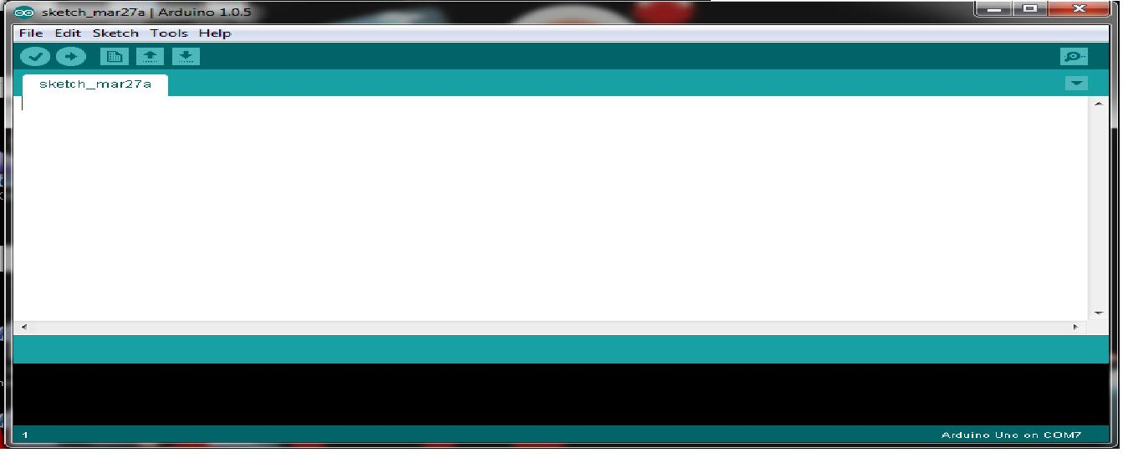

Fig 3.2

2. Select the COM Port from tool

Select the COM Port
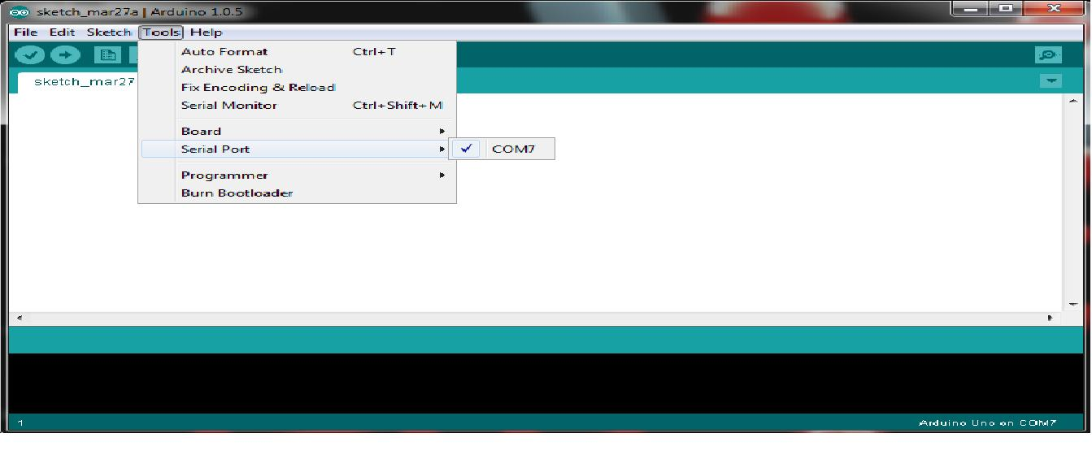

Fig 3.3

3. Select the required Arduino board from Tools as shown below

Select the required Arduino board
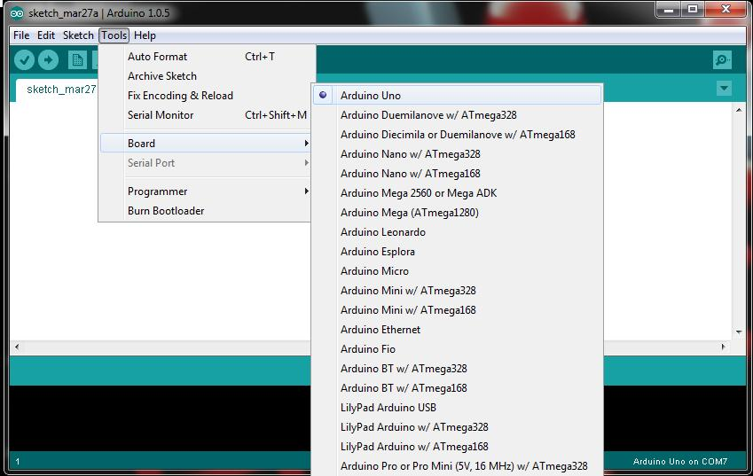

Fig 3.4

Fig 3.6

TEMPERATURE SENSOR (LM35)
FEATURES DESCRIPTION
- Calibrated Directly in ° Celsius (Centigrade)
- Linear + 10 mV/°C Scale Factor
- 0.5°C Ensured Accuracy (at +25°C) LM35 has an advantage over linear temperature
- Rated for Full −55°C to +150°C Range
- Suitable for Remote Applications
- Low Cost Due to Wafer-Level Trimming
- Less than 60-μA Current Drain
- Low Self-Heating, 0.08°C in Still Air
- Nonlinearity Only ±¼°C Typical
- Low Impedance Output, 0.1 Ω for 1 mA Load

DESCRIPTION
The LM35 series are precision integrated-circuit temperature sensors, with an output voltage linearly proportional to the Centigrade temperature. Thus the LM35 has an advantage over linear temperature sensors calibrated in ° Kelvin, as the user is not required to subtract a large constant voltage from the output to obtain convenient Centigrade scaling. The LM35 does not require any external calibration or trimming to provide typical accuracies of ±¼°C at room temperature and ±¾°C over a full −55°C to +150°C temperature range. Low cost is assured by trimming and calibration at the wafer level. The low output impedance, linear output, and precise inherent calibration of the LM35 make interfacing to readout or control circuitry especially easy. The device is used with single power supplies, or with plus and minus supplies. As the LM35 draws only 60 μA from the supply, it has very low self-heating of less than 0.1°C in still air. The LM35 is rated to operate over a −55°C to +150°C temperature range, while the LM35C is rated for a −40°C to +110°C range (−10° with improved accuracy). The LM35 series is available packaged in hermetic TO transistor packages, while the LM35C, LM35CA, and LM35D are also available in the plastic TO-92 transistor package. The LM35Dis also available in an 8-lead surface-mount small outline package and a plastic TO-220 package.

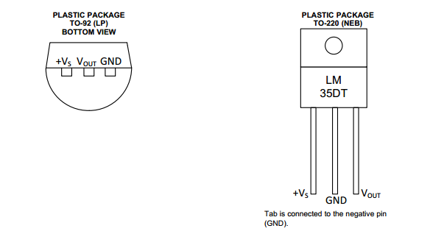
Figure. View of Temperature sensor

Soil NPK Sensor

The soil NPK sensor is suitable for detecting the content of nitrogen, phosphorus, and potassium in the soil. It helps in determining the fertility of the soil thereby facilitating the systematic assessment of the soil condition. The sensor can be buried in the soil for a long time. It has a High-quality probe, rust resistance, electrolytic resistance, salt & alkali corrosion resistance, to ensure the long-term operation of the probe part. Therefore, it is suitable for all kinds of soil. It is suitable for the detection of alkaline soil, acid soil, substrate soil, seedling bed soil & coconut bran soil.

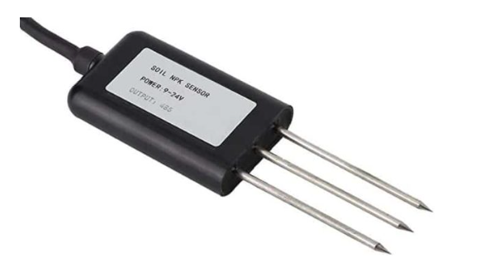
The sensor doesn’t require any chemical reagent. Since it has High measurement accuracy, fast response speed, and good interchangeability, it can be used with any microcontroller. You cannot use the sensor directly with the microcontroller as it has a Modbus Communication port. Hence you need any Modbus Module like RS485/MAX485 and connect the sensor to the microcontroller.
The sensor operates on 9-24V & power consumption is very low. While talking about the accuracy of the sensor, it is up to within 2%. The nitrogen, phosphorous & potassium measuring resolution is up to 1mg/kg (mg/l).

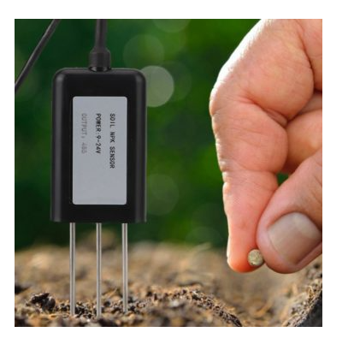

Specifications
1. Power: 9V-24V
2. Measuring Range: 0-1999 mg/kg (mg/l)
3. Operating Temperature: 5-45 °C
4. Resolution: 1mg/kg
5. Precision: ±2% F.S.
6. Output Signal: RS485
7. Baud Rate: 2400/4800/9600
8. Protection Class: IP68

LCD Display
Liquid crystal displays (LCDs) have materials which combine the properties of both liquids and crystals. Rather than having a melting point, they have a temperature range within which the molecules are almost as mobile as they would be in a liquid but are grouped together in an ordered form similar to a crystal.
An LCD consists of two glass panels, with the liquid crystal material sand witched in between them. The inner surface of the glass plates is coated with transparent electrodes which define the character, symbols or patterns to be displayed polymeric layers are present in between the electrodes and the liquid crystal, which makes the liquid crystal molecules to maintain a defined orientation angle.
One each polarisers are pasted outside the two glass panels. These polarisers would rotate the light rays passing through them to a definite angle, in a particular direction
When the LCD is in the off state, light rays are rotated by the two polarisers and the liquid crystal, such that the light rays come out of the LCD without any orientation, and hence the LCD appears transparent.
When sufficient voltage is applied to the electrodes, the liquid crystal molecules would be aligned in a specific direction. The light rays passing through the LCD would be rotated by the polarisers, which would result in activating / highlighting the desired characters.
The LCD’s are lightweight with only a few millimeters thickness. Since the LCD’s consume less power, they are compatible with low power electronic circuits, and can be powered for long durations.
The LCD’s don’t generate light and so light is needed to read the display. By using backlighting, reading is possible in the dark. The LCD’s have long life and a wide operating temperature range.
Changing the display size or the layout size is relatively simple which makes the LCD’s more customer friendly.
The LCDs used exclusively in watches, calculators and measuring instruments are the simple seven-segment displays, having a limited amount of numeric data. The recent advances in technology have resulted in better legibility, more information displaying capability and a wider temperature range. These have resulted in the LCDs being extensively used in telecommunications and entertainment electronics. The LCDs have even started replacing the cathode ray tubes (CRTs) used for the display of text and graphics, and also in small TV applications.
Crystalonics dot –matrix (alphanumeric) liquid crystal displays are available in TN, STN types, with or without backlight. The use of C-MOS LCD controller and driver ICs result in low power consumption. These modules can be interfaced with a 4-bit or 8-bit micro processor /Micro controller.
The built-in controller IC has the following features:
- Correspond to high speed MPU interface (2MHz)
- 80 x 8 bit display RAM (80 Characters max)
- 9,920 bit character generator ROM for a total of 240 character fonts. 208 character fonts (5 x 8 dots) 32 character fonts (5 x 10 dots)
- 64 x 8 bit character generator RAM 8 character generator RAM 8 character fonts (5 x 8 dots) 4 characters fonts (5 x 10 dots)
- Programmable duty cycles
1/8 – for one line of 5 x 8 dots with cursor
1/11 – for one line of 5 x 10 dots with cursor
1/16 – for one line of 5 x 8 dots with cursor
- Wide range of instruction functions display clear, cursor home, display on/off, cursor on/off, display character blink, cursor shift, display shift.
FUNCTIONAL DESCRIPTION OF THE CONTROLLER IC
REGISTERS:
The controller IC has two 8 bit registers, an instruction register (IR) and a data register (DR). The IR stores the instruction codes and address information for display data RAM (DD RAM) and character generator RAM (CG RAM). The IR can be written, but not read by the MPU.
The DR temporally stores data to be written to /read from the DD RAM or CG RAM. The data written to DR by the MPU, is automatically written to the DD RAM or CG RAM as an internal operation.
When an address code is written to IR, the data is automatically transferred from the DD RAM or CG RAM to the DR. data transfer between the MPU is then completed when the MPU reads the DR. likewise, for the next MPU read of the DR, data in DD RAM or CG RAM at the address is sent to the DR automatically. Similarly, for the MPU write of the DR, the next DD RAM or CG RAM address is selected for the write operation.
The dot-matrix liquid crystal display controller and driver LSI displays alphanumeric, Japanese kana characters, and symbols. It can be configured to drive a dot-matrix liquid crystal display under the control of a 4- or 8-bit microprocessor. Since all the functions such as display RAM, character generator, and liquid crystal driver, required for driving a dot-matrix liquid crystal display are internally provided on one chip, a minimal system can be interfaced with this controller/driver.
Block Diagram

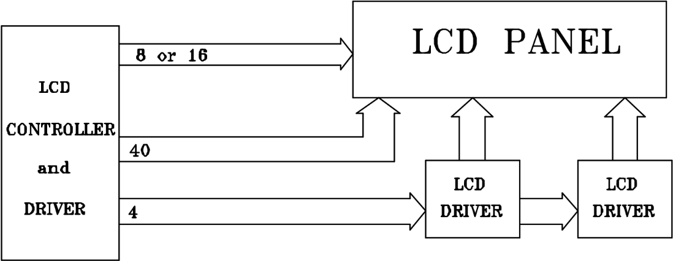

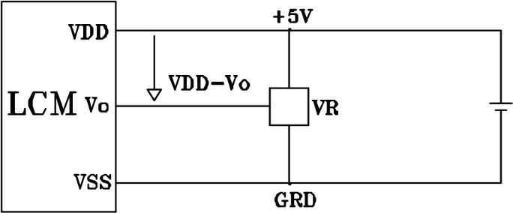

VDD-Vo: LCD DRIVING VOLTAGE
VR: 10K-20K
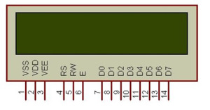

Absolute Maximum Ratings
Item | Symbol | Min | Max | Unit
Power Voltage | VDD -VSS | 0 | 7.0 | V
Input Voltage | V_{in} | V_{SS} | VDD | V
Operating Temperature Range | TOP | 0 | +50 | T
Storage Temperature Range | T_{ST} | -20 | +60 | T

PUMP Motor:
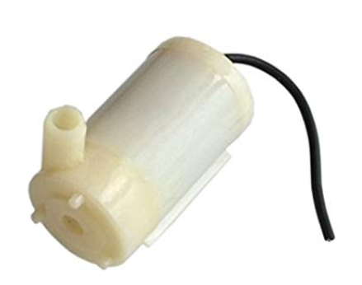
PUMP MOTOR SPECIFICATION:
- DC 3-6V 120L/H Low Mini Submersible Motor Pump New Water Pumps Item Type: Electronics Specification:
- DC Voltage: 2.5-6V Maximum lift:40-110cm / 15.75"-43.4“
- Flow rate:80-120L/H Outside diameter of water outlet: 7.5mm / 0.3" Material: engineering plastic Driving mode: brushless dc design, magnetic driving Continuous working life of 500 hours Package includes: 1 x Micro Submersible Aquarium Pump

POWER SUPPLY UNIT
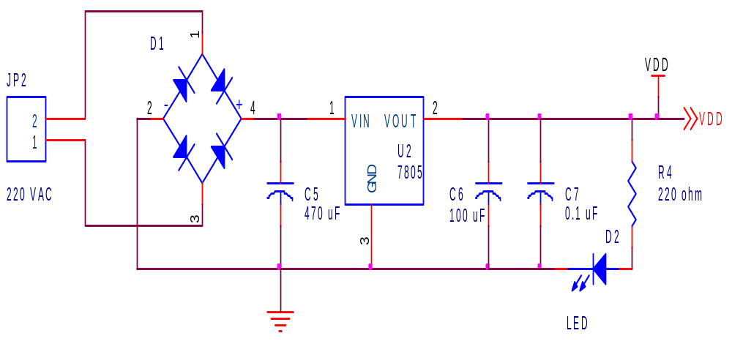

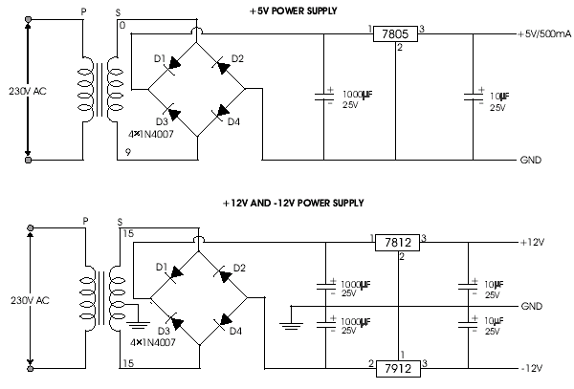2.1 CIRCUIT DIAGRAM OF POWER SUPPLY
2.1.1 WORKING PRINCIPLE:
The AC voltage, typically 220V rms, is connected to a transformer, which steps that ac voltage down to the level of the desired DC output. A diode rectifier then provides a full-wave rectified voltage that is initially filtered by a simple capacitor filter to produce a dc voltage. This resulting dc voltage usually has some ripple or ac voltage variation.A regulator circuit removes the ripples and also remains the same dc value even if the input dc voltage varies, or the load connected to the output dc voltage changes.

2.1.2 TRANSFORMER:
The potential transformer will step down the power supply voltage (0-230V) to (0-6V) level. Then the secondary of the potential transformer will be connected to the precision rectifier, which is constructed with the help of op–amp. The advantages of using precision rectifier are it will give peak voltage output as DC, rest of the circuits will give only RMS output.

2.1.3 BRIDGE RECTIFIER:
When four diodes are connected as shown in figure, the circuit is called as bridge rectifier. The input to the circuit is applied to the diagonally opposite corners of the network, and the output is taken from the remaining two corners.
Let us assume that the transformer is working properly and there is a positive potential, at point A and a negative potential at point B. the positive potential at point A will forward bias D3 and reverse bias D4.
The negative potential at point B will forward bias D1 and reverse D2. At this time D3 and D1 are forward biased and will allow current flow to pass through them; D4 and D2 are reverse biased and will block current flow.
The path for current flow is from point B through D1, up through RL, through D3, through the secondary of the transformer back to point B. this path is indicated by the solid arrows. Waveforms (1) and (2) can be observed across D1 and D3.
One-half cycle later the polarity across the secondary of the transformer reverse, forward biasing D2 and D4 and reverse biasing D1 and D3. Current flow will now be from point A through D4, up through RL, through D2, through the secondary of T1, and back to point A. This path is indicated by the broken arrows. Waveforms (3) and (4) can be observed across D2 and D4. The current flow through RL is always in the same direction.
In flowing through RL this current develops a voltage corresponding to that shown waveform (5). Since current flows through the load (RL) during both half cycles of the applied voltage, this bridge rectifier is a full-wave rectifier.
One advantage of a bridge rectifier over a conventional full-wave rectifier is that with a given transformer the bridge rectifier produces a voltage output that is nearly twice that of the conventional full-wave circuit.
This may be shown by assigning values to some of the components shown in views A and B. assume that the same transformer is used in both circuits. The peak voltage developed between points X and y is 1000 volts in both circuits. In the conventional full-wave circuit shown—in view A, the peak voltage from the center tap to either X or Y is 500 volts.
Since only one diode can conduct at any instant, the maximum voltage that can be rectified at any instant is 500 volts.
The maximum voltage that appears across the load resistor is nearly-but never exceeds-500 v0lts, as result of the small voltage drop across the diode. In the bridge rectifier shown in view B, the maximum voltage that can be rectified is the full secondary voltage, which is 1000 volts. Therefore, the peak output voltage across the load resistor is nearly 1000 volts. With both circuits using the same transformer, the bridge rectifier circuit produces a higher output voltage than the conventional full-wave rectifier circuit.

2.1.4 IC VOLTAGE REGULATORS:
Voltage regulators comprise a class of widely used ICs. Regulator IC units contain the circuitry for reference source, comparator amplifier, control device, and overload protection all in a single IC. IC units provide regulation of either a fixed positive voltage, a fixed negative voltage, or an adjustably set voltage. The regulators can be selected for operation with load currents from hundreds of milli amperes to tens of amperes, corresponding to power ratings from milli watts to tens of watts.
A fixed three-terminal voltage regulator has an unregulated dc input voltage, Vi, applied to one input terminal, a regulated dc output voltage, Vo, from a second terminal, with the third terminal connected to ground.
The series 78 regulators provide fixed positive regulated voltages from 5 to 24 volts. Similarly, the series 79 regulators provide fixed negative regulated voltages from 5 to 24 volts.

Humidity sensor
Measurement and control of temperature and relative humidity finds applications in numerous areas. These days devices are available which have both temperature and humidity sensors with signal conditioning, ADC, calibration and communication interface all built inside them. The use of such smart sensors greatly simplify the design and reduces the overall cost. We discussed in past about Humidity and temperature measurements with Sensirion’s SHT1x/SHT7x sensors. These sensors are capable of measuring both temperature and relative humidity and provide fully calibrated digital outputs. While SHT1x/SHT7x are very accurate sensors, they are still expensive for hobbyists use. This articles discusses the DHT11 sensor which also provides calibrated digital outputs for temperature and humidity but is relatively lot cheaper than the Sensirion sensors. The DHT11 sensor uses a proprietary 1-wire protocol which we will be exploring here and implementing with the PIC16F628A microcontroller that will receive the temperature and humidity values from the sensor and display them on a 16×2 character LCD.
About DHT11 sensor
The DHT11 sensor comes in a single row 4-pin package and operates from 3.5 to 5.5V power supply. It can measure temperature from 0-50 °C with an accuracy of ±2°C and relative humidity ranging from 20-95% with an accuracy of ±5%. The sensor provides fully calibrated digital outputs for the two measurements. It has got its own proprietary 1-wire protocol, and therefore, the communication between the sensor and a microcontroller is not possible through a direct interface with any of its peripherals. The protocol must be implemented in the firmware of the MCU with precise timing required by the sensor. The following timing diagrams describe the data transfer protocol between a MCU and the DHT11 sensor. The MCU initiates data transmission by issuing a “Start” signal. The MCU pin must be configured as output for this purpose. The MCU first pulls the data line low for at least 18 ms and then pulls it high for next 20-40 ?s before it releases it.
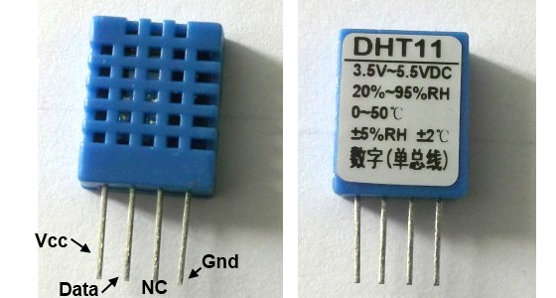
DHT11 sensor comes in a single row 4-pin package
Next, the sensor responds to the MCU “Start“ signal by pulling the line low for 80 ?s followed by a logic high signal that also lasts for 80 ?s. Remember that the MCU pin must be configured to input after finishing the “Start“ signal. Once detecting the response signal from the sensor, the MCU should be ready to receive data from the sensor. The sensor then sends 40 bits (5 bytes) of data continuously in the data line. Note that while transmitting bytes, the sensor sends the most significant bit first.
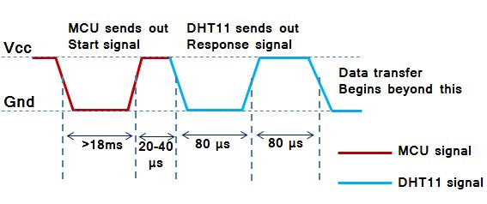
"Start" and "Response" signals

The 40-bit data from the sensor has the following structure.
Data (40-bit) = Integer Byte of RH + Decimal Byte of RH + Integer Byte of Temp. + Decimal Byte of Temp. + Checksum Byte
For DHT11 sensor, the decimal bytes of temperature and humidity measurements are always zero. Therefore, the first and third bytes of received data actually give the numeric values of the measured relative humidity (%) and temperature (°C). The last byte is the checksum byte which is used to make sure that the data transfer has happened without any error. If all the five bytes are transferred successfully then the checksum byte must be equal to the last 8 bits of the sum of the first four bytes, i.e.,
Checksum = Last 8 bits of (Integer Byte of RH + Decimal Byte of RH + Integer Byte of Temp. + Decimal Byte of Temp.)
Now lets talk about the most important thing, which is signalling for transmitting “0″ and “1″. In order to send a bit of data, the sensor first pulls the line low for 50 ?s. Then it raises the line to high for 26-28 ?s if it has to send “0″, or for 70 ?s if the bit to be transmitted is “1″. So it is the width of the positive pulse that carries information about 1 and 0.
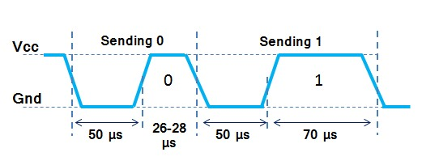
Timing difference for transmitting "1s" and "0s"
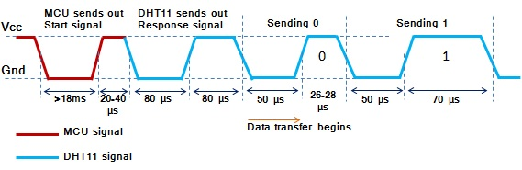
Start, Response and Data signals in sequence
At the end of the last transmitted bit, the sensor pulls the data line low for 50 ?s and then releases it. The DHT11 sensor requires an external pull-up resistor to be connected between its Vcc and the data line so that under idle condition, the data line is always pulled high. After finishing the data transmission and releasing the data line, the DHT11 sensor goes to the low-power consumption mode until a ne

CHAPTER-4
SERIAL COMMUNICATION
4.1 INTRODUCTION:
Serial communication is basically the transmission or reception of data one bit at a time. Today's computers generally address data in bytes or some multiple thereof. A byte contains 8 bits. A bit is basically either a logical 1 or zero. Every character on this page is actually expressed internally as one byte. The serial port is used to convert each byte to a stream of ones and zeroes as well as to convert a stream of ones and zeroes to bytes. The serial port contains a electronic chip called a Universal Asynchronous Receiver/Transmitter (UART) that actually does the conversion.
The serial port has many pins. We will discuss the transmit and receive pin first. Electrically speaking, whenever the serial port sends a logical one (1) a negative voltage is effected on the transmit pin. Whenever the serial port sends a logical zero (0) a positive voltage is affected. When no data is being sent, the serial port's transmit pin's voltage is negative (1) and is said to be in a MARK state. Note that the serial port can also be forced to keep the transmit pin at a positive voltage (0) and is said to be the SPACE or BREAK state. (The terms MARK and SPACE are also used to simply denote a negative voltage (1) or a positive voltage (0) at the transmit pin respectively).
When transmitting a byte, the UART (serial port) first sends a START BIT which is a positive voltage (0), followed by the data (general 8 bits, but could be 5, 6, 7, or 8 bits) followed by one or two STOP Bits which is a negative(1) voltage. The sequence is repeated for each byte sent. Figure 1 shows a diagram of what a byte transmission would look like.

At this point you may want to know what the duration of a bit is. In other words, how long does the signal stay in a particular state to define a bit. The answer is simple. It is dependent on the baud rate. The baud rate is the number of times the signal can switch states in one second. Therefore, if the line is operating at 9600 baud, the line can switch states 9,600 times per second. This means each bit has the duration of 1/9600 of a second or about 100µsec.
when transmitting a character there are other characteristics other than the baud rate that must be known or that must be setup. These characteristics define the entire interpretation of the data stream. The first characteristic is the length of the byte that will be transmitted. This length in general can be anywhere from 5 to 8 bits.

The second characteristic is parity. The parity characteristic can be even, odd, mark, space, or none. If even parity, then the last data bit transmitted will be a logical 1 if the data transmitted had an even amount of 0 bits. If odd parity, then the last data bit transmitted will be a logical 1 if the data transmitted had an odd amount of 0 bits. If MARK parity, then the last transmitted data bit will always be a logical 1. If SPACE parity, then the last transmitted data bit will always be a logical 0. If no parity then there is no parity bit transmitted.
The third characteristic is the amount of stop bits. This value in general is 1 or 2. Assume we want to send the letter 'A' over the serial port. The binary representation of the letter 'A' is 01000001. Remembering that bits are transmitted from least significant bit (LSB) to most significant bit (MSB), the bit stream transmitted would be as follows for the line characteristics 8 bits, no parity, 1 stop bit and 9600 baud.
LSB (0 1 0 0 0 0 0 1 0 1) MSB

The above represents (Start Bit) (Data Bits) (Stop Bit). To calculate the actual byte transfer rate simply divide the baud rate by the number of bits that must be transferred for each byte of data. In the case of the above example, each character requires 10 bits to be transmitted for each character. As such, at 9600 baud, up to 960 bytes can be transferred in one second.

The above discussion was concerned with the "electrical/logical" characteristics of the data stream. We will expand the discussion to line protocol. Serial communication can be half duplex or full duplex. Full duplex communication means that a device can receive and transmit data at the same time. Half duplex means that the device cannot send and receive at the same time. It can do them both, but not at the same time. Half duplex communication is all but outdated except for a very small focused set of applications.

Half duplex serial communication needs at a minimum two wires, signal ground and the data line. Full duplex serial communication needs at a minimum three wires, signal ground, transmit data line, and receive data line. The RS232 specification governs the physical and electrical characteristics of serial communications. This specification defines several additional signals that are asserted (set to logical 1) for information and control beyond the data signal
These signals are the Carrier Detect Signal (CD), asserted by modems to signal a successful connection to another modem, Ring Indicator (RI), asserted by modems to signal the phone ringing, Data Set Ready (DSR), asserted by modems to show their presence, Clear To Send (CTS), asserted by modems if they can receive data, Data Terminal Ready (DTR), asserted by terminals to show their presence, Request To Send (RTS), asserted by terminals if they can receive data. The section RS232 Cabling describes these signals and how they are connected.
The above paragraph alluded to hardware flow control. Hardware flow control is a method that two connected devices use to tell each other electronically when to send or when not to send data. A modem in general drops (logical 0) its CTS line when it can no longer receive characters. It re-asserts it when it can receive again. A terminal does the same thing instead with the RTS signal. Another method of hardware flow control in practice is to perform the same procedure in the previous paragraph except that the DSR and DTR signals.
Note that hardware flow control requires the use of additional wires. The benefit to this however is crisp and reliable flow control. Another method of flow control used is known as software flow control. This method requires a simple 3 wire serial communication link, transmit data, receive data, and signal ground. If using this method, when a device can no longer receive, it will transmit a character that the two devices agreed on. This character is known as the XOFF character. This character is generally a hexadecimal 13. When a device can receive again it transmits an XON character that both devices agreed to. This character is generally a hexadecimal 11.

4.2 NULL MODEM:
Serial communications with RS232. One of the oldest and most widely spread communication methods in computer world. The way this type of communication can be performed is pretty well defined in standards. I.e. with one exception. The standards show the use of DTE/DCE communication, the way a computer should communicate with a peripheral device like a modem. For your information, DTE means Data Terminal Equipment (computers etc.) where DCE is the abbreviation of Data Communication Equipment (modems).
One of the main uses of serial communication today where no modem is involved—a serial null modem configuration with DTE/DTE communication—is not so well defined, especially when it comes to flow control. The terminology null modem for the situation where two computers communicate directly is so often used nowadays, that most people don't realize anymore the origin of the phrase and that a null modem connection is an exception, not the rule.
In history, practical solutions were developed to let two computers talk with each other using a null modem serial communication line. In most situations, the original modem signal lines are reused to perform some sort of handshaking. Handshaking can increase the maximum allowed communication speed because it gives the computers the ability to control the flow of information. A high amount of incoming data is allowed if the computer is capable to handle it, but not if it is busy performing other tasks. If no flow control is implemented in the null modem connection, communication is only possible at speeds at which it is sure the receiving side can handle the amount information even under worst case conditions.

4.3 RS232:
When we look at the connector pin out of the RS232 port, we see two pins which are certainly used for flow control. These two pins are RTS, request to send and CTS, clear to send. With DTE/DCE communication (i.e. a computer communicating with a modem device) RTS is an output on the DTE and input on the DCE. CTS are the answering signal coming from the DCE.
Before sending a character, the DTE asks permission by setting its RTS output. No information will be sent until the DCE grants permission by using the CTS line.
If the DCE cannot handle new requests, the CTS signal will go low. A simple but useful mechanism allowing flow control in one direction. The assumption is that the DTE can always handle incoming information faster than the DCE can send it. In the past, this was true. Modem speeds of 300 baud were common and 1200 baud was seen as a high speed connection.
For further control of the information flow, both devices have the ability to signal their status to the other side. For this purpose, the DTR data terminal ready and DSR data set ready signals are present. The DTE uses the DTR signal to signal that it is ready to accept information, whereas the DCE uses the DSR signal for the same purpose. Using these signals involves not a small protocol of requesting and answering as with the RTS/CTS handshaking. These signals are in one direction only.
The last flow control signal present in DTE/DCE communication is the CD carrier detect. It is not used directly for flow control, but mainly an indication of the ability of the modem device to communicate with its counter part. This signal indicates the existence of a communication link between two modem devices.

4.4 NULL MODEM WITHOUT HANDSHAKING:
How to use the handshaking lines in a null modem configuration? The simplest way is to don't use them at all. In that situation, only the data lines and signal ground are cross connected in the null modem communication cable. All other pins have no connection. An example of such a null modem cable without handshaking can be seen in the figure below.

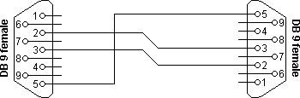

Connector 1 | Connector 2 | Function
2 | 3 | Rx |  | TX
3 | 2 | TX |  | Rx
5 | 5 | Signal ground

Fig.4.1. Simple null modem without handshaking

4.5 COMPATIBILITY ISSUES:
If you read about null modems, this three wire null modem cable is often talked about. Yes, it is simple but can we use it in all circumstances? There is a problem, if either of the two devices checks the DSR or CD inputs. These signals normally define the ability of the other side to communicate. As they are not connected, their signal level will never go high. This might cause a problem.
The same holds for the RTS/CTS handshaking sequence. If the software on both sides is well structured, the RTS output is set high and then a waiting cycle is started until a ready signal is received on the CTS line. This causes the software to hang because no physical connection is present to either CTS line to make this possible. The only type of communication which is allowed on such a null modem line is data-only traffic on the cross connected Rx/TX lines.
This does however not mean that this null modem cable is useless. Communication links like present in the Norton Commander program can use this null modem cable. This null modem cable can also be used when communicating with devices which do not have modem control signals like electronic measuring equipment etc.

As you can imagine, with this simple null modem cable no hardware flow control can be implemented. The only way to perform flow control is with software flow control using the XOFF and XON characters.

CHAPTER-6
RESULT AND CONCLUSION
RESULT:
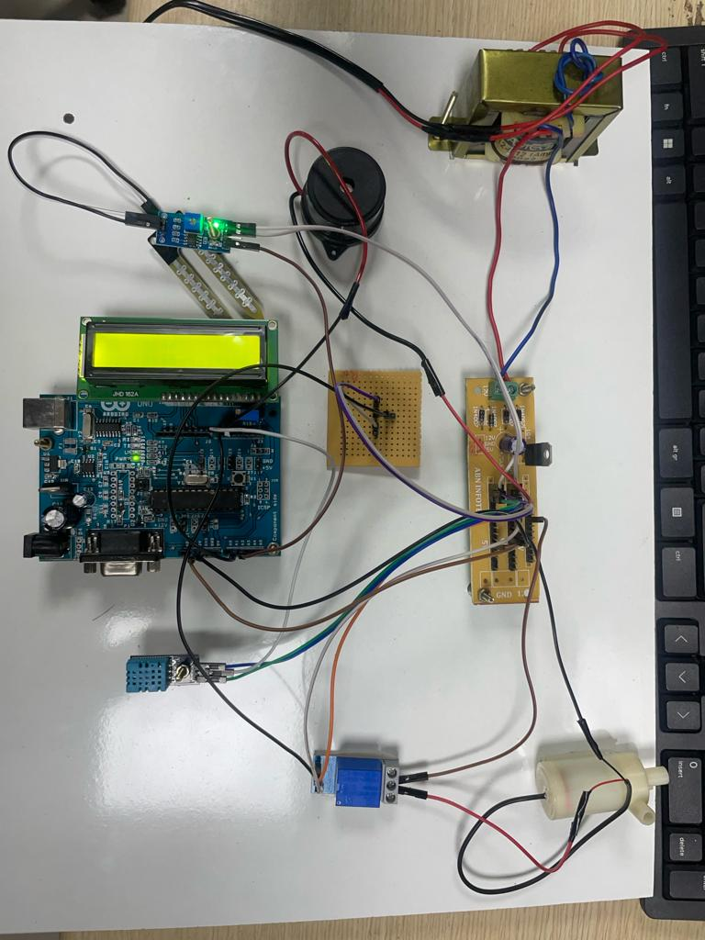
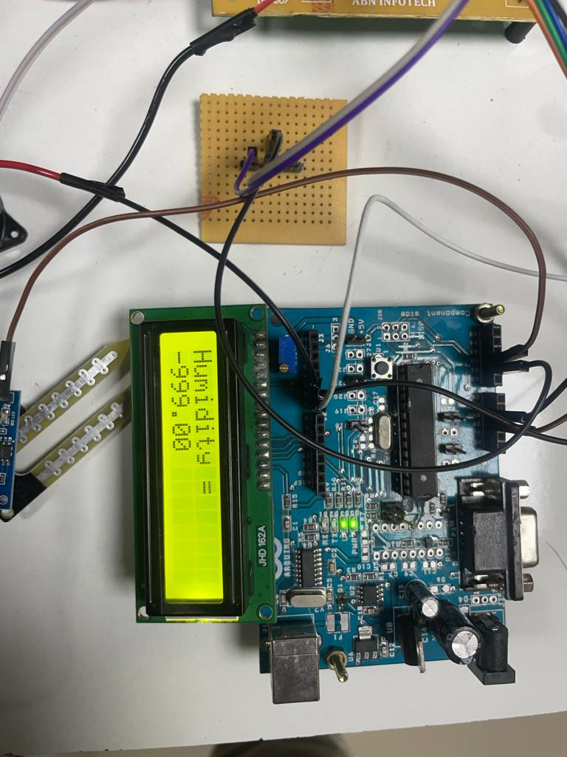
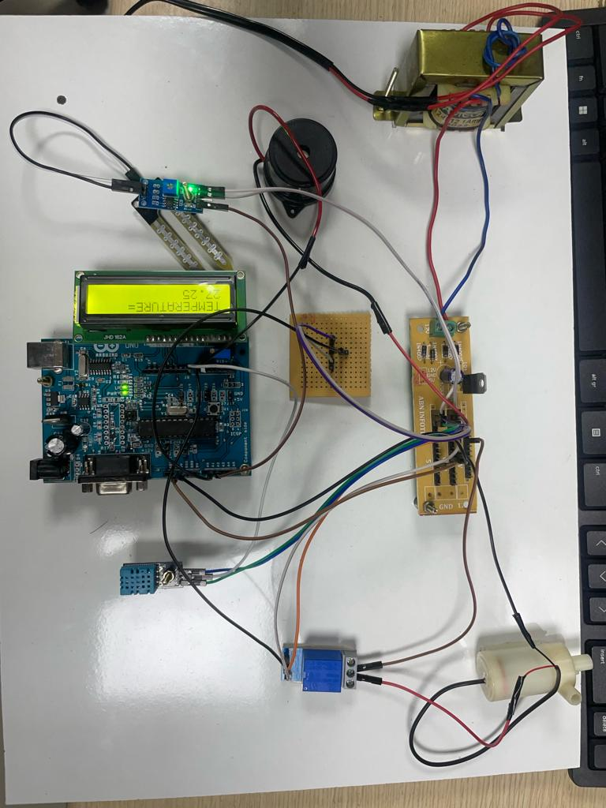

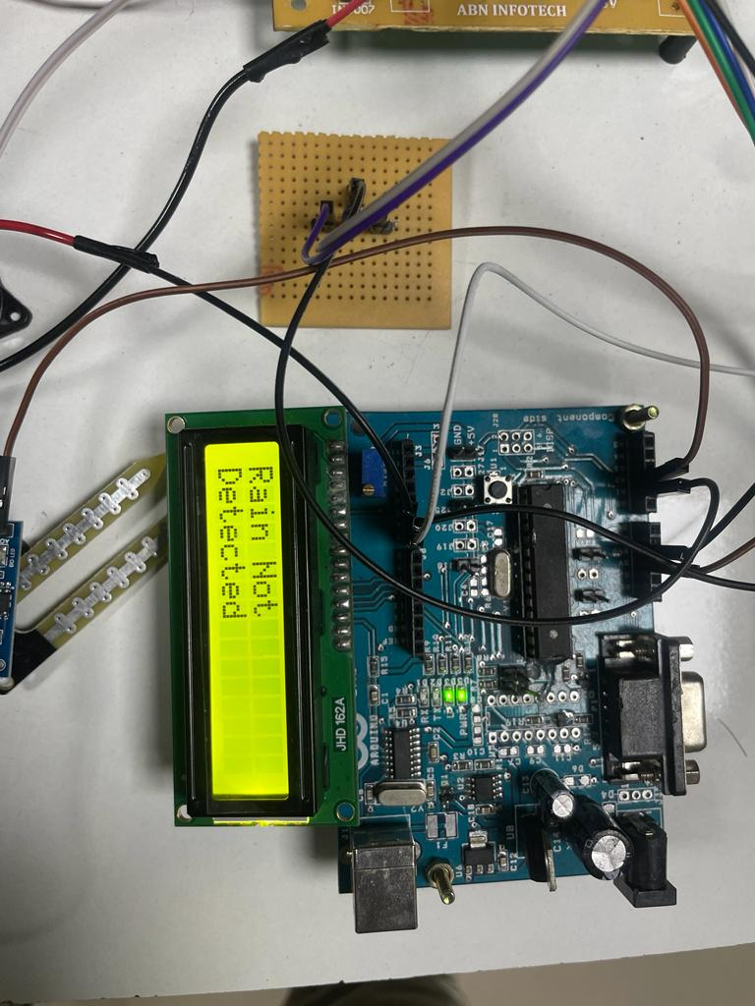

CONCLUSION:
More clever and efficient agricultural production methods are needed to address the issues of diminishing arable land and the growing global population's demand for food. Everyone must comprehend the connection between sustainable agriculture and food security. The creation of new technologies to increase agricultural output and encourage farming as a legitimate career option for young, creative people. The influence of numerous agricultural technologies, particularly IoT and AI technology, on enhancing agriculture's intelligence and efficiency in meeting future needs was the main topic of this article. It is believed that both the industry's promise for the future and its current challenges serve as a guidance for academics and engineers. In order to improve agricultural productivity, every square inch of field must be managed utilizing sustainable IoT-based sensors and AI technology.

CHAPTER-7
REFERENCES:
- N. Zhang, M. Wang, and N. Wang, ‘‘Precision agriculture—A worldwide overview,’’ Comput. Electron. Agricult., vol. 36, nos. 2–3, pp. 113–132, 2002.
- V. Hakkim, E. Joseph, A. Gokul, and K. Mufeedha, ‘‘Precision farming: The future of Indian agriculture,’’ J. Appl. Biol. Biotechnol., vol. 4, no. 6, pp. 68–72, 2016.
- R. Gebbers and V. I. Adamchuk, ‘‘Precision agriculture and food security,’’ Science, vol. 327, no. 5967, pp. 828–831, Feb. 2010.
- F. J. Pierce and P. Nowak, ‘‘Aspects of precision agriculture,’’ in Advances in Agronomy, vol. 67. New York, NY, USA: Academic, 1999, pp. 1–85
- J. V. Stafford, ‘‘Implementing precision agriculture in the 21st century,’’ J. Agricult. Eng. Res., vol. 76, no. 3, pp. 267–275, Jul. 2000.
- J. Gubbi, R. Buyya, S. Marusic, and M. Palaniswami, ‘‘Internet of Things (IoT): A vision, architectural elements, and future directions,’’ Future Gener. Comput. Syst., vol. 29, no. 7, pp. 1645–1660, Sep. 2013.
- F. Nex and F. Remondino, ‘‘UAV for 3D mapping applications: A review,’’ Appl. Geomatics, vol. 6, no. 1, pp. 1–15, Mar. 2014.
- V. I. Adamchuk, J. W. Hummel, M. T. Morgan, and S. K. Upadhyaya, ‘‘On-the-go soil sensors for precision agriculture,’’ Comput. Electron. Agricult., vol. 44, no. 1, pp. 71–91, 2004.
- H. Jawad, R. Nordin, S. Gharghan, A. Jawad, and M. Ismail, ‘‘Energyefficient wireless sensor networks for precision agriculture: A review,’’ Sensors, vol. 17, no. 8, p. 1781, Aug. 2017.
- R. Sharma, S. S. Kamble, A. Gunasekaran, V. Kumar, and A. Kumar, ‘‘A systematic literature review on machine learning applications for sustainable agriculture supply chain performance,’’ Comput. Oper. Res., vol. 119, Jul. 2020, Art. no. 104926.

