One-Hot Encoding

It is used to convert discrete data into numerical data.

Create separate binary columns for each category.

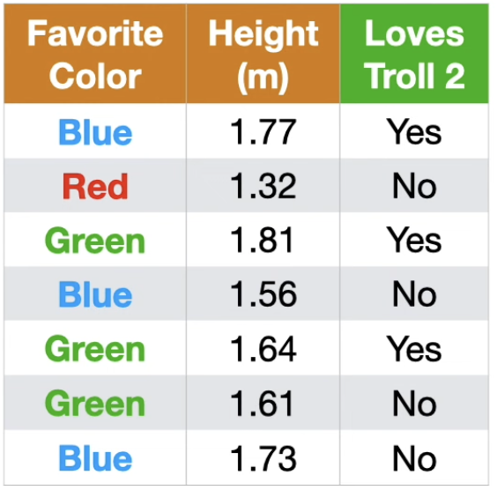
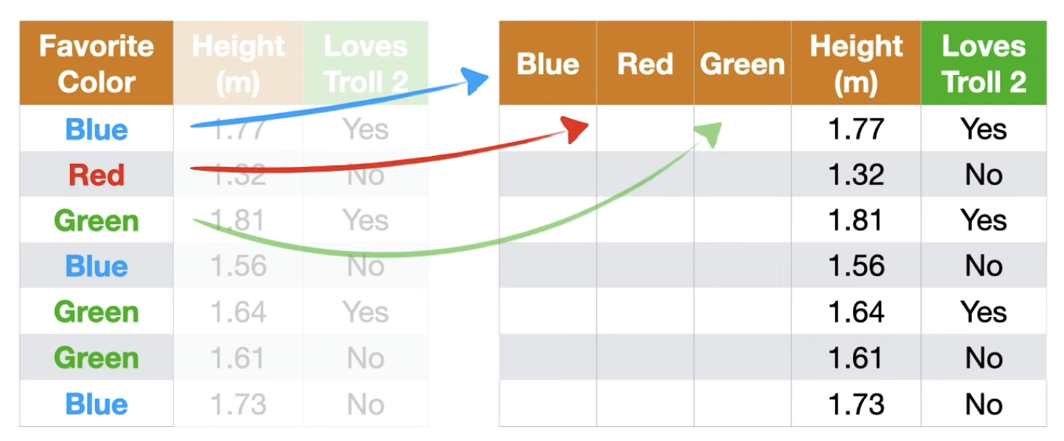

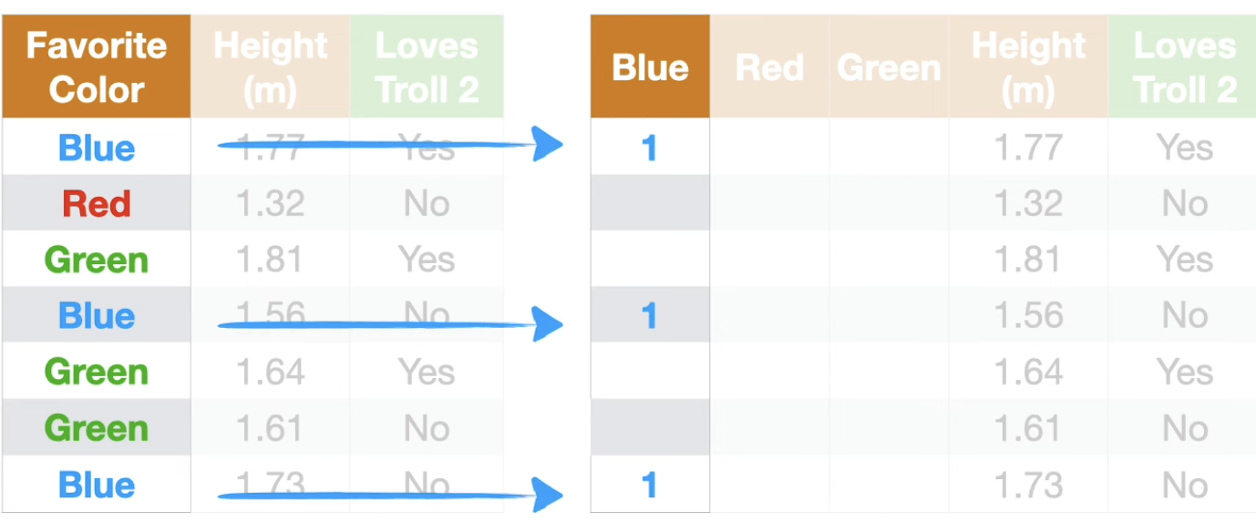
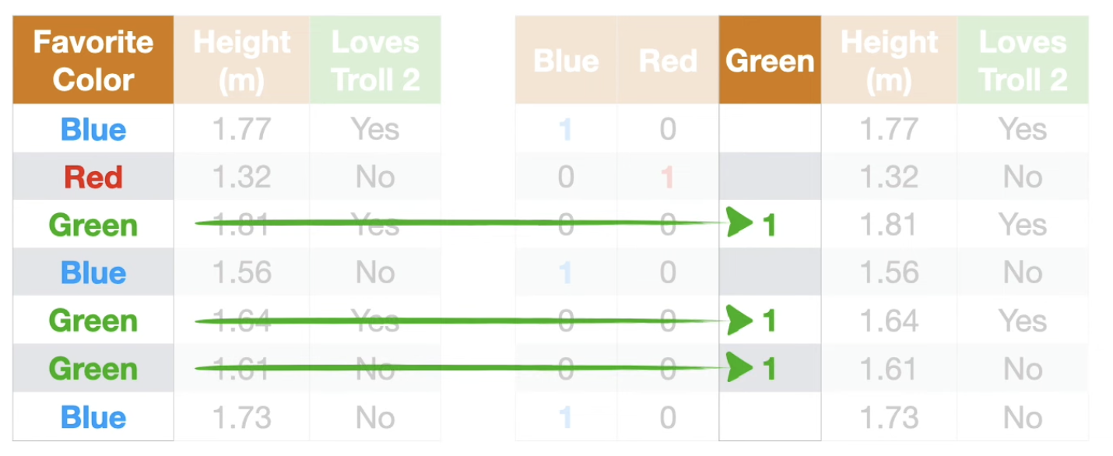

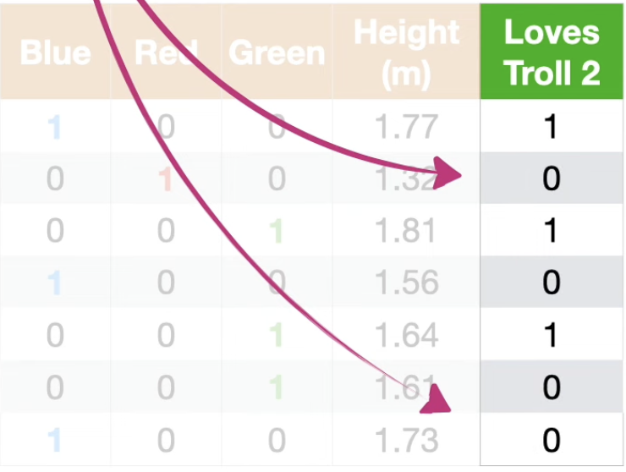
Use it when:
• Number of categories is small
• Categories have no order
• Models like Logistic Regression, Linear Regression
If categories are many → dimension explosion
Example:
City → 500 unique values
One-hot creates 500 columns.
That’s not correct for most models.

Frequency Encoding

Replace category with how often it appears.
Simply converting the discrete values to random numbers is called Label Encoding
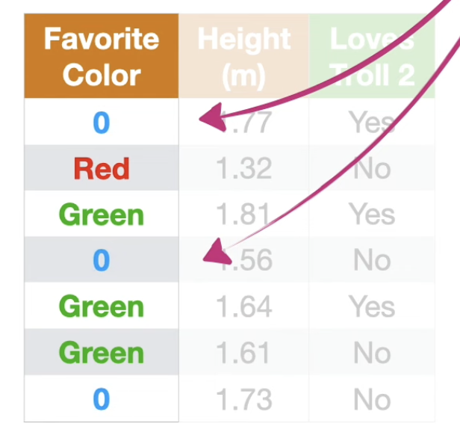
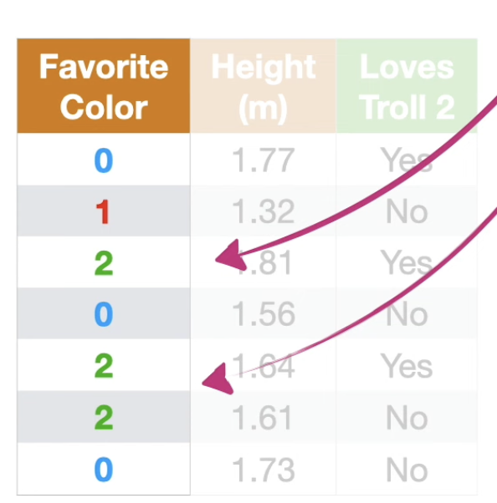

When to Use
Useful when:
• High cardinality features
• Many categories
• Tree models
Example:
- Airline codes
- User IDs
- Cities
- Products

Problem
Different categories may get same value.
Example:
Delhi = 10
Mumbai = 10
Model cannot distinguish them.
Target Encoding
Replace category with average target value.
Because we use the Target , the thing we wanted to predict, to determine what values to replace the discrete options, this method is called Target Encoding
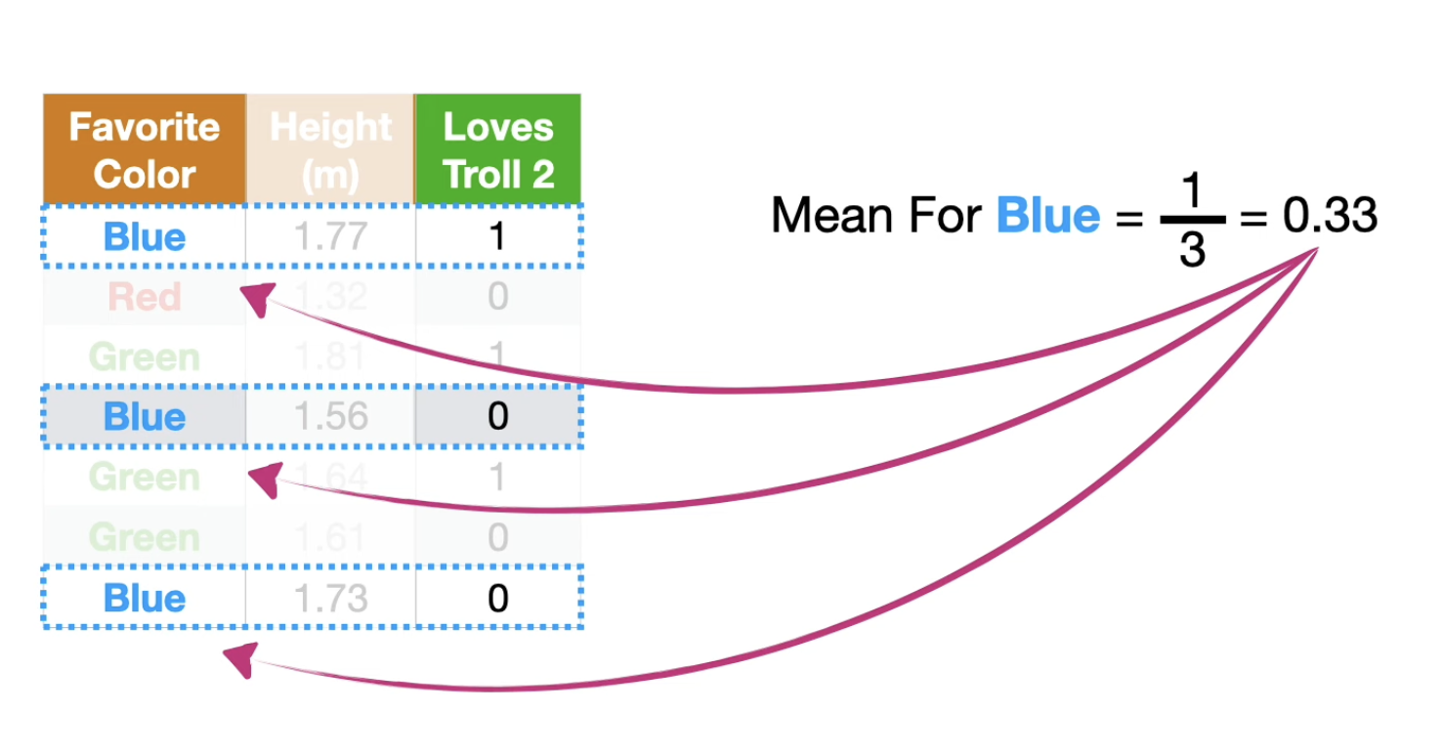

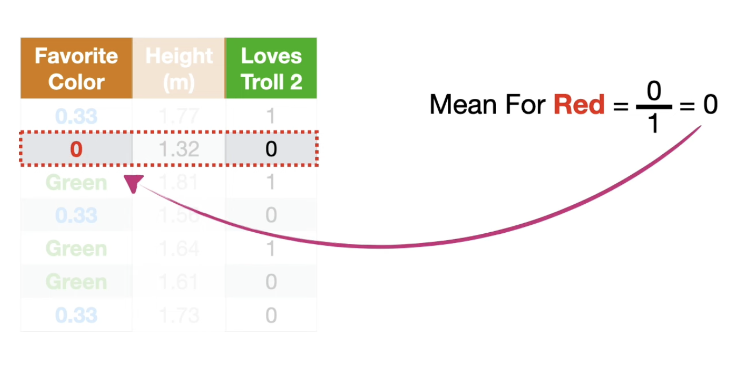
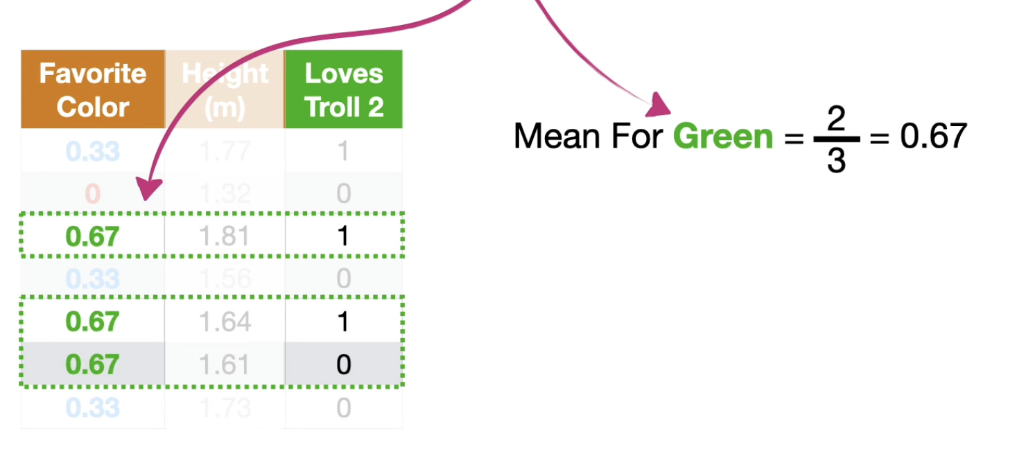

When to Use
Best for:
• High cardinality categories
• Tree models (XGBoost, LightGBM)

Problem
This method can cause data leakage.
If you use full dataset averages, the model indirectly sees the target.

Encoding Pitfalls

1. Dummy Variable Trap
These columns are linearly dependent.


2. Data Leakage

This makes model look artificially accurate.

3. High Cardinality

4. Unseen Categories
Example:
Train data:
City → Chennai, Delhi
Test data:
City → Bangalore
Model crashes.
Fix:
Use encoders that handle unseen values.
Example:
sklearn OneHotEncoder(handle_unknown='ignore')

