OUTLIER:

An Outlier is a data point that is significantly different from the rest of the data.

Example:
If most salaries are ₹20,000–₹80,000 and one value is ₹10,00,000 → that’s an outlier.

Types of Outliers

1. Natural Outliers (Valid Extreme Values)
These are genuine values.
Example:
- Billionaire income in salary dataset
- Extremely tall basketball player
- Huge stock market crash day
These contain real-world information.
If we remove them blindly → we destroy valuable signals.

2. Error Outliers (Data Errors)
These are wrong values caused by:
- Data entry mistakes
- Sensor errors
- Unit mismatch
Example:
- Age = 250
- Salary = -5000
- Height = 30 feet
These must be cleaned.
Rule:
If it's impossible → remove or fix.
If it's rare but possible → think before touching.

Detection methods (IQR, Z-score, Isolation Forest – intuition)

IQR (Interquartile Range)

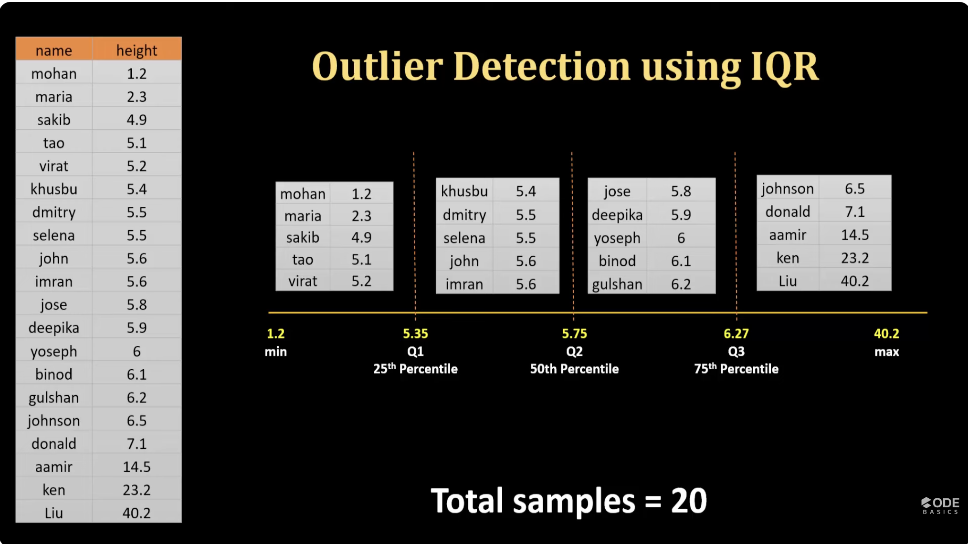
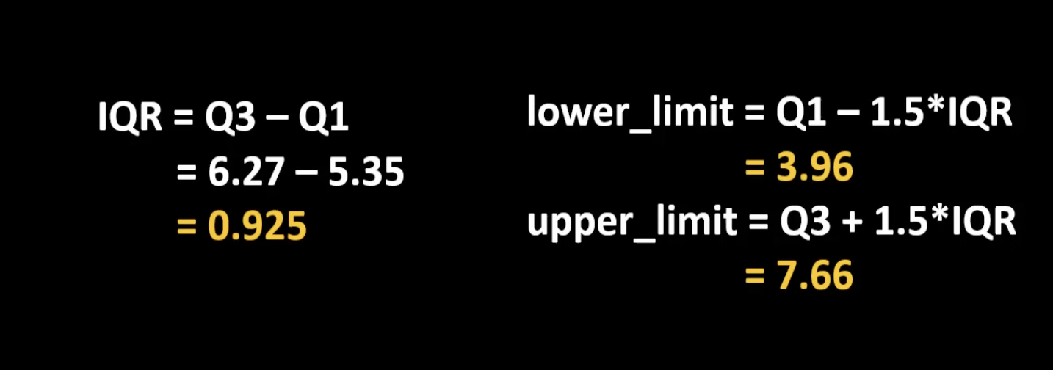

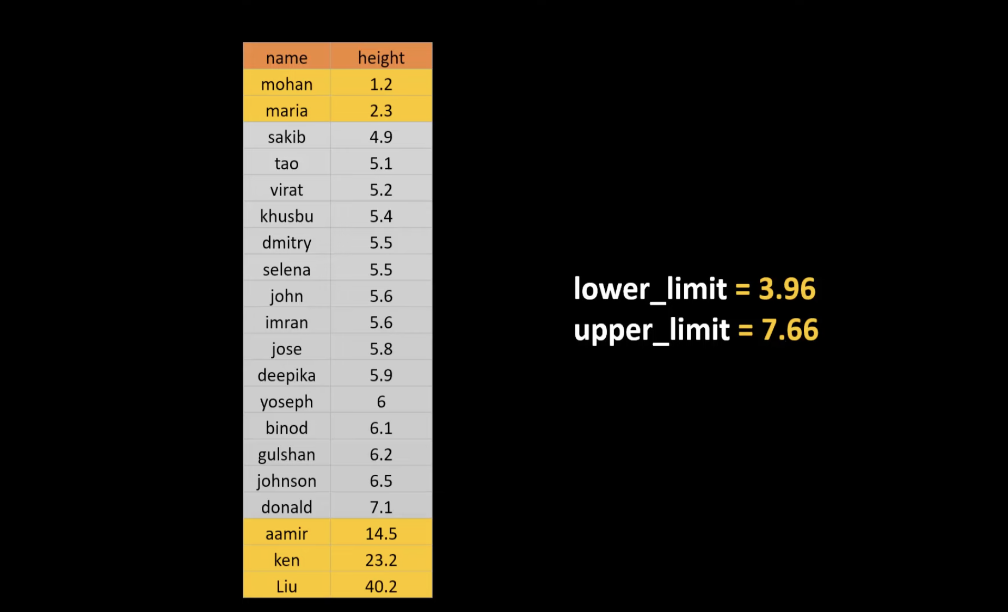

Best for:
✔ Skewed data
✔ Small to medium datasets
✔ Quick statistical check

When to Use IQR?
- Financial data
- Skewed distributions
- When mean & standard deviation are unreliable

Z-score:
A z-score tells you how many standard deviations a value is away from the mean of a dataset.

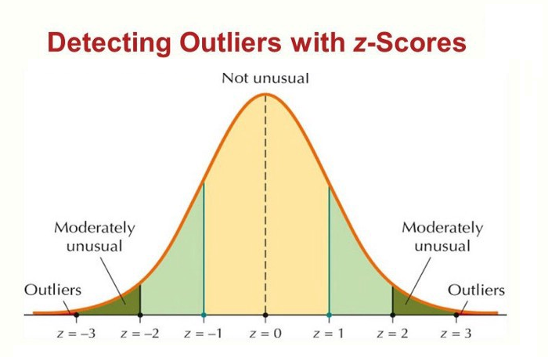

Best for:
✔ Normally distributed data

Formula
Z = (X − Mean) / Standard Deviation
Rule:
If |Z| > 3 and < -3 → outlier
That means:
Data point is more than 3 standard deviations away.

When NOT to Use Z-score?
If data is skewed.
Because mean shifts and standard deviation inflates.
Then the detection becomes useless.

Isolation Forest – intuition

Isolation Forest is an anomaly detection algorithm that is particularly effective in identifying outliers and anomalies in a dataset. It is an unsupervised ML algorithm.
It doesn’t use mean or quartiles.
It works like this:
- Randomly split data
- Outliers get isolated faster
- Normal points take more splits
Because outliers are rare and different.
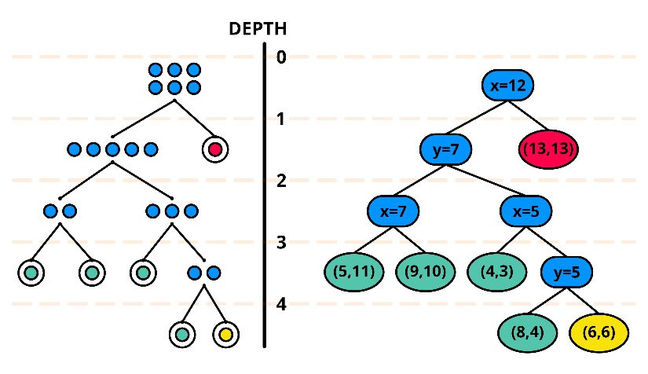

Intuition
Imagine random cuts on a dataset:
- Clustered data → hard to isolate
- Distant point → easy to isolate
That distant point = outlier

When to Use Isolation Forest?
✔ High-dimensional data
✔ Large datasets
✔ Complex patterns
✔ When distribution is unknown
Used in:
- Fraud detection
- Healthcare
- Manufacturing defect detection

Common Types of Distributions

1. Normal Distribution

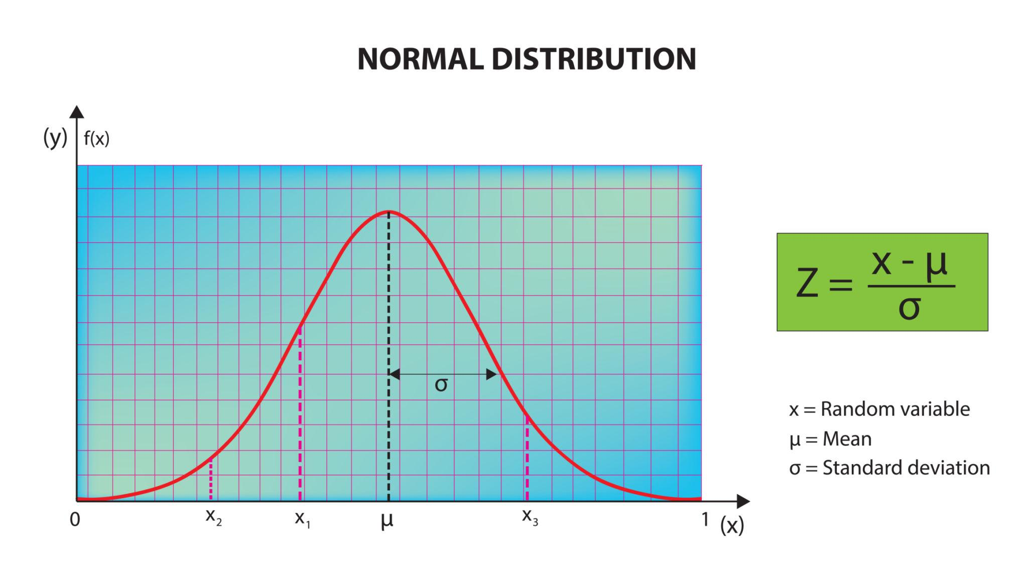
Properties:
- Symmetric
- Mean = Median = Mode
- 68–95–99.7 rule applies
Used in:
- Z-score outlier detection
- Many statistical tests
- Linear regression assumptions

2. Right Skewed Distribution
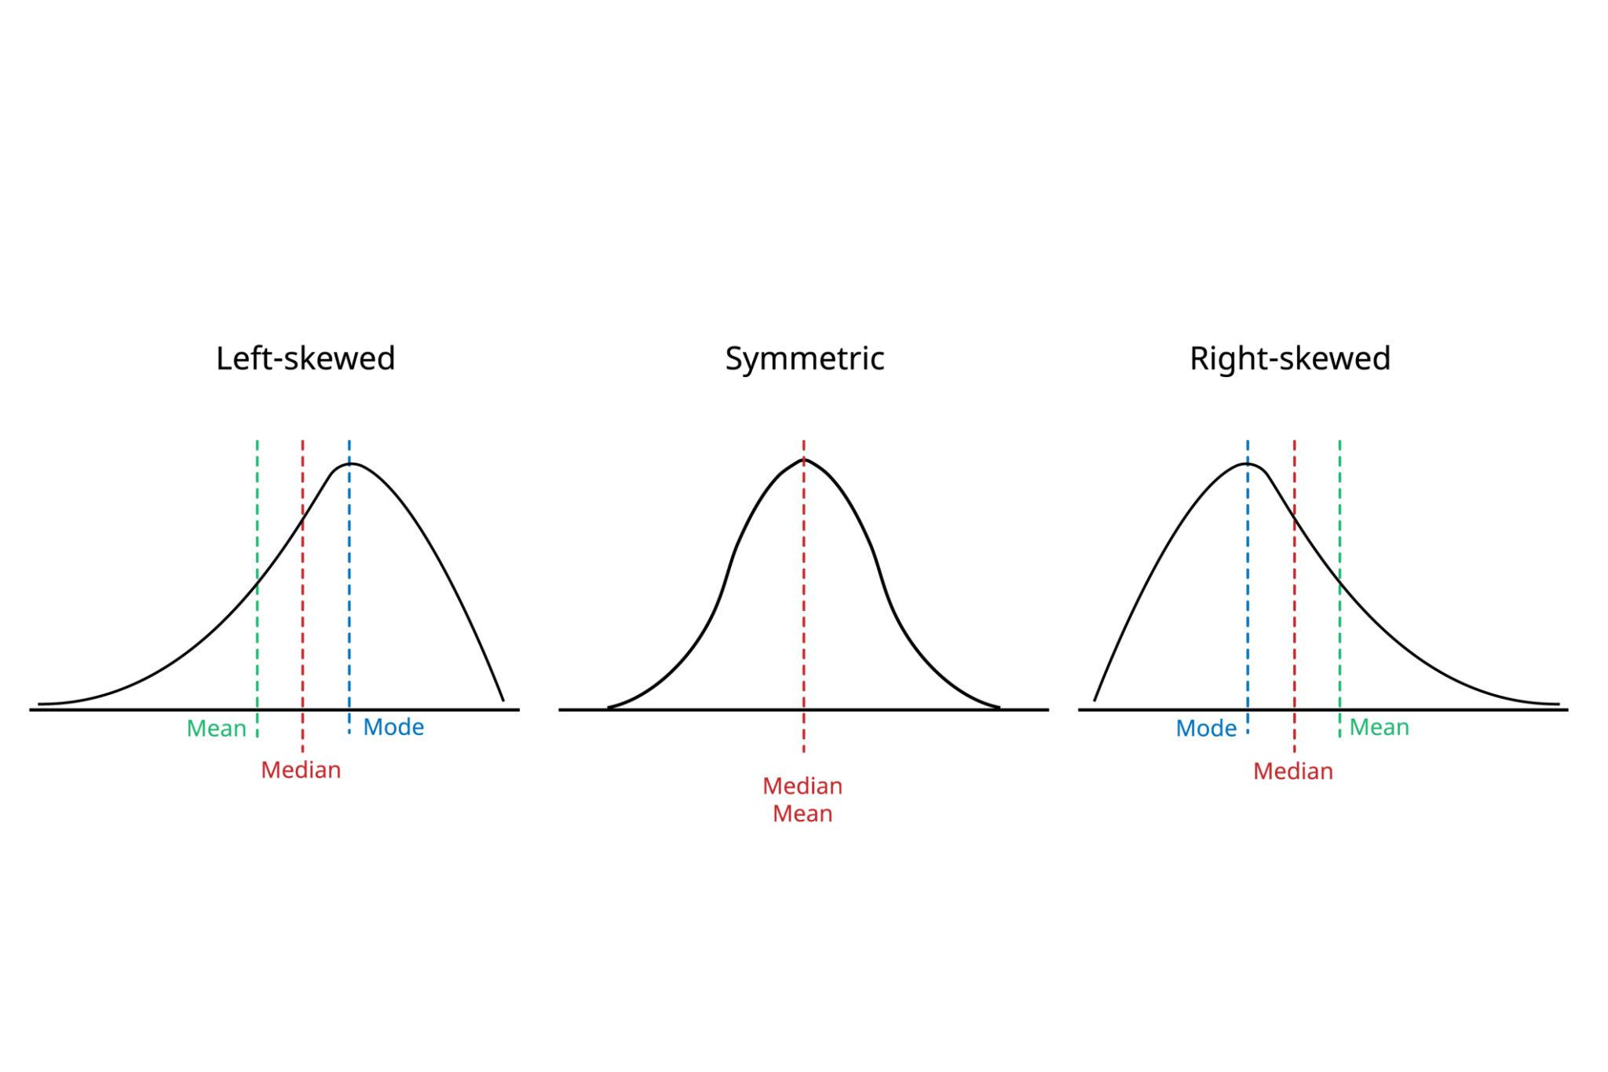

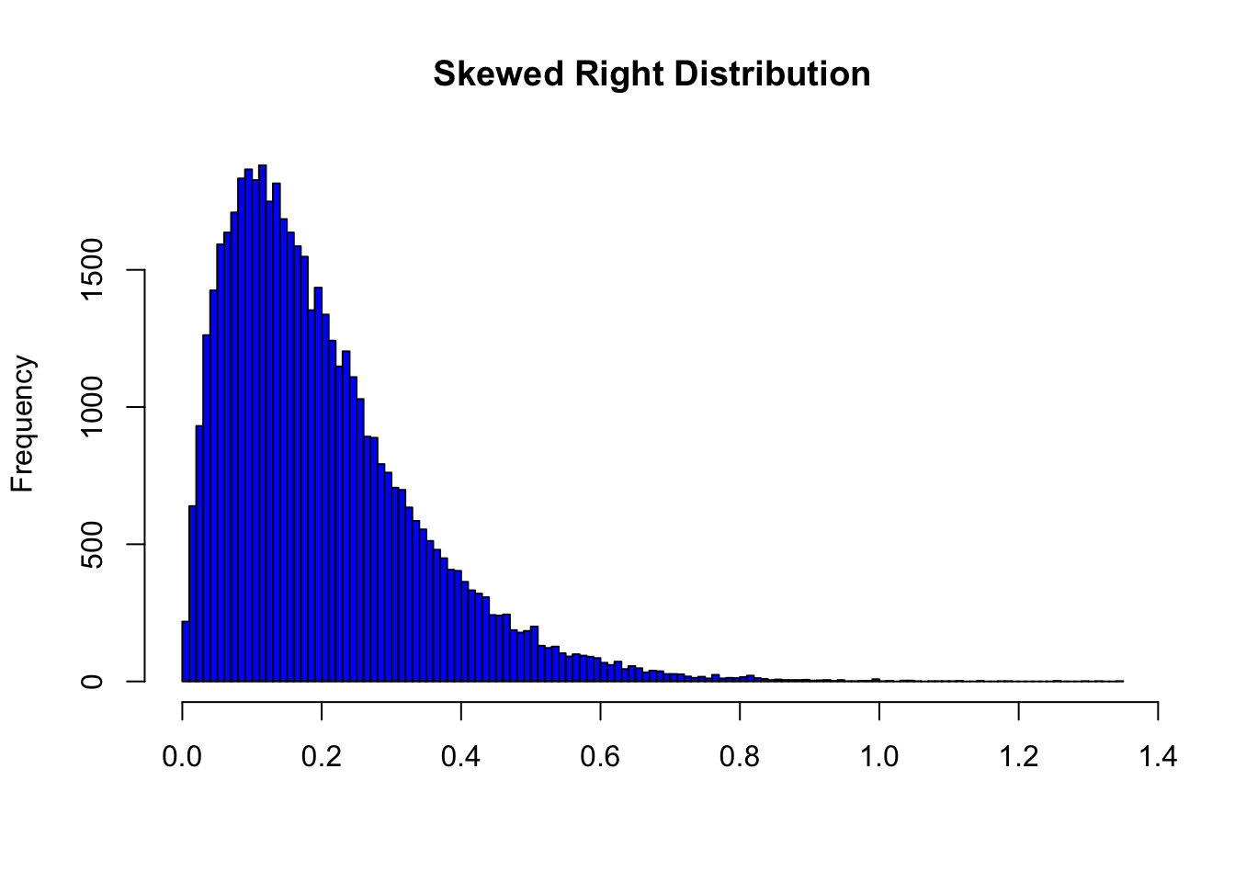
Common in:
- Income
- Sales
- House prices
- Website traffic
Here:
Mean > Median
You should use:
- IQR for outliers
- Log transformation (sometimes)

3. Left Skewed Distribution

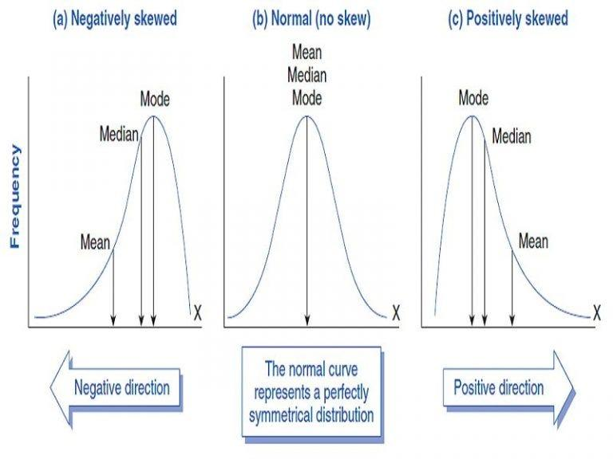

Less common.
Mean < Median

4. Uniform Distribution
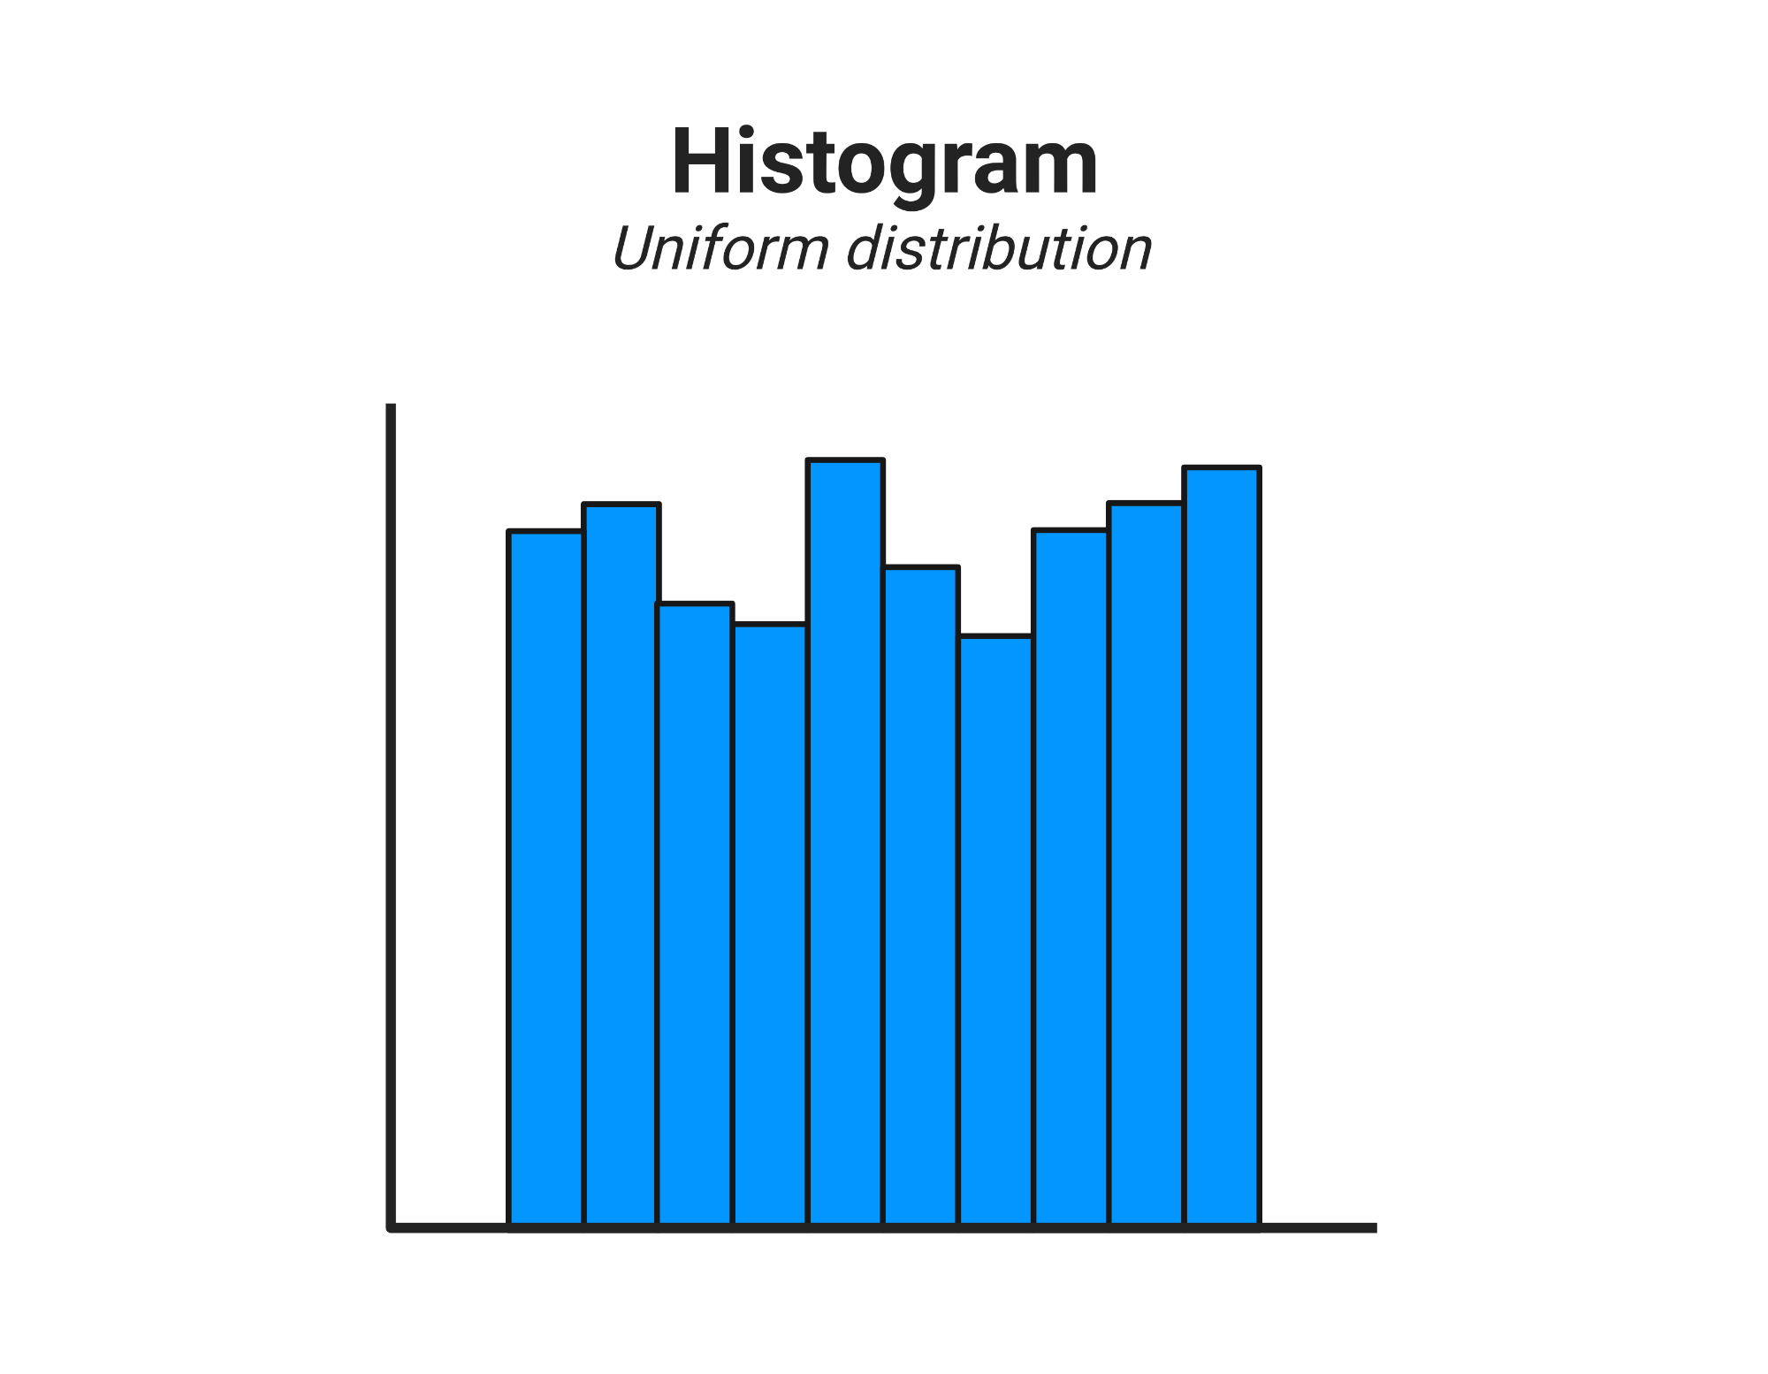

All values equally likely.
Rare in real-world raw business data.
