Model Selection

Model Selection in Machine Learning is the process of choosing the best suited model for a particular problem. Selecting a model depends on various factors such as the dataset, task, nature of the model,etc

Models can be selected based on :
1. Type of Data available:
- ﻿﻿﻿Images & Videos - CNN
- ﻿﻿﻿Text data or Speech data - RNN
- ﻿﻿﻿Numerical data - SVM, Logistic Regression, Decision trees, etc.
2. Based on the task we need to carry out:
- ﻿﻿﻿Classification tasks - SVM, Logistic Regression, Decision trees, etc.
- ﻿﻿﻿Regression tasks - Linear regression, Random Forest, Polynomial regression, etc.
- ﻿﻿﻿Clustering tasks - K-Means Clustering, Hierarchical

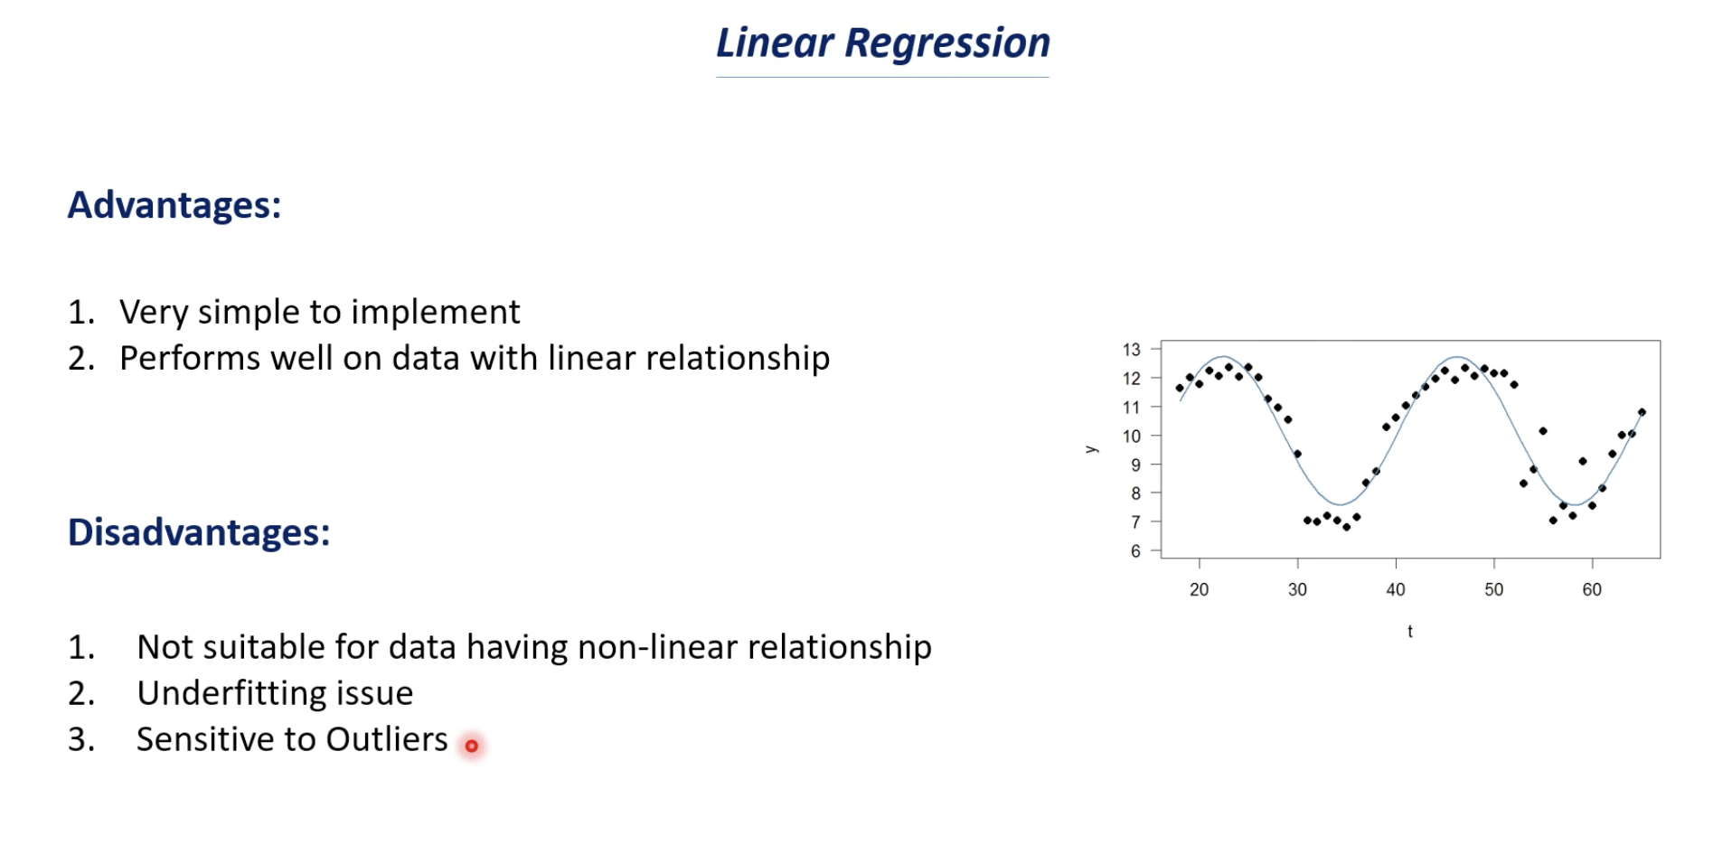

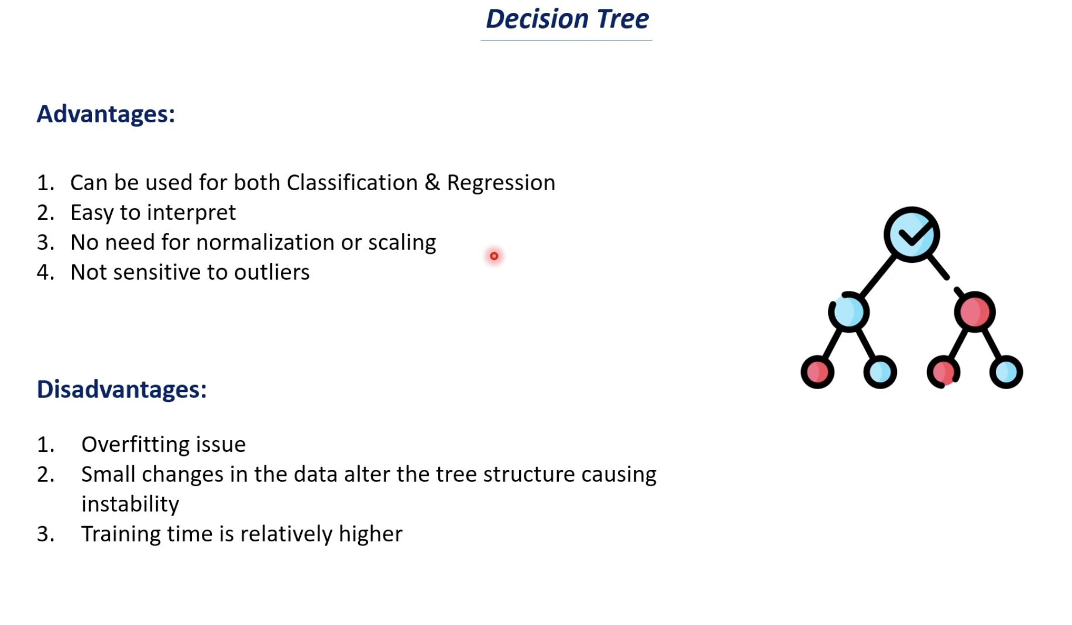

Interpretability vs Performance

Interpretability = “Can you explain the model’s decision?”

Example:
Loan rejection:
- Interpretable model says:
“Rejected because income is low and debt is high”
- Clear
-Human-understandable
-Trustworthy

Performance = “How accurate is the model?”

Usually:
- Simple models → easy to explain → lower accuracy
- Complex models → hard to explain → higher accuracy

So,
“Do I need to explain this model to humans?”
- YES → go interpretable
- NO → go for performance

Business Trade-offs

Trade-off 1: Accuracy vs Speed
- Real-time fraud detection → needs fast predictions
- We can’t run heavy models that take 5 seconds

Trade-off 2: Accuracy vs Explainability
- Bank rejects loan → must explain WHY
- “Model said so” = useless

Trade-off 3: Complexity vs Maintenance
- XGBoost model → high performance
- But:
  - Harder to debug
  - Harder to maintain
  - Requires tuning
Simple models = easier long-term

Trade-off 4: Data Size
- Small dataset → linear often better
- Large dataset → tree-based shines

