Bagging vs Boosting

Bagging :

It is also known as Bootstrap Aggregating.
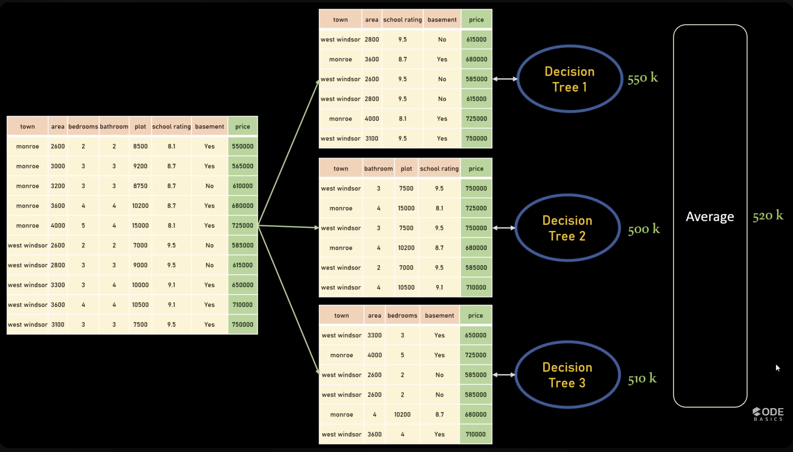

- Train multiple models in parallel
- Each model sees random samples of data (with replacement)
- Final output = average (regression) or majority vote (classification)

What it fixes:
- Reduces variance
- Prevents overfitting

Boosting :
- It is an ensemble model technique that attempts to build a strong classifier from the number of weak classifiers.
- First a model is built from the training data.
- Then the second model is built which tries to correct the errors present in the first model.
- The procedure is continued and models are added until either the complete training dataset is predicted correctly or the maximum number of models is added.
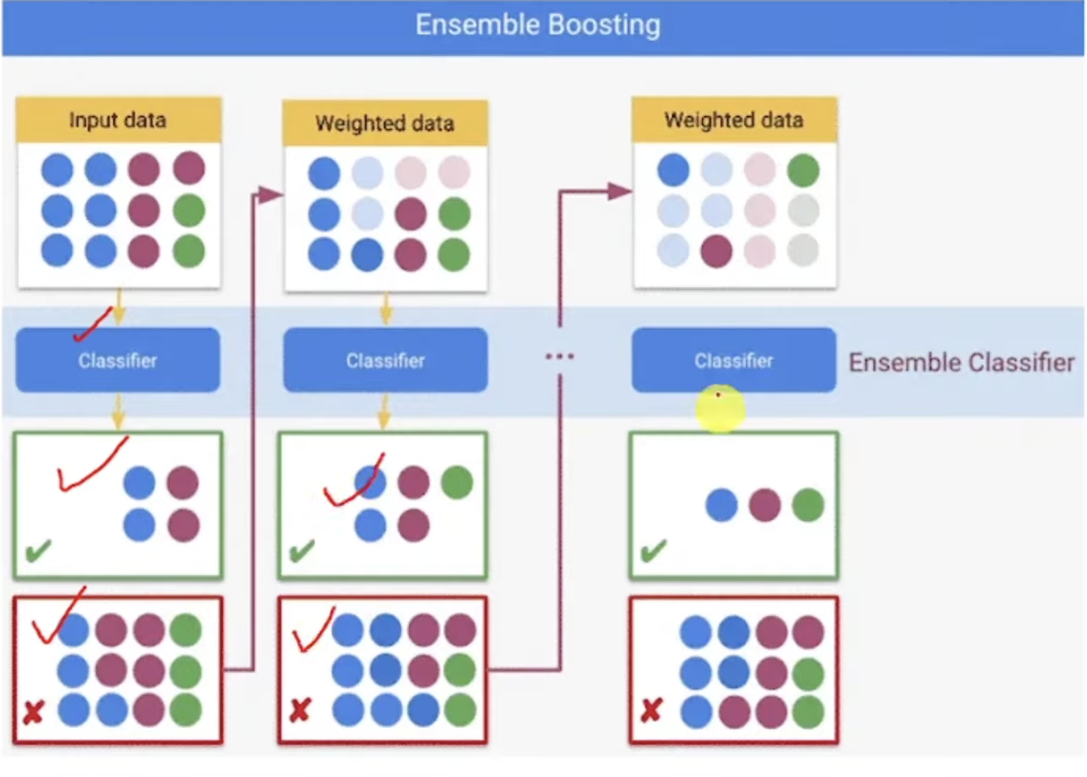

What it fixes:
- Reduces bias + variance
- Turns weak models → strong model

XGBoost

What it is:
Advanced version of gradient boosting with optimizations

Strengths:
- Handles missing values automatically
- Built-in regularization (L1, L2)
- Very accurate and stable
- Works great on structured/tabular data

Weakness:
- Slower than LightGBM
- More memory usage

LightGBM

What it is:
Microsoft’s faster version of boosting

Strengths:
- Very fast training
- Handles large datasets easily
- Uses leaf-wise tree growth (more aggressive learning)

Weakness:
- Can overfit easily if not tuned
- Less stable on small datasets

