

**Cloud Security & Management Lab**

**Submitted by**

**Name – Shiva Shukla**

**SAP ID – 500084634**

**Roll no – R2142201078**

**Batch – B1**

**Program – B.Tech CSE spl CCVT**

**Submitted**

**“ Ms. Amanjot Kaur” Mam**

**LAB 3: Installation and Configuration of virtualization using KVM**

**Step 1:** Install the packages

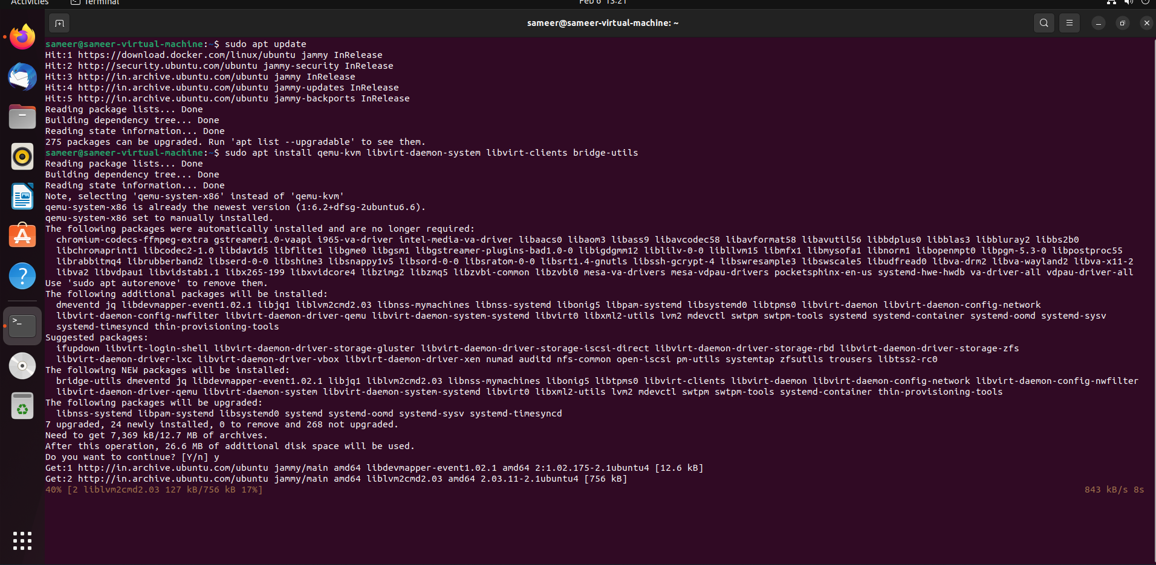

**Step 2:** Add user to the group

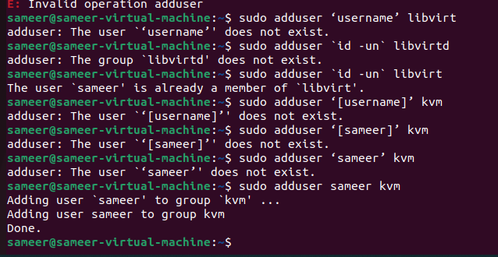

**Step 3:** Enable the libvirtd

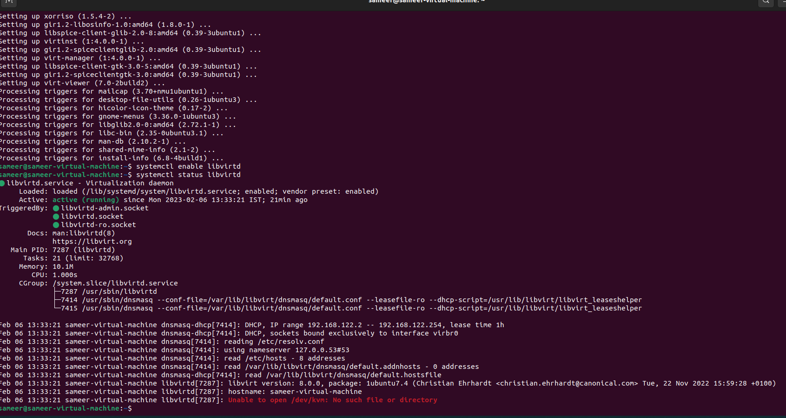

**Step 4:** Check the status of the libvirtd

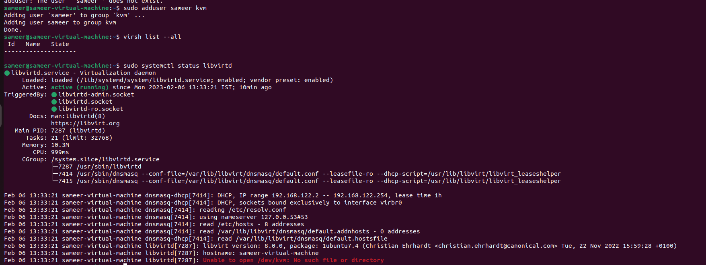

**Step 5:** Install the virt-manager

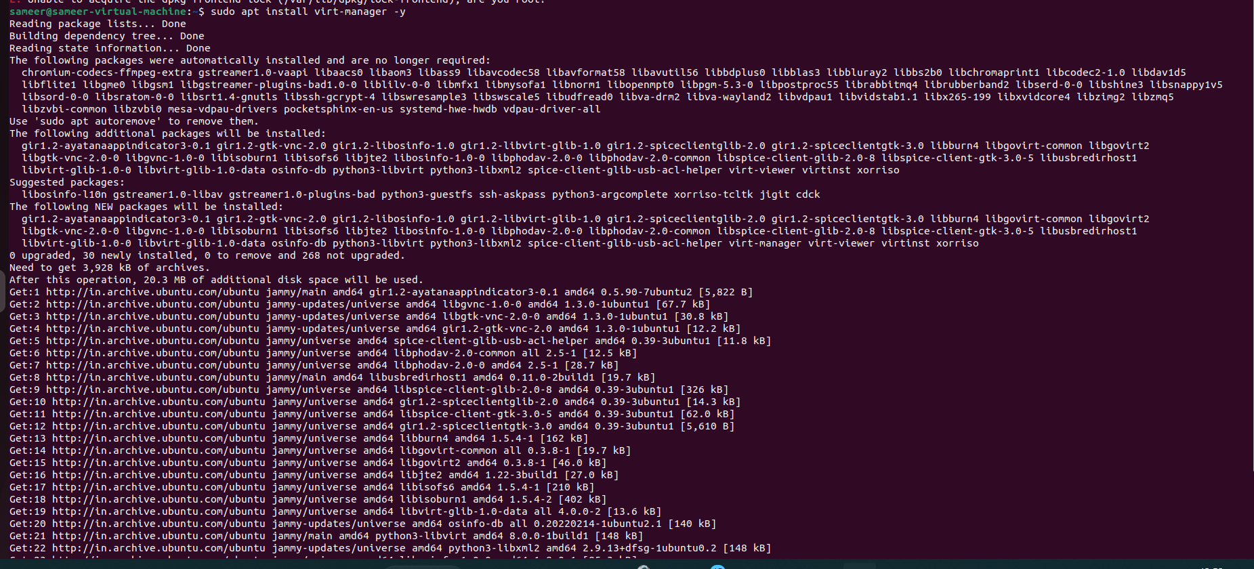

**Step 6:** Start the virt-manger





**Step 7:** Create a new virtual machine

