GLAZIA
Mini Design Canvas
Full-Stack Assignment — Product, UX, Architecture & Delivery Specification
Stack: Next.js + React + React Konva + Tailwind CSS + Node.js + Express.js + MongoDB
Assignment deadline: Thursday, September 24, 2026 — EOD

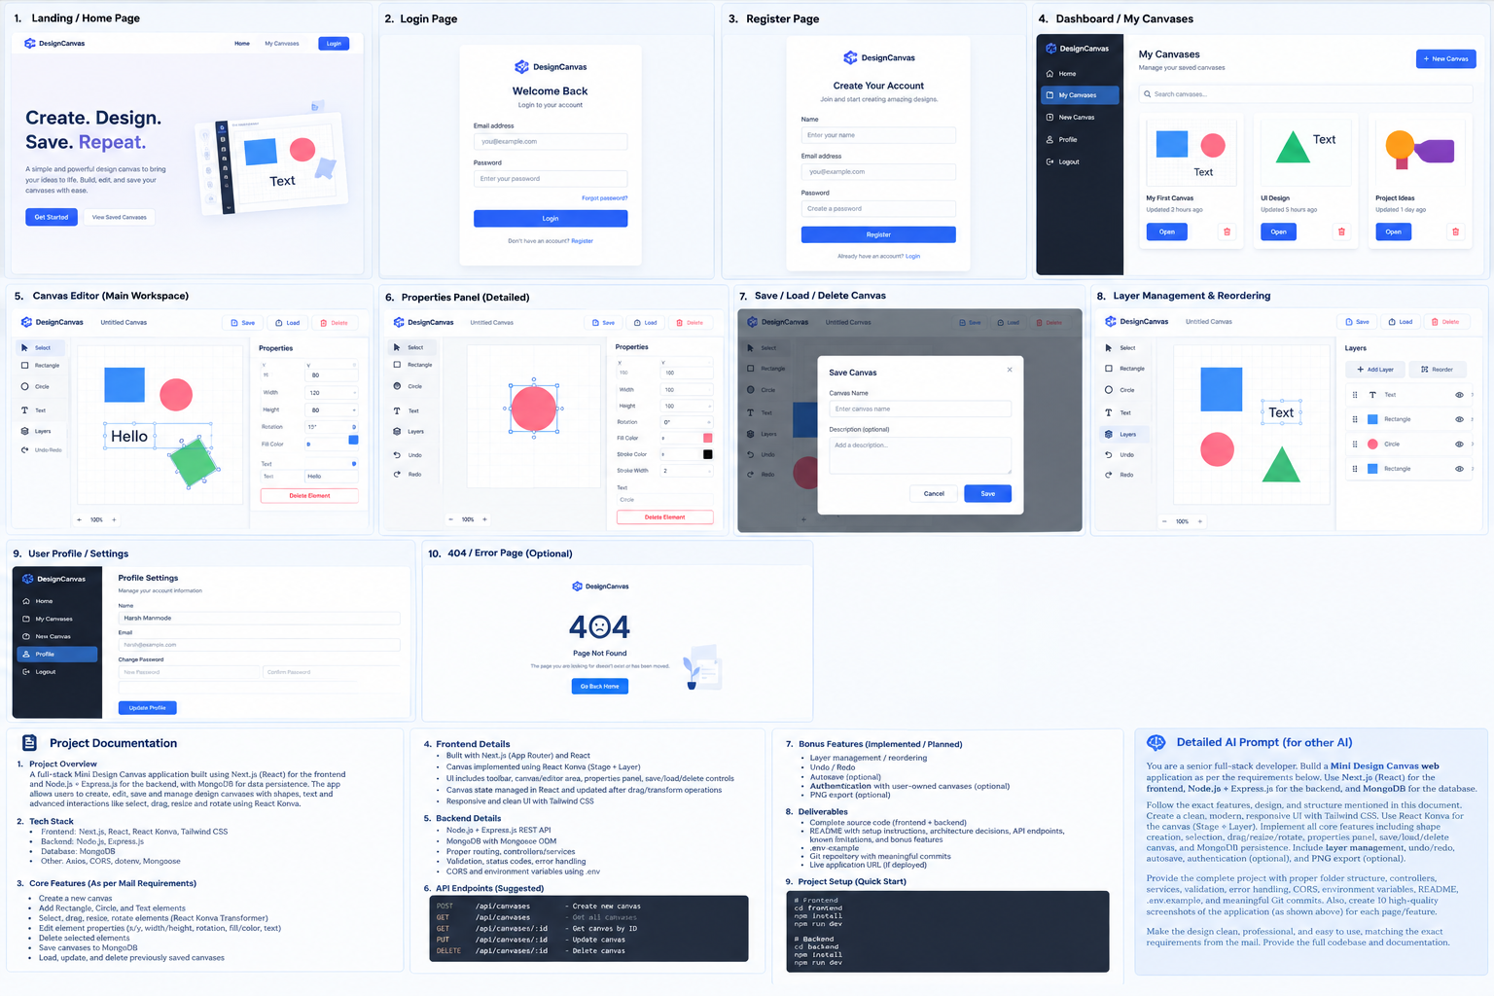
Design reference board: proposed screens and editor layouts.

1. Assignment Brief
Build a production-quality Mini Design Canvas web application for the Glazia Full Stack Developer Intern assignment. The application should allow a user to create a canvas, place basic design elements, manipulate them visually, edit their properties, and persist complete canvas documents in MongoDB through a Node.js/Express REST API.

Required stack
Area | Technology
Frontend | Next.js, React, Tailwind CSS
Canvas engine | React Konva / Konva — Stage + Layer + Transformer
Backend | Node.js + Express.js
Database | MongoDB + Mongoose
API | REST / JSON
Validation | Server-side request validation
Configuration | .env environment variables
Optional | Authentication, layers, undo/redo, autosave, PNG export

Core acceptance criteria
- Create a new canvas.
- Add Rectangle, Circle and Text elements.
- Select elements and show the selected element visually.
- Drag elements around the canvas.
- Resize and rotate elements with React Konva Transformer.
- Edit x, y, width, height, rotation, fill/color and text from the properties panel.
- Delete the selected element.
- Save a canvas to MongoDB.
- Load previously saved canvases.
- Update an existing saved canvas.
- Delete a saved canvas.
- Keep canvas state in React and synchronize state after drag/transform operations.
- Provide a clean toolbar, editor/canvas area, properties panel and save/load/delete controls.
- Provide REST API routes with validation, status codes, errors, CORS and environment variables.

2. Product & UX Specification

Design direction
- Modern SaaS-style interface: clean, spacious and professional.
- Primary accent: blue/indigo; neutral white/gray workspace.
- Tailwind CSS for all UI styling.
- Rounded cards, subtle borders, restrained shadows and clear hierarchy.
- Editor should prioritize the canvas and keep controls discoverable.
- Use responsive layouts, while optimizing the editor for desktop/laptop screens.
- Do not overdecorate the canvas; the canvas itself is the focus.

Recommended pages/screens
# | Screen | Purpose | Required?
1 | Landing / Home | Explain the product and provide entry points. | Recommended
2 | Login | Authentication entry if auth is implemented. | Optional bonus
3 | Register | Create an account if auth is implemented. | Optional bonus
4 | My Canvases / Dashboard | List saved canvases with open/delete/create actions. | Core workflow
5 | Canvas Editor | Main design workspace. | Mandatory
6 | Properties Panel | Edit selected element properties. | Mandatory
7 | Save / Load flow | Persist and retrieve canvas documents. | Mandatory
8 | Layers | View/reorder elements. | Bonus
9 | Profile / Settings | User settings if auth is implemented. | Optional
10 | 404 / Error | Friendly fallback/error state. | Recommended

Editor layout
- Top bar: application logo/name, canvas title, Save, Load/My Canvases, Delete.
- Left toolbar: Select, Rectangle, Circle, Text; optional Layers, Undo, Redo.
- Center: Konva Stage inside a scrollable/zoomable workspace.
- Right properties panel: x, y, width, height, rotation, fill, stroke/stroke width, and text when selected.
- Bottom/secondary area: zoom control and optional status information.
- When no element is selected, show canvas-level information or an empty-state message.

3. Canvas Data Model
The saved canvas should be serializable JSON. Keep the model simple enough to render deterministically.
Field | Type | Description
_id | ObjectId | MongoDB document ID.
name | String | Canvas name.
description | String | Optional description.
width | Number | Canvas width in pixels.
height | Number | Canvas height in pixels.
backgroundColor | String | Canvas background color.
elements | Array | Ordered list of canvas elements.
createdAt | Date | Creation timestamp.
updatedAt | Date | Last update timestamp.

Element schema
Field | Type | Notes
id | String | Frontend-generated stable element ID.
type | String | rectangle | circle | text
x | Number | Position on canvas.
y | Number | Position on canvas.
width | Number | Rendered width.
height | Number | Rendered height.
rotation | Number | Degrees.
fill | String | Color value.
stroke | String | Optional outline color.
strokeWidth | Number | Optional outline width.
text | String | Required/used for text elements.
fontSize | Number | Optional text size.
fontFamily | String | Optional text family.
visible | Boolean | Useful for layer management.
Important Konva detail: after a Transformer resize, normalize scaleX/scaleY back into width/height and reset scale to 1 so the persisted model stores actual dimensions rather than transient transform scale.

4. Core Editor Behaviour
- User clicks Rectangle/Circle/Text in the toolbar.
- Frontend creates a new element with a unique ID and sensible defaults.
- The new element is appended to the React elements array.
- User clicks an element; selectedElementId is updated.
- A Konva Transformer attaches to the selected node.
- User drags; onDragEnd updates x/y in React state.
- User resizes/rotates; onTransformEnd calculates the new dimensions/rotation and updates React state.
- Properties panel edits directly update the selected element.
- Delete removes the selected element from the React state.
- Save serializes the current canvas state and sends it to the backend.
- Load retrieves a document and hydrates the React canvas state.
- Update sends the current state using PUT.
- Delete removes the saved document and updates the dashboard/editor state.

Selection rules
- Clicking empty canvas clears selection.
- Only one element is selected at a time for the core implementation.
- Selected element gets Transformer handles and a visible selection outline.
- Delete key should remove the selected element if keyboard handling is implemented.
- Escape may clear selection.

5. Backend REST API
Method | Endpoint | Purpose | Success
POST | /api/canvases | Create/save a new canvas. | 201
GET | /api/canvases | List saved canvases. | 200
GET | /api/canvases/:id | Get one canvas. | 200
PUT | /api/canvases/:id | Update an existing canvas. | 200
DELETE | /api/canvases/:id | Delete a canvas. | 204 or 200

Suggested request body for POST/PUT
{
"name": "My First Canvas",
"description": "Demo design",
"width": 1000,
"height": 650,
"backgroundColor": "#ffffff",
"elements": [
{
"id": "el_001",
"type": "rectangle",
"x": 120,
"y": 100,
"width": 180,
"height": 120,
"rotation": 0,
"fill": "#2563eb"
}
]
}

HTTP status/error strategy
Case | Status | Example
Created | 201 | Canvas created successfully.
Success | 200 | Canvas retrieved/updated.
No content | 204 | Canvas deleted.
Validation error | 400 | Invalid name, dimensions or element.
Not found | 404 | Canvas ID does not exist.
Duplicate/conflict | 409 | Use only where a real conflict exists.
Server/database error | 500 | Unexpected backend failure.
Use a consistent JSON error shape such as: { "success": false, "message": "...", "errors": [] }.

6. Recommended Architecture

Repository structure
glazia-design-canvas/
├── frontend/
│ ├── app/
│ │ ├── page.tsx
│ │ ├── canvases/page.tsx
│ │ ├── editor/[id]/page.tsx
│ │ └── ...
│ ├── components/
│ │ ├── canvas/
│ │ │ ├── CanvasStage.tsx
│ │ │ ├── CanvasElement.tsx
│ │ │ └── SelectionTransformer.tsx
│ │ ├── editor/
│ │ │ ├── Toolbar.tsx
│ │ │ ├── PropertiesPanel.tsx
│ │ │ ├── TopBar.tsx
│ │ │ └── LayersPanel.tsx
│ │ └── ui/
│ ├── hooks/
│ ├── lib/
│ │ └── api.ts
│ ├── types/
│ └── ...
├── backend/
│ ├── src/
│ │ ├── config/
│ │ ├── controllers/
│ │ ├── middleware/
│ │ ├── models/
│ │ ├── routes/
│ │ ├── services/
│ │ ├── validators/
│ │ └── server.js
│ ├── .env.example
│ └── package.json
├── README.md
└── .gitignore

Frontend state
- Use React state or a small custom hook for canvas state.
- Keep selectedElementId separate from persisted elements.
- Expose addElement, updateElement, deleteElement, selectElement, loadCanvas and resetCanvas operations.
- Use immutable updates to prevent rendering bugs.
- Keep API calls in a dedicated API client rather than scattering fetch logic throughout components.

Backend layers
- Routes define URLs and HTTP methods.
- Controllers parse requests and produce responses.
- Services contain canvas persistence/business logic.
- Mongoose models define MongoDB schema.
- Validators reject malformed canvas documents before database writes.
- Central error middleware handles unexpected exceptions.

7. Environment Variables & Setup
frontend/.env.local
NEXT_PUBLIC_API_URL=http://localhost:5000/api
backend/.env
PORT=5000
MONGODB_URI=mongodb://127.0.0.1:27017/glazia_design_canvas
CLIENT_URL=http://localhost:3000

Local setup
- Clone the Git repository.
- Install frontend dependencies with npm install inside frontend.
- Install backend dependencies with npm install inside backend.
- Create backend/.env from .env.example.
- Create frontend/.env.local with the API URL.
- Start MongoDB locally or configure MongoDB Atlas.
- Start the Express server.
- Start the Next.js development server.
- Open the frontend URL and create a canvas.

Example scripts
- frontend: npm run dev / npm run build / npm run start
- backend: npm run dev / npm run start
- Use nodemon or an equivalent dev watcher for the backend if desired.

8. Bonus Features
Feature | Implementation idea | Priority
Layer management | Elements array order = z-order; drag/drop or up/down controls reorder it. | High
Undo/Redo | History stack of immutable canvas snapshots. | High
Autosave | Debounced PUT after changes, with save status indicator. | Medium
Authentication | JWT/session authentication; associate canvas.userId with user. | Medium
PNG export | Stage.toDataURL() and browser download. | Medium
Do not sacrifice core requirements for bonus features. Core functionality, clean architecture, validation and reliability should be complete first.

9. Testing & Quality Checklist
- Add each of the three element types.
- Select and deselect elements.
- Drag each element and reload the canvas to confirm position persistence.
- Resize a rectangle/circle and confirm width/height persist correctly.
- Rotate an element and confirm rotation persists.
- Edit fill/color and confirm persistence.
- Edit text content and confirm persistence.
- Delete selected element.
- Create and save a new canvas.
- List all canvases.
- Open a saved canvas.
- Update an existing canvas.
- Delete a canvas.
- Test invalid canvas IDs.
- Test invalid/missing request fields.
- Test backend when MongoDB is unavailable.
- Test CORS from the frontend.
- Run production build before delivery.

UX quality
- Buttons have disabled/loading states during API calls.
- Delete actions use confirmation to prevent accidental loss.
- Success/error feedback is visible.
- Empty states are helpful.
- No console errors in normal use.
- Layout works on common laptop resolutions.

10. Git & Delivery Requirements

Suggested commit sequence
- chore: initialize frontend and backend structure
- feat: build canvas editor shell and toolbar
- feat: add rectangle circle and text elements
- feat: add selection drag resize and rotation
- feat: add properties panel and element editing
- feat: add canvas REST API and MongoDB model
- feat: add save load update and delete workflows
- feat: improve validation error handling and loading states
- feat: add layer management and undo redo
- feat: add PNG export/autosave if implemented
- docs: add setup architecture API and limitations

Final repository checklist
- Complete source code.
- README.md with overview, features, architecture, setup, API, screenshots and limitations.
- .env.example files with no real secrets.
- .gitignore excluding node_modules, .env files, build artifacts and local files.
- Meaningful Git history.
- No hard-coded production secrets.
- No unnecessary dependencies.
- Live URL if deployed.

Submission email
The assignment email specifies the exact subject:
Full Stack Developer - Assignment Task
The email should contain the Git repository link and live application URL if available. Keep the final message concise and professional.

11. Master Prompt for Another AI Developer
You are a senior full-stack engineer and UI/UX engineer. Build a complete production-quality Mini Design Canvas web application for a Full Stack Developer Intern assignment.
TECH STACK — MUST USE
Frontend:
- Next.js with React
- Tailwind CSS
- React Konva / Konva
- The actual canvas must use Konva Stage, Layer and Transformer.
Backend:
- Node.js
- Express.js
- REST API
- MongoDB with Mongoose
- Environment variables
- CORS
- Validation
- Centralized error handling
CORE REQUIREMENTS — MUST IMPLEMENT
1. Create a new canvas.
2. Add Rectangle, Circle and Text elements.
3. Select elements.
4. Drag elements.
5. Resize elements with React Konva Transformer.
6. Rotate elements with React Konva Transformer.
7. Edit x, y, width, height, rotation, fill/color and text from a properties panel.
8. Delete the selected element.
9. Save canvases to MongoDB.
10. Load previously saved canvases.
11. Update saved canvases.
12. Delete saved canvases.
13. Keep canvas state in React and update it after drag/transform operations.
EDITOR UI
Create a polished desktop-first SaaS editor:
- Top bar: logo, canvas title, Save, Load/My Canvases, Delete.
- Left toolbar: Select, Rectangle, Circle, Text.
- Center: large Konva Stage/Layer workspace.
- Right: Properties Panel.
- Optional bottom: zoom and status.
Use Tailwind CSS for the application UI. Keep the canvas visually clean.
ELEMENT BEHAVIOUR
Use a stable unique ID for every element.
Store:
id, type, x, y, width, height, rotation, fill, stroke, strokeWidth, text, fontSize, visible.
For rectangle render Konva Rect.
For circle render Konva Circle or an equivalent representation that correctly persists dimensions.
For text render Konva Text.
Use Transformer for selected nodes.
On drag end, update x/y in React state.
On transform end, calculate actual width/height from node dimensions and scale, reset scaleX/scaleY to 1, and update React state. Persist the normalized dimensions rather than raw transform scale.
Clicking empty canvas clears selection.
BACKEND API
Implement:
POST /api/canvases
GET /api/canvases
GET /api/canvases/:id
PUT /api/canvases/:id
DELETE /api/canvases/:id
Use correct status codes:
201 create, 200 reads/updates, 204 or 200 delete, 400 validation, 404 not found, 500 unexpected server errors.
Use a consistent JSON error response.
Validate IDs and canvas payloads.
Use CORS and environment variables.
MONGODB MODEL
Canvas:
name, description, width, height, backgroundColor, elements, createdAt, updatedAt.
Use timestamps in Mongoose.
Elements can be stored as an array of subdocuments or a flexible validated structure.
ARCHITECTURE
Use a clean structure:
frontend/
app/
components/canvas/
components/editor/
components/ui/
hooks/
lib/
types/
backend/
src/config/
src/controllers/
src/middleware/
src/models/
src/routes/
src/services/
src/validators/
Keep API logic separate from UI components.
Keep controller/service/model responsibilities clear.
PAGES
Implement:
- Landing/Home
- My Canvases/Dashboard
- New Canvas
- Editor
- Optional Login/Register if authentication is implemented
- Optional Profile
- 404/error page
MY CANVASES
Show saved canvas cards with:
- canvas name
- updated time
- Open button
- Delete button
- New Canvas button
Add a loading state, empty state and error state.
SAVE/LOAD UX
Save should support a canvas name.
Show saving/saved/error states.
Before destructive delete, show confirmation.
Loading a canvas should hydrate the complete React canvas state.
After updating, refresh timestamps/list data correctly.
DESIGN
Use a clean modern professional design:
- white/light gray workspace
- blue/indigo primary accent
- subtle borders
- rounded cards
- restrained shadows
- clear typography
- responsive layout
Do not use excessive gradients or decorative elements that distract from the editor.
BONUS FEATURES — IMPLEMENT IF CORE IS STABLE
1. Layer management/reordering.
2. Undo/Redo.
3. Autosave with debounce.
4. Authentication and user-owned canvases.
5. PNG export using Konva Stage.toDataURL().
IMPORTANT: Do not let bonus features break the mandatory requirements.
QUALITY
- TypeScript may be used on the frontend.
- Use reusable components.
- Avoid duplicate logic.
- Handle async loading/error states.
- Prevent invalid numeric values.
- Avoid memory leaks from event listeners.
- Ensure Transformer refs are handled correctly.
- Ensure stage/node refs do not cause hydration problems in Next.js. Put Konva editor code in a client component.
- Do not expose secrets.
- Include .env.example.
- Make production build pass.
- Keep console clean.
README
Write a complete README containing:
- project overview
- screenshots
- features
- technology stack
- architecture
- folder structure
- local setup
- environment variables
- API endpoints
- data model
- design decisions
- known limitations
- bonus features implemented
- deployment instructions
- testing checklist
DELIVERY
Return the complete project source code, setup instructions and documentation. Use meaningful Git commits. The final repository must be ready for review as a coding assignment.
Before finishing, verify every mandatory requirement against a checklist and fix any missing item.

12. Recommended Implementation Order
- Initialize Next.js frontend with Tailwind and Express backend.
- Connect MongoDB and create the Canvas model.
- Create REST routes/controllers/services and test them independently.
- Build the editor shell and layout.
- Implement Stage + Layer and render static sample elements.
- Implement add/select/delete.
- Implement drag state updates.
- Implement Transformer resize/rotation and normalized state updates.
- Build properties panel and two-way editing.
- Connect save/load/update/delete APIs.
- Build My Canvases dashboard.
- Add validation, error states, loading states and confirmations.
- Implement selected bonus features.
- Write README and .env.example.
- Run end-to-end testing and production builds.
- Create final Git commits and prepare submission email.

13. Definition of Done
Area | Done when
Canvas | A user can create a blank canvas and see it immediately.
Elements | Rectangle, circle and text can be added.
Manipulation | Elements can be selected, dragged, resized and rotated.
Properties | Selected element properties can be edited and reflected on canvas.
Delete | Selected element can be removed.
Persistence | New and existing canvases are stored in MongoDB.
CRUD | POST/GET/GET by ID/PUT/DELETE work with appropriate responses.
Validation | Invalid payloads and IDs are handled safely.
Frontend state | Drag/transform/property changes update React state.
UX | Loading, empty, success, error and destructive-action states are handled.
Docs | README, .env.example and architecture/API information are included.
Delivery | Repository is clean, buildable and ready for reviewer setup.

14. Final Reviewer Demo Flow
- Open the application.
- Create a new canvas named 'Glazia Demo Canvas'.
- Add a rectangle, circle and text.
- Select the rectangle and change its position, size, rotation and color.
- Drag the circle and rotate it.
- Edit the text through the properties panel.
- Delete one element.
- Save the canvas.
- Return to My Canvases and open the saved canvas.
- Modify an element and update it.
- Reload the page and verify persistence.
- Delete the saved canvas.
- If bonuses exist, demonstrate layers, undo/redo, autosave or PNG export.

End of project specification

