ASSIGNMENT-4 DATA STRUCTURES.
Name-Harsh
Roll_no-1024030497
Batch-2C25
Ques-1)
Code->
#include <iostream>
using namespace std;
class Queue {
private:
int front, rear, size;
int* arr;
public:
Queue(int maxSize) {
size = maxSize;
arr = new int[size];
front = rear = -1;
}
~Queue() {
delete[] arr;
}
bool isEmpty() {
return front == -1;
}
bool isFull() {
return rear == size - 1;
}
void enqueue(int value) {
if (isFull()) {
cout << "Queue is full. Cannot enqueue.\n";
return;
}
if (isEmpty()) {
front = rear = 0;
} else {
rear++;
}
arr[rear] = value;
cout << "Enqueued: " << value << endl;
}
void dequeue() {
if (isEmpty()) {
cout << "Queue is empty. Cannot dequeue.\n";
return;
}
cout << "Dequeued: " << arr[front] << endl;
if (front == rear) {
front = rear = -1; // Queue becomes empty
} else {
front++;
}
}
void peek() {
if (isEmpty()) {
cout << "Queue is empty. No front element.\n";
} else {
cout << "Front element: " << arr[front] << endl;
}
}
void display() {
if (isEmpty()) {
cout << "Queue is empty.\n";
return;
}
cout << "Queue contents: ";
for (int i = front; i <= rear; i++) {
cout << arr[i] << " ";
}
cout << endl;
}
};
int main() {
int size;
cout << "Enter the size of the queue: ";
cin >> size;
Queue q(size);
int choice, value;
do {
cout << "\nQueue Operations Menu\n";
cout << "1. Enqueue (Add)\n";
cout << "2. Dequeue (Remove)\n";
cout << "3. Check if Empty\n";
cout << "4. Check if Full\n";
cout << "5. Display Queue\n";
cout << "6. Peek Front Element\n";
cout << "7. Exit\n";
cout << "Enter your choice: ";
cin >> choice;
switch (choice) {
case 1:
cout << "Enter value to enqueue: ";
cin >> value;
q.enqueue(value);
break;
case 2:
q.dequeue();
break;
case 3:
cout << (q.isEmpty() ? "Queue is empty.\n" : "Queue is not empty.\n");
break;
case 4:
cout << (q.isFull() ? "Queue is full.\n" : "Queue is not full.\n");
break;
case 5:
q.display();
break;
case 6:
q.peek();
break;
case 7:
cout << "Exiting program.\n";
break;
default:
cout << "Invalid choice. Please try again.\n";
}
} while (choice != 7);
return 0;
}
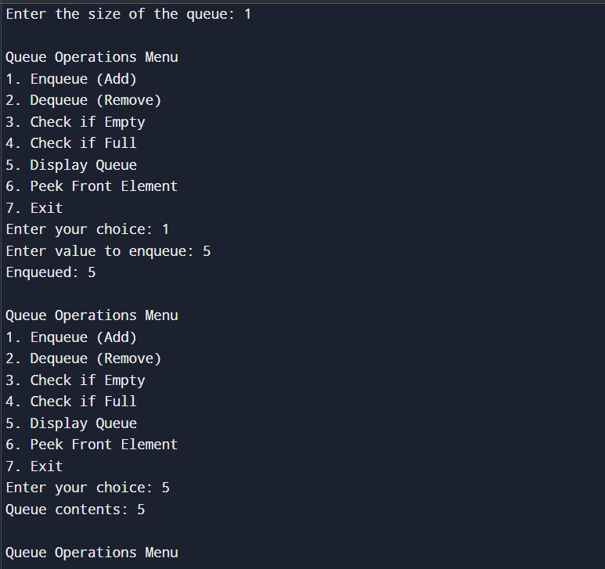
Ques-2)
Code->
#include <iostream>
using namespace std;
class CircularQueue {
private:
int front, rear, size;
int* arr;
public:
CircularQueue(int maxSize) {
size = maxSize;
arr = new int[size];
front = rear = -1;
}
~CircularQueue() {
delete[] arr;
}
bool isEmpty() {
return front == -1;
}
bool isFull() {
return (rear + 1) % size == front;
}
void enqueue(int value) {
if (isFull()) {
cout << "Queue is full. Cannot enqueue.\n";
return;
}
if (isEmpty()) {
front = rear = 0;
} else {
rear = (rear + 1) % size;
}
arr[rear] = value;
cout << "Enqueued: " << value << endl;
}
void dequeue() {
if (isEmpty()) {
cout << "Queue is empty. Cannot dequeue.\n";
return;
}
cout << "Dequeued: " << arr[front] << endl;
if (front == rear) {
front = rear = -1; // Queue becomes empty
} else {
front = (front + 1) % size;
}
}
void peek() {
if (isEmpty()) {
cout << "Queue is empty. No front element.\n";
} else {
cout << "Front element: " << arr[front] << endl;
}
}
void display() {
if (isEmpty()) {
cout << "Queue is empty.\n";
return;
}
cout << "Queue contents: ";
int i = front;
while (true) {
cout << arr[i] << " ";
if (i == rear) break;
i = (i + 1) % size;
}
cout << endl;
}
};
int main() {
int size;
cout << "Enter the size of the circular queue: ";
cin >> size;
CircularQueue q(size);
int choice, value;
do {
cout << "\nCircular Queue Operations Menu\n";
cout << "1. Enqueue (Add)\n";
cout << "2. Dequeue (Remove)\n";
cout << "3. Check if Empty\n";
cout << "4. Check if Full\n";
cout << "5. Display Queue\n";
cout << "6. Peek Front Element\n";
cout << "7. Exit\n";
cout << "Enter your choice: ";
cin >> choice;
switch (choice) {
case 1:
cout << "Enter value to enqueue: ";
cin >> value;
q.enqueue(value);
break;
case 2:
q.dequeue();
break;
case 3:
cout << (q.isEmpty() ? "Queue is empty.\n" : "Queue is not empty.\n");
break;
case 4:
cout << (q.isFull() ? "Queue is full.\n" : "Queue is not full.\n");
break;
case 5:
q.display();
break;
case 6:
q.peek();
break;
case 7:
cout << "Exiting program.\n";
break;
default:
cout << "Invalid choice. Please try again.\n";
}
} while (choice != 7);
return 0;
}
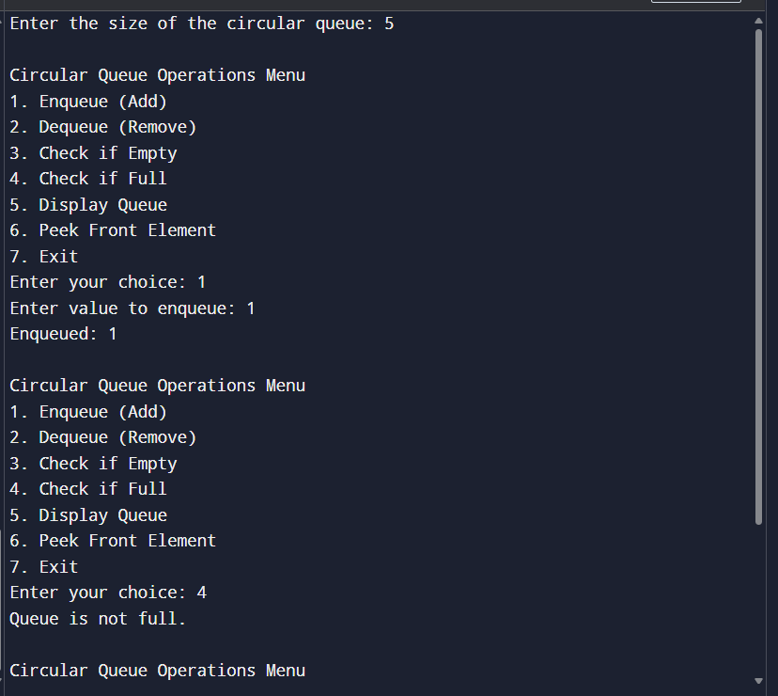
Ques-3)
Code->
#include <iostream>
#include <queue>
using namespace std;
void interleaveQueue(queue<int>& q) {
int n = q.size();
if (n % 2 != 0) {
cout << "Queue must have even number of elements.\n";
return;
}
int half = n / 2;
queue<int> firstHalf;
for (int i = 0; i < half; i++) {
firstHalf.push(q.front());
q.pop();
}
while (!firstHalf.empty()) {
cout << firstHalf.front() << " ";
firstHalf.pop();
cout << q.front() << " ";
q.pop();
}
cout << endl;
}
int main() {
queue<int> q;
q.push(4);
q.push(7);
q.push(11);
q.push(20);
q.push(5);
q.push(9);
cout << "Original queue: ";
queue<int> temp = q;
while (!temp.empty()) {
cout << temp.front() << " ";
temp.pop();
}
cout << "\nInterleaved queue: ";
interleaveQueue(q);
return 0;
}
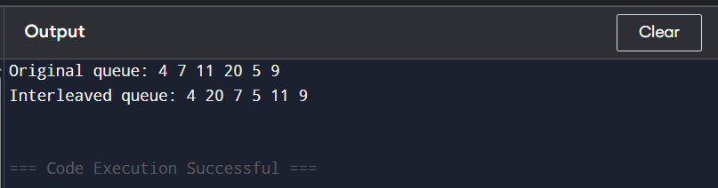
Ques-4)
Code->
#include <iostream>
#include <queue>
using namespace std;
void firstNonRepeating(string str) {
queue<char> q;
int freq[26] = {0};
for (int i = 0; i < str.length(); i++) {
char ch = str[i];
freq[ch - 'a']++;
q.push(ch);
while (!q.empty() && freq[q.front() - 'a'] > 1) {
q.pop();
}
if (q.empty()) {
cout << "-1 ";
} else {
cout << q.front() << " ";
}
}
cout << endl;
}
int main() {
string input = "aabc";
firstNonRepeating(input);
return 0;
}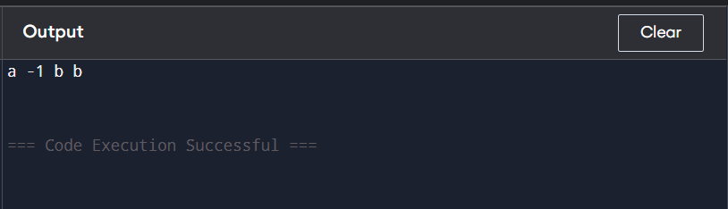
Ques-5)
1)using two queues
#include <iostream>
#include <queue>
using namespace std;

class StackTwoQueues {
private:
queue<int> q1, q2;

public:
void push(int x) {
q2.push(x);
while (!q1.empty()) {
q2.push(q1.front());
q1.pop();
}
swap(q1, q2);
}

void pop() {
if (!q1.empty()) q1.pop();
}

int top() {
if (q1.empty()) return -1;
return q1.front();
}

bool isEmpty() {
return q1.empty();
}

void display() {
queue<int> temp = q1;
while (!temp.empty()) {
cout << temp.front() << " ";
temp.pop();
}
cout << endl;
}
};

int main() {
StackTwoQueues st;
st.push(10);
st.push(20);
st.push(30);
st.display();
st.pop();
st.display();
cout << "Top: " << st.top() << endl;
return 0;
}
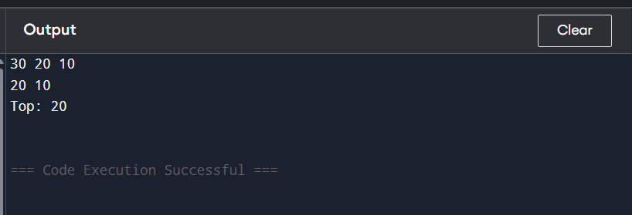
Using one queue
#include <iostream>
#include <queue>
using namespace std;
class StackOneQueue {
private:
queue<int> q;
public:
void push(int x) {
q.push(x);
int n = q.size();
for (int i = 0; i < n - 1; i++) {
q.push(q.front());
q.pop();
}
}
void pop() {
if (q.empty()) {
cout << "Stack is empty.\n";
return;
}
q.pop();
}
int top() {
if (q.empty()) return -1;
return q.front();
}
bool isEmpty() {
return q.empty();
}
void display() {
queue<int> temp = q;
while (!temp.empty()) {
cout << temp.front() << " ";
temp.pop();
}
cout << endl;
}
};
int main() {
StackOneQueue st;
st.push(100);
st.push(200);
st.push(300);
st.display();
st.pop();
st.display();
cout << "Top: " << st.top() << endl;
return 0;
}
