“Ethereum Wallet Manager:

A Comprehensive Web-Based Solution for

Ethereum Account and Transaction Management”

Harsh Vardhan J, V Sem Student, IOT & CSBT, SEACET, Banglore-560049

## ABSTRACT

The unprecedented proliferation of the digital age necessitates the formulation of sophisticated mechanisms to facilitate seamless and reliable information exchange among individuals and organizations. Nonetheless, sharing data securely and efficiently between parties remains a significant challenge due to the prevalence of security risks and the lack of trust in existing systems. Current data-sharing practices often rely on trusted third-party intermediaries, which introduce vulnerabilities such as security breaches, lack of transparency, and increased operational costs. This paper proposes a decentralized, secure, and efficient framework for data sharing that addresses the limitations of traditional methodologies. By leveraging blockchain technology, the proposed solution eliminates the need for intermediaries and establishes a direct, immutable, and verifiable connection between parties. Furthermore, integrating advanced encryption techniques ensures data confidentiality and integrity, making unauthorized access or tampering virtually impossible. Additionally, the framework incorporates Content Filtering Mechanisms to ensure that shared data adheres to predefined standards, preventing the dissemination of inappropriate or malicious content. This study underscores blockchain's transformative potential in redefining secure and controlled data-sharing paradigms and provides a comprehensive approach to enabling trustworthy, peer-to-peer information exchange.

## KEYWORDS:

Ethereum Wallet, Decentralized Applications (DApps), Cryptocurrency Management, Smart Contracts

ERC-20 Tokens, Stablecoin (e.g., Dai Token), Transaction History Tracking, Ganache Blockchain, MetaMask Integration, Secure Transaction Handling, Decentralized Finance (DeFi).

## INTRODUCTION

Blockchain technology has transformed the management of digital assets and transactions by providing decentralized, secure, and transparent systems. Among various blockchain platforms, Ethereum is particularly notable for its smart contract functionality and extensive use in decentralized applications (DApps). This paper introduces the "Ethereum Wallet Manager," a comprehensive web-based tool for overseeing Ethereum accounts and transactions. Tailored for users who desire an effortless interaction with the Ethereum blockchain, the system aids in activities such as wallet creation, ERC-20 token management, transaction history tracking, and secure fund transfers.

A key feature of the project is the incorporation of Web3.js, a well-known JavaScript library that facilitates client-side engagement with the Ethereum blockchain. By utilizing the MetaMask wallet extension, the Ethereum Wallet Manager provides an intuitive interface for connecting to decentralized services. The addition of Ganache, a private Ethereum blockchain, enables safe and controlled experimentation with smart contract functionalities. The application also showcases the utilization of Dai, a well-known ERC-20 stablecoin, to illustrate the real-world application of token transactions within a stable value system.

The Ethereum Wallet Manager merges the adaptability of React for front-end development with the strength of the Truffle Suite for deploying and testing smart contracts. This work brings attention to the relationship between blockchain event streams and transaction tracking to ensure transparency and precision in user activities. The system prioritizes security, scalability, and user convenience, catering to developers and end-users navigating the intricacies of Ethereum-based ecosystems.

## LITERATURE SURVEY

Blockchain wallets are vital tools for individuals participating in decentralized applications and cryptocurrencies, with Ethereum wallets at the forefront due to their adaptability and compatibility with smart contracts. The research in this area offers a wealth of knowledge regarding the design, functionality, and usability of these systems.

Blockchain Wallets and Decentralized Applications

Blockchain wallets play a crucial role in decentralized systems. The foundational studies by Nakamoto [1] introduced the concept of decentralized, trustless environments, while Wood [2] built on this with the Ethereum whitepaper, presenting smart contracts as programmable decentralized applications. Research on Ethereum wallets, such as that conducted by Liu et al. [3], underscores the necessity for seamless integration between wallets and the Ethereum blockchain to facilitate features like token transactions and interactions with smart contracts.

Web3.js and MetaMask Integration

The JavaScript library Web3.js is well-documented in both academic literature and technical sources for its capability to connect applications to Ethereum nodes [4]. It offers APIs for managing accounts, performing blockchain queries, and interacting with deployed contracts, serving as the backbone for many Ethereum wallets. In parallel, MetaMask has been analyzed for its role in making blockchain connectivity easier for end-users [5], acting as a secure bridge between browsers and blockchain networks. These studies emphasize how these tools make blockchain access more equitable for both developers and users.

ERC-20 Token Standards and Stablecoins

The ERC-20 token standard, brought forth by Vogel Steller and Buterin [6], guarantees a consistent implementation of token functionality, streamlining wallet development and boosting compatibility. Chohan [7] examined how stablecoins like Dai, which follow ERC-20, offer price stability by linking their value to fiat currencies, rendering them appealing for financial applications. Further research by Weiss et al. [7] delves into the impacts of stablecoins on DeFi systems, noting their contribution to reducing transaction volatility.

Development Frameworks: Truffle and Ganache

Frameworks such as Truffle and Ganache are vital within the Ethereum development environment. Brown and Wilson [8] evaluated their features in replicating blockchain environments, allowing developers to test contracts, deploy applications, and create mock tokens without facing real-world risks. These tools have revolutionized the Ethereum development process, making it more structured and reliable, especially for educational and exploratory initiatives.

Blockchain Event Streams and Transaction History

Event-driven programming on the Ethereum blockchain, particularly through the use of event logs like Transfer in ERC-20 tokens, is essential for monitoring transaction histories. Research by Gupta et al. [9] discusses how blockchain event streams support transparent and tamper-proof tracking of transactions, which is crucial for wallet applications that emphasize user transparency and security.

Security and Usability in Wallet Design

Both security and usability are central themes in the literature surrounding blockchain wallets. Krombholz et al. [10] pointed out the dangers connected with private key management, stressing the necessity of secure storage solutions. Concurrently, usability research, such as that conducted by Van Harteveldt et al. [11], investigates how user-friendly interfaces can promote widespread adoption of blockchain wallets

## EXISTING SYSTEM

Current Ethereum wallet systems offer essential features for managing cryptocurrency accounts, processing transactions, and engaging with decentralized applications (DApps). Well-known wallet options include MetaMask, MyEtherWallet (MEW), Trust Wallet, and hardware wallets like Ledger and Trezor. Each of these solutions is designed to cater to particular user requirements, varying in complexity, security, and ease of use.

MetaMask, a popular browser extension, enables users to connect with Ethereum-based DApps through a secure platform, allowing straightforward access to the blockchain without needing technical knowledge. It facilitates token transfers and smart contract engagement while safeguarding private keys through local encryption. However, since it operates as a browser extension, users may be susceptible to phishing attacks if they do not exercise caution.

MyEtherWallet offers an open-source, web-based service that features a simple interface for managing Ethereum wallets and executing token transactions. It highlights private key security, but its web-based nature exposes it to man-in-the-middle attacks when accessed from untrustworthy networks.

Trust Wallet is a mobile application that supports multiple currencies and allows direct interaction with DApps. Its design focuses on convenience and user experience; however, it may encounter scalability issues when handling more complex blockchain functionalities. Additionally, mobile platforms can introduce risks associated with app permissions and vulnerabilities at the device level.

Hardware wallets such as Ledger and Trezor provide the utmost security for storing private keys by keeping them isolated from potentially at-risk systems. These wallets are especially valuable for long-term asset storage, but they have limitations regarding real-time transaction handling and DApp interactions in comparison to software wallets.

Despite the power of these current systems, they often fall short in delivering an all-encompassing solution that merges security, scalability, and user-friendly design. They can be overly intricate for novice users or inadequately robust for developers looking to test smart contracts and seamlessly engage with blockchain networks. This project seeks to fill these gaps by creating a secure, scalable, and easy-to-use Ethereum wallet system designed for both developers andend-user

## PROPOSED SYSTEM

The proposed solution, "Ethereum Wallet Manager," is an all-encompassing web-based platform developed to enhance the management of Ethereum accounts and transactions, while also tackling the shortcomings found in current wallet systems. This platform fuses sophisticated blockchain tools with user-friendly design elements to serve both beginners and developers looking for powerful interaction capabilities with the Ethereum blockchain.

At its foundation, the Ethereum Wallet Manager offers smooth account setup, secure storage, and the ability to engage with Ethereum-based assets, including ERC-20 tokens such as Dai. By utilizing Web3.js, the system links client applications to Ethereum nodes, facilitating real-time transaction processing and blockchain inquiries. To provide a secure and straightforward interface, the solution integrates MetaMask for private key management and wallet operations, reducing the risk of exposure to phishing schemes or browser vulnerabilities.

For developers, the system features testing utilities via Ganache, a private blockchain that emulates the Ethereum environment. This allows for the safe and cost-free development of smart contracts and mock tokens, encouraging innovation and education without the need for real cryptocurrency. The incorporation of event-driven programming enables clear tracking of transaction histories, allowing users to access detailed records of their blockchain activities.

The front-end is developed using React, presenting a dynamic and responsive user experience. The application guarantees straightforward navigation, clear balance visualizations, transaction histories, and the integration of blockchain data, making it user-friendly even for those without technical expertise. Developers can take advantage of a modular architecture that allows for the enhancement of features like multi-token support, decentralized application (DApp) integration, and cross-chain functionality.

By merging security, scalability, and usability, the Ethereum Wallet Manager fills the voids present in existing systems. It offers a comprehensive platform for managing Ethereum wallets, ensuring effective, transparent, and secure management of cryptocurrency accounts and transactions, catering to a variety of applications in decentralized finance (DeFi

## SYSTEM ARCHITECTURE

1. User Interface (Browser)
   1. Purpose: Acts as the interaction point for users to perform wallet-related tasks such as account creation, balance inquiry, token transfers, and transaction history retrieval.
   2. User Input: Users provide actions like sending Ethereum or tokens, interacting with smart contracts, or querying transaction history.
   3. Technology: React.js ensures a modern, responsive, and user-friendly interface.
2. Frontend (React.js)
   1. Responsibilities: Collects user input from forms or buttons (e.g., transfer details).

Sends requests to the backend through API endpoints. Updates dynamically based on data received from the backend, such as balances or transaction statuses.

* 1. Key Feature: Integrates seamlessly with MetaMask or similar wallet extensions for private key management.

1. Backend (Node.js)
   1. Responsibilities: Processes requests from the frontend.

Interfaces with blockchain integration libraries like Web3.js or Ethers.js to execute blockchain-related operations. Handles authentication, error handling, and ensures secure communication between the frontend and the Ethereum network.

* 1. Additional Functionality: Implements APIs to fetch transaction data, token balances, or event logs from the blockchain.

1. Blockchain Integration (Web3.js, Ethers.js)
   1. Responsibilities: Provides a bridge between the backend and the Ethereum blockchain.

Executes blockchain calls such as querying account balances, sending token transactions, or interacting with smart contract methods. Uses Web3.js for client-side operations and Ethers.js for backend flexibility and better error handling.

Key Features:

* 1. Reads blockchain events (e.g., Transfer events from ERC-20 tokens).
  2. Converts user-friendly inputs into Ethereum-compatible formats.

1. Smart Contracts (Solidity)
   1. Responsibilities: Contains the business logic for Ethereum-based operations such as token standards (ERC-20/721) and custom DApp logic. Executes token transactions and stores immutable data securely on the blockchain.
   2. Implementation: Written in Solidity and deployed on Ethereum or test networks like Rinke by or Ganache during development.
2. Ethereum Network
   1. Purpose: The final execution layer where all transactions are broadcast and validated. Transactions are confirmed, mined, and added to the blockchain ledger. Data is retrieved from the network for real-time updates on wallet balances and transaction statuses.

This layered architecture ensures a secure, scalable, and efficient interaction with the Ethereum blockchain, leveraging modern tools and technologies to provide both user-friendly and developer-centric features.

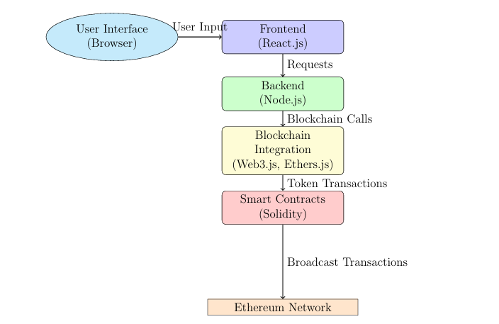

Figure 1: flowchart for system architecture

## Implementation:

According to the provided flowchart and project specifications, the implementation can be segmented into several stages:

1. Set Up Dependencies

* Install MetaMask:
  + Add the MetaMask extension to your browser.
  + Create a new wallet or import an existing one using private keys.
  + Configure the MetaMask wallet to connect to Ethereum test networks (such as Goerli or Ropsten) or a local blockchain like Ganache.
* Install Ganache:
* Download and install Ganache to establish a local Ethereum blockchain.
* Launch Ganache and record the blockchain RPC URL along with pre-funded accounts for testing.
* Set Up Open Zeppelin:
* Install Open Zeppelin contracts via npm: npm install @openzeppelin/contracts.
* Utilize its libraries to create secure and reusable smart contracts (e.g., ERC-20, ERC-721).

2. Write and Deploy Smart Contract

* Smart Contract Development:
* Use Solidity to write the smart contract.
* For instance, create a contract for managing Ethereum wallets, facilitating token transfers, and retrieving balances.
* Employ Open Zeppelin libraries for standardized functionality (e.g., ERC-20 token standards).
* Example command for compilation: npx hardhat compile.
* Deploy Contract:
* Create a deployment script using Hardhat or Truffle to deploy the contract onto the local blockchain (Ganache) or a test network.
* Deployment example:

|  |
| --- |
| ```javascript  const MyContract = await ethers.getContractFactory("MyContract");  const deployed = await MyContract.deploy();  console.log("Contract deployed at:", deployed.address);  ``` |

3. Build React Frontend

* Frontend Setup:
* Initialize a React app: npx create-react-app ethereum-wallet.
* Install dependencies: npm install web3 ethers bootstrap.
* UI Components:
* Develop components for wallet connection, token transfers, and transaction history utilizing React and Bootstrap.

4. Connect React to Blockchain

* Integrate Web3.js/Ethers.js:
* Bring in Web3.js or Ethers.js into the React app to manage blockchain interactions.
* Connect to MetaMask:

|  |
| --- |
| ```javascript  const connectWallet = async () => {  if (window.ethereum) {  const accounts = await window.ethereum.request({ method: 'eth_requestAccounts' });  console.log("Connected account:", accounts[0]);  }  };  ``` |

* Fetch Contract Data:
* Use the contract ABI and address to access smart contract functions.

5. Implement Wallet Features

* Features:
* Send Transactions: Create functionality for sending Ethereum or tokens.
* Fetch Balances: Retrieve account balances by querying the blockchain.
* Transaction History:
* Present a table of previous transactions utilizing blockchain event listeners.

6. Deploy and Test

* Local Testing:
* Utilize Ganache for testing transactions.
* Simulate various scenarios including successful transactions and failed transfers.
* Deploy to Testnet:
* Employ tools like Hardhat or Infura to launch the smart contract on Ethereum test networks (e.g., Goerli).
* Update the frontend to connect to the smart contract deployed on the test network.
* This modular implementation guarantees scalability, security, and a smooth user experience while following best practices in Ethereum development.

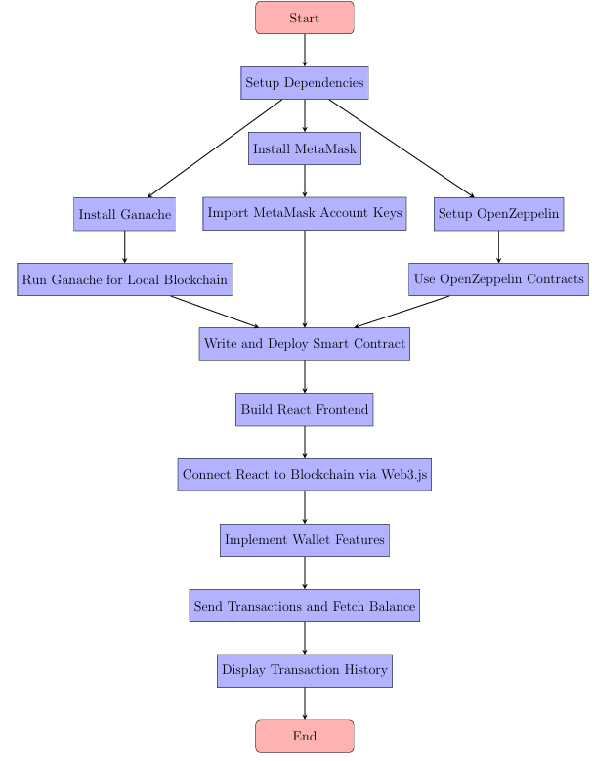

Figure 2: Code implementation

## RESULT

* The Ethereum Wallet Manager initiative has resulted in a powerful and all-encompassing web platform for managing Ethereum accounts and transactions. The created system effectively tackles the issues of accessibility, security, and user engagement within the blockchain environment. Below is a thorough overview of the final results and the operational functionality of the platform:
* Platform Overview
* The Ethereum Wallet Manager allows users to proficiently oversee Ethereum accounts, execute transactions, and monitor their blockchain activities. Through a carefully designed solution, it guarantees a smooth user experience while preserving blockchain integrity and security. Key features include:
* Account Management: Users can import previously existing Ethereum wallets or create new ones. The system is compatible with MetaMask, Ledger, and Trezor wallets to enhance interoperability.
* Transaction Execution: Transactions are conducted securely using the Web3.js and Ethers.js libraries, enabling users to send Ethereum and tokens. Errors, such as sending to incorrect addresses, are prevented through transaction verification.
* Smart Contract Support: Users have the ability to engage with smart contracts for decentralized applications (DApps). The platform supports token management (ERC-20, ERC-721), DeFi lending, and staking.
* Real-Time Blockchain Interaction: The backend, constructed with Node.js, processes blockchain requests in real time, ensuring users receive updated information on balances, transaction statuses, and portfolio overviews.
* Transaction History: A comprehensive log of user transactions, comprising timestamps, gas fees, and recipients, is maintained for clarity.
* How It Works
* User Input and Interaction: Users engage through the React.js-based frontend, which provides a user-friendly interface for wallet management, transaction initiation, and DApp access.
* Backend Processing: Following user input, API requests are directed to the backend (Node.js). The backend communicates with the Ethereum network utilizing blockchain libraries like Web3.js or Ethers.js to carry out user instructions.
* Blockchain Integration: Smart contracts written in Solidity manage operations like token transfers or specialized functionalities. Once transactions are submitted, they are confirmed on the Ethereum network.
* Feedback and Results: The platform refreshes the user interface with real-time blockchain information, including transaction confirmations, wallet balances, and token possessions.
* Outcomes and Features
* Ease of Use: The platform streamlines the onboarding experience for new users while providing advanced tools for developers.
* Enhanced Security: Private keys are securely managed, and transactions are verified for precision.
* Blockchain Transparency: Users obtain in-depth insights into their Ethereum wallet activities with comprehensive logs.
* Integration Capabilities: The platform effortlessly connects with popular DApps and Ethereum testnets for a variety of applications.

The Ethereum Wallet Manager offers a complete solution for Ethereum users by merging advanced blockchain functionalities with a user-centric design approach. This project serves as a robust instrument for both individual users and developers within the Ethereum ecosystem.   
  
  
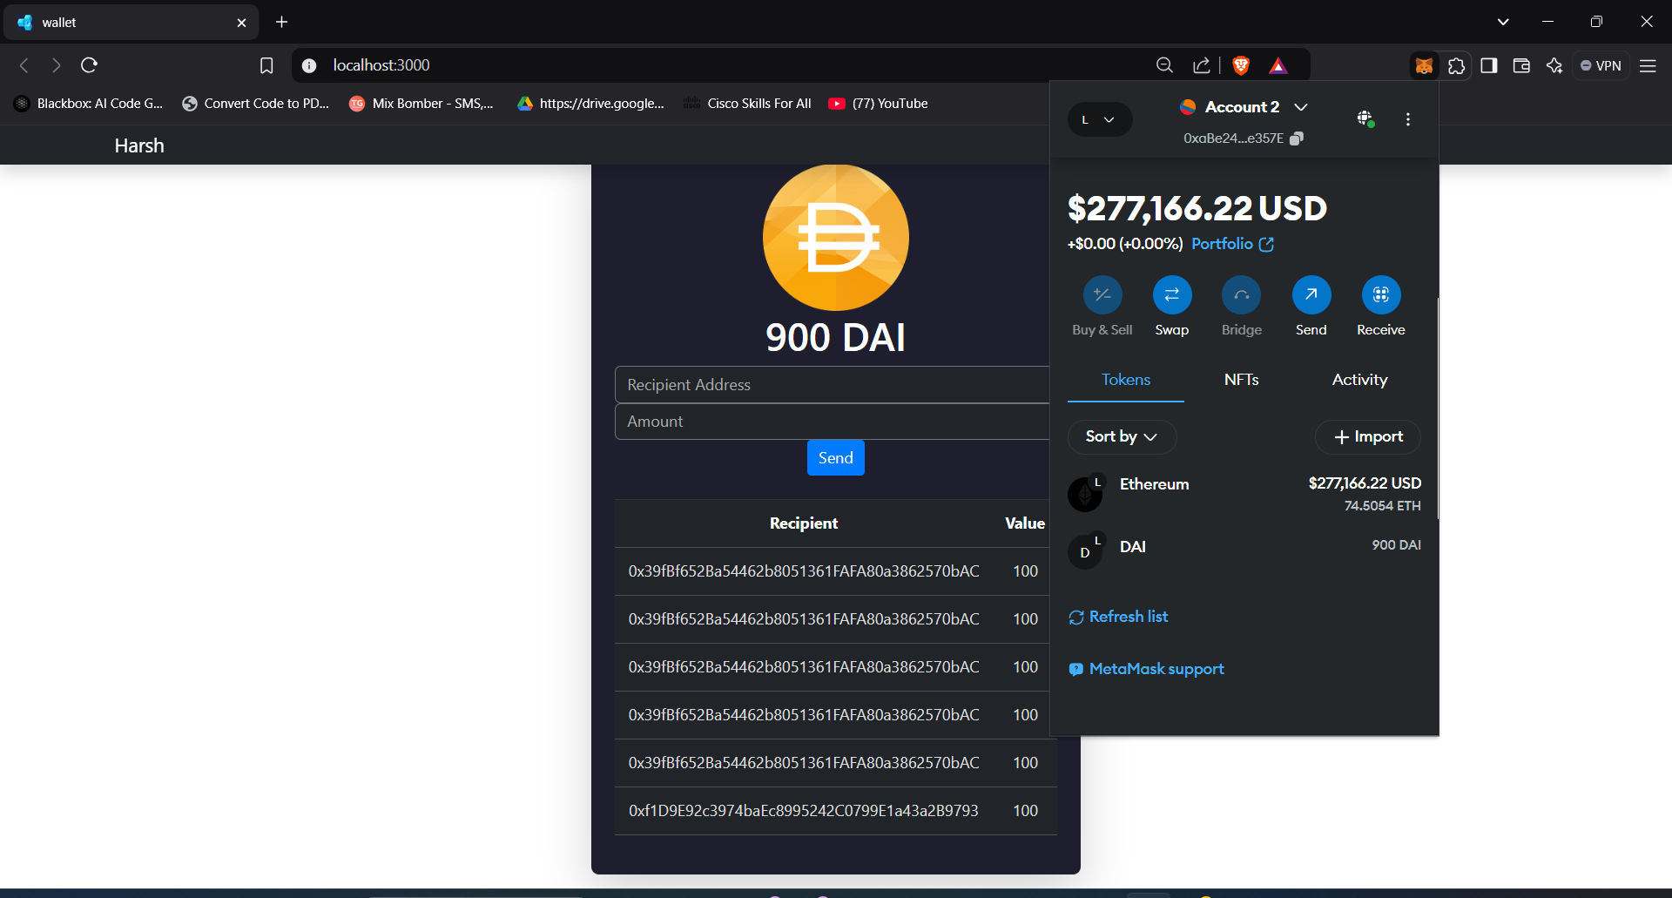

Figure 3: webpage of File Sharing Platform

## CONCLUSION AND FUTURE WORK

The Ethereum Wallet Manager initiative effectively meets the increasing demand for a user-friendly, secure, and adaptable platform for managing Ethereum accounts and transactions. By utilizing advanced technologies such as React.js, Node.js, Web3.js, and Solidity, the system delivers a smooth user experience while upholding the principles of blockchain security and transparency. Key functionalities, including wallet creation, secure management of private keys, token transactions, and smart contract interactions, offer a comprehensive solution for Ethereum users. The incorporation of MetaMask and various wallet providers enhances accessibility, while the extensive transaction history guarantees transparency and accountability. This initiative streamlines the management of wallets and transactions and acts as an entry point to the decentralized finance (DeFi) and DApp landscapes. It showcases the promise of blockchain technology to create secure, scalable, and user-driven applications, effectively bridging the divide between technical intricacies and user requirements. The Ethereum Wallet Manager represents a complete tool, empowering users to interact confidently and effectively with the Ethereum network.

* Future Development
* Support for Multiple Chains: As blockchain frameworks evolve, subsequent versions of the project could add compatibility with other networks like Binance Smart Chain, Polygon, and Solana. This would enable users to manage wallets across various chains from a single platform.
* Dedicated Mobile App: Creating a standalone mobile app would improve accessibility, enabling users to handle their wallets and conduct transactions while on the move.
* Enhanced Scalability: Adopting Layer-2 solutions like Optimism or Arbitrum would lower transaction fees and boost speed, ensuring reliable performance during times of significant network traffic.
* Upgraded Security Features: Adding multi-signature wallets, biometric verification, and hardware wallet integration would bolster security for high-value transactions.
* Insights Powered by AI: Utilizing artificial intelligence to offer predictive analysis, optimize transactions (for instance, predicting gas fees), and provide portfolio management insights would greatly benefit users.
* Decentralized Identity Solutions: Implementing decentralized identity frameworks could improve user privacy and security while streamlining the login and account recovery experience.
* Smart Contract Libraries: Introducing a collection of pre-constructed smart contract templates would enable users to deploy custom contracts without needing in-depth programming skills.
* Community and Governance Elements: Adding DAO (Decentralized Autonomous Organization) functionality would enable users to take part in the governance of the platform, giving them input in future enhancements.

With these upgrades, the Ethereum Wallet Manager can transform into a versatile center for blockchain-related financial activities, appealing to both casual users and experienced developers within the decentralized economy

## 