**Product** : Nail Cutter

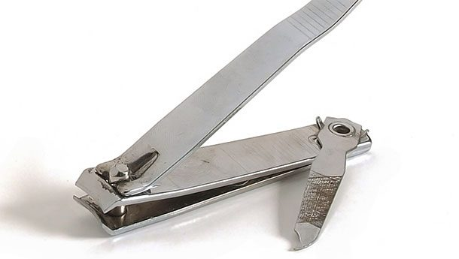

**Bad Design :**

* **Lack of Clipping Containment**: Traditional nail cutters do not have any mechanism to catch or contain nail clippings, leading to scattered clippings that can be difficult to clean up.
* **Inconvenient Cleanup**: Users often need to use a secondary method, such as placing a piece of paper or using a vacuum, to collect the clippings, adding extra steps and inconvenience.

**Solutions:**

* **Ergonomic Design**: Design the nail cutter with an ergonomic shape that naturally directs clippings into a built-in catcher, reducing the likelihood of them scattering.
* **Integrated Clipping Catcher**: Design the nail cutter with an integrated compartment or shield that catches the nail clippings as they are cut. This could be a small, detachable container or a built-in part that can be emptied easily.

**Product** : Elevator Buttons

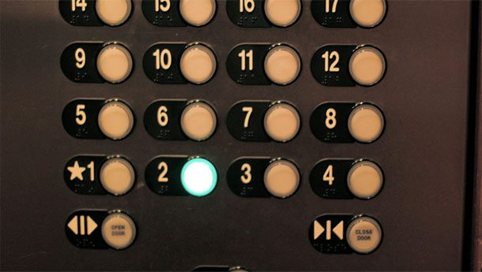

**Bad Design:**

* **Inflexibility**: Once a floor button is pressed, the inability to deselect it means that any accidental or mistaken selections cannot be corrected. This inflexibility can be frustrating for users.
* **Wasted Time**: If a user accidentally presses the wrong floor, the lift will stop at the unintended floor, wasting time for all passengers. This is particularly problematic in busy buildings where lift efficiency is crucial.
* **Emergency Situations**: In emergency situations, the ability to quickly change or cancel floor selections could be crucial. Fixed selections do not allow for this flexibility.

**Solutions:**

* **Touchscreen Interface**: Use a touchscreen interface where users can easily select and deselect floors. A clear, intuitive interface can help prevent mistakes and make corrections straightforward.
* **Deselect Functionality**: Implement a feature where users can press a selected button again to deselect it. This simple toggle mechanism would allow for easy correction of mistakes.

**Product** : Dustpan and Broom

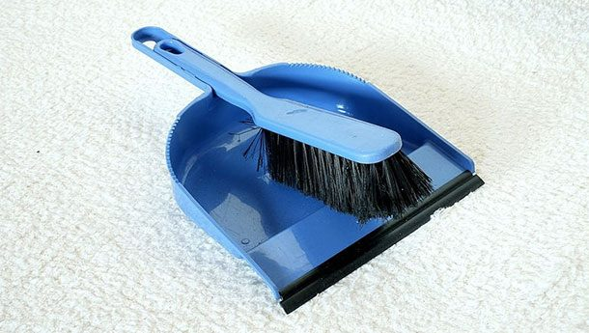

**Bad Design:**

* **Improper Angle**: The angle at which the dustpan meets the floor is often not flush, causing a small gap that dust and debris can slip through.
* **No Debris Funnel**: Traditional designs often lack a mechanism to funnel dust into the pan, resulting in some dust being left behind.

**Solutions:**

* **Flexible Rubber Edge**: Design the dustpan with a flexible rubber edge that conforms to the floor’s surface, ensuring no gaps for dust to escape.
* **Strong, Even Bristles**: Use strong, evenly distributed bristles on the broom to gather all dust particles effectively.

**Product** : Car Infotainment

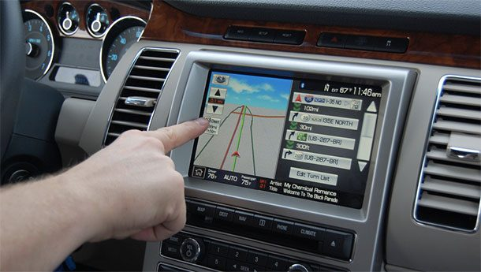

**Bad Designs:**

* **Complex Menus**: Infotainment systems often have complex, multi-layered menus that require significant attention to navigate, diverting the driver’s focus from the road.
* **Distracting Visuals**: Bright screens, animated graphics, or excessive information can be visually distracting, drawing the driver’s eyes away from the road.

**Solutions:**

* **Simplified Menus**: Design the system with simplified, flat menus that minimize the number of steps needed to access key functions.
* **Minimalist Display**: Use a minimalist design with clean, simple visuals and essential information only, reducing visual distraction.
* **Advanced Voice Control**: Implement advanced, reliable voice control systems that allow drivers to perform most functions hands-free.

**Product** : Sticker

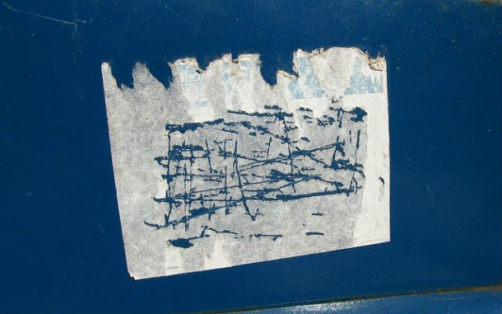

**Bad Design:**

* **Strong Adhesive**: Pricing stickers often use strong adhesives to ensure they stay in place during transport and handling, which can make removal difficult and leave behind residue.
* **No Easy-Peel Feature**: Many pricing stickers lack an easy-peel feature, such as a tab or non-stick edge, making it difficult to remove the sticker without tearing it.

**Solutions:**

* **Residue-Free Adhesive**: Use adhesives specifically designed to leave no residue when removed, similar to those used for removable labels or Post-it notes.
* Use of labels instead of stickers
* **Perforated Edges**: Design stickers with perforated edges that help them tear in a controlled manner, reducing the likelihood of leaving behind fragments.